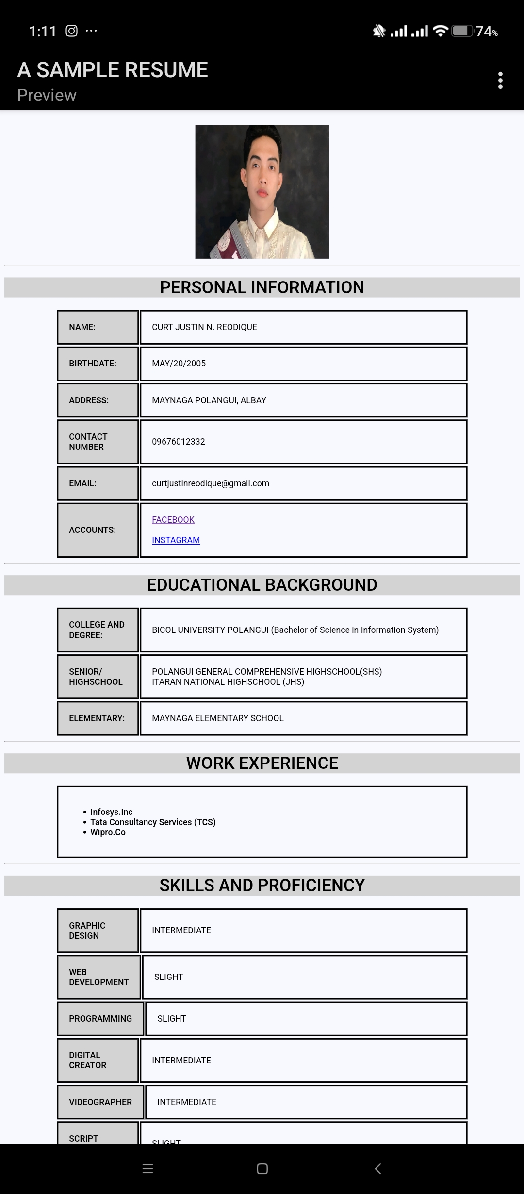

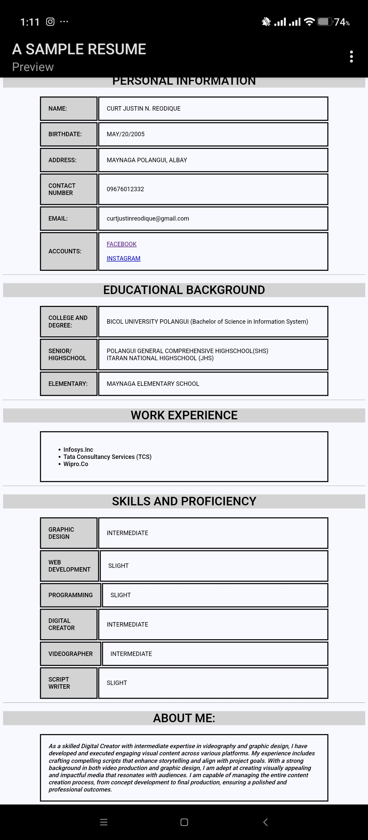

# CODE:

<!DOCTYPE html>

<html>

<head>

<meta charset=”UTF-8”>

<meta name=”viewport” content=”width=device-width, initial-scale=1”>

<title>A SAMPLE RESUME</title>

<style>

Body{

Background-color: ghostwhite;

}

Table, td{

Font-family: Arial, sans-serif

Border-collapse: collapse;

Width:80%;

}

Th,td{

Border: 3px solid;

Text-align: left;

Padding: 20px;

}

Th{

Background-color: lightgrey;

}

H1{

Background-color: lightgray;

}

Td{

Font-size: 100%;

}

</style>

</head>

<body>

<br>

<center>

<img src=”image//images//IMG1.jpg” alt=”applicant pic” width=”250” height=”250”>

<hr>

<h1> PERSONAL INFORMATION </h1>

<table>

<th> NAME:</th>

<td> CURT JUSTIN N. REODIQUE </td>

</table>

<table>

<th> BIRTHDATE:</th>

<td> MAY/20/2005</td>

</table>

<table>

<th> ADDRESS:</th>

<td> MAYNAGA POLANGUI, ALBAY</td>

</table>

<table>

<th> CONTACT NUMBER</th>

<td> 09676012332 </td>

</table>

<table>

<th> EMAIL:</th>

<td> [curtjustinreodique@gmail.com</td](mailto:curtjustinreodique@gmail.com%3c/td)>

</table>

<table>

<th> ACCOUNTS:</th>

<td <a href=”

[https://www.facebook.com/curtjustin.reodique.3?mibextid=ZbWKwL”>FACEBOOK</a><br><br](https://www.facebook.com/curtjustin.reodique.3?mibextid=ZbWKwL”%3eFACEBOOK%3c/a%3e%3cbr%3e%3cbr)> <a href= <https://www.instagram.com/yamato_justin?igsh=Nm5qcDVqbzFxdjFu>> INSTAGRAM </a>

</table>

<hr>

<h1> EDUCATIONAL BACKGROUND</h1>

<table>

<th> COLLEGE AND DEGREE:</th>

<td> BICOL UNIVERSITY POLANGUI (Bachelor of Science in Information System)</td>

</table>

<table>

<th> SENIOR/<br>HIGHSCHOOL</th>

<td> POLANGUI GENERAL COMPREHENSIVE HIGHSCHOOL(SHS) <br> ITARAN NATIONAL HIGHSCHOOL (JHS)</td>

</table>

<table>

<th> ELEMENTARY:</th>

<td> MAYNAGA ELEMENTARY SCHOOL </td>

</table>

<hr>

<h1> WORK EXPERIENCE</h1>

<table>

<td> <ul> <b>

<li>Infosys.Inc</li>

<li> Tata Consultancy Services (TCS)</li>

<li> Wipro.Co</li>

</b>

</ul>

</td>

</table>

<hr>

<h1>SKILLS AND PROFICIENCY</h1>

<table>

<th> GRAPHIC DESIGN </th>

<td> INTERMEDIATE</td>

</table>

<table>

<th>WEB DEVELOPMENT</th>

<td> SLIGHT </td>

</table>

<table>

<th> PROGRAMMING </th>

<td> SLIGHT</td>

</table>

<table>

<th> DIGITAL CREATOR</th>

<td> INTERMEDIATE</td>

</table>

<table>

<th> VIDEOGRAPHER </th>

<td> INTERMEDIATE </td>

</table>

<table>

<th> SCRIPT WRITER</th>

<td> SLIGHT</td>

</table>

<hr>

<h1> ABOUT ME:</h1>

<table>

<td <i> <b>As a skilled Digital Creator with intermediate expertise in videography and graphic design, I have developed and executed engaging visual content across various platforms. My experience includes crafting compelling scripts that enhance storytelling and align with project goals. With a strong background in both video production and graphic design, I am adept at creating visually appealing and impactful media that resonates with audiences. I am capable of managing the entire content creation process, from concept development to final production, ensuring a polished and professional outcomes.</i></b>

</td>

</table>

</center>

</body>

</html>