CARLOS HILADO MEMORIAL STATE UNIVERSITY
COLLEGE OF COMPUTER STUDIES • DEPARTMENT OF INFORMATION SYSTEMS
ACADEMIC YEAR 2026–2027 • FIRST SEMESTER
PROFE 7: WEB APPLICATION DEVELOPMENT
ACTIVITY #3 – LOW FIDELITY WIREFRAME FRAMEWORK
Comprehensive Structural Blueprint for Personal Portfolio Website (Laragon / PHP 8 / MySQL)

Student Name: | MARTIN C. DIASANTA
Course, Year & Section: | Bachelor of Science in Information Systems (BSIS) – 4A
Course Instructor: | Prof. Manuel Andres Buncio
Submission Date: | September 28, 2026 (Due Today)
1. Activity Overview & Executive Summary
This activity submission presents the formal Low-Fidelity (Lo-Fi) Wireframe Framework for my Personal Portfolio Website (locally engineered in Laragon using Plain Core PHP 8, MySQL PDO, Bootstrap 5, and Vanilla JavaScript). In Human-Computer Interaction (HCI) and user interface engineering, low-fidelity wireframing serves as an indispensable architectural phase that abstracts away distracting visual aesthetics (color palettes, high-resolution imagery, and intricate styling) to rigorously evaluate visual hierarchy, information chunking, ergonomic thumb zones, and user conversion flows.
Core Design & Pedagogical Objectives:
• Establish Structural Hierarchy: Direct recruiter attention from identity introduction down to conversion (project case studies, resume download, and validated contact channels) following natural F-shape and Z-shape ocular scanning paths.
• Standard Wireframe Primitives: Render all graphic assets as rectangular placeholders with diagonal 'X' crosses, button outlines, percentage progress bars, and form controls per international UX prototyping standards.
• Responsive Fluidity (Desktop vs. Mobile): Benchmark 12-column desktop layouts against 375px/390px mobile viewports, ensuring 48px touch targets, off-canvas navigation, and horizontal swipe rails.
• Modular Codebase Translation: Map every wireframe section directly into the modular PHP includes (`includes/navbar.php`, `index.php`, `project.php`, `contact.php`, `includes/footer.php`) and PDO database schema.

2. Information Architecture & Navigation Flowchart
The portfolio website employs a hybrid architecture: an intuitive Single-Page Application (SPA) anchor flow for the main presentation surface (`index.php`), coupled with dedicated multi-page routing for granular technical evaluations (`project.php?id=X` and `projects.php`). Dynamic content is managed through a normalized MySQL schema (`personal_portfolio`), secured via PDO prepared statements and CSRF token verification.
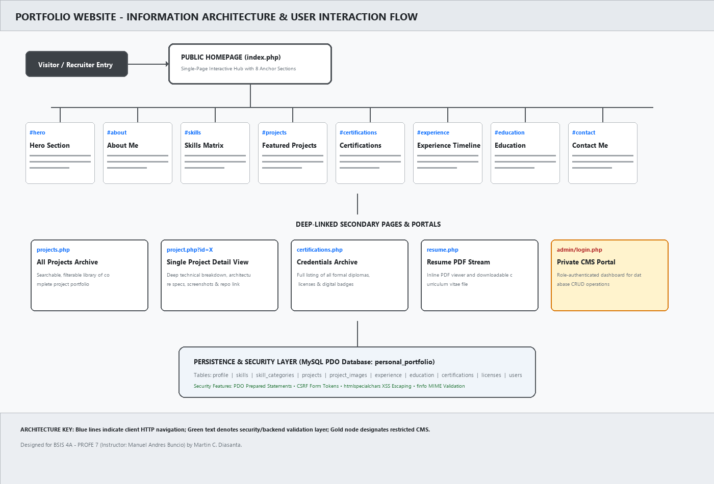
Figure 1: Complete Information Architecture, Route Mapping & User Interaction Flowchart
Architectural Layer | Components & Routes | Technical & UX Functionality
Public Presentation Layer | index.php (8 Anchor Zones) | Seamless one-page scroll containing Hero, About, Skills, Projects, Certs, Experience, Education, and Contact.
Deep Technical Showcase | projects.php & project.php | Filterable project archive and dedicated single-project case studies with multi-screenshot galleries and live links.
Asset & Document Stream | resume.php & uploads/ | Secure server-side streaming of curriculum vitae PDF with mime-type verification and execution blocking.
Restricted Management CMS | admin/login.php & Dashboard | Authenticated administrative control panel with password hashing (`password_verify`) and full database CRUD.
Data Persistence Layer | MySQL (personal_portfolio) | 10 normalized relational tables managed via PDO prepared statements with emulated prepares explicitly disabled.

3. Low-Fidelity Wireframe Blueprints: Desktop Viewport (1400px)
3.1 Global Sticky Navigation, Hero Section & About Me Container
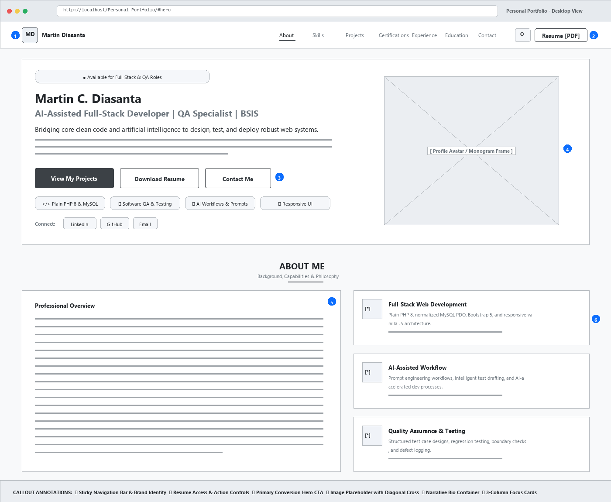
Figure 2: Desktop Low-Fidelity Wireframe – Navigation Bar, Hero Section & About Me Bio with 3-Pillar Cards
Callout | UI Component Name | Wireframe Representation & Functional Interaction
① | Sticky Navbar & Brand Monogram | Fixed 60px header containing student initials badge ('MD'), student name, and 7 section anchor triggers with active scroll-spy indicators.
② | Action Controls Toolbar | Houses client-side dark/light mode toggle ('O') and high-visibility 'Resume [PDF]' action streaming Martin's verified curriculum vitae.
③ | Primary Hero Conversion CTAs | High-contrast primary trigger ('View My Projects') anchoring directly to showcase grid, accompanied by secondary outline triggers ('Download Resume', 'Contact Me').
④ | Profile Avatar Bounding Box | Constrained aspect-ratio box with diagonal cross 'X'. In final build, dynamically populates Martin Diasanta's formal photo with fallback monogram initials.
⑤ | Narrative Bio Container | Single-card narrative outlining BSIS studies at Carlos Hilado Memorial State University, prompt engineering expertise, and career aspirations.
⑥ | 3-Pillar Capability Grid | 3 stacked cards detailing core competencies: Full-Stack Web Development (PHP/MySQL), AI-Assisted Workflows, and Quality Assurance & Testing.

3.2 Technical Skills Matrix & Featured Projects Showcase Grid
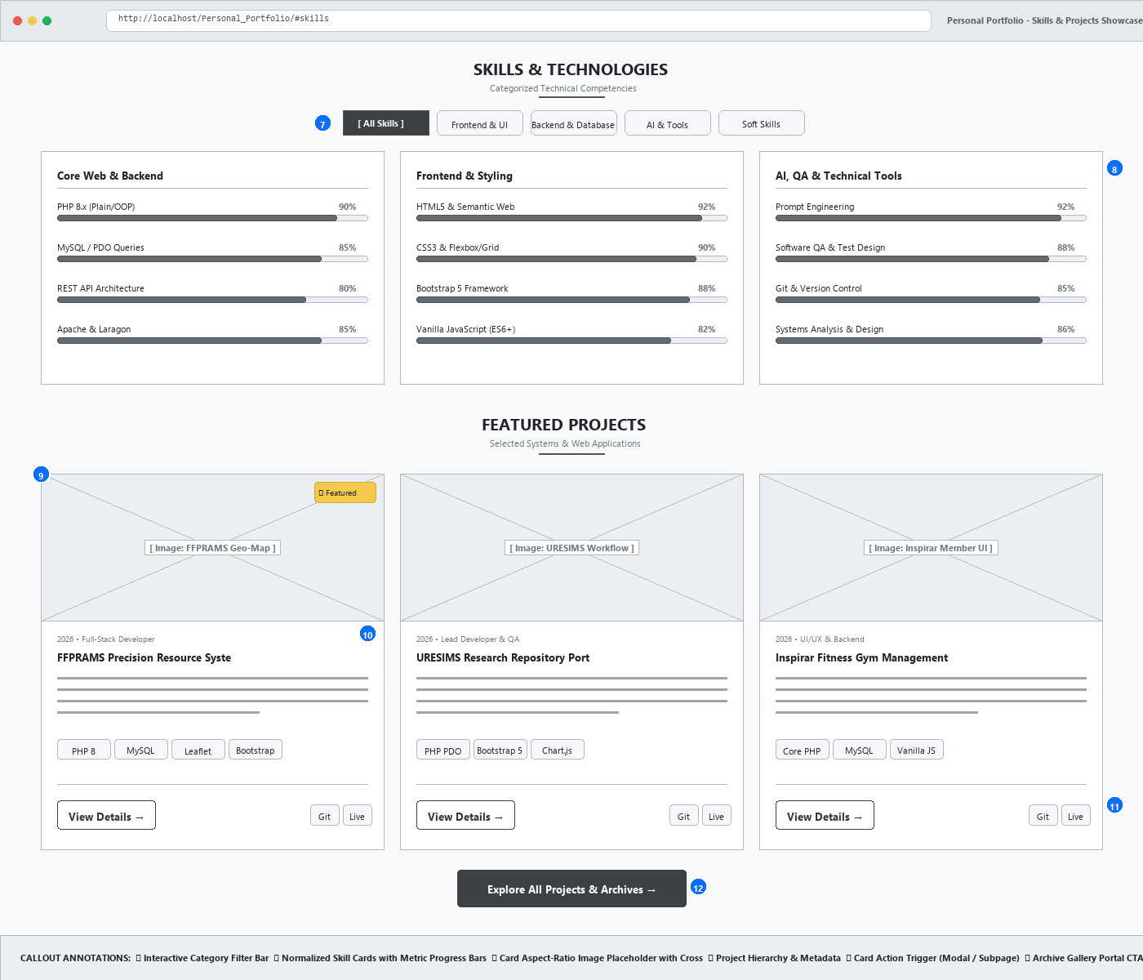
Figure 3: Desktop Low-Fidelity Wireframe – Categorized Skills Matrix with Progress Indicators & 3-Column Project Grid
Callout | UI Component Name | Wireframe Representation & Functional Interaction
⑦ | Interactive Category Filter Pills | Horizontal tab navigation ('All Skills', 'Frontend', 'Backend & DB', 'AI & Tools'). Filters skill cards instantly via JavaScript data attributes.
⑧ | Normalized Skill Cards & Bars | Presents categorized proficiencies (e.g. PHP 90%, MySQL 85%, QA 88%) with numerical badges and visual progress bar fill tracks.
⑨ | 16:9 Project Thumbnail Box | Standardized wireframe image placeholder with cross lines and '★ Featured' status ribbon. Enforces consistent card geometry.
⑩ | Project Metadata & Title Block | Displays project year (2026), developer role ('Full-Stack Developer'), concise system summary, and stack tags (PHP 8, MySQL, Leaflet).
⑪ | Card Action Triggers | Direct 'View Details →' CTA routing to single project view (`project.php?id=X`), accompanied by external GitHub and Live Demo anchor links.
⑫ | Archive Gallery Portal CTA | Centered call-to-action button guiding recruiters to the comprehensive project catalog and historical archives (`projects.php`).

3.3 Experience Timeline, Academic Credentials & Secured Contact Section
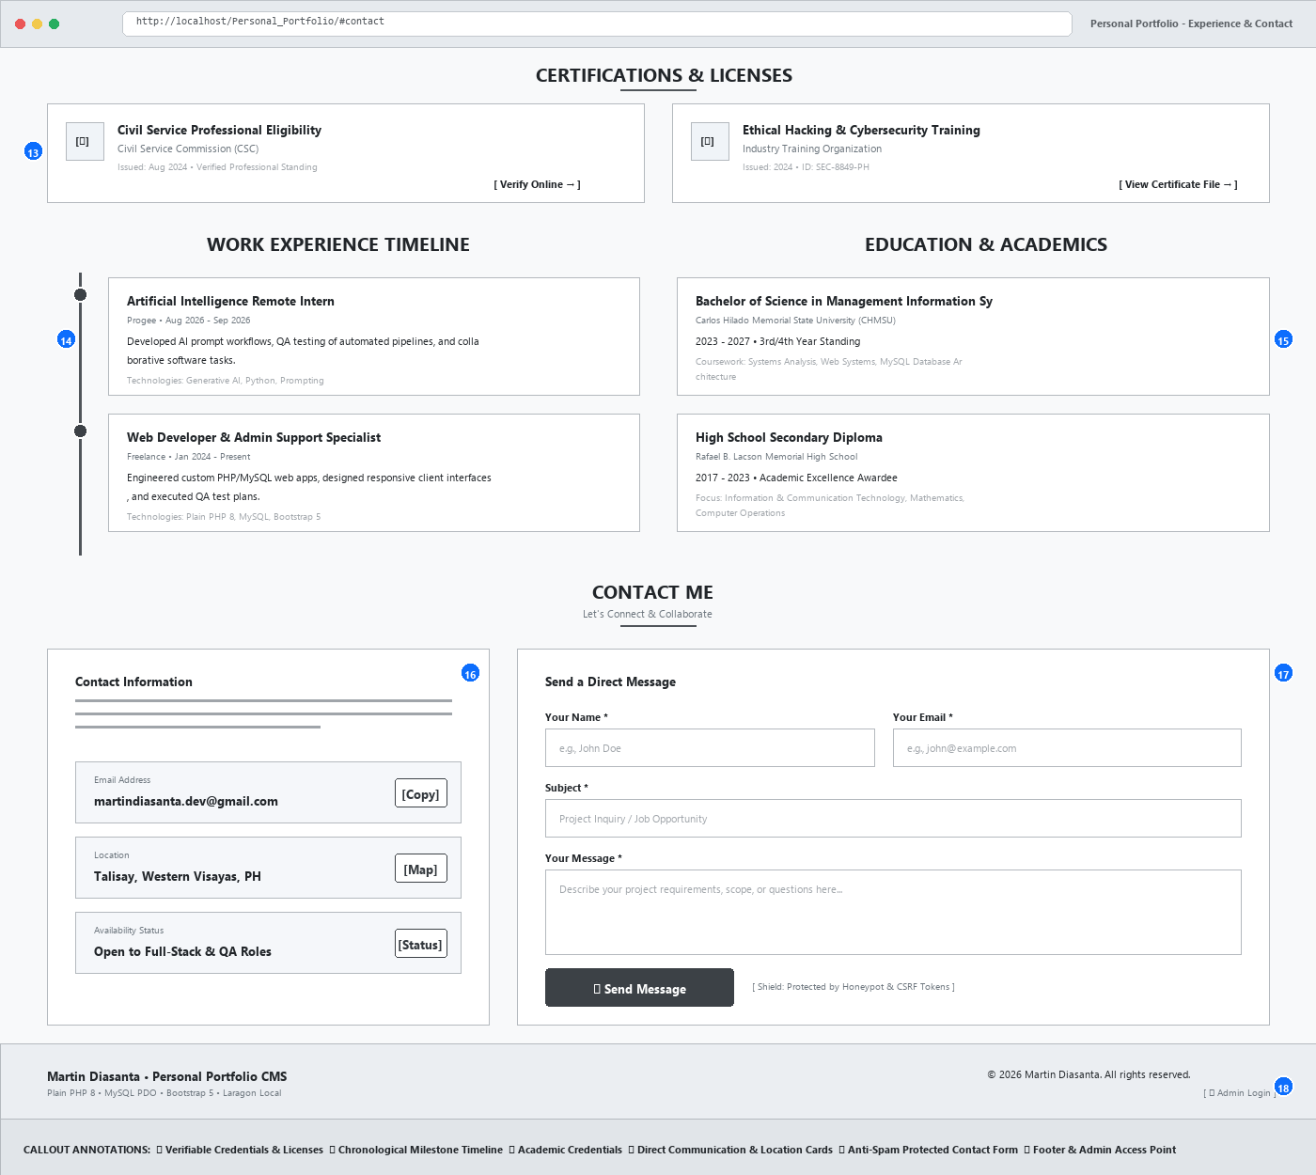
Figure 4: Desktop Low-Fidelity Wireframe – Certifications, Work Experience Rail, Education & Secured Contact Form
Callout | UI Component Name | Wireframe Representation & Functional Interaction
⑬ | Verifiable Credentials Cards | Two-column grid showcasing Civil Service Commission (CSC) Professional Eligibility and Cybersecurity training with live online verification triggers.
⑭ | Chronological Timeline Rail | Continuous vertical rail with node indicators documenting Progee AI Internship and Freelance development positions, including responsibilities and tech stack.
⑮ | Academic History Cards | Displays tertiary degree details (BSIS at CHMSU) alongside secondary honors at Rafael B. Lacson Memorial High School, highlighting database coursework.
⑯ | Direct Communication Cards | Interactive cards displaying direct contact methods (email with 1-click clipboard copy action, physical location in Talisay, and availability status badge).
⑰ | Secured Contact Input Form | Two-column form with full validation. Integrates hidden honeypot anti-spam fields and server-side CSRF tokens for injection-safe message dispatching.
⑱ | Footer & Admin Access Point | Global copyright notice, tech stack acknowledgement, and discreet admin login anchor (`/admin/login.php`) leading to the private portfolio CMS.

3.4 Mobile Responsive Viewport (375px Fluid Breakpoint)
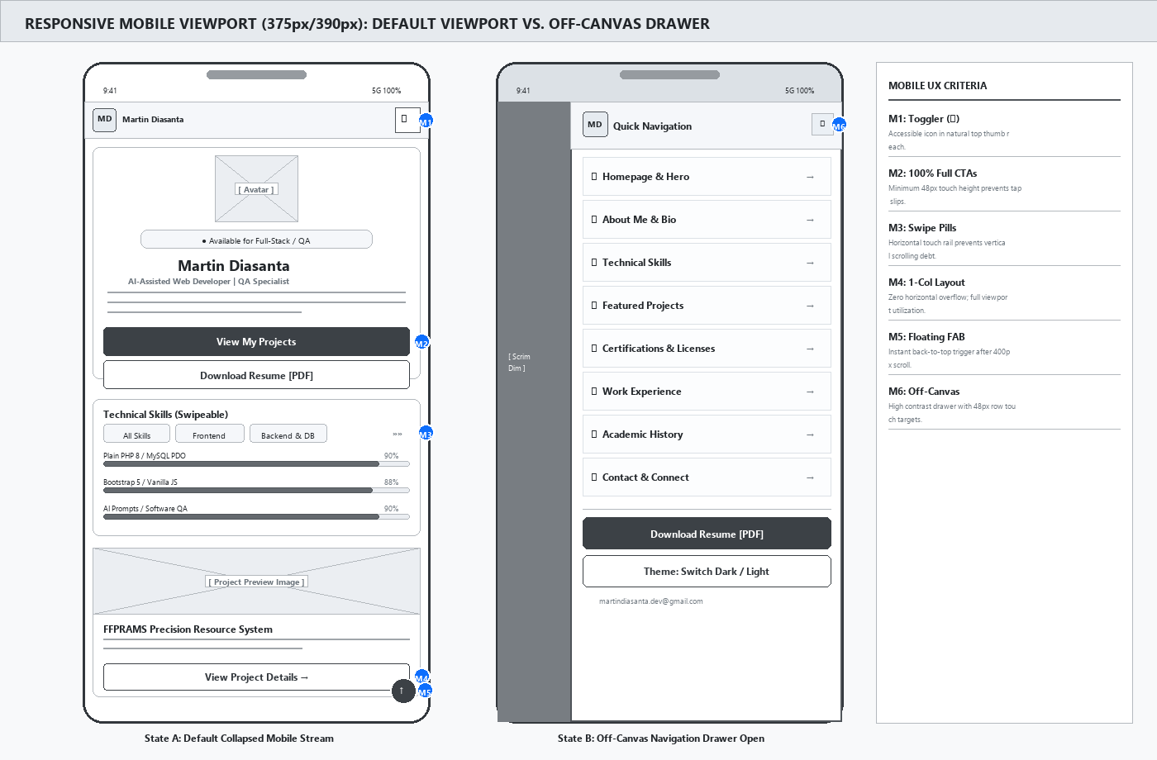
Figure 5: Mobile Viewport Wireframe (375px / 390px) & Ergonomic One-Handed Thumb-Zone Specifications
Callout | UI Component Name | Wireframe Representation & Functional Interaction
M1 | Hamburger Navigation Toggler | Replaces desktop horizontal links with an accessible off-canvas drawer triggered via a high-contrast hamburger icon (☰) positioned in the top-right thumb zone.
M2 | 100% Full-Width Touch CTAs | Hero action buttons stack vertically to fill 100% of viewport width with a minimum touch height of 48px to eliminate tap target errors on touchscreens.
M3 | Swipeable Filter Chips | Category filter buttons transform into a horizontal swipe rail (`overflow-x: auto`), conserving vertical viewport real estate while maintaining instant category access.
M4 | Single-Column Card Stacking | Desktop 3-column project cards collapse into single-column full-width cards with edge-to-edge images and touch-optimized action buttons.
M5 | Floating Back-to-Top Button | Persistent floating action button (FAB) in the lower-right thumb zone, automatically fading in after 400px of scroll depth to provide quick return to navigation.
M6 | Off-Canvas Navigation Drawer | Slide-out modal drawer activated by hamburger icon (☰), providing 48px touch targets, quick resume download, and dark mode toggle.

3.5 Secondary Deep-Dive Page: Single Project Detailed Case Study (project.php)
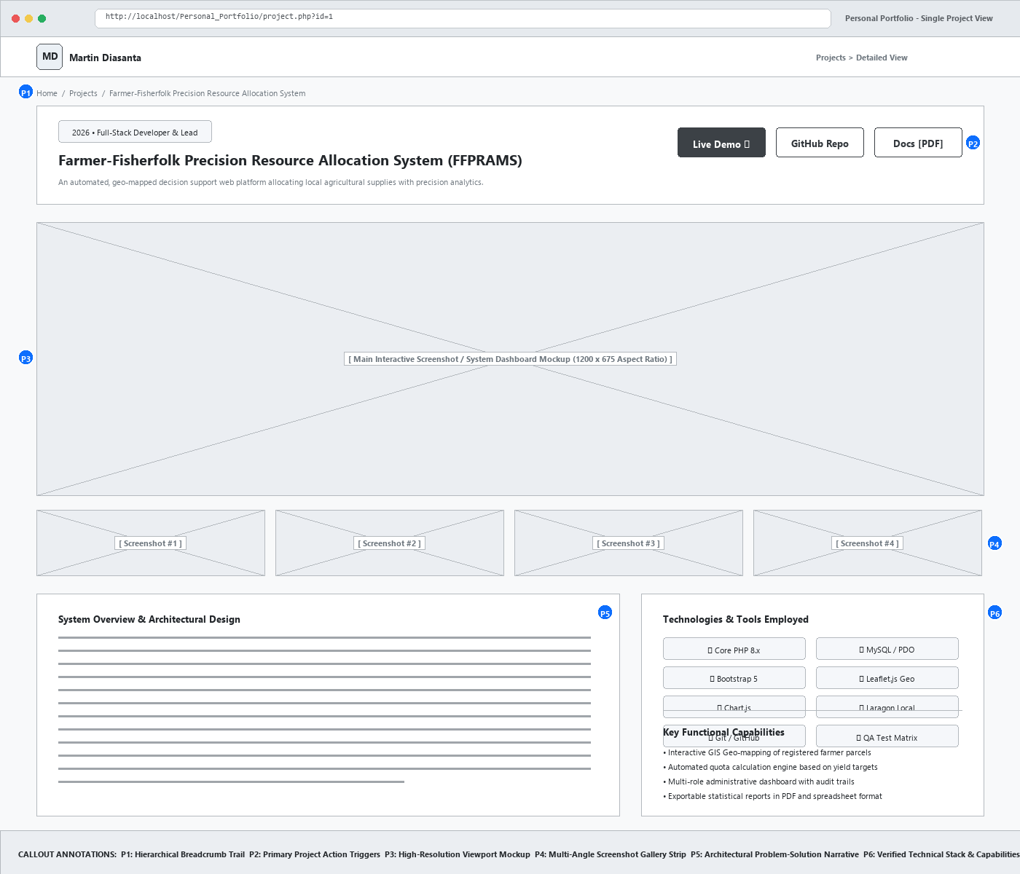
Figure 6: Secondary Page Low-Fidelity Wireframe – Single Project Detail View (project.php) with Gallery Strip
Callout | UI Component Name | Wireframe Representation & Functional Interaction
P1 | Hierarchical Breadcrumb Trail | Provides spatial orientation (`Home > Projects > Project Title`), allowing intuitive backtracking without browser history dependence.
P2 | External Action Triggers | High-visibility action cluster linking directly to live deployment URL, public GitHub source code repository, and technical documentation PDF.
P3 | Primary Viewport Mockup | Large-format 16:9 wireframe box displaying main user interface screenshot with full-width responsive scaling.
P4 | Multi-Angle Thumbnail Strip | Sub-gallery strip featuring clickable thumbnail placeholders to inspect system sub-views (e.g. database admin, mobile view, query analytics).
P5 | Architectural Narrative | Dedicated content block articulating problem statement, system design decisions, PDO database schema, and security considerations.
P6 | Verified Tech Stack Matrix | Organized 2-column checklist of all languages, libraries, and frameworks utilized (Core PHP 8, MySQL, Leaflet.js, Bootstrap 5).

4. Usability Rationale & HCI Principles
• Visual Scanning Hierarchy (F-Pattern & Z-Pattern): Eye-tracking studies demonstrate that web users scan screen content in an 'F-shape' pattern. The portfolio wireframe leverages this by placing the identity monogram and value proposition at the top left, followed by primary action triggers across the horizontal top bar, and supporting detail cards down the left column.
• Whitespace & Cognitive Load Management: Generous negative space (padding: 4rem to 5rem between sections) prevents visual fatigue, allowing technical recruiters to immediately parse key competencies (PHP 8, MySQL, QA) without cognitive overload.
• Progressive Disclosure: Secondary details—such as comprehensive project writeups and full certification records—are cleanly abstracted into modal dialogs or sub-pages (`project.php`). This preserves a streamlined homepage experience while satisfying technical reviewers requiring deep architectural evidence.
• Accessibility & Touch Target Ergonomics: All touch triggers comply with WCAG 2.1 AA standards, providing a minimum bounding box of 48x48 pixels on mobile displays. Form inputs incorporate persistent label tags, high-contrast placeholder text, and clear error state boundaries.
5. Codebase Translation Architecture (Laragon / Core PHP 8 / MySQL)
Wireframe Section | Template File / Include | Database Model / Security Implementation
Global Navigation | includes/navbar.php | PHP session status check, dynamic brand initials monogram generator.
Hero & Bio Section | index.php (Lines 74–205) | PDO query to `profile` table; availability badge toggle; dynamic resume link.
Skills & Competencies | index.php (Lines 210–263) | Relational join between `skills` and `skill_categories`; dynamic progress bars.
Featured Projects Grid | index.php (Lines 266–340) | PDO query filtered by `is_published = 1` and sorted by `is_featured DESC`.
Project Detailed View | project.php | Prepared SQL query (`WHERE id = ?`); secondary query to `project_images`.
Experience Timeline | index.php (Lines 408–458) | Ordered query to `experience` table; date formatting helper (`format_date`).
Contact & Spam Shield | contact.php & index.php | CSRF token validation (`require_csrf_token()`) and hidden honeypot field anti-bot.
Private Admin CMS | admin/index.php & admin/*.php | Password hashing (`password_hash`), session regeneration, brute-force throttling.
6. Student Reflection & Conclusion
Conducting this low-fidelity wireframing activity for PROFE 7 reinforced the fundamental truth of software engineering: clarity of layout structure precedes efficiency of code implementation. Prior to establishing this framework, UI development often risked subjective visual indecision and repetitive CSS refactoring. By intentionally stripping away color palettes, high-resolution imagery, and intricate CSS gradients, I was able to evaluate the portfolio strictly on its structural merits—verifying that my positioning as an AI-Assisted Full-Stack Developer and QA Specialist is immediately obvious within the first five seconds of page viewing.
Furthermore, mapping the responsive mobile breakpoint (Figure 5) forced critical ergonomic considerations: transforming horizontal navbar links into an accessible off-canvas drawer, establishing 48px touch targets, and implementing horizontal chip-swiping. This architectural blueprint ensures that my Laragon-hosted PHP/MySQL portfolio is built on a solid, user-centered foundation ready for high-fidelity styling, administrative CMS management, and professional production deployment.
Prepared and Submitted by:
MARTIN C. DIASANTA
Student, BS in Information Systems (BSIS 4-A)
Carlos Hilado Memorial State University

