Mine Position Image

學號：7112056007

姓名：王昱婷

日期：2024/9/18

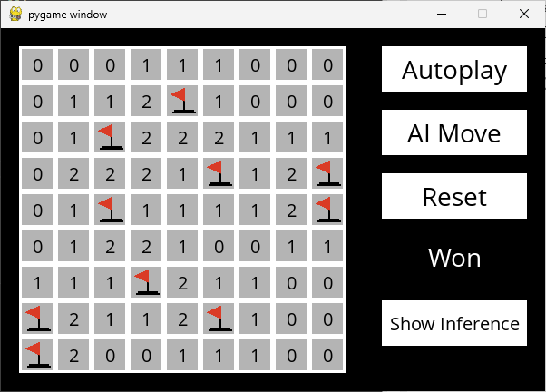

Figure 1: Beginner Mine Positions

Mine Position File: mine1.txt

(H, W, M)=(9, 9, 10)

Index Positions: [13, 20, 32, 35, 38, 44, 57, 63, 68, 72]

(Row, Column): (1, 4), (2, 2), (3, 5), (3, 8), (4, 2), (4, 8), (6, 3), (7, 0), (7, 5), (8, 0)

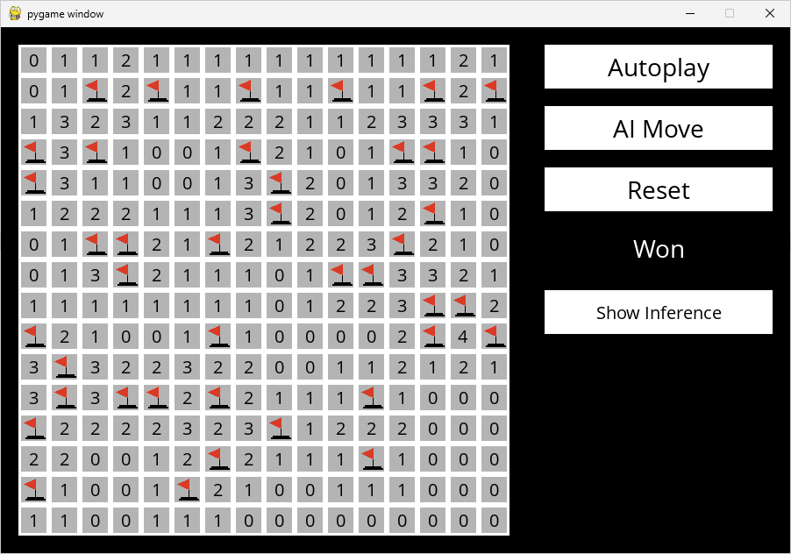

Figure 2: Intermediate Mine Positions

Mine Position File: mine2.txt

(H, W, M)=(16, 16, 40)

Index Positions: [18, 20, 23, 26, 29, 31, 48, 50, 55, 60, 61, 64, 72, 88, 93, 98, 99, 102, 108, 115, 122, 123, 141, 142, 144, 150, 157, 159, 161, 177, 179, 180, 182, 187, 192, 200, 214, 219, 224, 229]

(Row, Column): (1, 2), (1, 4), (1, 7), (1, 10), (1, 13), (1, 15), (3, 0), (3, 2), (3, 7), (3, 12), (3, 13), (4, 0), (4, 8), (5, 8), (5, 13), (6, 2), (6, 3), (6, 6), (6, 12), (7, 3), (7, 10), (7, 11), (8, 13), (8, 14), (9, 0), (9, 6), (9, 13), (9, 15), (10, 1), (11, 1), (11, 3), (11, 4), (11, 6), (11, 11), (12, 0), (12, 8), (13, 6), (13, 11), (14, 0), (14, 5)

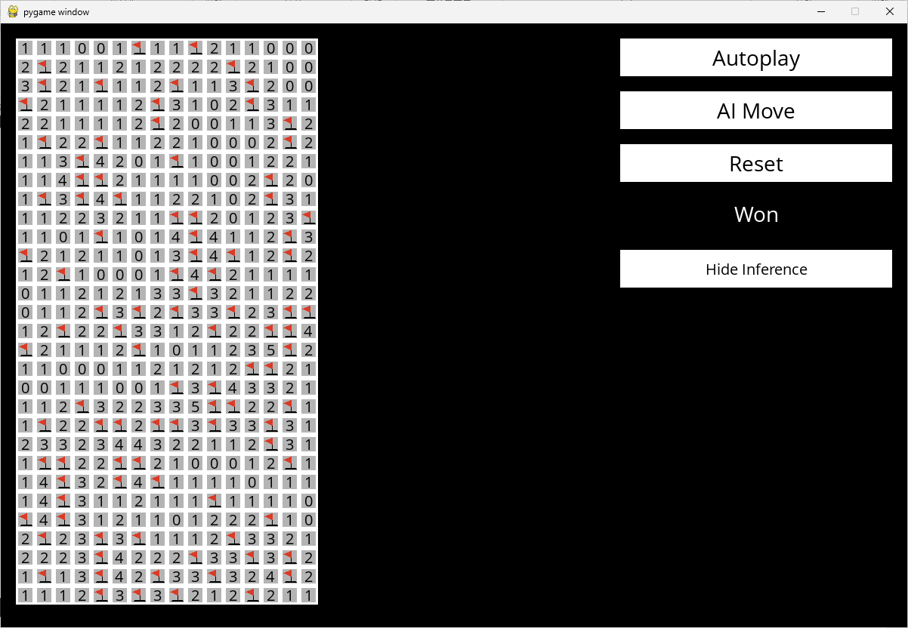

Figure 3: Expert Mine Positions

Mine Position File: mine3.txt

(H, W, M)=(30, 16, 99)

Index Positions: [6, 9, 17, 27, 33, 36, 40, 44, 48, 55, 60, 71, 78, 81, 84, 94, 99, 104, 115, 116, 125, 129, 131, 133, 141, 152, 153, 159, 164, 169, 174, 176, 185, 187, 190, 194, 200, 202, 217, 228, 230, 232, 235, 238, 239, 242, 245, 250, 253, 254, 256, 262, 270, 284, 285, 296, 298, 307, 314, 315, 318, 321, 324, 325, 327, 328, 330, 333, 349, 353, 354, 357, 358, 366, 370, 373, 375, 386, 394, 400, 402, 413, 417, 420, 422, 427, 436, 441, 444, 446, 449, 452, 455, 458, 462, 468, 470, 472, 476]

(Row, Column): (0, 6), (0, 9), (1, 1), (1, 11), (2, 1), (2, 4), (2, 8), (2, 12), (3, 0), (3, 7), (3, 12), (4, 7), (4, 14), (5, 1), (5, 4), (5, 14), (6, 3), (6, 8), (7, 3), (7, 4), (7, 13), (8, 1), (8, 3), (8, 5), (8, 13), (9, 8), (9, 9), (9, 15), (10, 4), (10, 9), (10, 14), (11, 0), (11, 9), (11, 11), (11, 14), (12, 2), (12, 8), (12, 10), (13, 9), (14, 4), (14, 6), (14, 8), (14, 11), (14, 14), (14, 15), (15, 2), (15, 5), (15, 10), (15, 13), (15, 14), (16, 0), (16, 6), (16, 14), (17, 12), (17, 13), (18, 8), (18, 10), (19, 3), (19, 10), (19, 11), (19, 14), (20, 1), (20, 4), (20, 5), (20, 7), (20, 8), (20, 10), (20, 13), (21, 13), (22, 1), (22, 2), (22, 5), (22, 6), (22, 14), (23, 2), (23, 5), (23, 7), (24, 2), (24, 10), (25, 0), (25, 2), (25, 13), (26, 1), (26, 4), (26, 6), (26, 11), (27, 4), (27, 9), (27, 12), (27, 14), (28, 1), (28, 4), (28, 7), (28, 10), (28, 14), (29, 4), (29, 6), (29, 8), (29, 12)

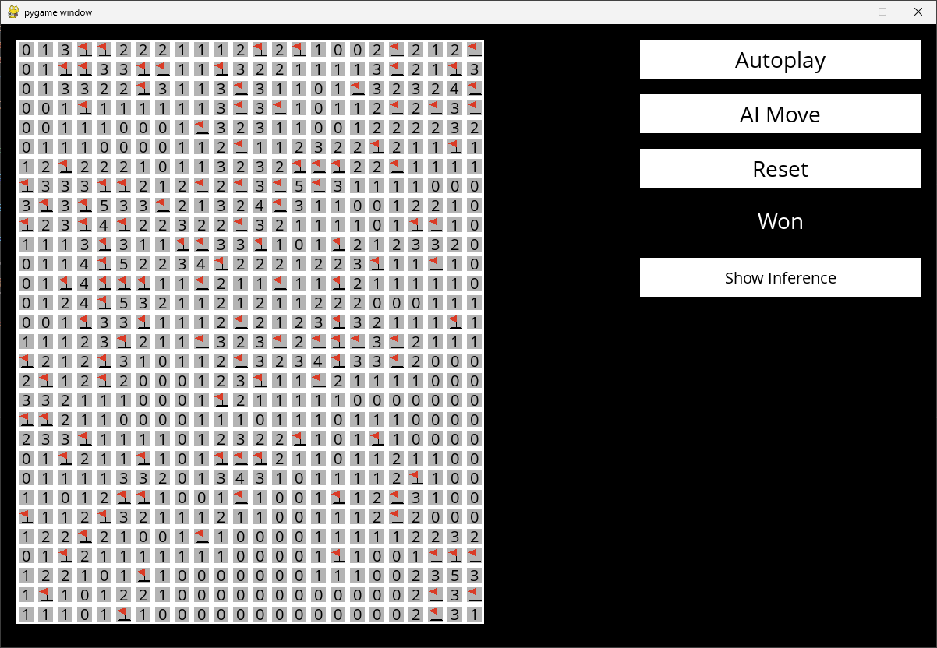

Figure 4: Custom Mine Positions

Mine Position File: mine4.txt

(H, W, M)=(30, 24, 120)

Index Positions: [3, 4, 12, 14, 19, 23, 26, 27, 30, 31, 34, 43, 46, 54, 59, 65, 71, 75, 83, 85, 91, 93, 95, 105, 131, 138, 142, 146, 158, 159, 160, 163, 168, 172, 173, 177, 179, 181, 183, 193, 195, 199, 205, 216, 219, 221, 227, 236, 237, 244, 248, 249, 252, 256, 268, 274, 282, 285, 290, 292, 293, 294, 297, 301, 304, 316, 339, 342, 347, 352, 358, 365, 369, 373, 375, 376, 377, 379, 384, 388, 395, 400, 403, 409, 412, 420, 423, 442, 456, 457, 483, 494, 498, 506, 510, 514, 515, 516, 548, 557, 558, 563, 568, 571, 576, 580, 595, 603, 609, 626, 640, 645, 646, 647, 654, 673, 693, 695, 701, 717]

(Row, Column): (0, 3), (0, 4), (0, 12), (0, 14), (0, 19), (0, 23), (1, 2), (1, 3), (1, 6), (1, 7), (1, 10), (1, 19), (1, 22), (2, 6), (2, 11), (2, 17), (2, 23), (3, 3), (3, 11), (3, 13), (3, 19), (3, 21), (3, 23), (4, 9), (5, 11), (5, 18), (5, 22), (6, 2), (6, 14), (6, 15), (6, 16), (6, 19), (7, 0), (7, 4), (7, 5), (7, 9), (7, 11), (7, 13), (7, 15), (8, 1), (8, 3), (8, 7), (8, 13), (9, 0), (9, 3), (9, 5), (9, 11), (9, 20), (9, 21), (10, 4), (10, 8), (10, 9), (10, 12), (10, 16), (11, 4), (11, 10), (11, 18), (11, 21), (12, 2), (12, 4), (12, 5), (12, 6), (12, 9), (12, 13), (12, 16), (13, 4), (14, 3), (14, 6), (14, 11), (14, 16), (14, 22), (15, 5), (15, 9), (15, 13), (15, 15), (15, 16), (15, 17), (15, 19), (16, 0), (16, 4), (16, 11), (16, 16), (16, 19), (17, 1), (17, 4), (17, 12), (17, 15), (18, 10), (19, 0), (19, 1), (20, 3), (20, 14), (20, 18), (21, 2), (21, 6), (21, 10), (21, 11), (21, 12), (22, 20), (23, 5), (23, 6), (23, 11), (23, 16), (23, 19), (24, 0), (24, 4), (24, 19), (25, 3), (25, 9), (26, 2), (26, 16), (26, 21), (26, 22), (26, 23), (27, 6), (28, 1), (28, 21), (28, 23), (29, 5), (29, 21)