Table 1. Counts and entropy for Mine1.txt to Mine5.txt position (SN=1)

|  |  |  |  |  |  |  |  |  |  |  |  |  |  |
| --- | --- | --- | --- | --- | --- | --- | --- | --- | --- | --- | --- | --- | --- |
| No. | Level | 0 | 1 | 2 | 3 | 4 | 5 | 6 | 7 | 8 | 9 | Marked  Entropy | Ave. RE |
| 1 | Beginner | 28 | 28 | 10 | 5 | 0 | 0 | 0 | 0 | 0 | 10 | 2.052689 | 1.971392 |
| 2 | Intermediate | 71 | 75 | 41 | 25 | 3 | 1 | 0 | 0 | 0 | 40 | 2.307885 | 2.236311 |
| 3 | Expert | 77 | 127 | 92 | 57 | 27 | 1 | 0 | 0 | 0 | 99 | 2.474732 | 2.427066 |
| 4 | Custom-1 | 178 | 196 | 145 | 56 | 22 | 3 | 0 | 0 | 0 | 120 | 2.379143 | 2.314933 |
| 5 | Custom-2 | 8 | 19 | 43 | 72 | 83 | 83 | 42 | 8 | 2 | 360 | 2.338970 | 2.289718 |

Figure 1: Mine1.txt marked game board嵌入characters“On Ju”

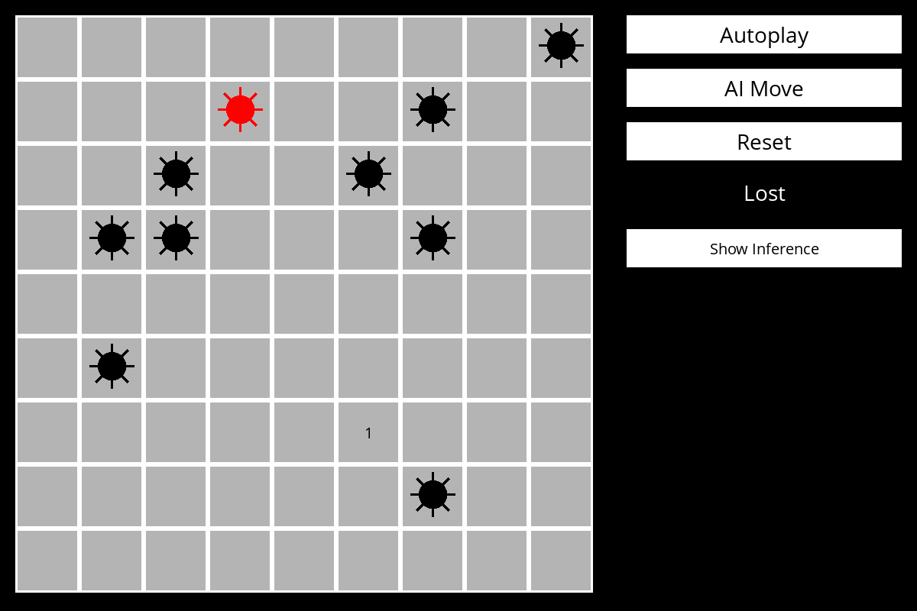

Figure 2: Mine2.txt marked game board嵌入characters“On July 13, 2024, T”

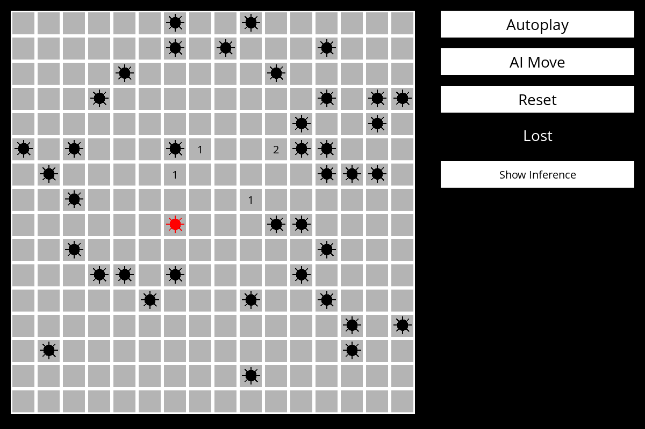

Figure 3: Mine3.txt marked game board嵌入characters“On July 13, 2024, Trump survived an assassi”

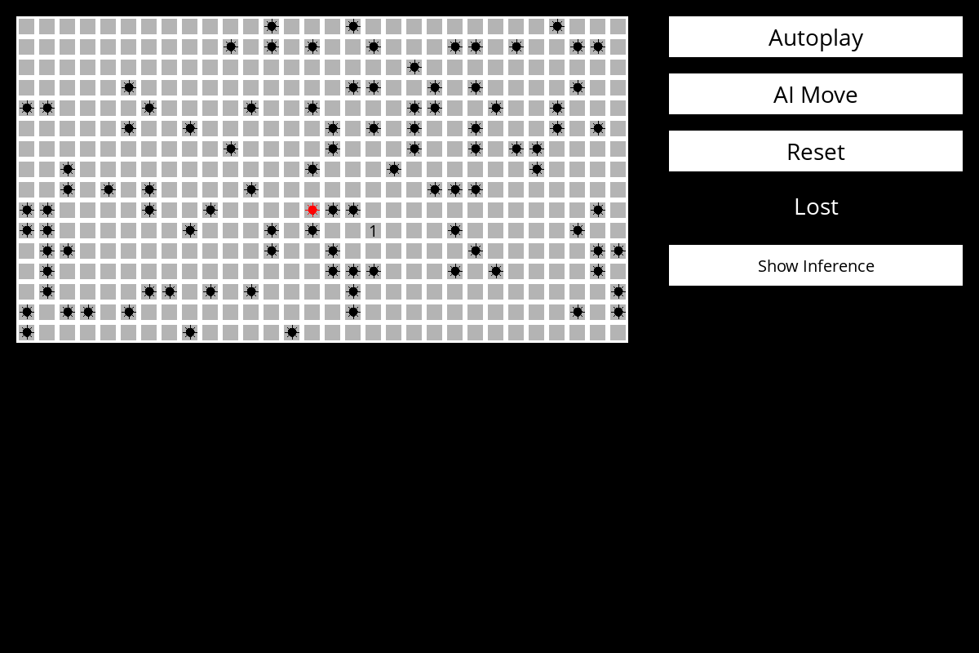

Figure 4: Mine4.txt marked game board嵌入characters“On July 13, 2024, Trump survived an assassination attempt”

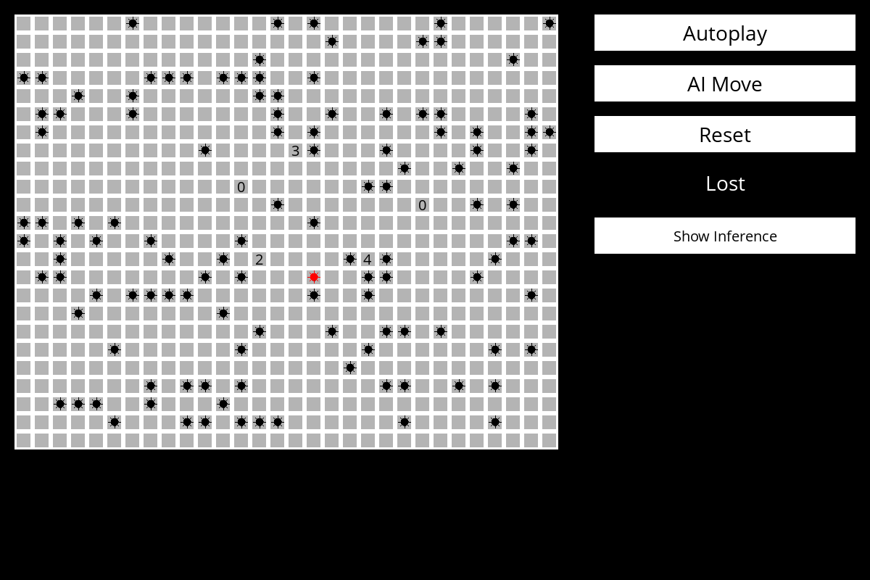

Figure 5: Mine5.txt marked game board嵌入characters“On July 13, 2024, Trump survived an assassination attempt while addressing a campaign ral”

