Route: /user/register (Passed)

Includes: jwt and bcrypt

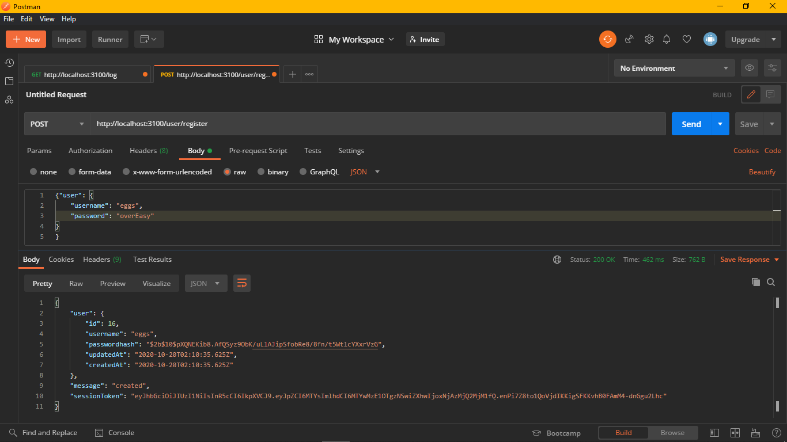

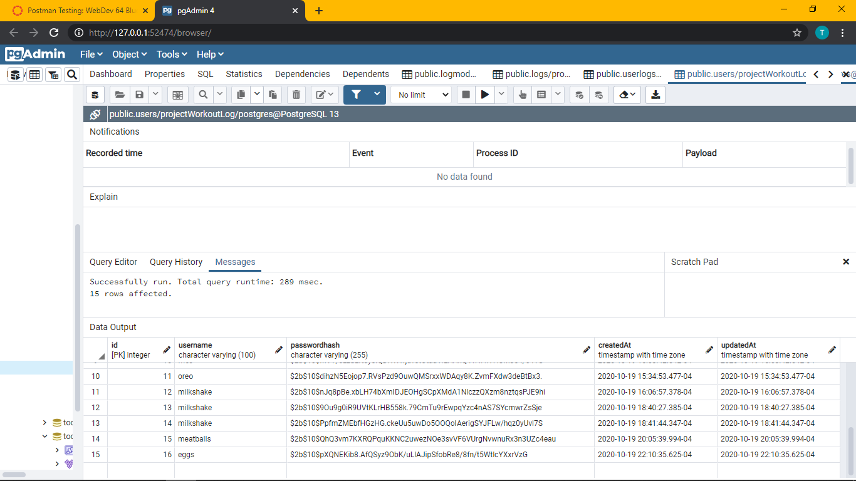

Route /user/login (user exists in database) (Passed)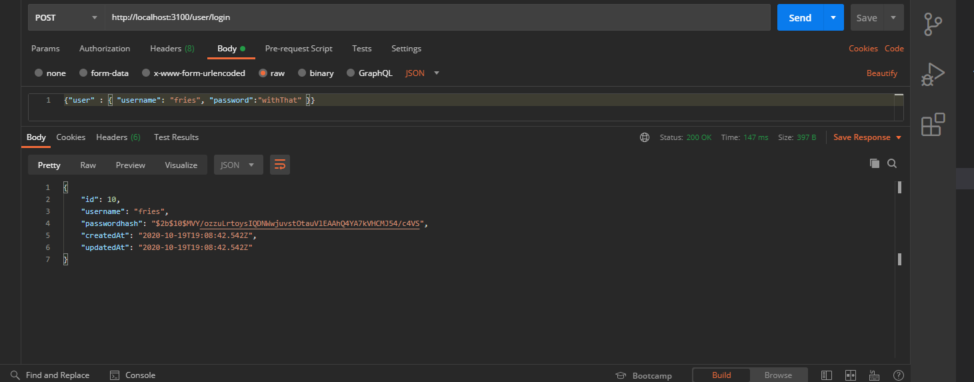

Route /user/login (user does NOT exist in database) (Passed)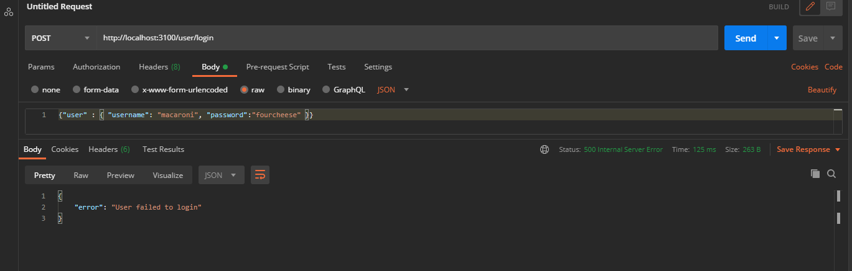

Route /user/login with authentication and user exists in the database. Status = 200 (Passed)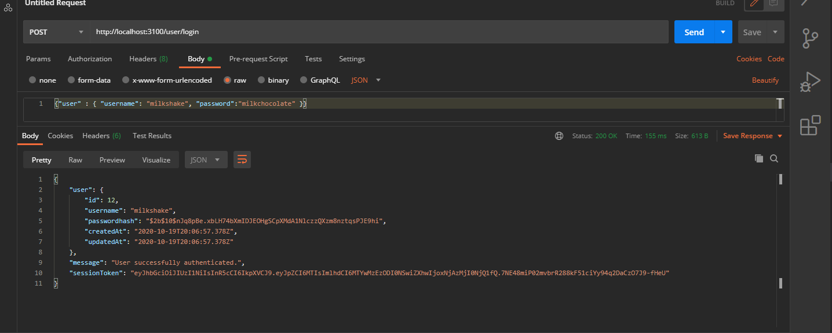

Route /user/login with authentication and user does NOT exist in the database. Status = 500 (Passed)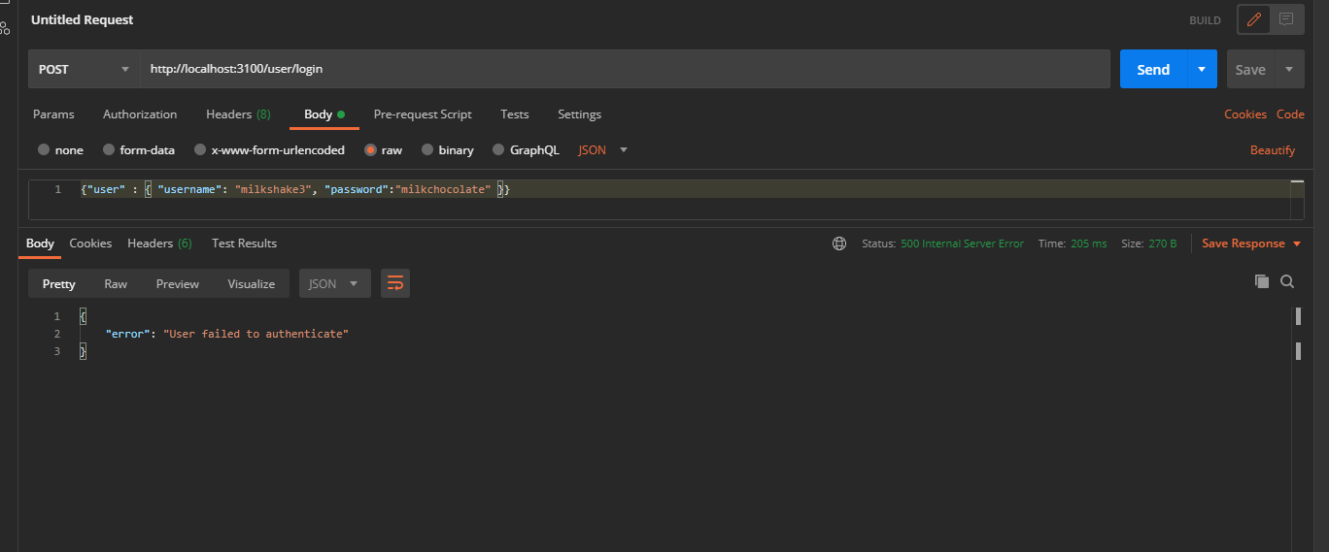

Route /user/login with authentication and user exists in the database, but password is incorrect. Status = 502 (Passed)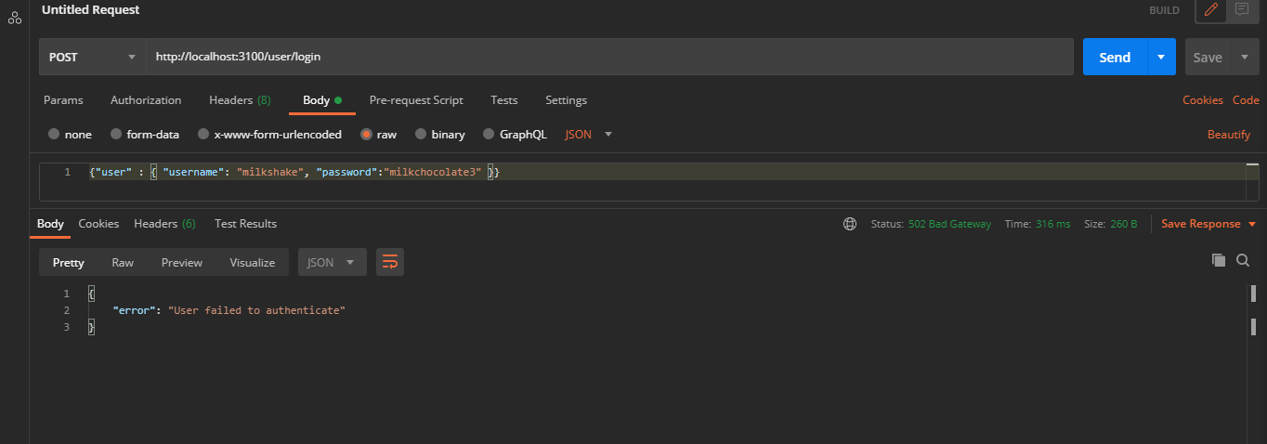

Route /log POST: Create log. (FAILED)

Receiving error: Class constructor model cannot be invoked without new. While, trouble shooting, I successfully created three tables logs, userlogs, and logmodels with the required attributes (see db screenshot below). However, I have not been able to add to the table.