Sand Boil Detection and Prediction

Tina Benita Rego
Dept. of Computer Science & Engr St Joseph Engineering College
An Autonomous Institution Vamanjoor, Mangaluru, India tinabenitaa@gmail.com

Vanesha Relitsa Cutinho
Dept. of Computer Science & Engr St Joseph Engineering College
An Autonomous Institution Vamanjoor, Mangaluru, India vaneshacutinho5@gmail.com
Sharanya S Shetty
Dept. of Computer Science & Engr St Joseph Engineering College
An Autonomous Institution Vamanjoor, Mangaluru, India sharanyashetty2612@gmail.com

Dr. Sunita G
Associate Professor
Dept. of Computer Science & Engr St Joseph Engineering College
An Autonomous Institution Vamanjoor, Mangaluru, India sunithag@sjec.ac.in
Vaishnavi Bharadwaj B
Dept. of Computer Science & Engr St Joseph Engineering College
An Autonomous Institution Vamanjoor, Mangaluru, India vaishnavibharadwajb@gmail.com

Abstract—Sandboils play a crucial role in geotechnical engi- neering and disaster management. They emerge during periods of heightened groundwater pressure triggered by events like earth- quakes or heavy rainfall, posing risks such as soil liquefaction and infrastructure instability. Detecting sandboils is pivotal for minimizing their impact and bolstering disaster readiness. Liter- ature reveals ongoing efforts in sandboil detection, emphasizing the need for efficient methodologies. This project proposes a novel approach involving image acquisition of affected areas, followed by image processing algorithms to identify sandboils.The research methodology entails experimentation with image datasets from known sandboil-prone regions. Results confirm the effectiveness of the proposed method, offering automated sandboil detection that expedites response times and enhances risk management strategies. The automated image processing solution reduces reliance on manual inspections and enabling swift responses to potential threats. This translates to cost savings, improved labor efficiency, and heightened overall disaster preparedness. Future endeavors could focus on algorithm refinement, integration of additional sensor data, and usage of drones, expanding the scope of application and enhancing disaster management capabilities.
Index Terms—Viola Jonas (VJ) , You Only Look Once (YOLO),Single Shot Box Detector (SSD), Support Vector Machine (SVM), Convolutional Neural Network (CNN)

- INTRODUCTION
The detection of sandboils is a critical aspect of geotechnical and geological hazard assessment, particularly in regions prone to flooding, seismic activity, or areas with high groundwater levels. Sandboils, also referred to as sand boils or sand boils, are geological phenomena that occur when water under pressure forces its way to the surface, carrying fine sand and silt with it. This phenomenon is commonly associated with events such as floods, earthquakes, or other disturbances that increase water pressure in the ground.
The key steps of the image processing approach include pre- processing, feature extraction, and classification. In the pre-

processing stage, the acquired images are enhanced and filtered to improve the quality of relevant features. Feature extraction involves identifying distinctive patterns and attributes that are indicative of sandboils. Finally, a classification algorithm is employed to differentiate between areas with sandboils and those without.
The background of the proposed visual approach using image processing lies in the advancement of technology and the increasing availability of high-resolution imaging devices. Leveraging these technologies for automated sandboil detec- tion can significantly improve the speed and accuracy of hazard assessment, leading to more effective disaster prepared- ness and response strategies. This research contributes to the ongoing efforts to develop innovative and technology-driven solutions for geohazard detection and management.

Problem Statement
The issue at hand is the lack of a reliable and timely detection mechanism for sand boils, a geotechnical hazard with potentially disastrous effects on infrastructure and pub- lic safety.Traditional detection methods are time-consuming, expensive, and frequently incapable of providing early in- dications. The main aim of our work is to address this significant issue by developing an automated detection system and predictive model using image processing technique. The method will greatly improve the ability to detect sand boils quickly, allowing for proactive action and hazard mitigation.

Scope
The project’s importance in the actual world is considerable since it addresses a serious issue with broad applications across multiple fields. The following are the areas of application where the project can have a significant impact:

  - Geotechnical Engineering and Infrastructure Man- agement: The initiative has the potential to transform how geotechnical engineers monitor soil stability and decrease the risk of sand boils, ultimately improving the resilience of vital infrastructure such as highways, bridges, and levees.
  - Natural Disaster Management: Sandboils are fre- quently caused by natural disasters such as earthquakes, floods, and excessive rainfall. The early warning system developed for the project can help disaster management authorities make timely choices to protect communities and assets.
  - Planning for Construction and Development:This de- vice can help the construction sector by recognizing pos- sible sand boil concerns before starting projects, resulting in safer construction practices and cost savings.
  - Land Use Planning and Agriculture:Sandboils have the potential to impair agricultural activity and land use. The study can help identify and manage sandboil-prone locations, allowing for better land-use decisions.
  - Civil Engineering Study: This project’s data can con- tribute to current civil engineering research, allowing for a better understanding of sand boil production and its causes.
  - Management of Water Resources: Sandboils can have an impact on water quality and flow patterns. The project can help monitor and manage water resources in sandboil- prone areas.
In summary, the project’s importance spans numerous disci- plines, including engineering and disaster management, as well as environmental monitoring and public safety. Its possible applications could save lives, safeguard infrastructure, and improve the overall resilience of populations and ecosystems in sandboil-prone locations.

- LITERATURE SURVEY
This section gives the details of the various works which were carried out for sandboil detection.
“Significance of Sand Boil Detection Near Levees” [1] addresses Levees are embankments or flood banks constructed along naturally occurring water bodies in order to stop flood- ing. They provide protection for vast amounts of commercial and residential properties, especially in the New Orleans area. However, levees and flood-walls degrade over time due to the impact of severe weather, development of sand boils, subsidence of land, seepage, development of cracks, etc. Further, published data indicates that coastal Louisiana lost approximately 16 square miles of land between 1985 and 2010. In 2005, there were over 50 failures of the levees and flood walls protecting New Orleans, Louisiana, and its sur- rounding suburbs following the passage of Hurricane Katrina
and landfall in Mississippi. These failures caused flooding in 80% of the city of New Orleans and all of St. Bernard Parish. Events like Hurricane Katrina in 2005 have shown that levee failures can be catastrophic, and very costly. If these levees fail due to these conditions, there is a potential for significant property damage, and loss of life, as experienced in New Orleans in the 2005 hurricane, Katrina. It is of great importance to monitor the physical conditions of levees for flood control .

The research [2] on “Experimental study on the mechanism of sandboils and associated settlements due to soil lique- faction in loose sand” The mechanism of sand boiling and its induced settlements were investigated with model testing. The thicknesses of the non-liquefiable layer, the gap sizes, and the overburden pressures were varied in the test program composed of 16 tests. On the basis of the PWP transducers recording transient variations of the water pressure, one laser displacement sensor measuring the plate settlement, and high- speed camera monitoring the process, the mechanism of sand boiling was discussed insightfully.

The research [3] on “Evaluation of Settlements in Sand Deposits Following Liquefaction During Earthquakes” By examining a bulk of laboratory test data on sands obtained by using a simple shear apparatus, a family of curves was established in which the volumetric strain resulting from dissipation of pore water pressures is correlated with the density of sand and conventionally used factor of safety against liquefaction. Thus, given the factor of safety and the density in each layer of a sand deposit at a given site, the volumetric strain can be calculated and by integrating the volume changes throughout the depth, it becomes possible to estimate the amount of settlements on the ground surface produced by shaking during earthquakes. The outcome of the data arrangements as above was put in a framework of methodology to estimate the liquefaction-induced settlements of the ground. The proposed method- ology was used to estimate the settlements at several sites devastated by liq- uefaction during the 1964 Niigata earthquake. The estimated values of the settlements were examined in the light of known performances of the sand deposits at respective site. It was shown that the proposed method- ology may be used for predicting liquefaction-induced settlements with a level of accuracy suitable for many engineering purposes.

The study [4] on “Effects of porous media thickness and its hydraulic gradient history on the formation of sand boils: Experimental investigation” This paper uses laboratory ex- periments to study sand boil formation and reformation for various sand thicknesses and hydraulic gradients to fill this knowledge gap. Sand layer thicknesses of 90 mm, 180 mm and 360 mm were adopted in evaluating sand boil reactivation, which was created by imposing hydraulic head fluctuations. While the first experiment (i.e., 90 mm sand layer) yielded a value for icr smaller (by 5%) than Terzaghi’s (1922) value,

the same theory underestimated icr by 12% and 4% for
180 mm and 360 mm sand layers, respectively. Moreover, icr needed for the reformation of sand boils decreased by 22%, 22% and 26% (relative to icr applicable to the initial sand boil) for the 90 mm, 180 mm and 360 mm sand layer thicknesses, respectively. We conclude that the formation of sand boils requires consideration of sand depth and the history of sand boil formation, particularly in relation to sand boils that form (and potentially reform) under oscillating pressures (e.g., tidal beaches). Sand column experiments were conducted under controlled laboratory conditions to recreate sand boils in internally stable sand of varying layer thickness. The experimental results showed that thicker sand layers required higher hydraulic gradients (i) for sand boil formation than those predicted by Terzaghi’s (1922) equation for the critical hydraulic gradient for fluidization (icr). This reveals the im- portance of sand layer thickness in sand boil formation, which is neglected in existing formulae for predicting the conditions under which a sand boil may arise.Experimental observations prior to the sand boil emergence indicate that heave is more likely to be a pre-curser to sand boil formation in experiments with a thicker sand layer (360 mm), with no heave observed for the thinnest sand layer (90 mm).

The paper presented [5] in “Observations on SandBoils from Simple Model Tests” addresses Earthquake-induced soil liquefaction has been recognized as a hazard for over forty years (e.g. Seed and Lee, 1966; Ishihara, 1985) and static liquefaction for longer (e.g. Koppejan et al., 1948). Loose saturated sands attempting to settle during shaking are unable to dissipate fluid from the contracting void spaces quickly enough, and individual soil grains lose contact with each other and go into suspension (as observed by, e.g., Sasaki et al., 2001). The soil consequently loses strength and dramatic failures occur via a number of mechanisms such as the soil’s loss of strength (Fig. 2.2 a) or sand boils (Fig. 2.2 b), bursts of liquefied sand spilling over the ground surface . These appeared during testing, as thin vertical channels through the silt layer that may or may not contain sand. These often appeared to widen as they approached the surface. Ejection was often sufficiently violent to disturb the surface of the water (which was always above the soil surface) indicating great speed and pressure release despite the small-scale nature of the test. These always occurred after the two seconds applied shaking had finished. Further experiments (not presented - Ritchie, 2006; Moran, 2007) in which the same and similar models were subjected to increasingly longer duration shaking showed that an exceptionally long duration of shaking was required to cause boiling during shaking. This may be because the required redistribution of fluid required a much greater length of time than the duration of shaking. This correlates with many eyewitness accounts of earthquakes.Silt clouds appeared to be due to the top surface of the silt being entrained in suspension by the pore fluid.On the one occasion that a silt cloud hit the base of the surface layer, a sand boil began at the place and moment of impact. This suggests that silt
clouds, while not necessarily of engineering importance, have information to give that can be utilized in the future.

The study [6] in ”Object Detection” addresses mage recog- nition allows machines to identify objects, people, entities, and other variables in images. It is a sub-category of computer vision technology that deals with recognizing patterns and regularities in the im- age data, and later classifying them into categories by interpreting image pixel patterns.Image recog- nition includes different methods of gathering, processing, and analyzing data from the real world. As the data is high- dimensional, it creates numerical and symbolic information in the form of decisions. The process of classification and localization of an object is called object detection. Once the object’s location is found, a bounding box with the correspond- ing accuracy is put around it. Depending on the complexity of the object, techniques like bounding box annotation, seman- tic segmentation, and key point annotation are used for detection. Steps include Data Collection, Pre-processing of the image data,Model archi- tecture and training process, Traditional machine learning algorithms for image recognition.

The research paper [7] on “Machine Learning Methods “ introduces arious machine learning methods are described required for sand- boil detection:
The Viola-Jones’ object detector uses AdaBoost algorithm as the learning algorithm. Using OpenCV, Haar features are calculated and gath- ered. These are then passed through a cascading architecture . The detec- tor starts with a sub- window in each image. This subwindow slides over the image in incremental steps. Windows are checked at every position and scale. They are then passed off to a layer in the cascade filter for processing. The layers vote the window whether it contains the required object or not. If it does not contain the object searched for, then the window is rejected.
You Only Look Once, or YOLO is a popular object detection algorithm based on the concept of Region Proposal Networks
. It is a deep learning framework based on TensorFlow and consumes a lot of compu- tational power. The object detection task at hand is to determine the location of the image where the sand boil is present. Previous methods consisted of pipelines that had multiple steps to perform this very same task. It predicts the presence of sand boils from individual image pixels, the bounding box coordinates and class probabilities of each region or cell. Any input image given to this dense neural network will output a vector of bounding boxes and class predictions.
The single shot multibox detector is an improvement on the YOLO object detector in the sense that it does not have to traverse through the image twice like YOLO does. It can map out the object in a single shot. It is a very fast approach and extremely accurate. SSD is also a deep learning method for object detection.

The research paper [8] “Viola-Jones’ Object Detector” we decipher the Viola-Jones algorithm, the first ever real-time

face detection system. There are three ingredients working in concert to enable a fast and accurate detection:the integral image for fea- ture computation, Adaboost for feature selec- tion and an attentional cas- cade for efficient computational resource allocation. Here we propose a complete algorithmic description, a learning code and a learned face de- tector that can be applied to any color image.Since the Viola-Jones al- gorithm typically gives multiple detections, a post-processing step is also proposed to reduce detection redundancy using a robustness argument. A waterfall model of cascade layers filters out as many negatives as possible in the shortest time possible. If any of the windows contain a positive image, then they are retained and passed on to the next classifier. This means that the windows discarded in the first few stages are most likely to be negative. Most true negatives are collected in the initial stages of the cascade. In the subsequent steps, the remaining positives are closely examined and determined to be true positives. Haar cascades are known to be one of the fastest and accurate methods for face detection, even if it is relatively an old algorithm (2001). A cas- cade’s detection rate is equal to the product of every layer’s detection rates. As in, for a cascade with 4 layers with each layer’s detection rate at 0.99,the final rate would be 0.99 raised to the power of 4, which is 0.96. The detection rate decreases in subsequent layers because every layer is unable to achieve a 100% detection rate. This causes the cascade to lose some positive images. Hence, the number of false negative detection increases for a very high number of cascade stages. Viola Jones’ object detection algorithm achieves real-time detection of objects. This makes it an ex- tremely popular algorithm to run on mobile devices and cameras.

The research paper [9] “You Only Look Once (YOLO) Object Detector” YOLO reframes the object detection pipeline of older papers such as R-CNN , Faster-RCNN as a single regression problem.Within YOLO, the input image is divided into a grid of S x S cells. For every object that is within the image, one grid cell is responsible for detecting it. The cell responsible is the one where the center of the object falls into. Each cell predicts B bounding boxes and C class probabilities. The bounding box prediction has 5 components – (x, y, w, h, confidence score). Here, (x, y) coordinates represent the center of the box in relation to the grid cell location.The cell division and prediction responsibilities of each grid cell. The image bounded inside the red box is the sand boil area that needs to be detected. Since the center of that square lies within the grid cell in the center, it is now responsible for making the prediction of the sand boil. Each of these grid cells makes a total of S x S x B * 5 predictions, as described earlier. It is also important to predict the class probabilities for each cell. These conditional probabilities Pr(class(i) — Object) are necessary to create a region proposal network. YOLO is refreshingly simple.A single convolutional network simultane- ously predicts multiple bounding boxes and class probabilities for those boxes. YOLO trains on full images and directly optimizes detection per- formance. This unified
model has several benefits over traditional methods of object detection.

The research paper [10] ‘Single Shot Multibox Detector ” Single shot multibox detector can localize the object in a single for- ward pass of the network. The single shot multibox detector’s architecture builds on the VGG-16 architecture but discards the fully connected layers. VGG-16 performs very well on high-quality image classification. However, in this research, we use the MobileNetV2 architecture in the place of VGG- 16. MobileNetV2 is one of the most recent mobile architectures (published by Google in March 2019). It favors speed over accuracy but still manages to output excellent detections. Features are extracted at multiple scales by the MobileNet network and forward passed to the rest of the network. In MultiBox, researchers created priors (popularly known as anchors in Faster R-CNN terms), which are values of fixed size bounding boxes that are pre-computed and closely match the original ground truth boxes. Pri- ors are chosen in a way such that the ratio of original ground 13 truth boxes to the prediction is greater than 0.5. This is also called IoU (intersection over union). In SSD, priors are fixed manually. For each prediction of a bounding box, a set of C class predictions are computed for every possible class in the dataset. Our approach, named SSD, discretizes the output space of bounding boxes into a set of default boxes over different aspect ratios and scales per feature map location. At prediction time, the network generates scores for the presence of each object category in each default box and produces adjustments to the box to better match the object shape. Additionally, the network combines predictions from multiple feature maps with different resolutions to naturally handle objects of various sizes. SSD is simple relative to methods that require object proposals because it completely eliminates proposal generation and subsequent pixel or feature resampling stages and encapsulates all computation in a single network. This makes SSD easy to train and straightforward to integrate into systems that re- quire a detection component. Experimental results on the PASCAL VOC, COCO, and ILSVRC datasets confirm that SSD has competitive accuracy to methods that utilize an additional object proposal step and is much faster, while providing a unified framework for both training and infer- ence.

The study [11] ‘Stacking” A total of 8 different methods were used, including Support Vec- tor Machine (SVM) which is a discriminative classifier which is defined by a separating hyperplane, Logistic Regression which is a technique for analyzing data where there are one or more independent variables that de- termine the dependent variable (outcome), Extremely randomized Tree or ET which constructs random- ized decision trees from the original learning sample and uses above-average decision to improve the predictive accuracy and control over-fitting, Random Decision Forests which is an ensemble learning method for classification, regression, and other tasks, K nearest neighbors which stores all available

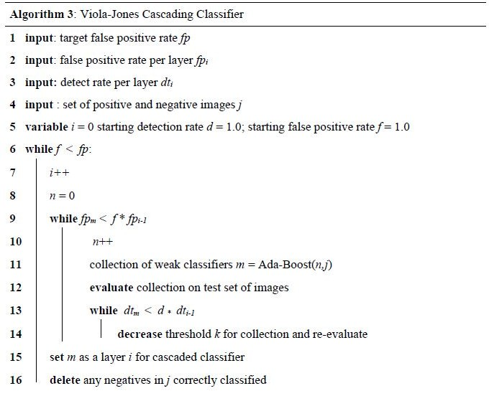
cases and classifies new cases based on a similarity measure, Bagging which creates individuals for its ensemble by training each classifier on a random redistribution of the training set, Gradient Boosting Classifier (GBC) which builds an additive model in a forward stage-wise fashion, and eXtreme Gradient Boosting (XGB) that has more advanced features for model tuning. The comparison of different object detection methods was done they determined the best ones to use for the detection of sandboils. They have also developed a Stacking-based machine learning predictor which focuses on using the best methods to increase the detection accuracy of the machine learning model.

- Algorithms

Viola Jones:
- METHODOLOGY

Viola-Jones algorithm is a machine-learning technique for object detection proposed in 2001 by Paul Viola and Michael Jones in their paper “Rapid object detection using a boosted cascade of simple features”. The algorithm was primarily conceived for face detection but is also an efficient solution for resource-constrained devices.
Given a grayscale image, the algorithm analyzes many win- dows of different sizes and positions and tries to detect the target object by looking for specific image features in each window. The Viola-Jones algorithm is based on four main ideas: Haar-like features Integral images for accelerating the feature computation AdaBoost learning for feature selection Cascade of classifiers for fast rejection of windows without faces.
In [7] Open Source Computer Vision (OpenCV) was used to run the viola jones algorithm. Firstly, the positive and negative samples of sand boils were sorted into different folders. Then, we extracted the information about coordinates (x, y, w, h) where x, y are the top corner and w, h are the width and height of the object inside the image. Then, the cascade is trained using 25 stages, 4500 positive samples, and 3000 negative samples. This results in an xml file that can be used to make the predictions on a test dataset. The test dataset contains a total of 8300 images out of which 2000 are negative samples, and the rest are positive samples of sand boils. The cascade training is stopped at stage 25, and the intermediate stages, 10, 15, 20 and 25 are tested for performance. The best performance is achieved by cascade stage 15. This is evidenced in the results section. After this, the accuracy is measured, and bounding boxes are drawn based on the predicted outputs.
You Only Look Once (YOLO) You Only Look Once (YOLO) is one of the most popular model architectures and object detection algorithms. It uses one of the best neural network architectures to produce high accuracy and overall processing speed, which is the main reason for its popularity.// YOLO algorithm aims to predict a class of an object and the bounding box that defines the object location on the input image. It recognizes each bounding box using four numbers:

Fig. 1. Viola-Jones’ Algorithm

Center of the bounding box (b_{x},b_{y}) Width of the box (b_{w})
Height of the box (b_{h})
In addition to that, YOLO predicts the corresponding number c for the predicted class as well as the probability of the prediction (P_{c})
In [7], For YOLO, the configuration of the basic net was left unchanged except for the width, height and the number of classes. A TensorFlow implementation of the darknet, called Darkflow was used to run YOLO. Darknet is an open source neural network framework written in C language. The architecture of the detector consists of 24 convolutional layers followed by 2 fully connected layers. Alternating 1 x 1 convolutional layers reduce the feature space from the earlier layers. These layers are pre-trained on the ImageNet classification dataset. For the problem, they chose to train the network from scratch, without initializing the weights for the network. The average moving loss starts at a very high value and slowly reduces. The network must be trained until the loss falls below 0.01 in order to get the best bounding boxes. The training ran for around 2 weeks on a server, at which point the loss function was extremely low. At this point, the latest checkpoint is used to test the detections on a test dataset of 112 images. After the detections are made, the accuracy can be measured by comparing the ground truth files with the predicted outputs.
Support Vector Machine (SVM) Support Vector Machine

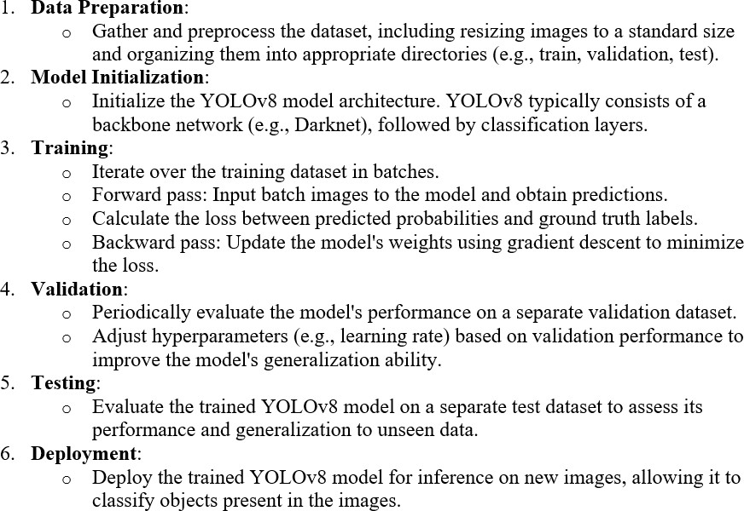

Fig. 2. YOLO Algorithm

(SVM) is a powerful and versatile machine learning algorithm used for both classification and regression tasks. [7]. Its main objective is to find the optimal hyperplane that separates different classes in the feature space while maximizing the margin between classes. SVM works by mapping input data into a high-dimensional space and then finding the hyperplane that best separates the classes.
Here’s how SVM works:
Data Preparation: SVM works with labeled data, meaning you need a dataset where each data point is associated with a class label. Each data point should also have features that describe it.
Feature Space: SVM maps each data point into a high- dimensional feature space. In this feature space, each feature corresponds to a dimension, and the data points are represented as vectors.
Finding the Optimal Hyperplane: The goal of SVM is to find the hyperplane that best separates the data points into different classes while maximizing the margin, which is the distance between the hyperplane and the closest data points (support vectors). This hyperplane is the one that maximizes the margin and minimizes the classification error.
Margin Optimization: SVM optimizes the margin by solving a constrained optimization problem. The optimization objective is to maximize the margin while ensuring that all data points are correctly classified or fall within a certain margin of the hyperplane.
Kernel Trick: In cases where the data is not linearly separable
in the original feature space, SVM can use a kernel trick to map the data into a higher-dimensional space where it becomes linearly separable. Common kernel functions include linear, polynomial, radial basis function (RBF), and sigmoid kernels. Classification: Once the optimal hyperplane is found, SVM can classify new data points by determining which side of the hyperplane they fall on.

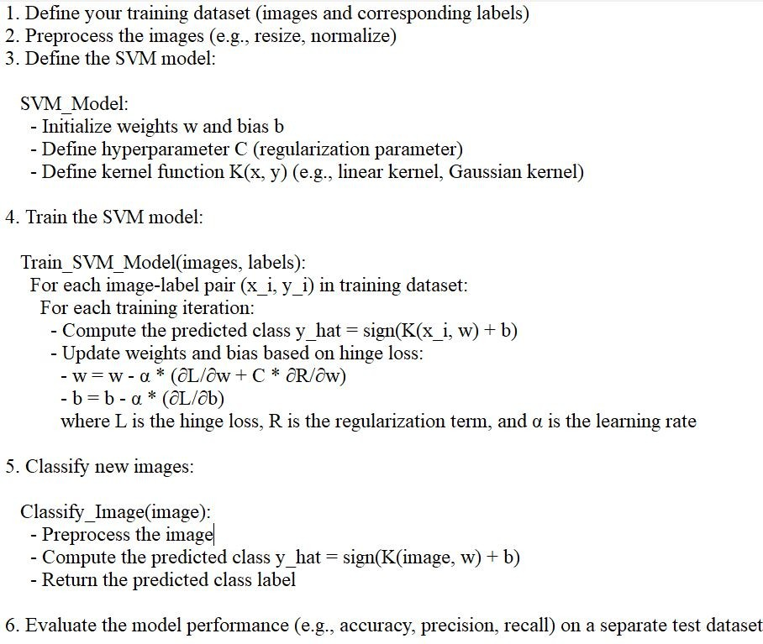
Fig. 3. SVM Algorithm

Overall this algorithm is particularly effective in scenarios with complex decision boundaries and works well even in high-dimensional spaces. SVM has various kernel functions (e.g., linear, polynomial, radial basis function) that allow it to handle nonlinear relationships between features. SVM is widely used in various fields, including image classification, text classification, and bioinformatics, due to its robustness and ability to generalize well to unseen data.

Convolution Neural Network (CNN)
The Convolutional Neural Network (CNN) is a class of deep neural networks primarily used for analyzing visual imagery. Inspired by the organization of the animal visual cortex, CNNs consist of multiple layers of interconnected neurons that perform hierarchical feature extraction. The key components of a CNN include convolutional layers, pooling layers, and fully connected layers. Convolutional layers apply filters to input images to extract features like edges and textures, while pooling layers downsample feature maps to reduce computational complexity. Finally, fully connected layers combine the extracted features to make predictions.

CNNs have revolutionized various computer vision tasks, including image classification, object detection, and image segmentation, due to their ability to automatically learn discriminative features from raw pixel data.

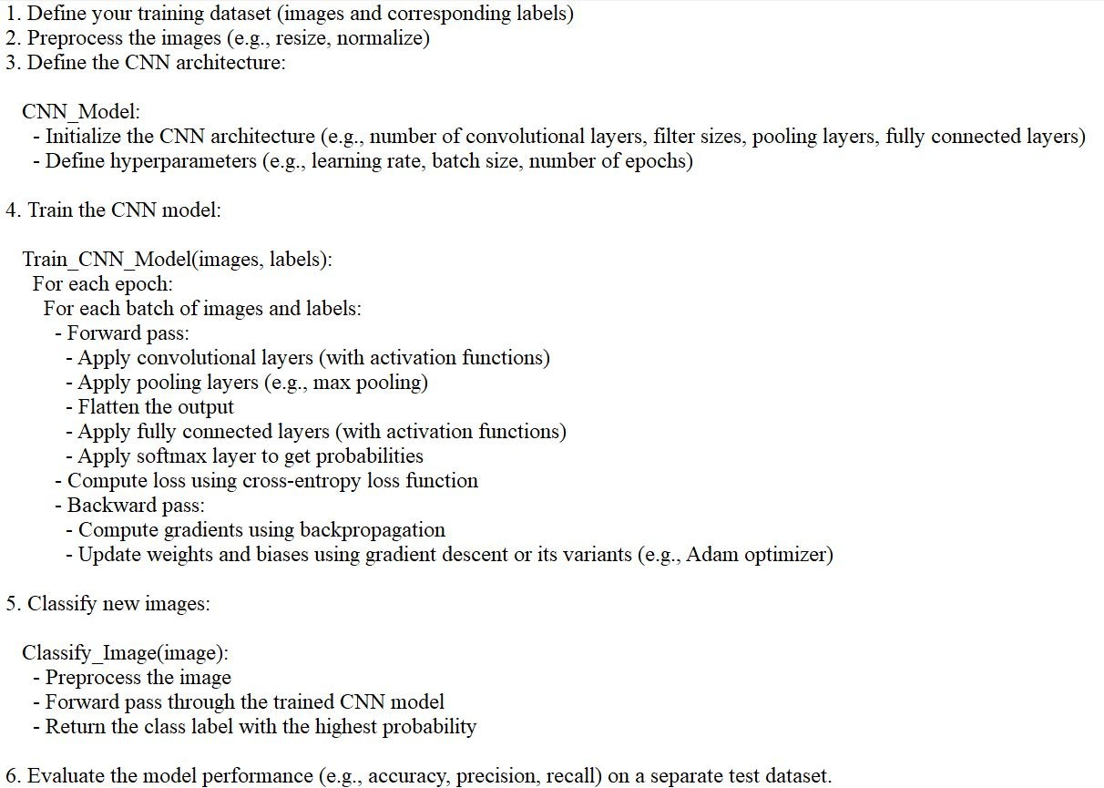

Fig. 4. CNN Algorithm

CNNs are trained using a large dataset of labeled images, where the network learns to recognize patterns and features that are associated with specific objects or classes. Proven to be highly effective in image-related tasks, achieving state-of- the-art performance in various computer vision applications. Their ability to automatically learn hierarchical representations of features makes them well-suited for tasks where the spatial relationships and patterns in the data are crucial for accurate predictions
CNNs are trained using a supervised learning approach. This means that the CNN is given a set of labeled training images. The CNN then learns to map the input images to their correct labels. The training process for a CNN involves the following steps:
Data Preparation: The training images are preprocessed to ensure that they are all in the same format and size.
Loss Function: A loss function is used to measure how well the CNN is performing on the training data. The loss function is typically calculated by taking the difference between the predicted labels and the actual labels of the training images. Optimizer: An optimizer is used to update the weights of the CNN in order to minimize the loss function.
Backpropagation: Backpropagation is a technique used to
calculate the gradients of the loss function with respect to the weights of the CNN. The gradients are then used to update the weights of the CNN using the optimizer.

- Design
Detecting sand boils, which are indicative of potential levee breaches or weaknesses, can be crucial for infrastructure pro- tection and disaster mitigation. Image processing techniques can be effectively utilized for this purpose. Here’s the design outline for sand boil detection using image processing:
  - 1. Image Acquisition: Obtain images of the levee area using drones equipped with high-resolution cameras or satellite imagery. Alternatively, deploy fixed cameras strategically along the levee for continuous monitoring.
  - 2. Pre-processing: Correct for lens distortion and ad- just image brightness and contrast. Convert images to grayscale to simplify processing. Apply noise reduction techniques to enhance image quality.
  - 3. Segmentation: Utilize thresholding techniques to sep- arate potential sand boil regions from the background. Ex- periment with different thresholding methods (e.g., global thresholding, adaptive thresholding) to handle variations in lighting and terrain.
  - 4. Feature Extraction: Extract features such as area, perimeter, circularity, and texture from segmented re- gions. Use morphological operations (e.g., erosion, di- lation) to refine the regions and remove noise.
  - 5. Classification: Train a machine learning model using labeled data to classify segmented regions as either sand boils or background. Use extracted features as input to the classifier.
  - 6. Post-processing: Apply morphological operations to further refine the detected regions and remove false posi- tives. Perform spatial and temporal analysis to validate detection and reduce false alarms. Implement logic to merge overlapping detection and remove isolated outliers.
  - 7. Visualization and Reporting: Visualize the detected sand boils overlaid on the original images or on a map of the levee area. Generate reports with information on the location, size, and confidence level of detected sand boils. Provide alerts or notifications to relevant stakeholders for timely action.
  - 8. Integration: Integrate the sand boil detection system with existing levee monitoring infrastructure. Develop APIs or interfaces for seamless integration with other sys- tems (e.g., Geographic Information Systems, emergency response platforms). Ensure scalability and compatibility with different hardware configurations.
  - 9. Validation and Optimization: Validate the perfor- mance of the detection system using ground truth data collected from field inspections. Continuously optimize the algorithms based on feedback and new insights gained from monitoring activities. Regularly update the machine learning model with new labeled data to improve accu- racy and adapt to changing conditions.

  - 10. Deployment and Maintenance: Deploy the sand boil detection system in operational levee monitoring networks. Establish protocols for routine maintenance, calibration, and software updates. Provide training and documentation for operators and maintenance personnel.

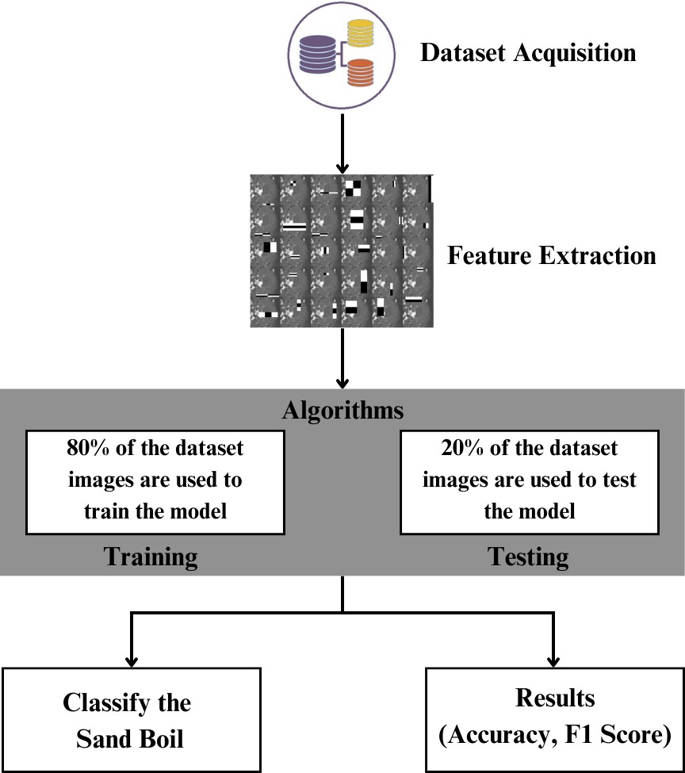

Fig. 5. Architecture Diagram

This diagram represents a process flow for a machine learning task, specifically for classifying images of sand boils. Here’s a step-by-step explanation of the diagram:

Dataset Acquisition: The first step involves collecting a dataset, which is represented by the stack of colored discs. This dataset consists of images that will be used to train and test a machine learning model.
Feature Extraction: After acquiring the dataset, the next step is to extract features from the images. Feature extraction involves processing the images to identify and quantify relevant characteristics or patterns that the machine learning algorithms can use to learn from the data.
Algorithms: The extracted features are then fed into algorithms. This part of the process is divided into two main phases:
Training: 80% of the dataset images are used to train the model. During training, the algorithm learns to recognize patterns and features that are indicative of sand boils.
Testing: The remaining 20% of the dataset images are used to test the model. Testing evaluates how well the model has learned to classify sand boils by using data it has not seen during the training phase.
Classify the Sand Boil: The primary goal of the model is to classify images as sand boils. This step is likely the application of the trained model to new data to make predictions or classifications.
Results (Accuracy, F1 Score): The final step is to assess the performance of the model using metrics such as accuracy and the F1 score. Accuracy measures the proportion of correct predictions made by the model, while the F1 score is a harmonic mean of precision and recall, providing a balance between the two for situations where uneven class distribution might make accuracy a less reliable metric.

Overall, the diagram outlines a typical supervised machine learning workflow for image classification, from data collec- tion to model evaluation.

- IMPLEMENTATION
- Description of Dataset
In this research, the dataset was collected from different sources. There is no centralized, easy-to-access data for levees and sand boils available. Hence, most of the collection was done manually. An additional explanation of the subsets of data used for each method is described below.
The dataset comprises 50 images sourced from various sources, primarily Google Images. Analysis of sand boils using machine learning and image processing requires two types of data – negative and positive samples. These images were meticulously selected to ensure diversity, including instances where the presence of sand boils may be challenging to detect even for human observers. Positive samples showcase instances where sand boils are clearly identifiable, whereas negative samples portray scenarios where sand boils are absent entirely. Both these types of data are essential to train the machine learning methods on what constitutes a sand boil and what does not. Such a balanced dataset is crucial for training machine learning algorithms and employing image processing techniques effectively. Additionally, efforts were made to ensure the inclusion of challenging cases to enhance the robustness of the models developed through this research.

- Experimental Setup
Feature Extraction: In this section, we describe the fea- tures from both positive and negative samples that have been extracted and fed into the machine learning methods. For the Viola-Jones algorithm, the features used are called Haar features. These are calculated internally by OpenCV. They can be visualized to see which regions of the image contribute to the classification of it being a positive sample. Further discussion and examples can be found in the results section. For the YOLO algorithm and the SSD method, since the architecture can be considered a part of the convolutional neural network, the features are extracted internally by the convolutional net itself. For the non-deep learning methods, we need to extract some features manually.

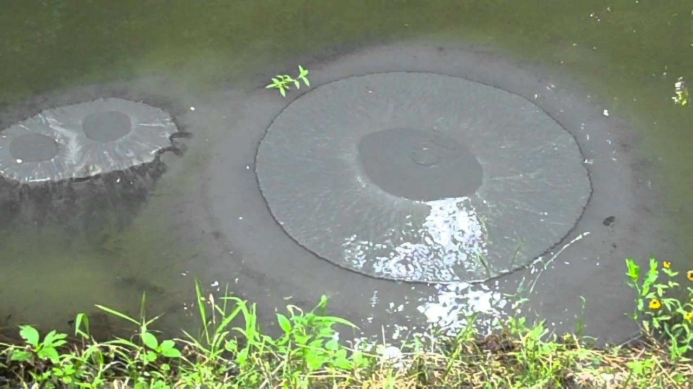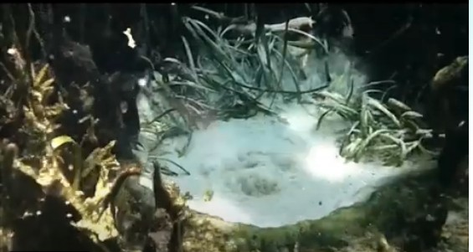

Fig. 6. Positive Image
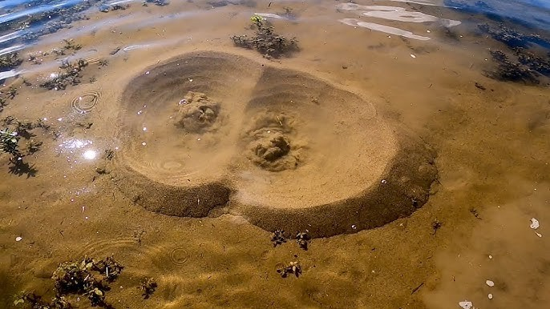
Fig. 7. Positive Image

Haralick Features: Haralick features or textural features for image classification are very important in identifying the texture characteristics of an object in an image. For aerial photographs or satellite images, these features can isolate the textures and regions of interest of the image being searched for. In conjunction with machine learning methods, these features can be extremely useful in identifying sand boils from satellite imagery. The basis of these features is a gray-level co- occurrence matrix. The matrix is generated by counting the number of times a pixel with a value i is adjacent to a pixel with a value j and then dividing the entire matrix by the total number of such comparisons made. Each entry is therefore considered to be the probability that a pixel with a value i
Fig. 8. Negative Image
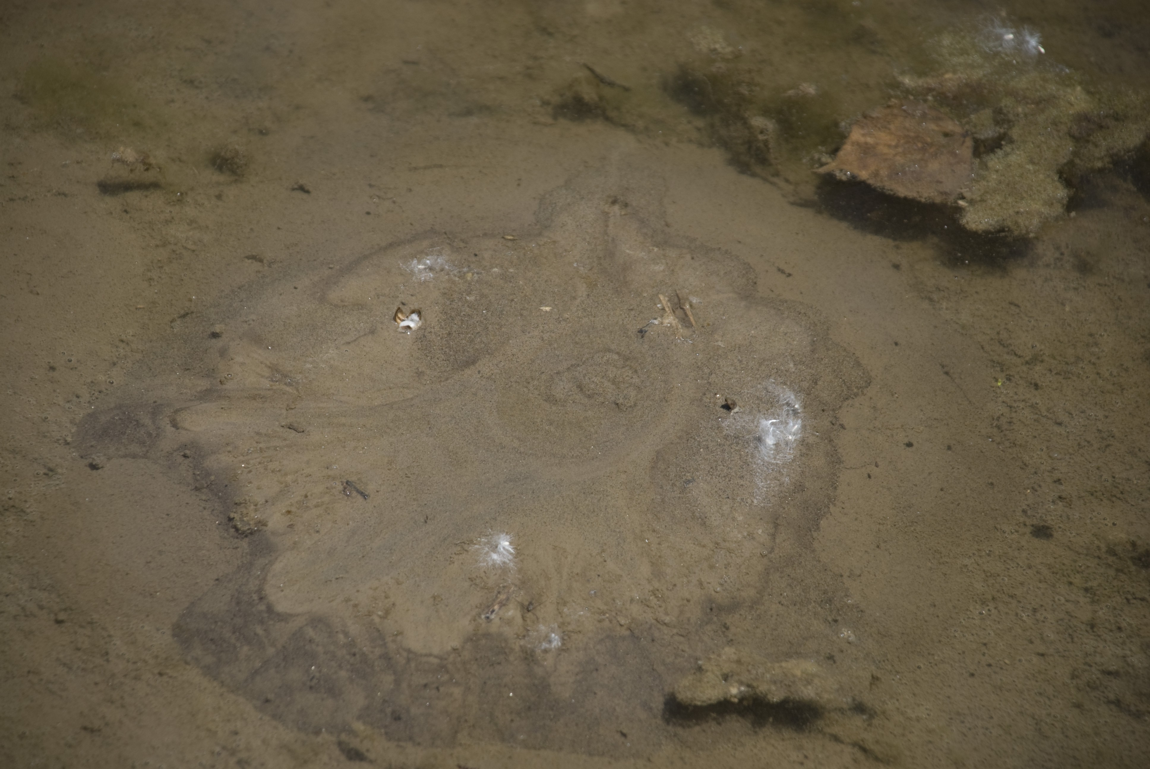

Fig. 9. Negative Image

will be found adjacent to a pixel of value j. This feature is rotation invariant and works very well for our case because the structure of a sand boil is predictable conceptually. Haralick features yield a list of 13 features.
Hu Moments: Hu moments, also known as image moments are important features in computer vision and image recogni- tion fields. They are useful for describing object segmentation and other properties. It is a weighted average (or moment) of the image pixel intensities. For a binary image, it is the sum of pixel intensities (all white) divided by the total number of pixels in that image. The moments associated with a shape remain constant even on rotating the image. The Hu moments of K differ from that of S0, S1, . . . S4. Whereas, the values for

all the images containing S in them happen to be similar. It is also evident that the moment values for the images are rotation invariant. Hence, these are good features for the detection of sand boils. Hu Moments yields a list of 7 features. H[0] is the first Hu moment of K0 (which is a binary image of the letter ‘K’). H[1], similarly, is the second Hu moment value for K0 and so on. In cases like sandboils, Hu moments are used because these features are rotation invariant and provide a clear distinction between two types of images, as evidenced in the image. Therefore, the assumption is that for sand boils the values H[0], H[1], . . . , H[6] will remain similar to each other and therefore help during testing.
Histograms: Histograms can be generated directly using OpenCV’s calcHist function in Python on C++. It calculates the histogram of one or more arrays. We use it to generate 2D histograms to understand the distribution of pixel intensities in the image. This proves to be a useful feature for the detection of images based on the assumption that similar images will have similar histograms. The number of bins can be specified in the parameters required. It can range from 32, 64 to 256. The difference between a 32-bin and 256-bin histogram. It yields a list of 32 features.
Histogram of Oriented Gradients (HOG): Computer vision world has been known for improving the accuracy of detection for images with fixed outlines such as pedestrians. Dalal and Triggs are known for detecting humans using these features. The algorithm counts the occurrences of gradient orientation in localized portions of an image. Similar to edge detection, it describes the local object appearance and shape in an image. The image is divided into small connecting regions and for each pixel in each cell, a histogram of gradient direction is calculated. This results in a final list of appended histograms which is the final list of features.

- RESULTS AND DISCUSSION
- Viola Jones
In the Viola-Jones’ object detection algorithm, we achieve an overall accuracy of 86.11%. The precision is 0.8170 and recall is 0.8241. The F1 score is 0.8205. 6305 images were used for training data and 78 images were used for testing data. Overall, the Viola-Jones algorithm performs very well despite being one of the oldest methods for object detection.

- YOLO
YOLO yields a set of detections that appear to be correct for a classifier – not as a detector. In the YOLO algorithm, we achieve an overall accuracy of 98.74% which is the highest among the other methods. The precision is 0.9281 and recall is 0.9633. The F1 score is 0.9453. 6303 images were used for training data and 14 images were used for testing data.

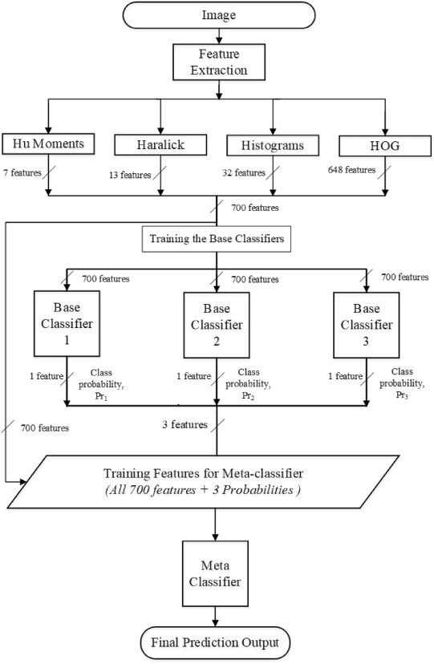

Fig. 10. Feature Extraction

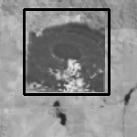

Fig. 11. Viola Jones Algorithm Detecting a Sand Boil

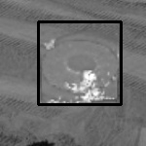

Fig. 12. Viola Jones Algorithm Detecting a Sand Boil
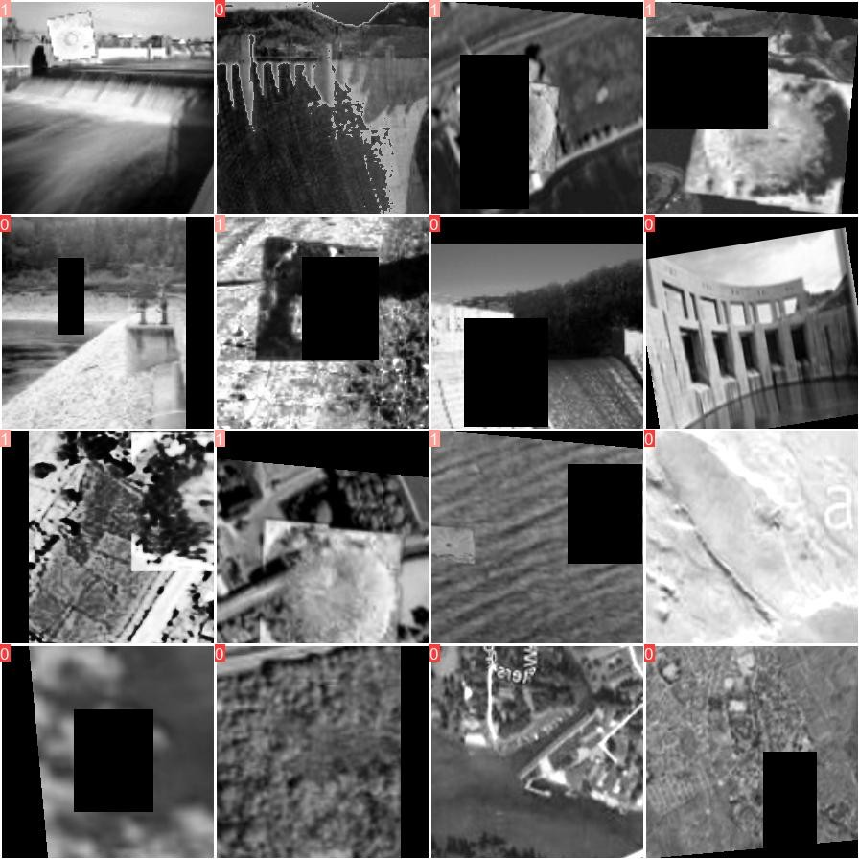

Fig. 13. YOLO Algorithm Training Images

- SVM
In SVM, our model achieves an impressive overall accu- racy of 90.90%, placing it as the second-highest performer among the compared methods. This accuracy indicates the model’s ability to correctly classify instances, highlighting its effectiveness in distinguishing sand boils accurately. With a precision of 0.8571 and a recall of 1.0, the SVM demonstrates a strong balance between identifying relevant instances and avoiding false positives. The F1 score, a harmonic mean of precision and recall, stands at 0.9230, further affirming the

Fig. 14. YOLO Algorithm Testing Images

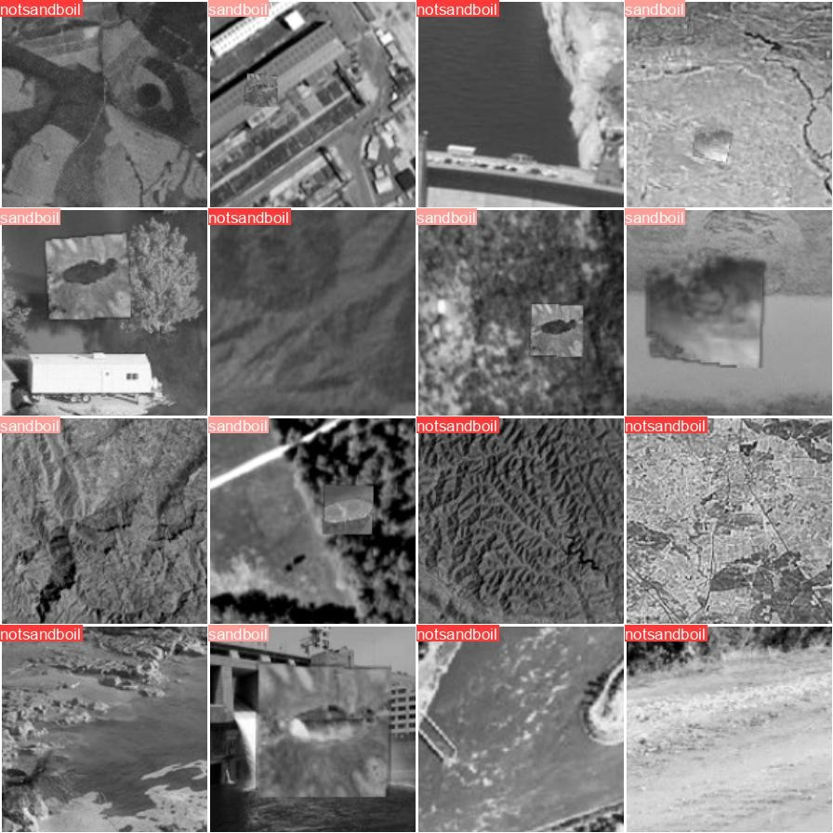

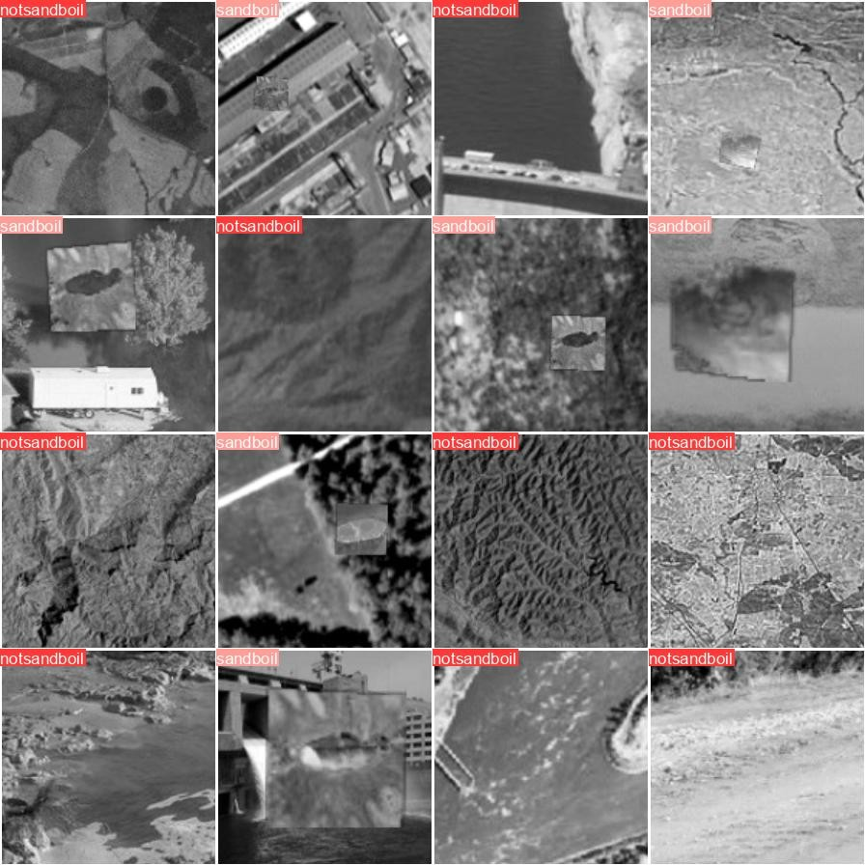
Fig. 15. YOLO Algorithm Prediction

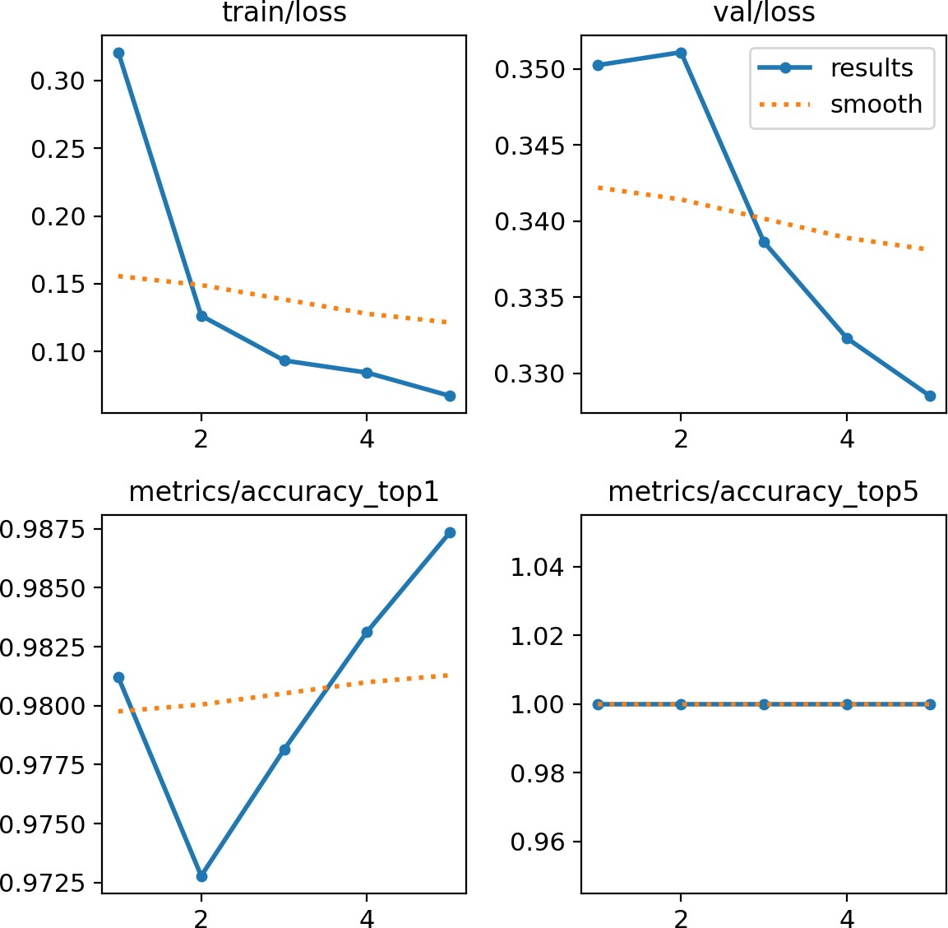

Fig. 16. YOLO Algorithm Graphs

model’s robustness in classification tasks. Leveraging a dataset comprising 249 images for training and 11 images for testing, the SVM model showcases its capacity to generalize well to unseen data, underlining its reliability in real-world scenarios.
this, the precision and recall metrics both register at 0.8333, indicating a balanced performance in correctly identifying positive instances while minimizing false positives. The F1 score, a harmonic mean of precision and recall, also aligns at 0.8333, consolidating the model’s effectiveness in achieving a balance between precision and recall. Notably, this CNN model was trained on a dataset comprising 249 images and evaluated on a separate test set consisting of 11 images.
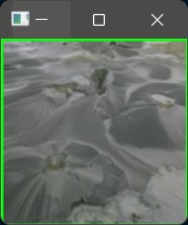
Fig. 18. CNN Detecting Sand boil

- CNN

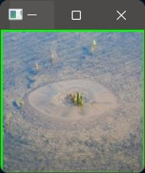
Fig. 17. SVM Algorithm Detecting Sand Boil

- Comparison Table
After comparing the performance of various object detection algorithms for detecting sand boils, it is evident that each method exhibits distinct strengths and weaknesses. The Viola- Jones algorithm, despite its age, demonstrates commendable performance with an accuracy of 86.11%, underscoring its robustness in object detection tasks. YOLO, on the other hand, emerges as the top performer with an impressive accuracy of 98.74%, showcasing its prowess in accurately detecting sand boils. SVM also proves to be a strong contender with an accu- racy of 90.90%, demonstrating its capability in classification tasks. However, CNN lags behind slightly with an accuracy of 81.82%, suggesting room for improvement in its feature extraction capabilities. Overall, while each algorithm presents its unique advantages, YOLO stands out as the most effective solution for detecting sand boils, offering unparalleled accu- racy and reliability.

- CONCLUSION AND FUTURE WORK
Here, we compared different object detection methods and

In the case of Convolutional Neural Networks (CNN), we attain an overall accuracy of 81.82%, which, comparatively, stands as the lowest among the methods assessed. Despite
determined the best ones to use for the detection of sand boils.We developed a stacking based machine learning predic- tor which focuses on using the best methods to increase the

TABLE I
COMPARISON OF ALL THE ALGORITHMS AND THE DATASETS

Algorithm | Viola Jones | YOLO | SVM | CNN
Precision | 86.11% | 98.74% | 90.90% | 81.82%
Accuracy | 0.8170 | 0.9281 | 0.8571 | 0.8333
Recall | 0.8241 | 0.9633 | 1.0 | 0.8333
F1-score | 0.8205 | 0.9453 | 0.9230 | 0.8333
Training | 6305 | 6000 | 249 | 249
Testing | 78 | 14 | 11 | 11

detection accuracy of the machine learning model. We also created a database of positive and negative samples of sand boils for use in research. After a comprehensive evaluation of various object de- tection algorithms for detecting sand boils, it is evident that each method possesses distinct strengths and limitations.
The Viola-Jones algorithm demonstrates commendable per- formance with an accuracy of 86.11emerges as the top per- former with an impressive accuracy of 98.74casing its effec- tiveness in accurately detecting sand boils. SVM also proves to be a strong contender with an accuracy of 90.90ability for classification tasks. However, CNN lags behind slightly with an accuracy of 81.82extraction capabilities. Overall, YOLO stands out as the most effective solution, offering unparalleled accuracy and reliability in sand boil detec- tion.
For future work, can improve sand boil detection by enhancing existing al- gorithms like CNNs with advanced architectures or domain-specific knowl- edge. Additionally, combining algorithms like YOLO and CNN could lead to bet- ter performance. Using drones equipped with high-resolution cam- eras presents a promising opportunity for efficient sand boil detection over large areas, especially in remote or inac- cessible locations. Further research should focus on optimizing algorithms for real-time deployment in diverse environmental conditions. Additionally, augmenting datasets with syn- thetic data and collecting more diverse samples will improve the accuracy and reliability of sand boil detection algorithms in real-world scenarios

ACKNOWLEDGMENT
We thank those responsible for shaping the paper. Without their guidance and help, the experience while constructing the dissertation would not have been so smooth and efficient.
We sincerely thank our guide, Dr Sunita G, Associate Pro- fessor, Department of Computer Science and Engineering, for her guidance and valuable suggestions that helped us complete this paper. We also thank our coordinator, Ms Supriya Salian, Dept of CSE, for her consistent encouragement.
We owe a profound gratitude to Dr Sridevi Saralaya, Head of the Department, Computer Science and Engineering, whose kind support and guidance helped us to complete this work successfully.
We are extremely thankful to our Principal, Dr Rio D’Souza, for his valuable guidance and encouragement throughout the work.
We express our deep gratitude to our Director, Rev. Fr Wilfred Prakash D’Souza, and Assistant Director, Rev. Fr Kenneth Rayner Crasta, for their consistent support and encouragement.
We would like to thank all the faculty and staff of the Department of Computer Science and Engineering who have always been with us, extending their support, precious sug- gestions, guidance, and encouragement through the work.
We also extend our gratitude to our friends and family members for their continuous support.

REFERENCES
- Ahmed Elgamal Zhaohui Yang. “Sand Boils and Liquefaction-Induced Lateral De-formation”. In: University of California at San Diego, U.S.A (2017).
- Chi-Chin Tsai. “Experimental study on the mechanism of sand boils and associated settlements due to soil liquefaction in loose sand”. In: Engineering Geology,Volume 306 (2022).
- Mitsutoshi Yoshimine Kenji Ishihara. “Evaluation of Settlements in Sand Deposits Following Liquefaction During Earthquakes”. In: SOILS AND FOUNDATIONS Vol. 32 (1992).
- Thomas Jenkins Amir Jazayeri Adrian D. Werner. “Effects of porous media thick-ness and its hydraulic gradient history on the formation of sand boils: Experimental investigation”. In: Elsevier (1992).
- VAndrew John Brennan. Observations on Sand Boils from Simple Model Tests. url: https://www.researchgate.net/publication/269157128 Observations
on Sand Boils from Simple Model Tests. accessed on 16.12.2023.
- Pragati Baheti. Image Recognition Guide. url: https://www.v7labs.com/blog/ image-recognition-guide. accessed on 15.12.2023.
- Aditi S. Kuchi. “Detection of Sand Boils from Images using Machine Learning Approaches”. In: University of New Orleans Theses and Dissertations. 2618. (2019).
- Yi-Qing Wang. “An Analysis of the Viola-Jones Algorithm”. In: Image Processing On Line (IPOL) (2014).
- Joseph Redmon Santosh Divvala Ross Girshick Ali Farhadi. “You Only Look Once:Unified, Real-Time Object Detection”. In: CVPR paper (2016).
- Wei Liu Dragomir Anguelov Dumitru Erhan Christian Szegedy Scott Reed Cheng-Yang Fu Alexander C. Berg. “SSD: Single Shot MultiBox Detector”. In: European Conference on Computer Vision (2016).
- Machine learning applications in detecting sand boils from images. url: https://www.sciencedirect.com/science/article/pii/S2590005619300128. accessed on 16.12.2023.

