Potential-deprivation accessibility across 67 European cities
Evidence pack: each claim with its supporting figure and table, a reader's guide to every statistical test (section 3), and the full glossary of abbreviations and indicators (section 6). Generated 2026-08-13 from the depacc-results branch. Two values still await Paris's final routing rounds and are flagged; everything else is final.

1. The sample and descriptive statistics
67 functional urban areas (FUAs) in 24 countries, 113.9 million inhabitants in total, drawn by the stratified design (4 macro-regions x 4 size strata), populations from 101,000 (Lomza) to 12.9 million (Paris), median 1.0 million. Routing: r5 over OpenStreetMap networks; walk for everyday services, car for emergency care.
Sample composition (number of cities):
Region | 100–250k | 250k–1M | 1–5M | >5M | Total
North | 3 | 5 | 5 | 0 | 13
West | 4 | 4 | 7 | 1 | 16
South | 4 | 4 | 7 | 3 | 18
CEE | 4 | 5 | 11 | 0 | 20

Key indicators across the 67 cities (population-weighted within each city, then summarised across cities):
Indicator | Mean | SD | Min | Median | Max
population | 1,700,110 | 2,104,313 | 101,050 | 1,006,055 | 12,886,280
mean_everyday | 0.301 | 0.098 | 0.104 | 0.289 | 0.505
mean_emergency | 0.216 | 0.14 | 0.085 | 0.17 | 0.801
gini_everyday | 0.468 | 0.089 | 0.272 | 0.492 | 0.625
gini_emergency | 0.459 | 0.111 | 0.231 | 0.445 | 0.774
spearman_rho | 0.43 | 0.166 | -0.019 | 0.42 | 0.743
divergence_gap | -0.009 | 0.134 | -0.296 | -0.007 | 0.328
compounding_pop_share_50 | 0.333 | 0.042 | 0.233 | 0.328 | 0.43
compounding_intensity | 0.381 | 0.021 | 0.323 | 0.381 | 0.434
pop_share_beyond_everyday_30 | 0.279 | 0.132 | 0.057 | 0.275 | 0.561
pop_share_beyond_emergency_30 | 0.068 | 0.074 | 0 | 0.043 | 0.287
Evidence files (depacc-results): cross/cityplane.csv (one row per city); the full per-city table is attached as cities_descriptives.csv.
Reading aids: mean_everyday is on [0,1] (0.30 = the average resident sits between the 15-minute ideal and full deprivation); mean_emergency is in multiples of the 45-minute-threshold deprivation (0.22 = well below it); Gini 0 = equal, 1 = maximal; divergence_gap > 0 = the city's inequality is emergency-side; rho near 0 = the two deprivation maps are unrelated, high = the same areas lose twice.

2. The claims, each with its evidence

H1 — City size buys everyday access, but not emergency care
Mean everyday deprivation falls ~19% per e-fold of population; mean emergency deprivation shows no detectable gradient, bounded within ±0.13 (TOST). The slope difference is itself significant.
Quantity | Estimate | Inference | Source table
Everyday elasticity | −0.19 (SE 0.023) | wild-cluster p = 0.0002; LOO [−0.20, −0.18] | inference_scaling_clustered.csv
Emergency elasticity | −0.05 (SE 0.047) | p = 0.37; TOST: within ±0.13 | inference_equivalence.csv
Slope difference (paired) | +0.14 | wild-cluster p = 0.004 | inference_regime_paired.csv
Robust re-estimates | Huber −0.19; median −0.21 | influence table; desert-excl. −0.20 | inference_influence.csv
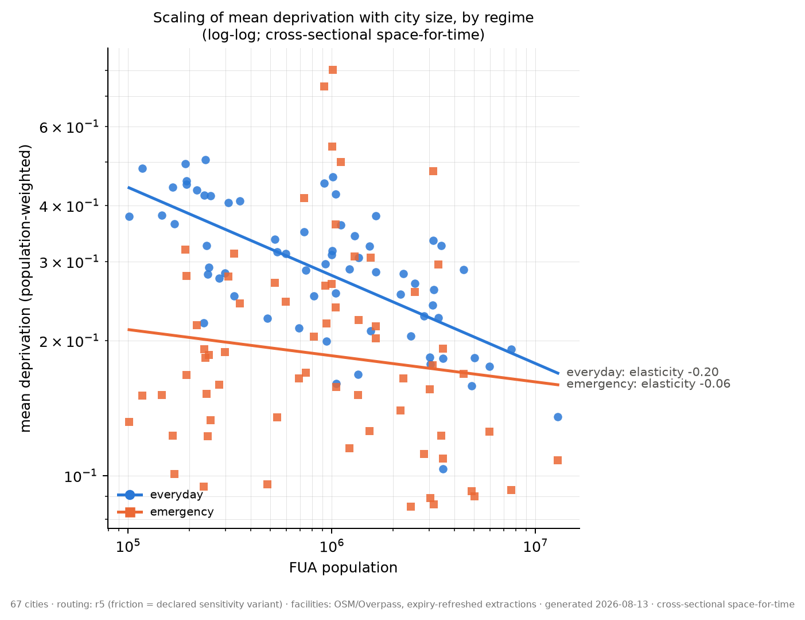
Evidence files (depacc-results): figures/scaling_elasticity.png · scaling.csv (country-FE variant) · inference_*.csv

H2 — Everyday inequality grows with size; emergency inequality does not
Quantity | Estimate | Inference | Source table
Everyday-Gini slope | +0.06 | wild-cluster p = 0.003 | inference_scaling_clustered.csv
Emergency-Gini slope | +0.00 | p = 0.94 | inference_scaling_clustered.csv
Slope difference (paired) | −0.056 | wild p ≈ 0.05 [awaiting Paris; 0.025 with Paris] | inference_regime_paired.csv
Specification curve | +0.02 to +0.08 | significant in 12/13 parameterisations (exception: Box-Cox form swap, p = 0.16) | sensitivity/specification_curve.csv
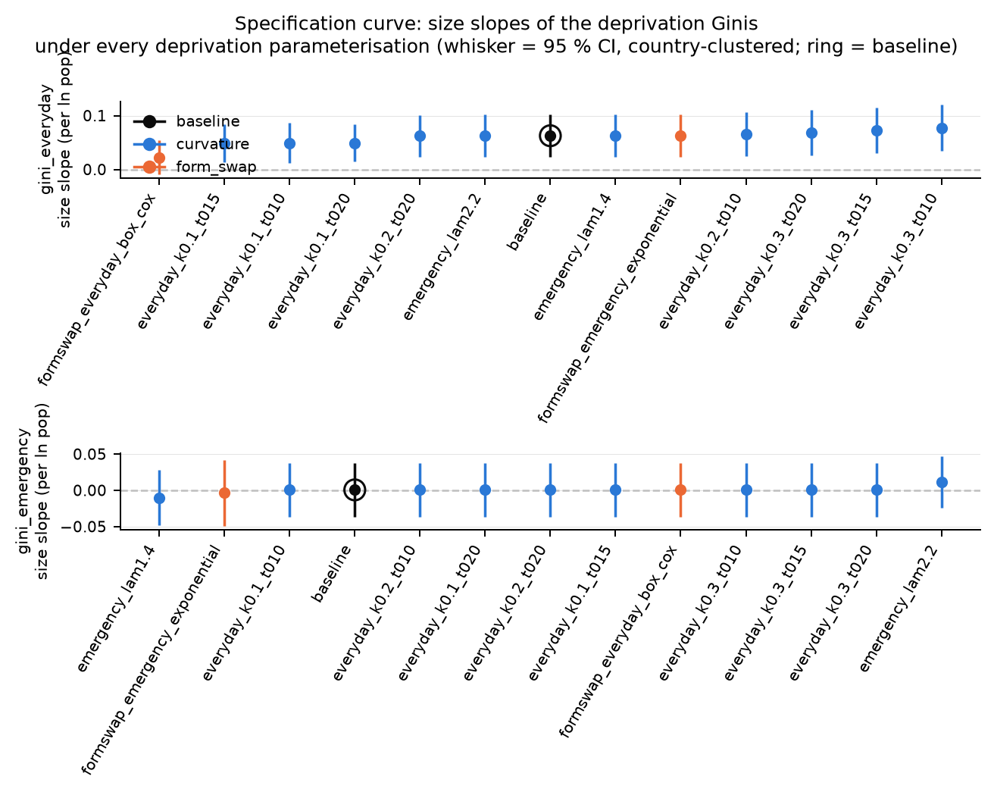
Evidence files (depacc-results): sensitivity/specification_curve.png — every point is the everyday-Gini size slope under one deprivation parameterisation; the ringed point is the baseline.

H3 — The divergence has a geography, and it is country-level
Regional contrasts tested by permuting whole countries across regions (the honest unit: region is a property of countries).
Outcome | Cohen f (city) | p (country permutation) | Reading
gini_emergency | 0.77 | 0.002 | CEE highest (median ≈0.54)
spearman_rho | 0.52 | 0.0016 | CEE most coupled (median ≈0.55)
compounding share (HH) | 0.53 | 0.0008 | regional structure in compounding
divergence_gap | 0.67 | 0.012 | West everyday-side, North emergency-side
gini_everyday | 0.54 | 0.33 — NOT significant | do not claim a regional everyday-Gini contrast
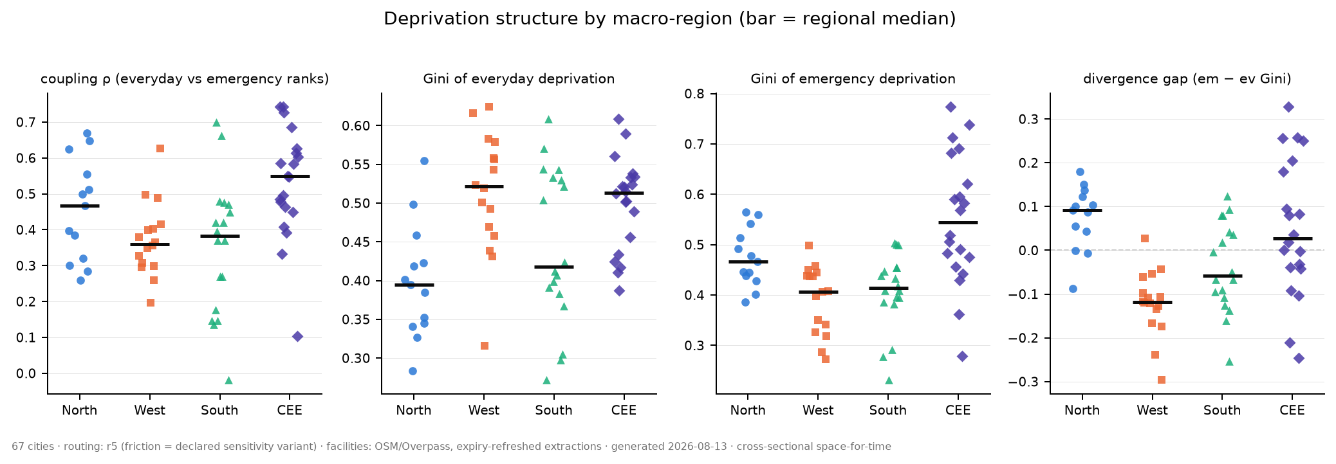
Evidence files (depacc-results): figures/region_strips.png · inference_regional.csv

H4 — No city types: regional gradients plus an emergency-desert group
k-means and Ward agree on one 62-vs-5 split: București, Rīga, Vilnius, Tallinn, Ljubljana — real separation (null p = 0.001) but an outlier group, not a typology (agreement with the region partition: ARI ≈ 0.07). See section 3 for the full clustering status including the new peeled analysis.
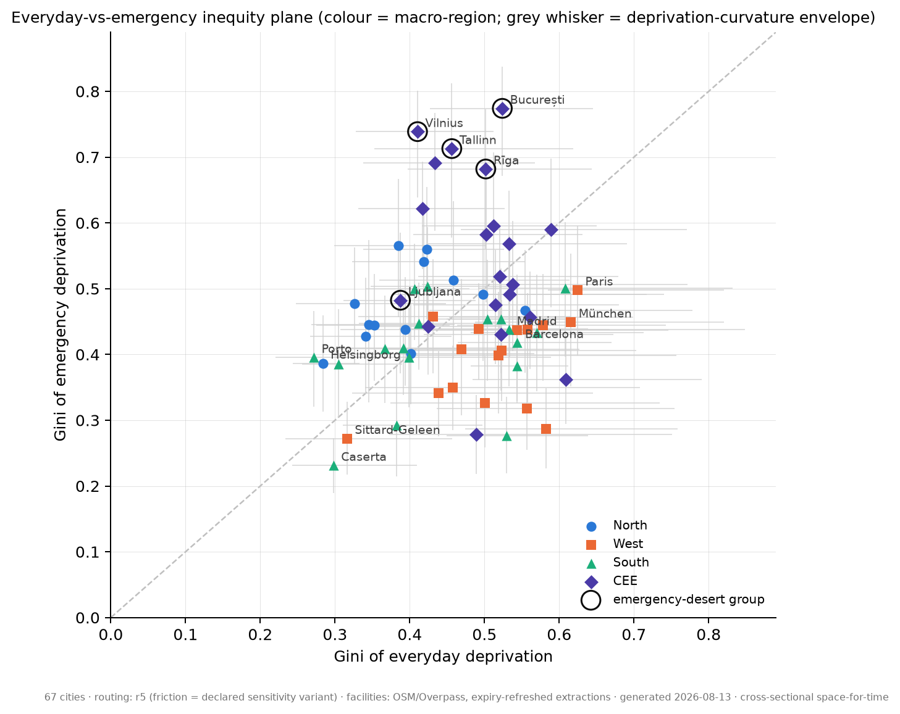
Evidence files (depacc-results): figures/cityplane.png (rings = desert group; grey whiskers = deprivation-curvature envelopes) · cityvector_clustered.csv · cluster_null.csv

H5 — Who carries it: children, almost everywhere; the elderly, locally
Stratum (census-harmonised) | Median everyday ratio | Cities > parity | Median HH gap | Cities > 0
Children (share <15, top quartile cells) | 1.27 | 88% | +0.14 | 88%
Elderly (share ≥65, top quartile cells) | 0.96 | 37% | −0.03 | 43%
Ratios use the covered-cell reference. The sharper Hamburg results (elderly 1.37×, low-rent 1.61×) are the Tier-2 national strata — finer data, different definitions, reported per city and never pooled.
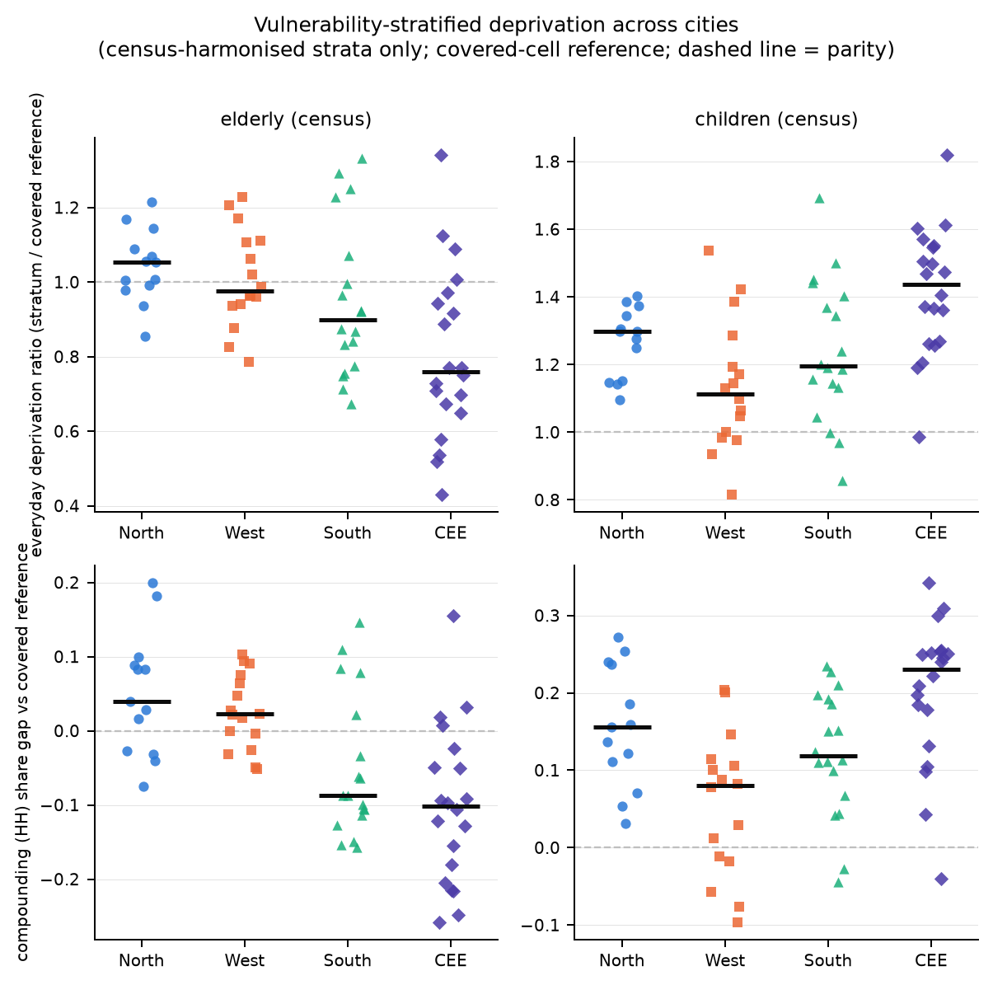
Evidence files (depacc-results): figures/vulnerability_strata.png · vulnerability.csv (one row per city and stratum) · vulnerability_summary.csv

H6 — Compounding is the norm
The HH (deprived-on-both) share exceeds the 25% independence benchmark in nearly every city (sample mean 33%, range 23–43%); coupling rho spans ≈0 to 0.74. The threshold choice moves the HH share ~6× more than any accessibility-model knob, which is why the continuous compounding_intensity is the headline number (regional contrast p_perm = 0.002).
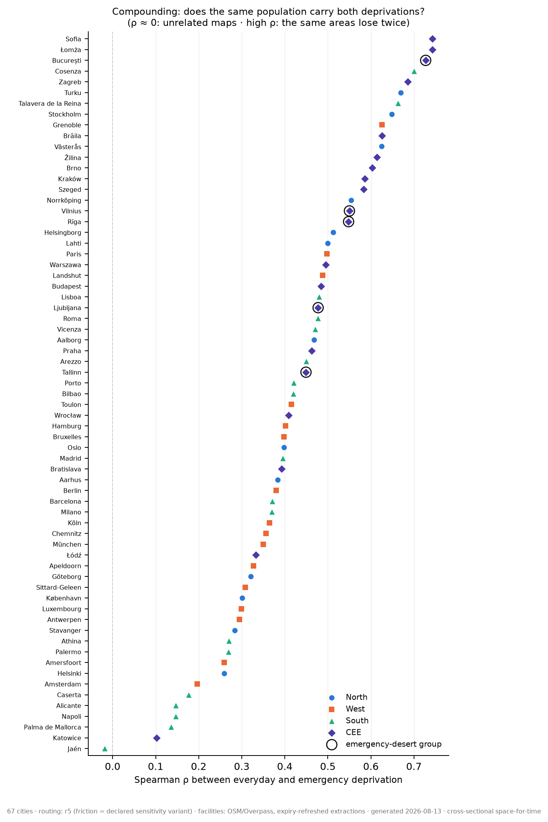
Evidence files (depacc-results): figures/rho_ranked.png · cityplane.csv (compounding_* columns) · sensitivity acceptance tables (threshold-axis dominance)
Spatial view — eight contrasting cities (read patterns, not cells: ~24% of population flips class between routing engines):
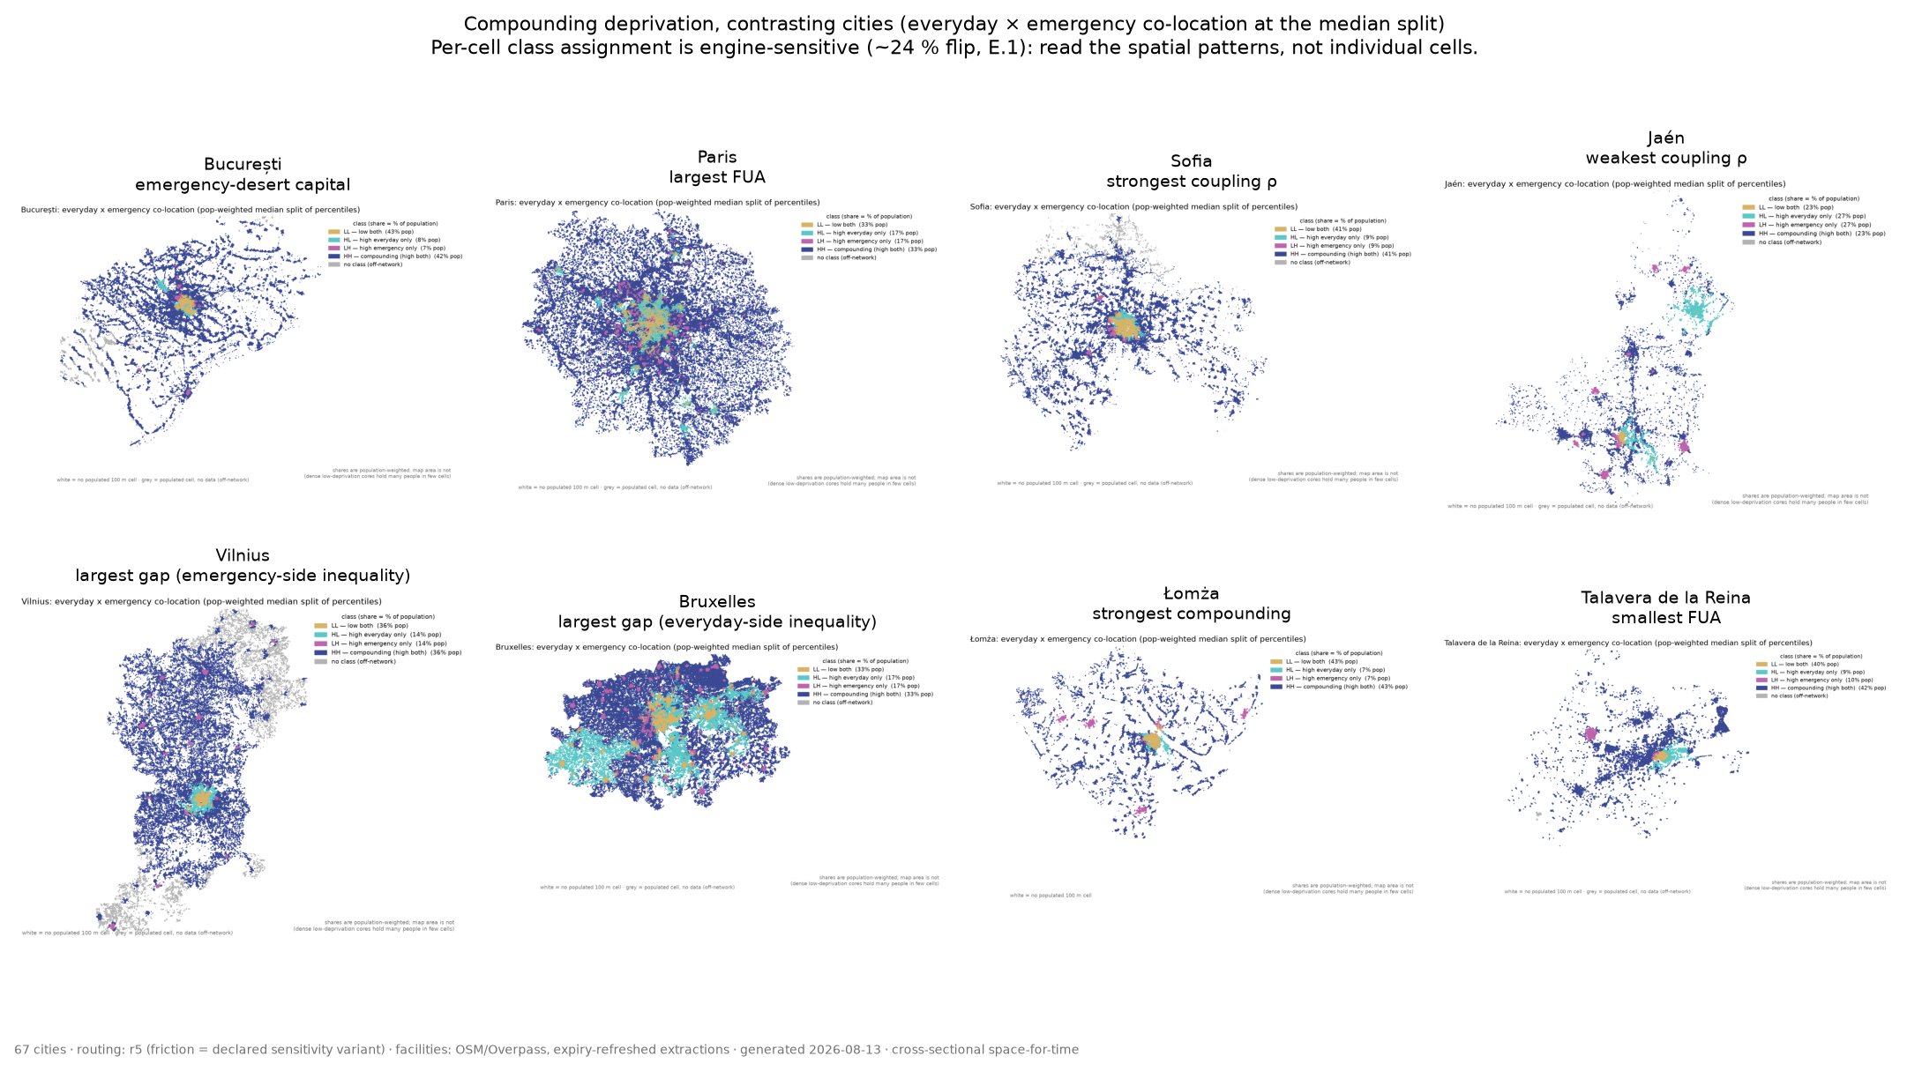
Evidence files (depacc-results): figures/compounding_gallery.png · per-city maps under cities/<city>/figures/

H7 — Deprivation is not mere access (and the claims survive both readings)
The pipeline computes deprivation-free travel-time indicators alongside the deprivation surfaces, and the headline regressions run on both. Three readings: (1) robustness — the everyday claim survives in pure access terms and the deprivation Ginis correlate 0.965/0.977 with pure travel-time Ginis, so nothing hinges on the deprivation function; (2) contribution — deprivation is the better-behaved outcome (R² 0.44 vs 0.16) because the DLF discounts welfare-irrelevant variation; (3) access averages cannot see coverage deserts — only the clinically anchored convex DCF exposes them.
Outcome vs size | Kind | Elasticity | p | R²
Everyday deprivation mean | deprivation | −0.196 | <0.0001 | 0.44
Everyday median travel time | access | −0.237 | <0.0001 | 0.16
Everyday mean travel time | access | −0.178 | <0.0001 | 0.31
Emergency deprivation mean | deprivation | −0.058 | 0.17 | 0.02
Emergency median travel time | access | −0.042 | 0.10 | 0.04
Emergency p90 travel time | access | −0.058 | 0.02 | 0.05
The honest nuance: emergency access improves marginally with size (p90 −0.06, p = 0.02) — a quarter of the everyday gradient — but it does not translate into deprivation relief: bigger cities get slightly faster, not meaningfully safer.
The desert demonstration — access averages vs anchored deprivation (ratios to the 67-city sample median):
City | Median emerg. time (min) | vs sample | p90 (min) | Deprivation | vs sample
vilnius | 14.0 | 1.2x | 54.5 | 0.801 | 4.7x
ljubljana | 23.0 | 1.9x | 62.5 | 0.737 | 4.3x
riga | 13.5 | 1.1x | 43.5 | 0.500 | 2.9x
bucuresti | 8.5 | 0.7x | 46.5 | 0.476 | 2.8x
tallinn | 13.0 | 1.1x | 31.5 | 0.416 | 2.4x
Bucharest's median emergency access is BETTER than the sample median (0.7×) while its emergency deprivation is 2.8× — a fifth of its population sits in the far tail that means and medians cannot see.
Why the emergency scatter is wide: size explains 2% of emergency deprivation; the share of population beyond 30-minute emergency care explains 81%, country membership 72%. Coloured by the k-means severity grades, the cloud resolves into three coverage bands with a significant grade structure (slope-×-grade interaction p = 0.010), while the everyday gradient holds within every grade:
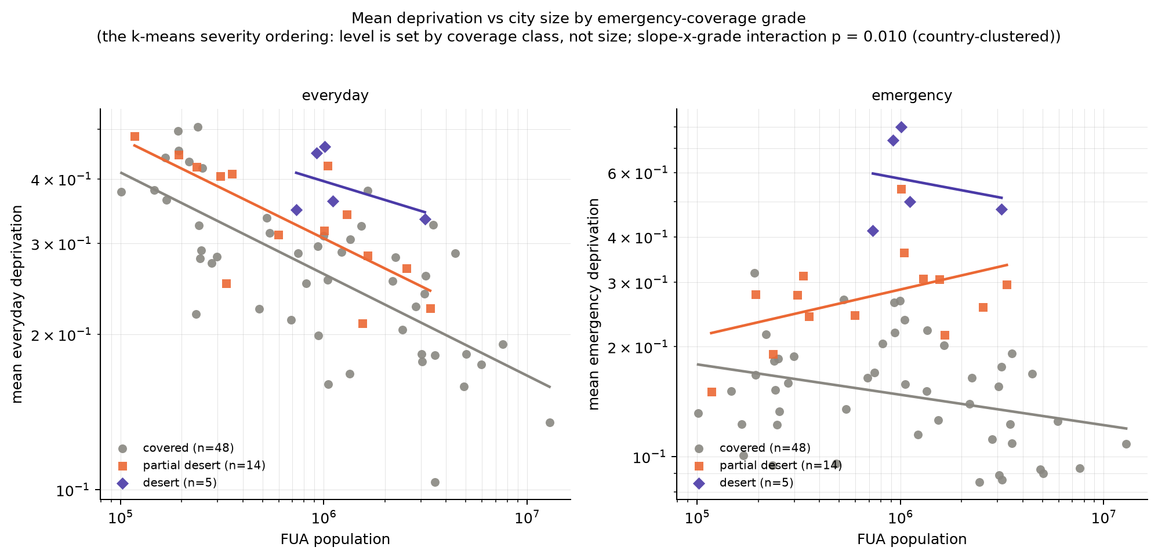
Evidence files (depacc-results): cross/deprivation_vs_access.csv · cross/desert_access_contrast.csv · cross/scaling_by_grade.csv · figures/scaling_by_coverage_grade.png

What is deliberately not claimed
- Absolute travel times or Gini levels under the friction engine (understated 34–314%; r5 is primary for this reason).
- Per-cell typology classes on any map (engine-sensitive; patterns only).
- Causal or longitudinal readings — every gradient is cross-sectional space-for-time.
- A regional everyday-Gini contrast (H3) or elderly compounding at the European level (H5).

3. How to read the statistical tests
Each test family in the tables: the question it answers, how it works, and how to read its number.
Log-log elasticity (scaling tables)
How does an outcome change with city size? Regress log(outcome) on log(population); the slope is the % change in the outcome per 1% change in population. −0.196 = a city 2.7× larger has ~19% lower mean everyday deprivation; 0 = no size relationship. R² = share of between-city variance size explains (0.44 is a lot for cross-country data; 0.02 essentially none).
Country-clustered standard errors
Cities within a country resemble each other, so the effective sample is ~24 countries, not 67 cities. The SE allows arbitrary within-country error correlation. Always cite the clustered p — the naive p overstates the evidence whenever an outcome has a national component (all of ours do).
Wild cluster bootstrap (p_wild)
Is the clustered p reliable with only ~24 clusters? The regression is re-estimated thousands of times on datasets built by flipping the sign of each country's residual block, null imposed. This is the citable p for the scaling claims; agreement with the clustered p (which holds throughout) means the approximation is fine.
Permutation test over countries (p_perm)
Do macro-regions differ, given that region is a property of whole countries? Compute the between-region F, then reshuffle which countries belong to which region thousands of times; p = share of shuffles with an F at least as large. This is the primary regional evidence. The city-level ANOVA p is shown only as an anti-conservative reference (everyday Gini: city p = 0.001, permutation p = 0.33 — claim dropped).
Cohen f
Group-contrast effect size, independent of significance: 0.10 small, 0.25 medium, 0.40 large. Our regional contrasts sit at 0.5–0.77.
Mixed model (p_mixed)
Region fixed effect + country random intercept — triangulation for the regional tests. Agreement with the permutation p is reassurance.
TOST equivalence test
Can we positively claim a slope is (near) zero, rather than merely failing to detect one? Two one-sided tests that the slope lies within ±bound. smallest_passing_bound = 0.126 means the data support 'the emergency elasticity is within ±0.13' but not '±0.10' — hence 'no detectable scaling, bounded within ±0.13', never 'proven flat'.
Paired regime test
Do the two regimes' size slopes differ within the same cities? Both regimes stacked (two rows per city); the regime × log-size interaction, country-clustered, IS the slope difference. Its wild p is the citable number.
Influence diagnostics (LOO, Cook's, Huber, median regression)
Does any single city carry a result? Refit dropping each city (LOO envelope = range of slopes), find the most influential city (Cook's distance), re-estimate with outlier-robust methods. A narrow LOO envelope containing the main estimate, with robust estimates nearby, means no city is load-bearing.
Clustering diagnostics (silhouette, bootstrap ARI, Gaussian null)
Is a clustering real? Three bars: separation (silhouette ~0.25 weak / 0.5 reasonable / 0.7 strong), stability (bootstrap ARI: recluster resampled cities, 1 = identical, ≥~0.8 stable), and surprise (null p: correlated structureless Gaussian data through the same k-selection). Claim a cluster only if all three pass — and check ARI vs the region partition, since with country nesting a 'cluster' can be a region in costume.
Specification curve
Does a claim depend on the deprivation parameterisation? Re-estimate it once per curvature/form variant and order the estimates. Robust = the whole curve on one side of zero with CIs clear of it; name exceptions (ours: the Box-Cox form swap for the everyday-Gini slope, p = 0.16).
Rank agreement (Spearman ρ / Kendall τ)
Does the ordering of cities survive an assumption change? Correlate city rankings under a variant vs baseline. Min ρ = 0.89 across all deprivation variants: no variant meaningfully reshuffles which cities rank high.
Slope-×-grade interaction
Once cities are grouped by emergency-coverage grade, does size still matter and do grades genuinely differ? Log deprivation on log size × grade, country-clustered Wald on the grade terms. p = 0.010: the grade structure is real; the small within-grade slopes say size is not what separates the bands.

4. k-means clustering: where it stands
Main pass (all 67 cities): k selected by silhouette over 2–6; k-means and Ward agree exactly.
Pass | k | Split | Silhouette | Bootstrap ARI | Null p | ARI vs region
Main (67 cities) | 2 | 62 / 5 (desert capitals) | 0.68 | 0.93 | 0.002 | ≈0.07
Peeled (62, deserts removed) | 2 | 48 / 14 | 0.38–0.44 | 0.76–0.78 | 0.002 | 0.07
The peeled pass (outliers removed, scaling and diagnostics recomputed) does find a second split that clears the null and is not the region partition: 14 cities — Oslo, Stockholm, Göteborg, Stavanger, Aalborg, Turku, Norrköping, Warszawa, Sofia, Zagreb, Palermo, Braila, Lomza, Luxembourg. What distinguishes them is the same axis that defined the desert group, at lower intensity: a real population share beyond the emergency thresholds (12.8% beyond 30 minutes vs 3.5% in the other 47; emergency Gini 0.53 vs 0.42; positive divergence gap).
Interpretation: European cities do not fall into multi-dimensional types. The only recoverable discrete structure is a severity ordering along ONE axis — emergency-periphery coverage: universal-coverage cities → partial-desert cities (the 14) → desert capitals (the 5). The second cut is moderate (silhouette ≈0.4, below the ≈0.5 'reasonable' bar) and only borderline bootstrap-stable (≈0.77), so present it as a gradient made visible, not as two city types.
Status: these peeled numbers are computed locally on the current 66/67-city tables and feature sets (slope features included where published; 8 DE/FR cities median-imputed on the SES slope by the documented bound). The CI version (cluster_null_peeled.csv, 999 null simulations, and Paris included) lands with the running batch's collect and my final report; expect the same qualitative picture.

5. Still pending
Paris routing resume rounds (automated). Until its final collect: the paired Gini-slope p (H2) and the CI peeled-clustering table are provisional; every other number above is final. The repo copy of this material (docs/results-headlines.md) updates automatically when Paris lands.

6. Glossary of abbreviations and indicators

Study design
Term | Meaning
FUA | Functional Urban Area (Eurostat/OECD): a city plus its commuting zone — the unit 'city' in this study.
Tier 1 / Tier 2 | Data depth. Tier 1 = every sampled FUA (EU-harmonised data). Tier 2 = deep-dive cities (DE/NL/FR…) with national fine-grid SES data and optionally transit.
everyday regime | GP, pharmacy, supermarket, school, green space — chosen, repeated, substitutable services accessed on foot; deprivation from a gravity-type potential measure.
emergency regime | Emergency-department hospital and ambulance station — non-substitutable, time-critical — accessed by car; deprivation from the nearest facility only.
space-for-time | Reading the cross-sectional city-size gradient as a development trajectory; no longitudinal data is used.
macro-regions | North (SE/NO/DK/FI), West (DE/NL/FR/BE/AT/LU), South (ES/IT/PT/EL), CEE (PL/CZ/RO/HU/SK, Baltics, HR/SI/BG).
E.1–E.5 / A–F | Validation exercises (engine cross-check, OSM completeness, external benchmark, resolution check, face validation) / plan workstreams.

Deprivation model
Term | Meaning
DLF | Deprivation Loss Function — the everyday regime's increasing S-shaped (logistic) function of effective travel time, in [0,1]. Parameters: t0 (inflection ≈ the 15-minute-city threshold), k (steepness), Lmax (ceiling).
DCF | Deprivation Cost Function — the emergency regime's convex, unbounded (Box-Cox) function of nearest travel time; λ ≈ 1.8 calibrated to clinical time-to-care anchors; reported in multiples of g(45 min), so 1.0 = the deprivation of arriving at the 45-minute threshold.
2SFCA | Two-Step Floating Catchment Area — the congestion adjustment: a facility serving many people relative to capacity inflates the effective travel time of its users. γ (gamma) sets how strongly congestion bites.
soft-min (κ) | A smooth minimum over reachable facilities: several nearby options beat the single nearest by a substitutability bonus ln(n)/κ. κ→∞ = plain nearest.
t_eff / t_nearest | Per-service effective (congestion-adjusted, soft-min) travel time / plain nearest-facility time, minutes.
t_regime_* | Composite travel time per regime (weighted mean over services) — deprivation-function-free; feeds the level indicators.
composite / weights | Regime deprivation = weighted mean of per-service deprivations (school and green sub-types weigh 0.5 each).
finite_fill | The large-but-finite time (default 120 min) assigned when a routable cell cannot reach a service within the walk cutoff — keeps the cell on the map at ~maximal deprivation. Level indicators contain this constant.
unreachable | A cell with no network path to any facility of any service (masked grey on maps) — distinct from reachable-but-service-deprived.

Indicators (city tables)
Term | Meaning
mean_everyday / mean_emergency | Population-weighted mean deprivation per regime (everyday in [0,1]; emergency in multiples of g(45 min)).
gini_everyday / gini_emergency | Population-weighted Gini (0 = equal, 1 = maximal inequality) of each deprivation surface within the city.
gini_t_* | The same Gini computed on travel times — the deprivation-function-free companion.
divergence_gap | gini_emergency − gini_everyday. Positive = the city's inequality problem is emergency-side; negative = everyday-side.
spearman_rho (ρ) | Rank correlation between the everyday and emergency percentile surfaces: 0 = unrelated maps; high = the same areas lose twice.
LL / LH / HL / HH | The co-location typology at the median split of both percentile surfaces; HH = high on both = compounding. HH > 25% = above-independence.
compounding_pop_share_50 / _75 | HH population share at the median / 75th-percentile split.
compounding_intensity | Population-weighted mean of min(everyday pct, emergency pct) — the continuous compounding measure; 1/3 independent, 1/2 coupled, 1/4 divergent.
jaccard_high | Overlap of the two 'high' sets (intersection/union) — threshold-based coupling companion to ρ.
pop_share_beyond_X | Population beyond X minutes of composite regime time — policy-threshold levels (contain the finite_fill constant).
p90_p50_ratio | 90th/50th percentile of the surface — tail inequality.
elasticity | Slope of log(outcome) on log(population): % change in the outcome per 1% change in city size.
slope_density_* / slope_ses_* | Within-city gradients of deprivation on density / on the harmonised SES covariate, used as cross-city features.
coverage grade | The k-means severity ordering of emergency coverage: covered / partial desert (the peeled 14) / desert (the 5 capitals).

Equity / vulnerability tables
Term | Meaning
SES | Socio-economic covariates (ses_* columns): EU census shares (age, employment, foreign-born) and national grids (rent, ownership…).
stratum / level | A population subgroup (e.g. elderly = top-quartile share-65+ cells). level names the data layer: age_census (EU-harmonised, pooled cross-city), age_national, income_tier2 (per-city only, never pooled).
covered reference (*_covered) | The comparison group restricted to cells where the stratum's SES column is actually published — the honest base.
ratio / hh_share_gap | Stratum mean deprivation ÷ reference (1 = parity, 1.3 = 30% more); stratum HH share − reference HH share.
concentration index | SES-rank-based inequality measure of deprivation (negative = deprivation concentrated among low-SES cells).
coverage_pop_share | Share of the city's population in cells where the SES column has a value — the gate for trusting a stratum.

Data and infrastructure
Term | Meaning
OSM / Overpass | OpenStreetMap and its query API — the facility source (completeness-benchmarked; extractions carry an expiry so all cities share an era).
GHS-POP | Global Human Settlement 100 m population grid — the analysis grid.
Eurostat Census 2021 grid / GISCO | The EU-harmonised 1 km census grid (age, employment, origin) broadcast onto the 100 m grid (ses_census_*).
EMP gap | Employment is voluntary in the census grid; DE and FR did not report it — their cities carry no harmonised SES slope by design (never substituted).
Zensus / INSEE / CBS | National statistical sources for Tier-2 fine grids (DE 100 m, FR 200 m, NL 100 m).
r5 / R5 | Conveyal's routing engine (via r5py) — the primary travel-time engine over OSM networks.
friction (surface) | The 1 km cost-distance rasters — the fast routing path, demoted to sensitivity variant after E.1 (levels off 34–314%; aggregate shares and ρ survive).
OD matrix | Origin–destination travel-time table (cells × facilities) per service and mode; carries a provenance sidecar naming the engine that built it.
reverse routing | Routing from the (few) facilities instead of the (many) cells — the transpose that makes an r5 city cost ~minutes.
routing budget | The per-run cap that stops routing cleanly with progress checkpointed (a green, resumable stop) — why big cities take several rounds.
ED | Emergency department (hospital with emergency care).
INKAR / BBSR · ABDA / Krankenhausverzeichnis | German federal accessibility indicators (external benchmark, passed) · German pharmacy/hospital registries (completeness benchmark, passed).
depacc-results | The orphan git branch where every run accumulates its summary tables and figures — the single source for all numbers above.

