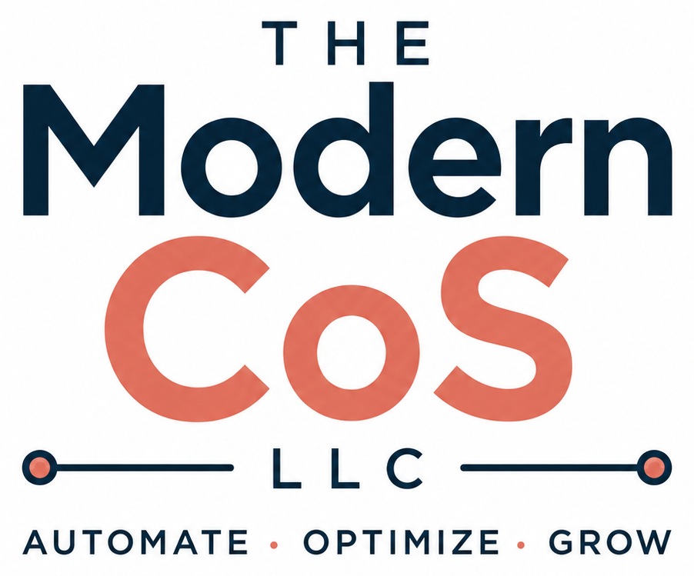
BRAND GUIDE
Visual & Verbal Identity Standards
The Modern CoS, LLC
Prepared for Tina Biello, Founder
Version 1.0 • July 2026
Internal reference document. Update as the brand evolves.

SECTION 1

Brand Foundation

Positioning Statement
The Modern CoS is an operations advisory firm powered by AI. We help small businesses work smarter, not harder, through practical AI, operational excellence, and systems that create lasting productivity and freedom.

Mission
Help small businesses work smarter, not harder, through practical AI and operational excellence.

Vision
Become the trusted operational partner for small businesses across the United States, empowering owners to replace chaos with clarity through practical AI, streamlined operations, and systems that give them the freedom to focus on growing their business rather than just running it.

Brand Promise
Every recommendation must save time, reduce complexity, or improve clarity. If it doesn't accomplish one of those, it doesn't get recommended.

Core Values
- Practical over trendy — solutions solve real business problems, not just showcase new technology.
- Systems create productive freedom — well-designed systems reduce stress and free owners to focus on what matters most.
- AI should simplify work — technology should remove complexity, not create it.
- Relationships before revenue — trust is built through honesty, service, and long-term partnership.
- Always be learning — the firm stays curious and adaptable as the technology evolves.
- Educate for self-sufficiency — clients are empowered to use and improve the systems built with them, not made dependent on the firm.

SECTION 2

Audience & Differentiation

Who We Serve
Small and lower-middle-market businesses generating $500K to $10M in annual revenue with 5 to 100 employees. These are owners growing faster than their internal operations can support, with limited or no dedicated operations staff, curious about AI but unsure where to start.
- 5 to 100 employees
- $500K to $10M in annual revenue
- Growing faster than their operations can support
- Limited or no dedicated operations staff
- Curious about AI but unsure where to begin
- An owner or small leadership team wearing too many hats

Where We Sit
More strategic than task support. More operationally practical than broad strategy consulting. More business-outcome-led than tool-first AI agencies. The Modern CoS doesn't out-assistant the assistant firms or out-COO the high-end COO firms — it owns the combination no competitor owns: operational fluency plus practical AI plus a productized ladder a buyer can actually understand.

Differentiators
Differentiator | Why It Matters
Operations-first, AI-enabled | Buyers want outcomes, not tool demos.
Productized advisory ladder | Easier to buy than opaque consulting.
Founder education for self-sufficiency | Distinguishes from dependency-heavy service models.
Digital products as low-risk entry points | Reduces acquisition friction.
U.S. small-business specialization | Keeps positioning tight and credible.

SECTION 3

Voice & Tone

Personality
The Modern CoS sounds like an experienced operator, not a consultant filling slide space. Direct. Specific. Outcome-focused. AI is the method, not the pitch — every piece of content should read like it came from someone who has actually done the work, not someone marketing around it.
- Direct — lead with the answer, not the throat-clearing
- Practical — concrete examples over abstractions and buzzwords
- Confident — a real point of view, not a neutral textbook tone
- Self-sufficient — teach clients to run the system, don't hoard the knowledge
- Honest about tradeoffs — no manufactured enthusiasm, no papering over gaps

Writing Rules
Say It Like This | Not Like This
"Here's what I'd fix first, and why it matters." | "In today's fast-paced business environment..."
Contractions, varied sentence length, plain English | Furthermore, Moreover, Additionally, Consequently
"This workflow saves about six hours a week." | "This innovative solution leverages cutting-edge AI."
Concrete numbers, named tools, real examples | Generic motivational language and corporate clichés
Short paragraphs that read like a person talking | Forced three-point frameworks and symmetrical bullet lists

Content Pillars
The four pillars that anchor recurring content, in LinkedIn posts, newsletters, and client-facing material:
- Chief of Staff Insights — operational lessons from real engagements
- Workflow Wednesday — a specific automation or process breakdown
- Behind the Systems — how a tool or SOP actually gets built
- Practical AI — AI as a means to an operational end, never the headline

SECTION 4

Logo System

Primary Logo
The full lockup — "THE Modern CoS LLC" with the "Automate • Optimize • Grow" tagline — is the default version. Use it whenever space allows: website header, proposals, email signature, social profile.

Clear Space & Minimum Size
- Keep clear space around the logo equal to the height of the "C" in CoS on every side — no text, edges, or other graphics inside that margin.
- Never scale the full lockup below 1.25" wide in print or 150px wide on screen — the tagline becomes illegible below that.
- For small placements (favicons, app icons, social avatars), use the coral "CoS" mark on its own rather than shrinking the full lockup.

Incorrect Usage
- Don't recolor the wordmark outside the approved navy and coral palette.
- Don't stretch, skew, or rotate the logo.
- Don't place the logo on busy photography or low-contrast backgrounds.
- Don't recreate the wordmark in a different typeface — always use the master file.
- Don't separate "THE," "Modern CoS," and "LLC" into different layouts.

SECTION 5

Color Palette

The palette is built from the logo itself — deep navy and warm coral, both sampled directly from the master file. Together they carry the brand's balance of trustworthy operator and human warmth.
Navy | Primary — anchors trust, authority, and the operational core of the brand  HEX #052439  RGB 5, 36, 57  CMYK C91 M37 Y0 K78
Coral | Accent — signals warmth, momentum, and the human side of the work  HEX #E0705D  RGB 224, 112, 93  CMYK C0 M50 Y58 K12

Usage Ratio
- Navy carries the majority of any layout — backgrounds, headlines, primary text.
- Coral is the accent — CTAs, highlights, the "CoS" in the wordmark, key stats. Used sparingly, it stays sharp.
- White space does the rest of the work. Don't crowd navy and coral together without breathing room.

Neutral Extension
Only navy and coral are locked in the logo file today. For web and document layouts that need a supporting neutral (body backgrounds, dividers, muted text), the following are recommended defaults — not yet part of the verified brand asset, so treat as provisional until formally adopted:
- Off-white background: #F7F5F2
- Muted text / captions: #5C5C5C
- Hairline rules / dividers: #D9D9D9

SECTION 6

Typography

Recommended Typefaces
The logo pairs a bold, rounded geometric sans for "Modern CoS" with a lighter, widely tracked treatment for "THE" and "LLC." The recommended system typefaces carry that same contrast into web and document use, both free via Google Fonts:
- Headlines & emphasis: Poppins (Bold / SemiBold) — geometric and rounded, closest system match to the wordmark
- Body copy: Inter (Regular / Medium) — clean and highly legible at small sizes, standard for the website build
- Labels & eyebrows: Poppins or Inter, all caps, letter-spaced, small size — mirrors the "THE" / "LLC" treatment

Type Scale
Use | Typeface / Weight | Size (web)
H1 / Page Title | Poppins Bold | 36–44px
H2 / Section Head | Poppins SemiBold | 26–30px
H3 / Subhead | Poppins Medium | 20–22px
Body | Inter Regular | 16–18px
Caption / Label | Inter Medium, tracked, all caps | 12–13px

SECTION 7

Quick Reference

Tagline
“Automate • Optimize • Grow” — always used with the full logo lockup, never restated as a standalone slogan without the mark.

Trademark Note
CoS Scan™, CoS Sprint™, Ops Intake™, and CoS on Call™ are verified. The Ops Seat™ and The CoS Method™ are pending final availability confirmation. Standing rule: verify name and trademark availability before any public use of a new offer name.

At a Glance
Navy | #052439 — primary
Coral | #E0705D — accent
Headline font | Poppins (Bold / SemiBold)
Body font | Inter (Regular / Medium)
Voice | Direct, practical, outcome-first — no corporate filler
Tagline | Automate • Optimize • Grow
Living document — update as pricing, naming, and trademark decisions finalize.

