Referee expertise:

Referee #1: GTPases – This reviewer is very positive and constructive and I want to give them all they asked for.

On our side; all comments can be addressed with plotting existing data and adding supplementary discussion.

Referee #2: NMR

Says publishable but wants (in addition to lots of extra discussion):

- test of model - We can easily do all this but it will take ~ 1 year (most optimistic theoretical timeline is 6 months, but I would say no way to get it all together in under a year)

- more detailed enzymology (at least analysis)

- binding assays

Referee #3: proteomics – My hunch is that this is someone junior or extremely frustrated and I would just go for it and attack them. I’m willing to risk it. Their only criticism (which they go over and over about) is that yes you did every single experiment, but not every experiment for every single mutant. The most pathetic part was when they say they started with 56 mutants but ended with 11 positions (either say 56 mutants and 16 mutants, or 24 positions and 11 positions, you piece of *&%#^&)

Problematic because wants details on each mutant… Case of “unlikely to be meaningful” but need to tread carefully.

Referees' comments:

Referee #1:

*In their manuscript, Perica and colleagues describe a detailed system-wide genetic, cellular and biophysical analysis of a molecular switch protein in order to analyse the molecular mechanism by which these central regulators of signal transduction differentially affect multiple biological functions. To carry out this work the authors focused on the small GTPase Ran/Gsp1, which is a very good choice as its activity is modulated by one main GEF and one main GAP, but forms protein-protein interactions with many different binding partners. High resolution crystal structures for 16 of such complexes are available, which allowed the authors to carry out a detailed analysis of the protein interfaces involved and design 56 point mutations that would likely interfere with a given interaction, and allow analysis of their functional significance on the biological processes regulated by Gsp1.*

*Making use of the genetic power of yeast the authors carry out a careful genetic interaction screen of the mutations selected, followed by mapping the physical interactions of the mutants by AP-MS. The AP-MS experiments indicated that many mutations had significant effects on the interaction with GAP and GEF proteins, which prompted the authors to quantify the effect of the mutations on GAP-mediated GTP hydrolysis and GEF-mediated nucleotide exchange, followed by NMR analysis of the effect of mutations on the conformational behaviour of active site residues with respect to GTP status.*

*This is a well-executed, exciting and insightful study that makes a fundamental contribution to our understanding of protein interaction networks and how a single switch protein can independently regulate multiple cellular processes. A key, and unexpected finding, of this study is the observation that the GI profiles did not group according to their location on the Gsp1 surface and binding partner interfaces, and hence that functional specificity is not determined solely by interaction with a given binding partner. Instead, the data show that the kinetic parameters of the GTPase cycle of Gsp1 are allosterically regulated by distal interface mutations. This leads the authors to suggest that the effect of a mutation on a biological process depends on its sensitivity to different properties of the GTPase cycle. This is an appealing and novel concept that will attract a lot of attention. The discovery of novel allosteric sites in a GTPase is particularly interesting given the link of mutations to disease and efforts to target their activity therapeutically.*

We would like to thank Reviewer 1 on this summary of our work and on the shared enthusiasm for our results. We especially appreciate this approval knowing that Reviewer 1 is an expert in small GTPases.

*Specific points:*

*- Ext. Data Fig. 2*

*Some mutants show quite a lot of variation between replicates and differ up to 6-fold from WT. Is this really close to WT expression? How may this effect the genetic interaction profiles?*

There are indeed 2 outlier data points in our Western blot data that deviate 6-fold from the mean WT expression, but also from the other replicates for those mutants. One of the mutants with an outlier point is K154M, which shows a weak phenotype in E-MAP screens, meaning it does not show significant genetic interactions and we do not follow up on this mutant in other parts of this study. The second mutant with the outlier value is one of the strong mutants, R108G, however, for the other two replicates of R108G expression levels, expression is in the same range as the WT Gsp1.

We are convinced that these are deviations due to technical variations, but in the light of our efforts towards reproducibility and transparency of scientific research, we chose not to exclude any datapoints.

However, the reviewer does raise a valid point we should address in more detail in our manuscript. We added a third panel to the Extended Data Figure 2, where we now show more explicitly that the variation in expression levels is not predictive of the differences between the mutants with strong and weak phenotype profiles. (STILL TO DO!)

Finally, we do observe up to 2-fold increase in expression levels of some of the strong mutants, and although we do not know how biologically significant this difference is, it might play a role in defining the complex cellular phenotype. We have modified a sentence (in red) in our Discussion section which now reads:

“Other effects such as direct perturbations of interactions, binding partner competition, and small changes in expression of Gsp1 or its partners undoubtedly also play a role in modulating the phenotype of our Gsp1 mutations. Nevertheless, our model explains to a remarkable degree how a single molecular switch motif can differentially control subsets of biological processes by using one of the three functional modes.”

Westerns: 6-fold are 2 outliers... Can address with extra analysis and discussion:

Overall analysis (all mutants together) showing the vast majority of mutants have small effects. Show (i) all data points or (ii) just means.

Sina plots showing there is little difference (? – or perhaps a small difference) in the distributions of expression level changes between weak and strong E-MAP mutants.

Add in main text that changes in expression levels could also play a role in modulating the detailed effects.

*- The authors present an enormous amount of data in this manuscript, which has resulted in some of the figures being overloaded and difficult to follow. I understand that there are restrictions to the number of figures in the main text, and hence the authors have tried to include a lot of subpanels. However, this has resulted in some of the figures not being as easy to interpret as they should be. This is particularly relevant to the figures depicting protein structures. They are crucial to the manuscript as they visualise some of the key messages of this story. Hence the authors should rethink how to illustrate these points and at least add additional structure figures to Supplementary.*

*Examples:*

*- The structures shown in Fig. 1c are not sufficient to allow the reader to fully understand the special relationship of the different protein surfaces mutated and their importance in the interaction with binding partners. The authors should consider showing a surface representation in addition in which the different protein interfaces are highlighted, maybe coloured according to the number of times they have been detected in protein-protein interactions.*

*- Similarly, the structures shown in Fig. 2d-f are not intuitive and don’t sufficiently convey the message. It may help to add figures with Gsp1 in a surface representation with the position of the different residues described indicated.*

We agree with the reviewer readers, especially those that are not used to looking at structures of small GTPases will need much more visual guidance to grasp the features of Gsp1 interfaces and conformations. We have therefore added a range of additional panels in Extended Data Figures. Additions to Figures are as follows:

Extended Data Figure 1 now has three additional panels, in addition to the Ran:partner complexes (panel a) and the matrix overview of mutated residues (panel e). Panels b-d now show the Gsp1:GDP (pdb: 3gj0) in surface representation where residues are coloured by the number of interfaces they comprise. Panel b focuses on interface core residues only, while panel c takes into account interface rim and surface residues as well. Panel d is there to help to orient the reader and shows the same structure in the same orientation but in cartoon representation with the secondary structure elements that are in the front labeled.

Changes to Figure 2 STILL TO DO – reviewer 2 also hates semicircle plot, so redo that whole figure.

Add a figure that has selected Gsp1:partner pairs and show interface and which residue is mutated.

*Minor points*

*- Suppl. Table 2 and Ext. Data Fig. 1:*

*Please provide the definition for rim and support.*

We have added the definition of the support, rim and core interface residues (described in Levy, JMB, 2012) to the Methods section: In brief, the three types of interface residues were defined as: SUPPORT residues have a ΔrASA > 0 & rASAmonomer < 25%, RIM residues have a ΔrASA > 0 & rASAcomplex > 25%, and CORE residues have ΔrASA > 0 & rASAm > 25% & rASAcomplex < 25%.

*- Page 46*

*The authors use the S. pombe homologue of the Gsp1 GAP Rna1 for their kinetic experiments as the S. cerevisiae homologue forms soluble aggregates. They should provide a brief comment on how they think this may (or may not) affect the kinetic parameters determined.*

We put in significant effort in optimizing a purification protocol for the *S. cerevisiae* RNA1, but we were reluctant to perform kinetics measurements with an enzyme for which the effective concentration was so unclear. We ultimately chose to use the ortholog from *S. pombe* as that was the only RanGAP for which there is a structure in complex with (oddly, mammalian) Ran (PDB ids: 1k5d and 1k5g).

There are a few things we think are relevant to discuss as our GTP hydrolysis kinetics experiments were done using a orthogonal GAP and we have now added this discussion to the Supplementary File 1.

1.) **Conservation of the GAP.** Although we cannot know for sure which residues from *S. cerevisiae* RNA1 form the interface with *S. cerevisiae* Gsp1, based on a sequence alignment between S*. pombe* and *S. cerevisiae* RNA1 the residues that form the interface in the PDB:1k5d structure are highly conserved. Overall, the interface residue conservation between the two Rna1 orthologs is higher than for the interfaces of other Gsp1 partners (71 % compared to the 30% sequence identity for Los1 which is also from *S. pombe*). Sequence identity values can be seen in Supplementary File 1 Table 1, to which we also added the information on the binding partner function, as per the suggestion of Reviewer 2.

We have also added a Supplementary Figure 13 to the Supplementary File 1 that illustrates how highly the RNA1 interface is conserved compared to the other interfaces from orthologous proteins with available X-ray crystal structures.

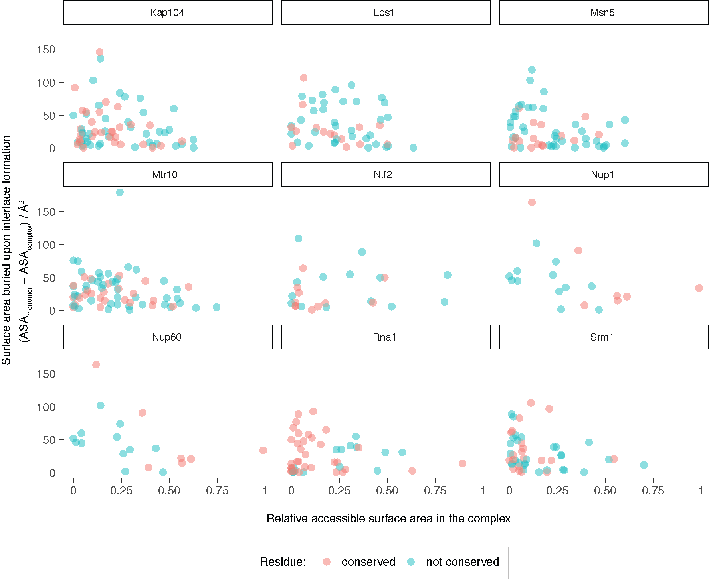

**Supplementary Figure 13** Conservation of interface residues where the X-ray crystal structure of the Gsp1 partner is from a species other than *S. cerevisiae*. Relative accessible surface are in the complex illustrates how buried the interface residue is. Interface rim residues have higher relative accessible surface area, than the interface core and support residues. Surface area that is buried upon complex formation (ASAmonomer - ASAcomplex) in Å2, shows how much absolute surface area an individual residue contributes to the interface. The few residues with the highest surface area buried upon complex formation comprise most of the core interface residues and contribute the most to the whole interface. All the interface buried residues that contribute the majority of the interface surface area in Rna1 GAP are completely conserved in sequence between *S. pombe* and *S. cerevisiae*.

Just show the alignment of the core interface residues between pombe and cerevisiae and human GAP.

2.) Comparable values to the human RAN/RANGAP1 pair from Klebe *et al*, Biochemistry (1995). They estimate the Km of 0.45 μM and kcat of 2.1 s-1 at 25˚C, while our values for the wild type *S. cerevisiae* Gsp1 and *S. pombe* GAP at 30˚C are Km of 0.4 μM and kcat of 8.9 s-1.

3.) Our conclusions are based on relative values between the mutants and the wild type, and we do not base any of the conclusions on the absolute values of the kinetic parameters.

Add discussion of pombe, perhaps add sequence alignment and highlight interface residues on GAP.

*Suppl. Tables 6-8*

*Please rearrange these tables such that the order of mutants listed is the same across all tables to make a comparison between them easier, ideally in ascending aa sequence.*

We agree with the reviewer about this suggestion. We originally ordered the mutants in these tables by the measured values, but relative ordering of the mutants by effects on the nucleotide exchange and hydrolysis is already clear from Fig. 3a-b, as well as Extended Data Figure 5. A reader would most likely used the Supplementary Data Tables for specific value lookup, for which an easy ordering of the mutants by residue number makes most sense. We have now changed the three tables accordingly.

Change mutant order.

- Suppl. Figs 2 and 3

The authors should show plots for GAP-mediated GTP hydrolysis and GEF-mediated nucleotide exchange for all their mutants.

STILL TO DO

Show all plots.

- Page 11, line 213:

Is anything known about PTMs modifying K101 in yeast? Are any proteomic data sets available that may allow the authors to comment on this?

Danielle is looking at our proteomics data for acetylation. We will decide how to proceed based on that result.

Look into proteomics data in yeast and add discussion on K101 PTMs (if anything known). There is data from Chuna’s lab!

Referee #2:

This manuscript by Kortemme, Krogan and coworkers addresses a very interesting question of how molecular switches regulate multiple processes. The authors use mutations as molecular perturbations to the input and output pathways of the switch and integrate systems level approaches with molecular and biophysical methods to tackle this problem. The conclusions are also exciting in that the switch cycle properties seem to tune the sensitivity of biological processes to this particular switch. Overall, the manuscript is written clearly and the authors have made a commendable effort to catalogue the methodology underlying the numerous methods they have used.

However, I have a number of major and minor reservations listed below that need to be addressed before the manuscript can be considered for publication.

Major questions:

1) The main conclusion from this work is a model for Gsp1 function, where different biological processes are sensitive to different aspects of the switching cycle, either cycling, GTP hydrolysis or nucleotide exchange (GDP to GTP). The authors ended up with this model starting with mutations to perturb various Gsp1-protein interaction interfaces. The power of this model is that it can now predict which processes will be affected if various parts of the cycle are tickled. However, this model has not been validated. The authors must now go the reverse direction, rationally design mutations to perturb the three aspects of the switch (cycling, activation and nucleotide exchange) and demonstrate that the model can successfully predict the effects of these mutations on downstream biological processes. Without this validation step, the predictive power of the model remains unclear and the manuscript remains one-sided.

Let’s try to craft a response that we can explain to the editor. We cannot rationally design kinetic effects of mutations, we don’t have an unbiased way of “predicting” / choosing mutations.

Could be problematic if reviewer insist. If so could pick mutants using the DSM data, confirm kinetics, and do E-MAP. Pain!

2) I have concerns listed below with the Michaelis-Menten data acquisition and analysis that need to be addressed because the enzyme data form a linchpin for the correlations and the eventual model generated in this paper.

a) As far as I could gather from the Methods section, the GAP-mediated GTP hydrolysis kcat and Km values have been obtained from data acquired at a single substrate concentration [S] >> Km (in contrast to GEF-mediated nucleotide exchange where 0.25 um - [S] >> Km have been used) and not by varying [S]. A single substrate concentration >> Km is insufficient to determine both kcat and Km reliably. At high [S], only kcat can be obtained since the velocity of the reaction becomes independent of Km. If the velocity is forcibly fit to kcat and Km, Km and kcat/Km values will be error-prone and this may explain why errors are larger in the GTP hydrolysis data than in GEF data (Extended data figure 5 panels a,b vs c,d). Since kcat/Km values are central to their conclusions, the authors must determine Km reliably using multiple [S] data.

In order to reliably determine the Km from a Michaelis-Menten curve based on the velocities for a range of concentrations we need to obtain the data for a range of concentrations from 10-fold below and 10-fold above the Km. As the Km for wild type Gsp1 is 0.4 μM, that would mean we would have to measure GTP hydrolysis when concentration of Gsp1 is 40 nM, which is unfortunately too low for the detection of the signal by the phosphate sensor.

Check if anyone else does kinetics with *pombe* and compare values.

We can emphasize that our kcat/Km are very reproducible.

Emphasize the relative relationship between kinetics for mutants – the conclusions are based on binning the mutants.

This would be a beautiful detailed kinetics study that would be valuable, and we share the love for kinetics.

Difficulty of these measurements in terms of small differences but nevertheless it is remarkable that they result in clear classification of the different processes.

2 points:

1) using curves in this way is a method that’s been used and has precedent (including GTPases)

2) for those

Option 1: Argue based on precedent for this analysis, plus we already know values are reasonable for wild-type.

Option 2: Validate approach for additional key mutants, ok if data agree, otherwise need more exp.

b) Interpretation: Enzyme kinetics data in Gsp1 must be interpreted with care because there are multiple steps involved in each reaction. The authors are referred to work on the Hsp70 chaperone system which is very similar to this switch in having ATP hydrolysis-enhancing factors (J-proteins) and nucleotide exchange factors (NEFs) facilitating the cycle. Careful enzyme kinetics work by the groups of Philip Christen, Roger McMacken, Bernd Bukau and others show that multiple steps must be considered in building a model (Hu, Mayer and Tomita, BiophysJ 2006). Some of the questions that authors need to consider are:

(i) How is the basal GTPase activity of Gsp1 taken into account? The authors have mentioned controls in the Methods. Equations used for correcting for the basal rate and equations used for fitting the data should be stated.

Describe in detail.

ii) What are the relative affinities of GDP and GTP for Gsp1? This is important, for example, in deciding how much excess GTP is needed in a nucleotide exchange experiment.

I think we can address this by adding suppl discussion because nucleotide affinities are so high, but should make sure we can confidently say it does not affect interpretation of kinetics. Also we have loading efficiency data.

(iii) Factors such as GAP and GEF may have residual affinities for the products of the enzyme reaction (GDP-Gsp1 and GTP-Gsp1 respectively). Are these numbers known to be negligible? If not, they have to be taken into account in determining 'kcat' and 'Km'.

Add suppl discussion.

(iv) Is there justification for using the Michaelis-Menten equations for these two reactions, instead of approximation-free A=B=C reaction kinetics? Is [ES] at a steady-state and very close to zero throughout the reaction?

Go through precedent in the literature. Perhaps could address with qualifying discussion on assumptions in the kinetics. Consult an expert… (Geeta?)

Overall, I would like to see a more careful analysis of the enzyme kinetics data in the context of the entire cycle.

3) Lines 183-186: "Taken together, the 31P NMR and kinetic data support a molecular mechanism whereby Gsp1 interface mutations allosterically shift the conformational distribution at the active site which in turn alters the GTPase switch cycle". This conclusion is too strong for the amount of data available to support it, though the data does indeed suggest such a possibility. Given that the allostery in Gsp1 is only an interesting side-story in this manuscript, the authors can tone down this conclusion.

The reviewer is wrong but toning down is easy.

a) The correlation in Fig. 3f looks much weaker when I plot the data without the log scale on the y-axis. It is equally likely to state from the plot that the y-ratio (without log) remains between 0.05 and 0.5 regardless of what the % of the second conformation is.

Make a not log plot!

Same answer, tone down.

b) While the 31P NMR data show that there are two conformations in slow exchange, they definitely don't indicate what the structural changes are between the two states and whether the conformational differences are local or global. For all we know, there may be two peaks because some sidechain is flipping in the vicinity, resulting in two peaks for 31P. Without data on other nuclei and strong correlations to structure across the entire protein, it is unwise to draw strong conclusions regarding the conformational exchange.

OK, tone down (but refer to other work on the conformations). Say reviewer is right that we do not know the structural details. But we do know effects are not just in the vicinity of the gamma phosphate as mutations are distal.

4) I find it difficult from the data to disentangle the effects of the mutations on the binding and on the cycle. A part of this problem is because the some of the mutations are directly at the interface of Srm1 and Rna1, which facilitate the cycle turnover. Secondly, I find the representation of AP-MS data in Fig. 2b/c very confusing. Particularly in Fig. 2b,

a) Why have only 6 prey proteins been quantified out of 16 whose interfaces were to be perturbed? How do we estimate how the interactions with the other 10 proteins have been affected?

Can try to address in discussion. For MS, the 6 are the ones we see. For the others, the reviewer is right, we don’t know. But most importantly, the interface locations of the mutations do not explain the GI data. Could replot that just for the 6 interfaces where we have MS data?

b) Kap95 has 7 core residues at the interface with Gsp1 from Ext. Data Fig. 1b (79, 80, 112, 143, 147, 154 and 157). In Fig. 2b for Kap95, I don't see 7 circles/half-circles of the same size. Has the classification of core residues changed?

Check this.

c) Again, for example, Kap95 seems to have approximately the same number of reds and blues. Pse1 has two reds and one blue. Srm1 has four bluish tinges and four reddish tinges. Excepting Yrb1, I don't find this evidence convincing for the statement that the introduced mutations perturb the interactions they were meant to perturb (lines 130 and 142 in the manuscript.

Check this and explain. We can apologize that we were confusing – the reviewer is right, the mutations sometimes perturb, sometimes not, and most of the time rewire. Can show the sina plots – abundance fold changes for mutations in and not in interfaces. For mutations in interfaces distribution expected (shifted to lower abundance). But when mutant not in interface then wide distribution.

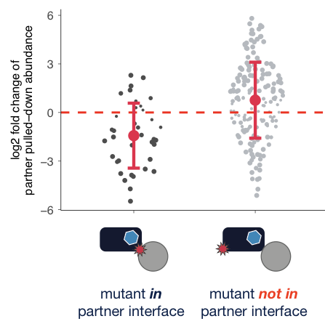

Overall, I am not convinced of the extent to which the mutations introduced in this work perturb the interfaces of the 16 interactors of Supplementary File 1 Table 1. The authors should purify the mutant Gsp1 proteins and measure their interactions with the partners whose interactions the mutations were meant to perturb, using robust biophysical methods such as ITC to settle this point.

Could try to argue but probably need to do at least some of these binding exp (as reviewer #3 also argues for them). Perhaps we can pick some strategic ones that would satisfy the 2 reviewers.

Minor changes:

1) It will help to put the function of the 16 proteins in Supplementary File 1 Table 1 as a separate column.

Yes, easy

2) Line 320, "highlighted in yellow": I was unable to locate the yellow colouring in Fig. 3c.

Fix

) Line 844 should read "run in parallel".

Fix

4) Numbers seem to be slightly off in line 155: R78K and T34Q are ~10-fold, but T34A is 6.3 and T34E is 3.7, hardly 10-fold.

fix

5) I find it very interesting that a cycling between two forms of a switch is necessary rather than one or the other conformation. A similar effect has been observed in a cis-trans molecular switch in the circadian clock (Partch and coworkers, Mol. Cell, 2017, 66:447). Perhaps the authors can comment on a possible mechanism of how cycle dynamics, rather end populations can impact downstream biological processes?

Cite that paper and add discussion. This is actually a deeper point that was also brought up by David after my talk in Seattle. Perhaps discuss the ultrasensitivity work more in this context.

We should go overboard about how this is a brilliant addition to our paper!

6) While reading the manuscript, I felt that the work was not sufficiently placed in perspective of what is known about the mode of operation of other molecular switches. A short paragraph on this may help the manuscript.

Ok add that.

Data presentation:

1) Fig. 2b/c is extremely confusing and took me a long time to interpret. They depict quantitative AP-MS data as semi-qualitative colours which do not help in making quantitative assessments.

a) Why are some half-circles missing their counterparts?

b) The meaning of circle size has changed between panels b and c. While this is indeed mentioned both on the plot and in the legend, it makes it very difficult to grasp the import of the figures.

c) In panel b, I found it very difficult to get a reliable estimate of circle size, which reports on the key DASA parameter, without actually using a ruler. Why has the core/rim classification of Ext. Data Fig. 1b changed though it portrays the same parameter? Consistency between these two figures will help.

Fig. 2b/c has to be reworked so that it is easier to understand the data. A simple histogram may work.

Rework 2b/c somehow.

Referee #3:

Perica et al. interrogate the small GTPase Gsp1 to identify the effects of directed point mutations, largely in interface regions. Through multiple assays, including genetic interaction, protein-protein interactions, NMR, and enzyme kinetics, they determine that mutations fall into three categories, affecting overall function, GTPase function, or GTP loading.

Unfortunately, despite starting the manuscript with 56 mutants, at the end, through multiple rounds of experimentation, the authors manage to describe the functional impact of mutating 11 sites in Gsp1. The core findings, that mutating 11 disparate sites in a GTPase affects its overall function and that many mutations affect function through allosteric regulation, are somewhat dissatisfying. Perhaps because of the systems-level scale of the analysis, there appears to be a lack of depth of understanding for any given mutation. For instance, how does T34Q (or any other amino acid substitution at the T34 position) lead to a strong change in GAP function?

Just because you lack depth of understanding, doesn’t mean we don’t provide it.

Points to address:

1. 2-9 replicates for Michaelis-Menten measurements? Why were there different numbers of replicates for some mutants compared to others?

We knew we needed to do some more.

2. Correlation plots for AP-MS experiments are disconcerting, as they show that, in many cases, the replicate pull-downs for a given mutant do not cluster together. For instance, the WT pulldown replicates do not cluster. Even more disconcerting is that the replicates for each mutant appear to have correlation values that are much less than 1.

Discuss with Danielle how to address.

From Danielle: My hypothesis here is that this is due to these all being mutants of the same protein. When we have different baits, yes we expect them to all be more different, but in APMS experiments, >95% of proteins identified are background proteins (i.e. not PPIs deterministic of a given mutant). With this, in mind when we analyze highly similar baits, such as a large set of mutants of the same bait, it would be expected imperfect clustering due to high similarity in the total peptide signature identified in each sample.

To the comment about correlations between replicates: Looks like generally we are in the .6-.8 range for correlations. It's not amazing, but also it's not terrible. Also, this correlation is done before any normalization procedure. We could also argue that APMS is an involved protocol (many washes etc.) that reduce reproducibility, but this might hurt the argument made above. Other ideas might be just to say, this is why we do rigorous statistical analysis, or point towards your other analysis with the functional separations and say, despite these less than ideal correlations, we still are able to extract data that separates the mutants accurately by function.

Maybe the point to emphasize: correlation is raw data. Confess the batch effects – because we so focused on biological replicates

Is there a way to illustrate that extracted high-confidence data is much more reliable.

Or some other way to assess the quality of raw data that is not correlations. Abundances?

3. Orthogonal validation experiments would strengthen the AP-Ms data. For instance, it should be fairly straightforward to perform co-IP western blots to demonstrate the loss of binding of SRM1 to T34A, as an example.

IPs. But the specific mutant asked about is tricky because effect may be too small for resolution of IP… Strategic mutants / partners and biophysics, as for reviewer #2?

4. p 11: The discussion of K101R and acetylation is speculative. The authors do not show that this lysine is acetylated in yeast.

Say clearly that speculative (perhaps there are some proteomics data on this, see also reviewer 1.)

5. The authors start with 56 mutants, but then drop to 22 mutants that ‘express and purify well’. What does this say about the other 34 mutants? Did they not express well? If so, then the GI and AP-MS data for these mutants should be removed.

Do you even have a biochemistry degree?! Let us explain to you a little thing called overexpression, as well as stability of small GTPases at 1-2 mM concentration when you add 10 mM EDTA for 3 hours at room temperature.

Explain. Refer to Westerns.

6. Similar note regarding the AP-MS experiments. 56 mutants were used for GI, but only 28 for AP-MS? The other 28, even if they were not in interface regions, should have been assessed for altered protein interactions, even as controls. Are the 22 mutants for enzyme kinetics a subset of the 28 mutants for AP-MS?

From Danielle: I am unaware of any PPI study doing this many mutants. Do you know of any?  We could do a bit more literature digging just to make sure, but I think that we could just state, that this is the largest PPI study of point mutations on a single protein, it is unrealistic for the review to request more, when we have already done more than anyone else. (We will write this in a more scholarly manner and back up with flashy papers that have much much fewer mutants)

Discuss scope with editor. AP-MS does not matter for main conclusion. We may not get away with it but perhaps Nevan can make the point.

7. Were only 13 of the mutants used for NMR?

How many NMR datasets have you collected for the paper that got you this job?

I think we can argue here, as the NMR mutants span the entire range so we could not learn more if doing more.

8. In Supp. Tables 6-8 the authors include std. dev. and std. error values. Often these values are of similar magnitude to the measured value, indicating that the confidence in the measured value is low. Yet it seems that these measured values were still used in the main figures, with no indication of the error. Some indication of significance should be assigned to these figures.

Explain more (editor wants to consult additional “stats” reviewer). Probably there are only a few high-error values and some / most of those may go down with additional GAP assays (?)