Dear Angela,

We have now addressed all reviewers’ comments in detail and would like to discuss our revisions with you. ADD POSITIVE COMMENTS OF rev 1 & 2 To us the most important review comments concerned the kinetic measurements and analysis, as these are central to our conclusion that different biological processes sense the kinetics of GTPase switching differentially, providing a novel link between systems-level functional genetics and biophysics. We found these review comments very helpful. We have added additional experiments and have consulted on the analysis with an expert on GTPase enzymology, David Lambright, who is now included as an author on the manuscript.

In addition to these experiments, the reviewers suggested:

- Clarification of the AP-MS data, which we have done (see substantial changes to the representation and interpretation, especially in Fig. 2). We hope that the new analysis now shows more clearly that, while the AP-MS data confirm that many of the mutations affect the targeted interactions, many other interactions are also changed in the cellular context when other interaction partners are present. Most importantly, the effects of mutations on individual targeted interfaces do not explain the genetic interaction data (Fig. XX). We therefore think that the results of additional in vitro binding experiments of the effects of mutants on specific individual interactions, as suggested by reviewer 2, are unlikely to alter our main conclusions. It would of course be an interesting future study to quantify the effect of all our mutation on each of the individual 16 Gsp1 binding partners with complex structures (but it would be a study focused on structural aspects of molecular recognition that would be quite different from our current manuscript).

- Study of additional mutants. DEEP VERSUS WIDE We have probed the functional effects of XX surface sites on Gsp1 with point mutations and quantitative genetic interactions (>80,000 genetic interaction measurements), and followed up on many of these mutants with proteomics, kinetics, and NMR. While this work is rather extensive in scope (we are not aware of another study that applies these systems-level and biophysical techniques on such a large set of point mutations), additional mutants could of course be interesting to study. However, we would like to note that our mutants already span a considerable range of behaviors. For example, the NMR data show that our mutants cover the entire range of the 2-state equilibrium we observe, from essentially 100% in state 1 for some mutants to essentially 100% in state 2 for others mutants, and yet other mutants with behaviors between the two extremes. Similarly, we see a considerable range of changes in kinetic parameters that we ultimately group unto three classes of behaviors (XXX). We therefore feel that additional mutants would be unlikely to uncover new classes of behaviors.

We would very much like to get your perspective on these points. Below we also include our detailed point-by-point response to all reviewer comments with corresponding changes in the manuscript in response to all points raised.

With many thanks in advance for your consideration,

Nevan Krogan & Tanja Kortemme

We first summarize our changes in response to what we saw as three general points raised by one of more of the reviewers. After this summary, we list the point-by-point responses to individual comments by each of the reviewers.

LEGEND:

*Referee comments are in italic, with specific suggestions underlined.*

Our responses to the referees are in black.

Text from the manuscript is in green, with changes in blue

**GENERAL POINT 1: Interpretation of kinetics data.**

Reviewer 2 had a series of questions about our kinetics data, and we hope we have provided satisfactory responses to each of the individual points in our detailed responses below. We would like to thank the reviewer for raising these points, which have prompted us to do additional experiments (Fig. XXX, Table XXX). We have also included additional more detailed analyses (XXX), for which we have consulted with an expert on GTPase enzymology, David Lambright, who is now included as an author on the manuscript. Specifically, to address the reviewer’s point of “*a more careful analysis of the enzyme kinetics data in the context of the entire cycle*”, we have added a discussion of assumptions when using the estimated Michaelis-Menten parameters to describe the kinetics of the GTPase cycle (Supplemental Discussion) and a section explaining that our conclusions are not dependent on the detailed individual steps of GTP hydrolysis and nucleotide exchange (XXX). Rather, we follow the established formalism by Wittinghofer and colleagues [REF], and show that grouping the kinetic behavior of our mutants into three classes explains the observed genetically interaction data for a phenotypically diverse set of point mutants (Fig. XXX). While we agree that the individual steps of each reaction, such as XXX, could be relevant, distinguishing these detailed effects at the level of cellular phenotypes is likely beyond the current precision of the systems-level data. We therefore believe a classification into kinetic groups independent of detailed differences provides a more robust interpretation of the data. We hope that this overarching point will be helpful when considering our point-by-point responses to the questions about our kinetics data.

**GENERAL POINT 2: Representation and interpretation of the AP-MS data.** The questions raised by reviewers #2 and #3 highlighted that our representation and interpretation of the AP-MS data was not clear. In particular, we did not intend to imply that the AP-MS data show that *all* the targeted interactions were affected as predicted, nor that these effects explain the functional data. Instead, one of our main observations is that the effects of the point mutants on biological functions *cannot* be explained by the position of the mutations in each individual targeted interface. Notably, the AP-MS data suggest a rather extensive changes of many physical interactions in the cellular context. We therefore think that pairwise affinity measurements *in vitro* of selected individual complexes would be unlikely to better explain the functional data. We apologize that our previous representation of the AP-MA data was unclear, and hope that our revisions help clarify. We have reworked the figures and text referring to the AP-MS data. We now highlight that: (i) Overall many (but not all) of the mutations affect the targeted interactions based on complex structures (new Fig. 2a, left distribution), and the AP-MS data also indicate rather widespread rewiring of physical protein-protein interactions (new Fig. 2a, right distribution). (ii) Importantly, the functional consequences of the mutations seen in the E-MAP data are better explained by changes in kinetic parameters (new Fig. 4b,c,d) than effects directly perturbing the targeted physical interaction interfaces (Fig. 1g).

We revised the main text, Figure 2, and Extended Data Figure 5 as follows:

**Physical interactions of Gsp1 mutants.**

To investigate further why the GI profiles of Gsp1 mutations did not group based on targeted specific physical interactions of Gsp1, we sought to determine how the physical interaction network of Gsp1 changes in response to the interface point mutations. We tagged wild-type Gsp1 and 28 mutants covering all interface residues shown in **Fig. 1e** with an amino- or carboxy-terminal 3xFLAG tag and quantified the abundance of 316 high confidence ‘prey’ partner proteins in complex with Gsp1 by AP-MS (**Fig. 2a**, **Extended Data Fig. 4**, **Supplementary File 4**). We refer to the prey partner protein abundance in the pulled-down Gsp1 complexes simply as “abundance” below. From our AP-MS data, we could quantify the abundance changes of the two core regulators Rna1 (GAP) and Srm1 (GEF), as well as four effectors Yrb1, Kap95, Pse1 and Srp1. Although, on average, when the Gsp1 mutation was in the interface core with the prey partner the abundance of the prey partner was decreased, we could also see notable changes in prey abundance in cases where the mutation was not directly in the interface (**Fig. 2b, Extended Data Fig. 5b**). We also observed a wide spread of abundance for the main regulators, GAP (Rna1) and GEF (Srm1), even for the mutations that are outside either of the interfaces (**Fig. 2c**, **Extended Data Fig. 5**, **Supplementary File 1 Table 5**). For example, mutations at the position 34, which is in the core of the interface with Yrb1, increase the levels of pulled-down GEF, and decrease the levels of pulled-down GAP, even though the residue is outside either of the interfaces (**Fig. 2c-d**). In summary, the AP-MS experiments confirm that the point mutations, in addition to affecting the targeted interactions also introduce extensive changes to the physical interaction network of Gsp1 that cannot simply be explained by the interface location of the mutations.

**GENERAL POINT 3: Study of additional mutations.**

Reviewers 2 and 3 suggested expanding our study with additional mutations, and collecting all experiments (functional genomics, proteomics, kinetics, NMR) on all mutants. Additional mutants could of course be interesting to study. We would like to note that our mutants already span a considerable range of behaviors. For example, the NMR data show that our mutants cover the entire range of the 2-state equilibrium we observe, from essentially 100% in state 1 for some mutants to essentially 100% in state 2 for others mutants, and yet other mutants with behaviors between the two extremes. Similarly, we see a considerable range of changes in kinetic parameters that we ultimately group unto three classes of behaviors (Fig. 4,c,d). We therefore feel that additional mutants would be unlikely to uncover new classes of behaviors.

**Point by point replies to reviewers**

**Referee #1:**

*In their manuscript, Perica and colleagues describe a detailed system-wide genetic, cellular and biophysical analysis of a molecular switch protein in order to analyse the molecular mechanism by which these central regulators of signal transduction differentially affect multiple biological functions. To carry out this work the authors focused on the small GTPase Ran/Gsp1, which is a very good choice as its activity is modulated by one main GEF and one main GAP, but forms protein-protein interactions with many different binding partners. High resolution crystal structures for 16 of such complexes are available, which allowed the authors to carry out a detailed analysis of the protein interfaces involved and design 56 point mutations that would likely interfere with a given interaction, and allow analysis of their functional significance on the biological processes regulated by Gsp1.*

*Making use of the genetic power of yeast the authors carry out a careful genetic interaction screen of the mutations selected, followed by mapping the physical interactions of the mutants by AP-MS. The AP-MS experiments indicated that many mutations had significant effects on the interaction with GAP and GEF proteins, which prompted the authors to quantify the effect of the mutations on GAP-mediated GTP hydrolysis and GEF-mediated nucleotide exchange, followed by NMR analysis of the effect of mutations on the conformational behaviour of active site residues with respect to GTP status.*

*This is a well-executed, exciting and insightful study that makes a fundamental contribution to our understanding of protein interaction networks and how a single switch protein can independently regulate multiple cellular processes. A key, and unexpected finding, of this study is the observation that the GI profiles did not group according to their location on the Gsp1 surface and binding partner interfaces, and hence that functional specificity is not determined solely by interaction with a given binding partner. Instead, the data show that the kinetic parameters of the GTPase cycle of Gsp1 are allosterically regulated by distal interface mutations. This leads the authors to suggest that the effect of a mutation on a biological process depends on its sensitivity to different properties of the GTPase cycle. This is an appealing and novel concept that will attract a lot of attention. The discovery of novel allosteric sites in a GTPase is particularly interesting given the link of mutations to disease and efforts to target their activity therapeutically.*

*Specific points:*

*- Ext. Data Fig. 2*

*Some mutants show quite a lot of variation between replicates and differ up to 6-fold from WT. Is this really close to WT expression? How may this effect the genetic interaction profiles?*

We thank the reviewer for raising this important point. There are indeed 2 outlier data points in our Western blot data (one for K154M and one for R108G) that deviate 6-fold from the mean WT expression (but also from other replicates for these mutants). To address the key point whether potential variations in expression level affect the functional profiles from genetic interactions, we added an additional analysis and panel to the Extended Data Figure 2. Panel c now shows more explicitly that the variation in expression levels is not predictive of the differences between the mutants with strong and weak genetic interaction profiles (the distributions of relative expression levels of weak and strong mutants are essentially indistinguishable).

However, expression level differences could contribute to the functional effects we observe at least for some mutants, and

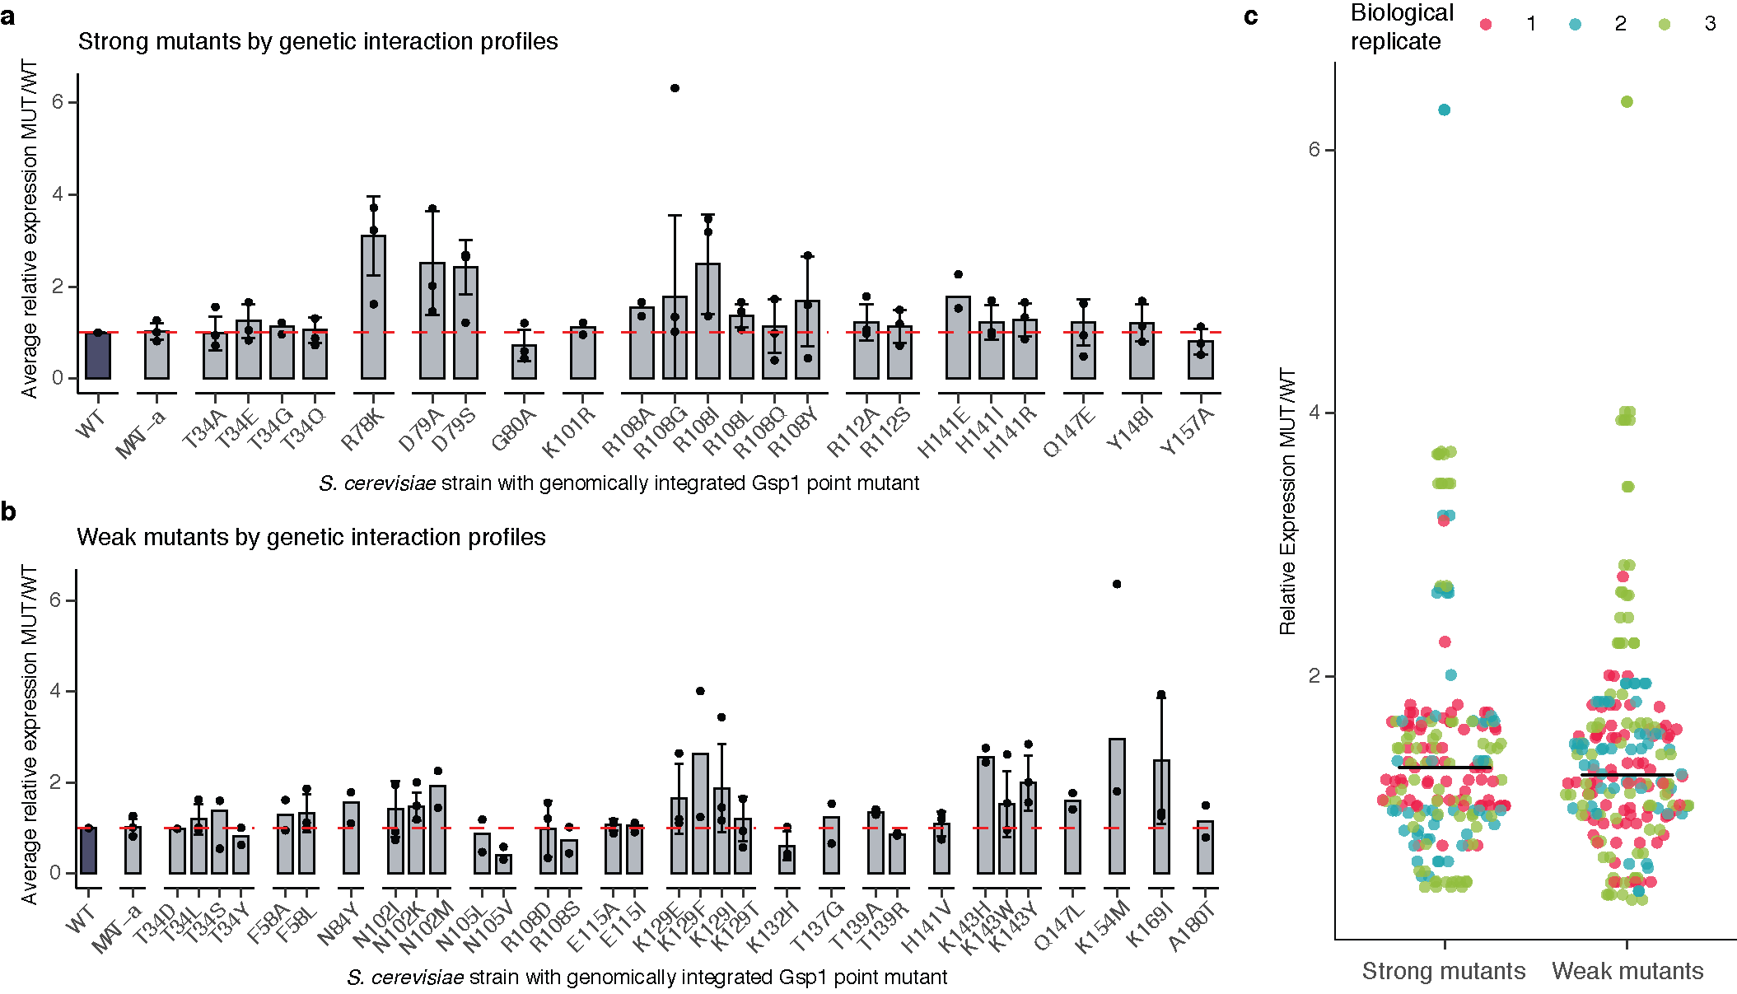

**Extended Data Figure 2. Expression levels of endogenously expressed Gsp1 protein in *S. cerevisiae* strains with genomically integrated Gsp1 point mutations profiled by Western Blot.** Expression levels are relative to the expression levels of wild-type Gsp1 protein. **a,** Expression data for strong mutants, defined as mutants with more than nine significant GIs. **b,** Expression data for weak mutants, defined as mutants with fewer than nine significant GIs. Bar heights indicate averages over 2 or more biological replicates (n) with error bars indicating one standard deviation for n >= 3. Overlaid points indicate individual biological replicates (each an average over at least 12 technical replicates per biological replicate for wild-type and MAT-α strains, and between one and six technical replicates per biological replicate for mutant strains). Dashed red line indicates expression at the level of wild-type Gsp1 (fold change of 1). **c,** Distributions of average relative expression changes for strong mutants and weak mutants, colored by biological replicate. All strains in a replicate were grown in parallel. Each point indicates an average over several technical replicates, as in **a** and **b**. Bars indicated the mean of the point distributions.

*- The authors present an enormous amount of data in this manuscript, which has resulted in some of the figures being overloaded and difficult to follow. I understand that there are restrictions to the number of figures in the main text, and hence the authors have tried to include a lot of subpanels. However, this has resulted in some of the figures not being as easy to interpret as they should be. This is particularly relevant to the figures depicting protein structures. They are crucial to the manuscript as they visualise some of the key messages of this story. Hence the authors should rethink how to illustrate these points and at least add additional structure figures to Supplementary.*

*Examples:*

*- The structures shown in Fig. 1c are not sufficient to allow the reader to fully understand the special relationship of the different protein surfaces mutated and their importance in the interaction with binding partners. The authors should consider showing a surface representation in addition in which the different protein interfaces are highlighted, maybe coloured according to the number of times they have been detected in protein-protein interactions.*

We agree and have made two changes: First, we now indicate interface location of the mutated residues in Fig. 1c. Second, we added a new Extended Data Fig. 1a that shows the GTPase in the same orientation as in the main text Fig. 1c and highlights each interface with the Cα atoms of mutated residues in sphere representation colored by the different interfaces. (We have moved the original Extended Data Fig. 1a showing the complex structures to the Supplementary File 1 Figure 1).

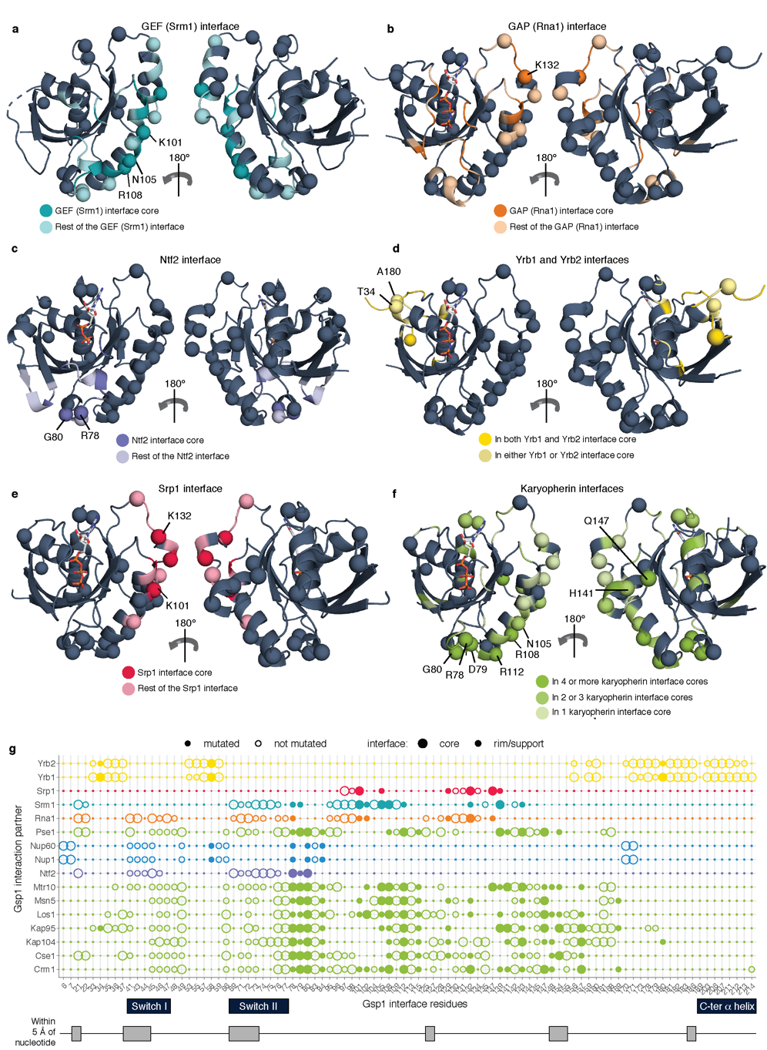

Extended Data Figure 1 **Extended Data Figure 1 Design of interface point mutations in *S. cerevisiae* Gsp1.** **a-f,** Structures of Ran/Gsp1 in the GTP-bound (marine, PDB ID: 1ibr) and GDP-bound (gray, PDB ID: 3gj0) states. Mutated Gsp1 residues are shown as spheres. Interface residues are coloured by the type of partner protein: **a,** Srm1 (GEF) interface core (dark teal) and interface rim and support (light teal); **b,** Rna1 (GAP) interface core (dark orange) and interface rim and support (light orange); **c,** Ntf2 interface core (dark purple) and interface rim and support (light purple); **d,** Residues that are in both the core of the Yrb1 and Yrb2 interfaces (dark yellow), and in only one of the two interfaces (light yellow); **e,** Srp1 interface core (dark pink) and interface rim and support (light pink); f, Residues that are in the core of more than four (dark green), two to three (green) and one (light green) karyopherin interface. Karyopherins are: Kap95, Crm1, Los1, Kap104, Msn5, Cse1, Mtr10. **g,** Location of Gsp1 residues in partner interfaces. Interface positions (core, rim/support) were defined by the difference in relative surface accessible surface area (ΔrASA) between monomer and complex, as previously described (Levy, 2010) (**Supplementary File 1 Table 2**). Residues within 5 Å of the nucleotide, in the canonical P-loop, or in the switch I or II regions are indicated and were not mutated. Chosen Gsp1 point mutation substitutions are provided in **Supplementary File 1 Table 3**.

*- Similarly, the structures shown in Fig. 2d-f are not intuitive and don’t sufficiently convey the message. It may help to add figures with Gsp1 in a surface representation with the position of the different residues described indicated.*

Since all three reviewers indicated that our original version of Fig. 2 was unclear, we have now reworked Fig. 2 and the accompanying text section (see also response to reviewer XX comment YY). We hope that the new representations in Fig. 2 now more clearly highlight the positions of the described residues.

*Minor points*

*- Suppl. Table 2 and Ext. Data Fig. 1:*

*Please provide the definition for rim and support.*

We thank the reviewer for pointing out this omission and have now added these definitions to the Methods section (as described in Levy, JMB, 2012): In brief, the three types of interface residues were defined as: SUPPORT residues have a ΔrASA > 0 & rASAmonomer < 25%, RIM residues have a ΔrASA > 0 & rASAcomplex > 25%, and CORE residues have ΔrASA > 0 & rASAm > 25% & rASAcomplex < 25%.

*- Page 46*

*The authors use the S. pombe homologue of the Gsp1 GAP Rna1 for their kinetic experiments as the S. cerevisiae homologue forms soluble aggregates. They should provide a brief comment on how they think this may (or may not) affect the kinetic parameters determined.*

While we cannot exclude slight differences between the kinetic parameters of *S. pombe* and *S. cerevisiae* GAP Rna1, we do not believe these differences would significantly affect our conclusions, for two main reasons: First, while there are sequence differences in between the *S. pombe* and *S. cerevisiae* GAP Rna1, residues in the interface with Gsp1 are highly conserved, suggesting that mechanism of catalysis and kinetic parameters are also likely to be similar. Second, we rely only on the relative differences between GAP kinetic parameters between different Gsp1 mutants to group our mutants into three classes. Even in the case of differences between the absolute kinetic parameters between the *S. pombe* and *S. cerevisiae* GAP Rna1, the order of mutants is less likely to be different, and even in the case of some differences, we expect the grouping to be robust to these changes. We have added a brief comment in the main manuscript, and a more detailed discussion in the Supplement, including a sequence alignment between *S. cerevisiae*, *S. pombe* and human GAP (Supplementary File 1 Fig. 14).

Main manuscript, page XXX:

**Supplementary Figure 1 Multiple sequence alignment between Rna1 from *S. cerevisiae* (Rna1_yeast) and *S. pombe* (Rna1_Schpo), as well as human RanGAP (RAGP1_human).** Interface core residues (based on the X-ray crystal structure between Rna1_Schpo and mammalian RAN, PDB ID: 1k5d) are highlighted in orange. All residues except Pro108 in Rna1_Schpo, which corresponds to Leu122 in Rna_yeast are conserved in sequence between *S. cerevisiae* and *S. pombe* Rna1.

Supplementary File 1 Supplementary Discussion section:

**Potential caveats using the GAP (Rna1) from *S. pombe.***

All of our GAP-mediated GTP hydrolysis kinetics experiments used the wild type and mutant Gsp1 from *S. cerevisiae*, but Rna1 GAP from *S. pombe*. We chose to use the Rna1 ortholog from *S. pombe* as *S. cerevisiae* Rna1 formed soluble aggregates after purification, and *S. pombe* Rna1 was the only RanGAP for which there was a structure in complex with Ran (PDB IDs: 1k5d and 1k5g).

While there could be slight differences between the kinetic parameters of *S. pombe* and *S. cerevisiae* GAP Rna1 acting on Gsp1, we do not believe these differences would significantly affect our conclusions, based on the following considerations:

1.) **Sequence conservation between *S. cerevisiae* and *S. pombe* Rna1.** A sequence alignment between *S. cerevisiae* *S. pombe* and human GAP proteins shows that all but one interface core residue in the PDB file 1k5d is absolutely conserved in sequence between *S. cerevisiae* and *S. pombe* (**Supplementary File 1 Supplementary Fig. 14**). Overall, out of the 1290 Å2 buried by *S. pombe* Rna1 upon interface formation with Ran/Gsp1 (PDB ID: 1k5d), 997 Å2 (77%)is buried by residues that are perfectly conserved in sequence between *S. pombe* and *S. cerevisiae*, and the sequence identity of the Rna1 interface with Ran/Gsp1 overall is 71% (Supplementary File 1 Table 1).

2.) **Comparable kinetic values to the human RAN/RANGAP1 pair.** The kinetic values for our *S. cerevisiae* Gsp1 and *S. pombe* Rna1 GAP are comparable to the kinetic values for the human RAN and human RANGAP1 reported by Klebe *et al.*1. They estimate the Km of 0.45 μM and kcat of 2.1 s-1 for RAN/RANGAP1 at 25˚C, while our values for the wild type *S. cerevisiae* Gsp1 and *S. pombe* Rna1 at 30˚C are Km of 0.4 μM and kcat of 8.9 s-1. In addition, it was shown that Rna1 from *S. pombe* can activate the hydrolysis in both human and *S. cerevisiae* Ran/Gsp1 (Becker et al, 1995).

3.) **Our conclusions are based on relative values between the wild-type Gsp1 and its point mutants.**

Although we report the absolute values of the kinetic parameters, when we compare the kinetic parameters with the results from genetic interaction profiles or AP-MS, we always use the relative parameters as compared to the wild type. Based on the sequence conservation and comparable kinetics described above, we expect the relative ordering of mutants to be similar as well. Importantly, we use the relative kinetic data to group our mutants into three classes. Even in the case of small quantitative differences caused by using the *S. pombe* instead of the *S. cerevisae* Rna1 GAP, we make the assumption that these differences would not significantly affect this grouping.

*Suppl. Tables 6-8*

*Please rearrange these tables such that the order of mutants listed is the same across all tables to make a comparison between them easier, ideally in ascending aa sequence.*

We have changed the three tables accordingly.

*- Suppl. Figs 2 and 3*

*The authors should show plots for GAP-mediated GTP hydrolysis and GEF-mediated nucleotide exchange for all their mutants.*

We now show plots for all mutants in the Supplementary File 1 Figures 3 and 4.

*- Page 11, line 213:*

*Is anything known about PTMs modifying K101 in yeast? Are any proteomic data sets available that may allow the authors to comment on this?*

We would like to thank Reviewer 1 and Reviewer 3 for raising this point. Initially we cited the work showing the corresponding residue, K99, is acetylated in human RAN (Choudhary, C. *et al.*, 2009), as well as that the acetylation of human Ran at the K99 position (corresponding to position K101 in Gsp1) perturbs GEF-mediated nucleotide exchange of human RAN *in vitro* (de Boor, S. *et al,* 2015). We should have also cited work by C. Choudhary and colleagues that shows K101 is also acetylated in *S. cerevisiae* (Henriksen et al, Mol Cell Proteomics, 2012). We have now cited the Henriksen et al paper and changed the text accordingly.

The modified section in the main text now reads:

A clear outlier of this ordering is the K101R mutant, which primarily affects GEF-mediated nucleotide exchange *in vitro* but, by GI profiles, groups with mutations affecting the efficiency of GTP hydrolysis. The lysine at this position was found to be acetylated in both *S. cerevisiae* (Henriksen, 2012) and human cells (Choudhary, 2009). The acetylation at this position in human RAN was shown to reduce the efficiency of nucleotide release from the RAN:GDP:GEF complex (de Boor, 2015). We hypothesize that while our K101R mutation affected the interaction with the GEF, it also likely broke a critical mechanism by which the cell reduces GEF activity, phenocopying the mutants with reduced GTP hydrolysis activity. This observation suggests the possibility that the allosteric sites discovered here might be used to control cellular functions *via* posttranslational modifications.

REFERENCES

Choudhary, C. *et al.* Lysine acetylation targets protein complexes and co-regulates major cellular functions. *Science* **325,** 834–840 (2009).

de Boor, S. *et al.* Small GTP-binding protein Ran is regulated by posttranslational lysine acetylation. *Proceedings of the National Academy of Sciences* **112,** E3679–88 (2015).

Henriksen, P. *et al.* Proteome-wide Analysis of Lysine Acetylation Suggests its Broad Regulatory Scope in Saccharomyces cerevisiae. *Mol. Cell Proteomics* **11,** 1510–1522 (2012).

*Referee #2:*

*This manuscript by Kortemme, Krogan and coworkers addresses a very interesting question of how molecular switches regulate multiple processes. The authors use mutations as molecular perturbations to the input and output pathways of the switch and integrate systems level approaches with molecular and biophysical methods to tackle this problem. The conclusions are also exciting in that the switch cycle properties seem to tune the sensitivity of biological processes to this particular switch. Overall, the manuscript is written clearly and the authors have made a commendable effort to catalogue the methodology underlying the numerous methods they have used.*

*However, I have a number of major and minor reservations listed below that need to be addressed before the manuscript can be considered for publication.*

*Major questions:*

*1) The main conclusion from this work is a model for Gsp1 function, where different biological processes are sensitive to different aspects of the switching cycle, either cycling, GTP hydrolysis or nucleotide exchange (GDP to GTP). The authors ended up with this model starting with mutations to perturb various Gsp1-protein interaction interfaces. The power of this model is that it can now predict which processes will be affected if various parts of the cycle are tickled. However, this model has not been validated. The authors must now go the reverse direction, rationally design mutations to perturb the three aspects of the switch (cycling, activation and nucleotide exchange) and demonstrate that the model can successfully predict the effects of these mutations on downstream biological processes. Without this validation step, the predictive power of the model remains unclear and the manuscript remains one-sided.*

We agree with the reviewer that it would be desirable to support our model with additional experiments and mutations, ideally even probing all residues of Gsp1. However, there are several considerations that ultimately lead us to conclude that new insights might be limited by simply adding more attempted mutations, and that tests of the model would best be done using additional orthogonal approaches (which, to do rigorously, would require a new study of similar scope to our current manuscript). Below we outline our reasoning which we hope is agreeable:

1. First, because of the considerable and unexpected allostery we uncovered in Gsp1, is beyond current structural modeling methods to predict mutations that will differentially perturb the different aspects of the GTPase switching cycle with notable success. It would thus be difficult to *rationally* design mutations that would affect specific ratios of the kinetics of switching and in turn specific functional consequences. We thus **do not** propose that we can predict the effects of point mutations of Gsp1 on cellular phenotype. We apologize if this was misleading and we have changed in the manuscript XXX.
2. There are of course known mutations in GTPases with drastic effects on the switching cycle, such as the Q->L mutation in switch II that impairs intrinsic and GAP-catalyzed hydrolysis, and the fast cycling F->A mutation in switch I that decreases nucleotide affinity, increases the intrinsic rate of nucleotide release and bypasses the requirement for activation by GEFs. We have not tested such drastic mutations in our system because they are likely to not be viable as we made all our mutations in the *S. cerevisiae* genomic copy of Gsp1 (for example, we attempted to make some mutations in the P loop, switch I or switch I (Supplementary File 1 Table 3) but none of them were viable). However, effects of these mutations in overexpression / protein injection assays are broadly consistent with our conclusions. CAN YOU ADD LIT EXAMPLES. We added the following text to our MS: XXX
3. We could attempt to find additional mutations with milder effects that are viable, but because of the difficulty in predicting kinetic behavior mentioned above, this effort would necessarily require trial-and-error, designing a range of new mutants, test both the kinetics parameters of those mutants *in vitro*, as well as measure their effects on the phenotype by performing E-MAP screens. Because our mutants already have a considerable range of kinetic parameters and span the range of the conformational equilibrium observable by our NMR experiment, we are not sure we would uncover fundamentally new behaviors observable by the current assays. While it is of course hard to argue against more data that would support our findings, we already include a considerable number of mutations in our current rather extensive study, and new mutants would add significant time and expense of genetic interactions, AP-MS, individual kinetics and NMR, perhaps yielding limited new insights.
4. Finally, a study that could address the Reviewer’s point and would test our model with a different approach would be to specifically perturb the kinetics of the GTPase cycle by perturbing the GAP or the GEF directly and compare those phenotypes to the phenotypes of the Gsp1 cycle mutants. However, the tools and constructs for such systematic perturbations are not established, and we think their development, rigorous characterization and application would be an entire new study.

*2) I have concerns listed below with the Michaelis-Menten data acquisition and analysis that need to be addressed because the enzyme data form a linchpin for the correlations and the eventual model generated in this paper.*

*a) As far as I could gather from the Methods section, the GAP-mediated GTP hydrolysis kcat and Km values have been obtained from data acquired at a single substrate concentration [S] >> Km (in contrast to GEF-mediated nucleotide exchange where 0.25 um - [S] >> Km have been used) and not by varying [S]. A single substrate concentration >> Km is insufficient to determine both kcat and Km reliably. At high [S], only kcat can be obtained since the velocity of the reaction becomes independent of Km. If the velocity is forcibly fit to kcat and Km, Km and kcat/Km values will be error-prone and this may explain why errors are larger in the GTP hydrolysis data than in GEF data (Extended data figure 5 panels a,b vs c,d). Since kcat/Km values are central to their conclusions, the authors must determine Km reliably using multiple [S] data.*

Instead of using a standard Michaelis-Menten approach, as used for the GEF data, we determined the kcat and Km parameters for the GAP-mediated hydrolysis by fitting the ***integrated*** Michaelis-Menten equation to the ***full*** reaction progress curve, which was continuously monitored from [S] >> Km at the initial time point to [S] << Km at the final time point as discussed below. However, the error bars were higher for the GAP than the GEF experiments for different reasons. First, in the initial manuscript we reported standard errors (std.dev/sqrt(n)) for the GEF data and standard deviations for the GAP data. In addition, we overestimated the standard deviations of the kcat/Km by treating the kcat and Km values as independent observations, which is not the case since they are simultaneously-determined from an analysis of the same experimental data set. The correct approach, which does not assume independence of the kcat and Km values, is to estimate the error for the mean kcat/Km directly from the variation in individual kcat/Km values between data sets. We now report correctly calculated standard errors and numbers of replicates for both the GAP and the GEF experiments. In addition, we now added more replicates of GAP-mediated GTP hydrolysis for the mutants that had high error bars, resulting in parameter values in which we are now more confident (Fig. 3a Extended Data Fig. 6, as well as individual curves in Supplementary File 1 Fig. 3).

In the following, we want to address the reviewer’s comment that kcat and Km cannot be reliably determined from data acquired at a single substrate concentration in more detail. First, we want to explain our reasons for using the integrated Michaelis-Menten formalism, followed by a general discussion about the accuracy of the method.

**1. Comparison of GEF and GAP assays and motivation for using integrated Michaelis-Menten equation to estimate the kinetic parameters of GTP hydrolysis**

A general difficulty with our measurements of both GAP and GEF GTPase kinetics of RAN/Gsp1 is the low Km and high kcat values compared to the *in vitro* measured values of other small GTPases and their GAPs and GEFs and the relatively weak biochemical effects of mutations that are viable in yeast.

For the GEF assay we were able to obtain very reproducible measurements between biological replicates by avoiding the nucleotide loading step and instead measuring the decrease in tryptophan fluorescence due to tryptophan to mant-group FRET after GEF-mediated exchange (as described in Klebe *et al*. Biochemistry, 1995a).

Using intrinsic tryptophan fluorescence can in principle be used to measure GTP hydrolysis, as was used initially by Klebe *et al*, Biochemistry, 1995a, but the small change of fluorescence (10%, compared to 40% upon to tryptophan to mant FRET) is not compatible with a plate reader measurement, which was necessary for our relatively large number of samples (for the GEF assay, we measured more than 1000 nucleotide exchange curves). For that reason, we decided to use a more recently established protocol that uses a phosphate sensor (Mishra and Lambright, 2015), shown to work for GAP hydrolysis measurements for RAB GTPases, as well as more recently for RAS in Bandaru *et al*, 2017.

We confirmed for wild-type Gsp1 that the values of kinetic parameters we obtained using a phosphate sensor were similar to those estimated by Klebe *et al* using intrinsic tryptophan fluorescence. Their values were a Km of 0.45 μM and kcat of 2.1 s-1 at 25˚C for mammalian RAN hydrolysis activated by *S. pombe* GAP, while our values for wild type *S. cerevisiae* Gsp1 and *S. pombe* GAP at 30˚C are Km of 0.4 μM and kcat of 8.9 s-1.

For the GEF-mediated exchange reaction, the Km values were high enough for us to obtain the Km and kcat by fitting the data for a range of Gsp1 concentrations to the standard exponential form of the Michaelis-Menten equation. However, as the Km for the GAP-mediated hydrolysis for many of the Gsp1 variants was rather low (0.1-0.4 μM), to obtain the kcat and the Km from the fitting the data for a range of Gsp1:GTP concentrations would require measuring GTP hydrolysis at Gsp1:GTP concentrations of <50 nM, which is too low for a reliable measurement of fluorescence signal increase by the phosphate sensor. We thus used the integrated Michaelis-Menten equation as explained below.

**2. Estimating the kcat and Km parameters of GAP-mediated hydrolysis using an accurate solution to the integrated Michaelis-Menten equation.**

Others (e.g. Goudar et al, 1999) have shown that both kcat and Km can be estimated with reasonable accuracy/precision from a single ***initial*** [S] >> Km by directly analyzing the ***full*** reaction progress curve with an analytical solution of the ***integrated*** Michaelis-Menten equation based on the Lambert ω function. This analysis is possible because the full reaction progress curve is characterized by an initial linear phase for [S] >> Km, a final exponential phase for [S], and a transition phase for [S] ~ Km. Whereas kcat is proportional to the slope of the initial linear phase (i.e. the initial velocity), Km is sensitive to the shape of the progress curve, which will have an extended linear phase if Km << initial [S] or no linear phase if Km >> initial [S]. Analyzing the full reaction progress curve with the integrated Michaelis-Menten equation differs fundamentally from traditional enzyme kinetic analysis of initial velocities for which case, as the reviewer correctly notes, the value of Km cannot be determined from a single initial [S] >> Km.

Use of the integrated Michaelis-Menten analysis requires the experiment to be set up with the following conditions: (i) [Gsp1:GTP0] >> Km, (ii) [GAP0] <<< [Gsp1:GTP0], and (iii) the reaction time course F(t) is measured to completion (i.e. until it approached equilibrium). Our experiments were all set up to fulfill those conditions, which means that the F(t) sampled a concentration range from [Gsp1:GTP] (at t = 0) >> Km to [Gsp1:GTP] (at t = final time) << Km.

The entire F(t) can then be directly analyzed by a non-linear fit with the analytical solution for the integrated Michaelis-Menten equation. As the initial linear phase of the time course is well measured, kcat can be well determined. As the exponential phase and transition region of the time course are also well measured, the maximum likelihood Km can be determined.

One way to illustrate how a single time course obtained from an experiment that satisfies the conditions (i) - (iii) contains enough information to estimate a classical v0 vs [S0] plot is to think of the time course curve as a series of consecutive linear segments where the initial velocity (v0) was determined from the slope of each segment and the [S] from the midpoint value that can be estimated from the fluorescence signal (as we have calibrated the sensor for our experimental conditions with free phosphate). These values can then be fitted with a hyperbolic function and Km and kcat values can be calculated using the Michaelis-Menten equation (kcat[S0] / (Km + [S0])). If we follow this procedure for one of our wild-type Gsp1 time courses, we obtain similar kcat and Km values as when using the integrated Michaelis-Menten fit for the same time course (two examples are given in the figure below). The above “trick” of using linear segments and the classical Michaelis-Menten equation is of course only an approximate method for calculating the kinetic parameters, but we believe it to be the best way to intuitively illustrate the approach and comparison to the integrated Michaelis-Menten equation formalism. The yellow and purple points are from separate experiments with 0.5 μM and 1 μM [GAP].

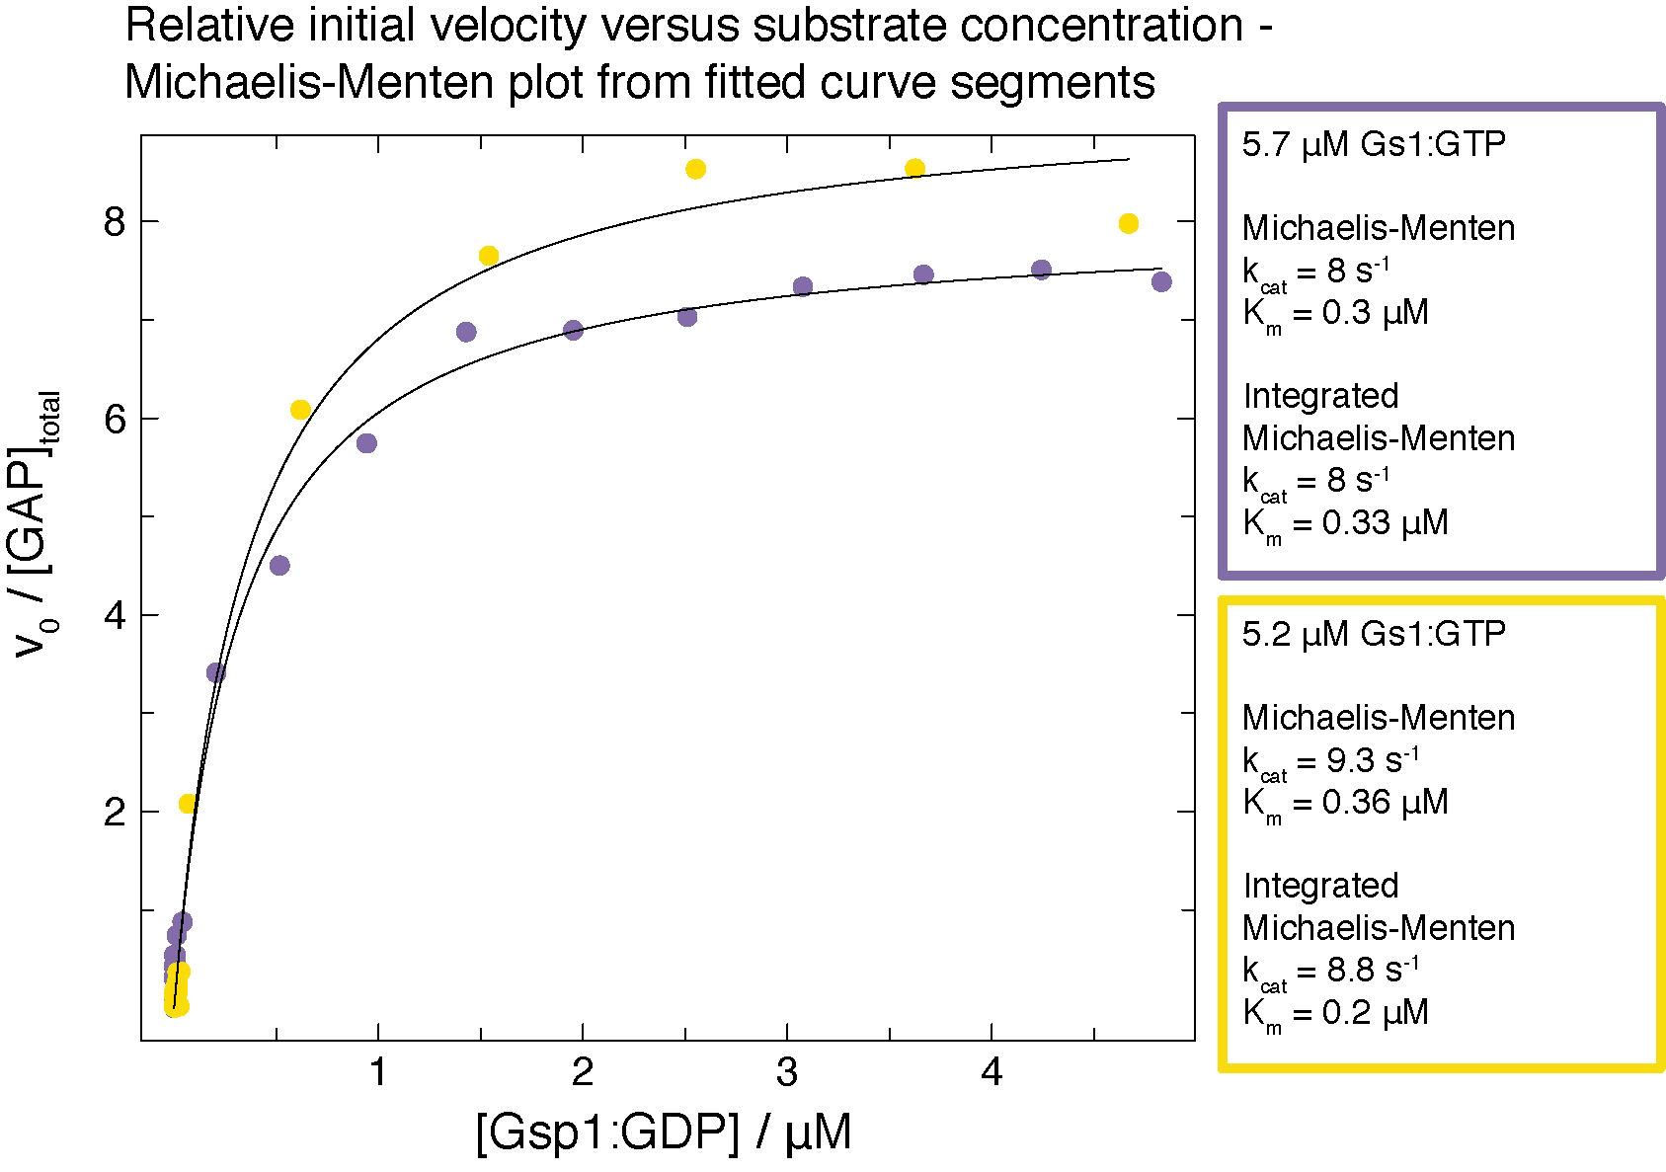

While we agree with the reviewer that there are limitations in the accuracy of the method, and in the ideal case we would want to determine the kcat and the Km parameters by measuring initial velocity for a wide range of initial [Gsp1:GTP], we would argue that given the low Km values and accuracy limitations of other methods rather than using the phosphate sensor, significant limitations exist even if we use the approach the reviewer suggests. For example, if we did a range of Gsp1 concentrations, in the cases where [Gsp1] is above Km the curve cannot be fitted to an exponential (as can be seen from the time course curved for the GAP assay we report in Supplementary File 1 Figure 3). Traditionally the initial velocity in such a case would be estimated from those data by a linear fit of the first 10% of the reaction. However, the accuracy of the linear fit to the initial data is also imperfect for a number of reasons. The very beginning of the reaction is, for technical reasons, always missed and the very high rate in the beginning necessarily means that the ratio of time points to concentration change is low. In many ways, using all of the collected data is more meaningful.

Finally, both our biophysical and cellular experiments (genetic and physical interactions) measure small differences, but our main conclusions are based on grouping mutants by the measured effects. Even though each measurement has different types of noise associated with it, the signal is strong enough for us to see clear groupings in Fig. 4.

*b) Interpretation: Enzyme kinetics data in Gsp1 must be interpreted with care because there are multiple steps involved in each reaction. The authors are referred to work on the Hsp70 chaperone system which is very similar to this switch in having ATP hydrolysis-enhancing factors (J-proteins) and nucleotide exchange factors (NEFs) facilitating the cycle. Careful enzyme kinetics work by the groups of Philip Christen, Roger McMacken, Bernd Bukau and others show that multiple steps must be considered in building a model (Hu, Mayer and Tomita, BiophysJ 2006). Some of the questions that authors need to consider are:*

The reviewer is correct, the GTPase cycle is only approximated by the two reactions forming the two sides of the cycle (exchange and hydrolysis) represented as simple enzyme-substrate Michaelis-Menten reactions. Especially the GEF-mediated nucleotide exchange is a multi-step reaction, and the individual steps for the RAN GTPase were worked out by Klebe *et al*. (Klebe et al., Biochemistry, 1995a). The same authors (Klebe et al, Biochemistry, 1995b) have also proposed that both reactions can be described enzymatically, and this approach has been regularly used for other small GTPases. (We will discuss this point further in our reply to comment (iv)).

We agree with the reviewer that GTPase kinetics data need to be interpreted with care, and we thank the reviewer for highlighting that we have not done a thorough enough job explicitly discussing all relevant details in our manuscript. We hope that our responses to the Reviewer’s questions below, as well as the additional discussion we added to the paper, will rectify this issue.

*(i) How is the basal GTPase activity of Gsp1 taken into account? The authors have mentioned controls in the Methods. Equations used for correcting for the basal rate and equations used for fitting the data should be stated.*

RAN/Gsp1 has very low intrinsic nucleotide exchange and hydrolysis rates, which are low even compared to other small GTPases, and both the GAP and the GEF increase the reactions 105-fold (Klebe et al, Biochemistry, 1995b). Although we do report the intrinsic hydrolysis rate for our mutants, all the intrinsic rates remain orders of magnitude below the enzyme facilitated reactions and we do not add the intrinsic exchange/hydrolysis term when we fit the data. We now add a note discussing this point in XXX; equations for fitting the data are given in XXX.

*ii) What are the relative affinities of GDP and GTP for Gsp1? This is important, for example, in deciding how much excess GTP is needed in a nucleotide exchange experiment.*

Ran binds GTP with very high affinity (Kd > 109 M-1) (Klebe et al., 1995b). Low dissociation rates leads to Ran:GDP and Ran:GTP complexes having half-lives of several hours (Bischoff and Ponstingl, 1991; Klebe et al., 1995a; Klebe et al., 1995b). The low intrinsic dissociation rates of GDP and GTP are paralleled by a low intrinsic rate of Ran·GTP hydrolysis.

As we state in our Methods, for most of our nucleotide exchange experiments we used 200 μM mant-GTP, going up to 1 mM mant-GTP for higher concentrations of Gsp1. The starting value of 200 μM was taken from the first published nucleotide exchange experiment using mant-labeled nucleotides in Klebe *et al*, 1995b. We have now added a note to our Methods stating the nucleotide affinities: XXX

*(iii) Factors such as GAP and GEF may have residual affinities for the products of the enzyme reaction (GDP-Gsp1 and GTP-Gsp1 respectively). Are these numbers known to be negligible? If not, they have to be taken into account in determining 'kcat' and 'Km'.*

The affinity of RanGAP for GDP-bound RAN is negligible; it is around ~100 μM, which is ~250-fold higher than the estimated Km for GAP-mediated GTP hydrolysis (0.4 μM from human RAN (Klebe et al, 1995a)). The measured affinity of RanGAP for GppNHp-bound RAN is around 7 μM (GppNHp is a non-hydrolysable analog of GTP) (Seewald *et al*, 2003), and it is likely that the affinity of RanGAP for GTP-bound RAN is lower than that. We have now added a note to the Methods: XXX

RanGEF, on the other hand, has comparable affinity for Gsp1:mant-GTP and Gsp1:GDP, which means that towards later stages of the time course, the [ES] and [EP] complexes are equally likely to form. For that reason, we followed the approach by Klebe *et al* (1995a) and fit the data using a combination of fits. For concentrations of substrate (Gsp1:GDP) that was much lower than the excess of mant-nucleotide (200 μM) we used a combination of two exponential decays, and, and for reactions with high concentrations of Gsp1, where the relative excess of mant-nucleotide was lower, we always estimated the initial rates using linear fits to the very beginning of the reaction, when levels of mant-nucleotide-bound Gsp1 are very low and therefore exchange is overwhelmingly from Gsp1-GDP to Gsp1-mant-nucleotide. We have now added a note to the Methods: XXX

*(iv) Is there justification for using the Michaelis-Menten equations for these two reactions, instead of approximation-free A=B=C reaction kinetics? Is [ES] at a steady-state and very close to zero throughout the reaction?*

*Overall, I would like to see a more careful analysis of the enzyme kinetics data in the context of the entire cycle.*

There is considerable precedent in the literature for using Michaelis-Menten equations to describe the GTPase cycle, by different labs and for different small GTPases including Ran (Klebe et al, 1995a), Ras (Gideon et al, 1992), or Rap (Brinkmann et al, 2002), and we have now added a paragraph about the validity of the Michaelis-Menten equations for the GTPase cycle to the Supplementary Discussion:

**Validity of the Michaelis-Menten equation under the experimental conditions used in our GTP cycle experiments.**

Historically there have been many attempts to formalize the conditions under which the Michaelis-Menten equation to describe enzyme kinetics are valid (as reviewed in Schnell, FEBS J, 2013). These conditions have converged on the steady-state approximation or more generally, on the reactant stationary assumption. The formal condition for steady-state approximation is that t[ES] (the time it takes for the steady-state levels of [ES] complex to accumulate) is substantially shorter than t[S] (the time where [S] changes significantly). The formal condition for reactant stationary assumption is that [S] ≈ [S0] during initial build-up of [ES].

The formal condition for validity of the Michaelis-Menten equation can be expressed as:

, where and , and koff and kon are the rates of [ES] complex formation (Hanson and Schnell, 2008).

The measured dissociation constant, , for the formation of the Ran:GDP:RCC1 complex from Ran:GDP and RCC1, where RCC1 is the human RanGEF is 0.9 μM (Klebe, 1995a), which is approximately the same as the KM value obtained for the GEF-mediate nucleotide exchange for both yeast and human Ran. That means that , which means the condition for validity of the Michaelis-Menten equation can be approximated as , and since in all of our GEF experiments both [E0] = 5-20 nM << Km and [E0] << [S0], the condition holds true for the entire range of [S0] values, both below and above the Km.

As can also be expressed as , and the measured koff of human Ran:GTP and RanGAP from *S. pombe* is estimated to be around 150 s-1, while our measured kcat values range from 1 to 10 s-1, as above, the assumption of steady-state holds true as long as [E0] << Km and [E0] << [S0], which is the case as we used 1-3 nM GAP in all of our experiments.

Michaelis-Menten formalisms have been used for multiple GTPases including Ran (Klebe et al, 1995a), Ras (Gideon et al, 1992), or Rap (Brinkmann et al, 2002).

Cited REFERENCES for GAP and GEF kinetics:

Bandaru, P. *et al.* Deconstruction of the Ras switching cycle through saturation mutagenesis. *Elife* **6,** (2017).

Bischoff, F. R. & Ponstingl, H. Mitotic regulator protein RCC1 is complexed with a nuclear ras-related polypeptide. *Proceedings of the National Academy of Sciences* **88,** 10830–10834 (1991).

Brinkmann, T. *et al.* Rap-specific GTPase Activating Protein follows an Alternative Mechanism. *Journal of Biological Chemistry* **277,** 12525–12531 (2002).

Gideon, P. *et al.* Mutational and kinetic analyses of the GTPase-activating protein (GAP)-p21 interaction: the C-terminal domain of GAP is not sufficient for full activity. *Molecular and Cellular Biology* **12,** 2050–2056 (1992).

Goudar, C. T., Sonnad, J. R. & Duggleby, R. G. Parameter estimation using a direct solution of the integrated Michaelis-Menten equation. *Biochimica et biophysica acta* **1429,** 377–383 (1999).

Klebe, C., Bischoff, F. R., Ponstingl, H. & Wittinghofer, A. Interaction of the nuclear GTP-binding protein Ran with its regulatory proteins RCC1 and RanGAP1. *Biochemistry* **34,** 639–647 (1995).

Klebe, C., Prinz, H., Wittinghofer, A. & Goody, R. S. The Kinetic Mechanism of Ran-Nucleotide Exchange Catalyzed by RCC1. *Biochemistry* **34,** 12543–12552 (1995).)

Hanson, S. M. & Schnell, S. Reactant Stationary Approximation in Enzyme Kinetics. *J Phys Chem A* **112,** 8654–8658 (2008).

Mishra, A. K. & Lambright, D. G. High-throughput assay for profiling the substrate specificity of Rab GTPase-activating proteins. *Methods Mol. Biol.* **1298,** 47–60 (2015).

Schnell, S. Validity of the Michaelis-Menten equation - steady-state or reactant stationary assumption: that is the question. *FEBS J* **281,** 464–472 (2013).

Seewald, M. J. *et al.* Biochemical Characterization of the Ran-RanBP1-RanGAP System: Are RanBP Proteins and the Acidic Tail of RanGAP Required for the Ran-RanGAP GTPase Reaction? *Molecular and Cellular Biology* **23,** 8124–8136 (2003).

*3) Lines 183-186: "Taken together, the 31P NMR and kinetic data support a molecular mechanism whereby Gsp1 interface mutations allosterically shift the conformational distribution at the active site which in turn alters the GTPase switch cycle". This conclusion is too strong for the amount of data available to support it, though the data does indeed suggest such a possibility. Given that the allostery in Gsp1 is only an interesting side-story in this manuscript, the authors can tone down this conclusion.*

*a) The correlation in Fig. 3f looks much weaker when I plot the data without the log scale on the y-axis. It is equally likely to state from the plot that the y-ratio (without log) remains between 0.05 and 0.5 regardless of what the % of the second conformation is.*

*b) While the 31P NMR data show that there are two conformations in slow exchange, they definitely don't indicate what the structural changes are between the two states and whether the conformational differences are local or global. For all we know, there may be two peaks because some sidechain is flipping in the vicinity, resulting in two peaks for 31P. Without data on other nuclei and strong correlations to structure across the entire protein, it is unwise to draw strong conclusions regarding the conformational exchange.*

We thank the reviewer for these comments, which prompted us to more carefully consider the representation and interpretation of the relationship between the conformational distributions of GTP-bound Gsp1 mutants and the GAP-mediated hydrolysis kinetics.

(i) Data representation: We changed how we plot the data and now directly compare ln ratios (energy differences), i.e. the ln ratios of relative catalytic efficiencies MUT/WT on the y axis and the ln ratios of the relative equilibrium constants for exchange (ratio of γ2 and γ1 peaks) MUT/WT on the x axis (**Fig. 3d**), assuming a 5% detection limit for γ2 and γ1 peaks for T34E/Q and H141R, K132H, Y157A, respectively.

Our data support γ state 2 as the active conformation for hydrolysis. The observed decrease in kcat/Km for mutants shifted to γ state 1 supports an induced fit mechanism, in which GTP-bound Gsp1 in either state can bind GAP, but in cases where Gsp1 is in γ state 1 (such as for T34E and T34Q) binding energy must be used to distort Gsp1 into γ state 2, which results in an overall increase in *Km* (Fersht, 1999). This model requires state 2 to be the hydrolytically competent conformation, consistent with the fact that the intrinsic hydrolysis rate of GTP-bound Gsp1 mutants systematically increases as mutants more greatly populate γ state 2 (**Extended Data Fig. 7c**).

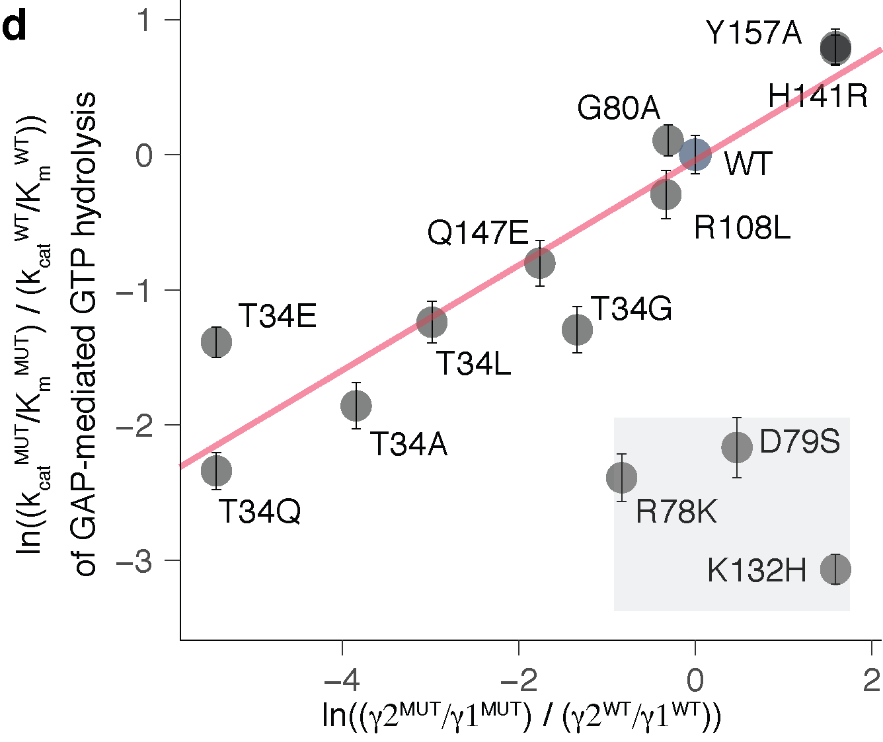

**Fig.3 d,** Ln ratios MUT/WT of the exchange constants Kex = population in γ2 / population in γ1 (assuming a detection limit of 3% for the γ peak estimation by 31P NMR) plotted against the ln ratios MUT/WT of the relative catalytic efficiency (kcat/Km) of GAP-mediated GTP hydrolysis. Error bars represent the mean plus/minus standard error of the mean across at least three replicates of individual GAP-mediated GTP hydrolysis measurements. Red line shows the least-squares linear fit excluding the GAP interface mutation K132H and the active site (switch 2) mutations R78K, and D79S (gray box).

(ii) Data interpretation. We agree that the 31P data alone do not provide structural detail on the differences between the two states across the entire protein. However, regardless of the extent of conformational change that leads to the observed chemical shift difference of the y phosphate in the active site, this change in the active site is caused by a several mutation that are distal (at least 18 Å away) from the site of the probe, as well as distributed across the protein surface (**Fig. 3e,f** and **Extended Data Fig.** **7d**). Our data therefore support an allosteric mechanism not just restricted to the vicinity of the active site. The induced fit model we propose here is moreover supported by three previous studies on the binding of Ran by RanBP1 and the subsequent allosteric activation of GAP-mediated hydrolysis:

a) Geyer et al (1999) showed that RanBP1 binding to Ran-GTP shifts Ran into the γ2 conformation.

b) Seewald et al (2002) solved the crystal structure of the Ran – RanBP1 – RanGAP ternary complex, which revealed that RanBP1 bound distally from both the Ran active site and the GAP interaction interface (with no contacts between RanBP1 and the GAP).

c) Seewald et al (2003) established that RanBP1 binding increases the *Kd* and *kon* of GAP binding to Ran-GPPNP (a close analog of GTP) but does not affect the rate-limiting step of GAP-mediated hydrolysis (the hydrolysis and subsequent release of inorganic phosphate).

Taken together, these studies suggest that RanBP1 accomplishes its activation of GAP-mediated hydrolysis by contributing binding energy towards distorting Ran to γ2 state, and that this distortion is achieved through binding at a site distal from the active site loops and the GAP interface. Given that the T34 position is in the Gsp1 interface with Yrb1 (the yeast RanBP1 homolog), we propose that the T34 mutants that primarily populate γ state 1 (T34E/Q/A/L) increase the energetic cost that GAP binding must overcome to distort Gsp1-GTP to γ state 2. This is a similar but opposite effect to RanBP1 binding, which decreases the cost that GAP binding must overcome, and is associated with decreased (tightened) *Kd* and *Km* values (Seewald et al 2003).

We have updated the text in a way we hope more clearly puts our data in the context of prior data on shifts in active site conformations.

*CHANGES TO THE MAIN TEXT:*

To probe the mechanism of these allosteric effects, we examined the impact of Gsp1 point mutations on the conformational distribution in the active site of GTP-bound Gsp1 using 1D 31P nuclear magnetic resonance (NMR) spectroscopy. Prior 31P NMR data on human Ran{Geyer, 1999 #139} and Ras{Geyer, 1996 #118} showed two distinct peaks for the γ-phosphate of bound GTP arising from differences in the local chemical environment of the γ-phosphate in each of two distinct conformations (termed γ1 and γ2) (**Extended Data Fig. 7a**). This work also showed that the ratio of γ1 and γ2 active state conformations can be tuned by mutations close to the active site, as well as by effector binding. Our 31P NMR spectra of *S. cerevisiae* wild-type Gsp1:GTP showed two distinct peaks for the γ-phosphate of bound GTP with 87% of wild-type Gsp1:GTP in the γ2 state conformation. Strikingly, the populations of the γ2 state in Gsp1 interface mutants ranged from close to 0% for T34E and T34Q, to close to 100% for H141R, Y157A, and K132H (**Fig. 3c**).

Furthermore, we observed a striking linear relationship between the relative log-transformed ratio of the two γ conformations and the log-transformed relative catalytic efficiency of GAP-mediated GTP hydrolysis **(Fig. 3d**) and intrinsic GTP hydrolysis (**Supplementary File 1 Table 8,** **Extended Data Fig. 7b, c**). From this relationship we can infer that the γ2 state represents the active site conformation of Gsp1:GTP that is more compatible with GAP-mediated GTP hydrolysis, compared to the γ1 state. Remarkably, the mutated residues that tune the population of the γ2 state (T34, H141, Q147, and Y157) are all distal, affecting the chemical environment of the Gsp1-bound GTP γ phosphate from at least 18 Å away (**Fig. 3e, f**). Furthermore, neither of these sites overlap with the allosteric inhibitor pockets successfully targeted by small molecule inhibitors in Ras{Canon, 2019, r05670;Kessler, 2019, r05463;Ostrem, 2013, r05039} (**Extended Data Fig. 7d**). Exceptions to the linear relationship are the K132H mutation, which is in the core of the GAP interface and is hence expected to directly affect the interaction with the GAP, and the D79S and R78K mutations, which are on the edge of the GTPase switch II region (from residues 69 to 77) and could lead to different perturbations of the nucleotide binding site geometry.

Cited REFERENCES relevant to 31P NMR and GTPase conformations:

Fersht, A. (1999). *Structure and Mechanism in Protein Science: A Guide to Enzyme Catalysis and Protein Folding*. Macmillan.

Geyer, M., Assheuer, R., Klebe, C., Kuhlmann, J., Becker, J., Wittinghofer, A., & Kalbitzer, H. R. (1999). Conformational states of the nuclear GTP-binding protein Ran and its complexes with the exchange factor RCC1 and the effector protein RanBP1. *Biochemistry*, *38*(35), 11250–11260.

Seewald, M. J., Körner, C., Wittinghofer, A., & Vetter, I. R. (2002). RanGAP mediates GTP hydrolysis without an arginine finger. *Nature*, *415*(6872), 662–666.

Seewald, M. J., Kraemer, A., Farkasovsky, M., Körner, C., Wittinghofer, A., & Vetter*.* I. R. (2003). Biochemical Characterization of the Ran-RanBP1-RanGAP System: Are RanBP Proteins and the Acidic Tail of RanGAP Required for the Ran-RanGAP GTPase Reaction? *Molecular and Cellular Biology* **23,** 8124–8136 (2003).

OK, tone down (but refer to other work on the conformations). Say reviewer is right that we do not know the structural details. But we do know effects are not just in the vicinity of the gamma phosphate as mutations are distal.

*4) I find it difficult from the data to disentangle the effects of the mutations on the binding and on the cycle. A part of this problem is because the some of the mutations are directly at the interface of Srm1 and Rna1, which facilitate the cycle turnover. Secondly, I find the representation of AP-MS data in Fig. 2b/c very confusing. Particularly in Fig. 2b,*

We agree with the reviewer that our description of the AP-MS data was confusing, and we have reworked Fig. 2 and the main text. , as summarized in GENERAL POINT 1 at the beginning of this document.

*a) Why have only 6 prey proteins been quantified out of 16 whose interfaces were to be perturbed? How do we estimate how the interactions with the other 10 proteins have been affected?*

After we have established that interface position does not explain the phenotype data, we thought it essential to assess changes in physical interactions in native-like conditions, where all the partners are present, and for that reason we have opted for using AP-MS. The drawback of AP-MS is that it is not optimal for quantifying transient and weak interactions, which is why we could only quantify the interaction differences for six of the partners for which we could identify significant amounts of the partner in **both** the wild type and the mutant.

Given that even for the six most abundant physical interaction partners (new Fig. 2b), including the two main regulators (new Fig. 2c) we could see that the rewiring of physical interactions is more extensive than could be expected b interface position, we pursued quantifying the effects of mutations on the GTPase cycle.

Can try to address in discussion. For MS, the 6 are the ones we see. For the others, the reviewer is right, we don’t know. But most importantly, the interface locations of the mutations do not explain the GI data. Could replot that just for the 6 interfaces where we have MS data?

*b) Kap95 has 7 core residues at the interface with Gsp1 from Ext. Data Fig. 1b (79, 80, 112, 143, 147, 154 and 157). In Fig. 2b for Kap95, I don't see 7 circles/half-circles of the same size. Has the classification of core residues changed?*

We have reworked the presentation of AP-MS data (**Fig. 2 and Extended Data Figure 5**), but to nevertheless address the reviewer’s question, core residues are defined as ΔrASA > 0 & rASAm > 0.25 & rASAcomplex < 0.25 (we have now, in addition to the original reference, added explicit definitions of interface residues in the Methods section). While we do not have AP-MS data for residue 154, the points representing residues 79, 80, 112, 143, 147, and 157 were indeed all visible in the previous version of Fig. 2b.

*c) Again, for example, Kap95 seems to have approximately the same number of reds and blues. Pse1 has two reds and one blue. Srm1 has four bluish tinges and four reddish tinges. Excepting Yrb1, I don't find this evidence convincing for the statement that the introduced mutations perturb the interactions they were meant to perturb (lines 130 and 142 in the manuscript.*

*Overall, I am not convinced of the extent to which the mutations introduced in this work perturb the interfaces of the 16 interactors of Supplementary File 1 Table 1. The authors should purify the mutant Gsp1 proteins and measure their interactions with the partners whose interactions the mutations were meant to perturb, using robust biophysical methods such as ITC to settle this point.*

Again, we wish to thank the reviewer for these comments. We realized that our presentation of physical interaction data was unclear and consequently misleading. We hope that the new data presentation and a new more streamlined text (GENERAL POINT 1) fixes this. The point we want to make is **not** that interface mutations perturb the interfaces *in vivo* (or at least in cell lysate) as predicted, but rather that, although we can **see a trend on average** (Fig. 2b), the trend is weak, and to really get to the bottom of the interesting biology behind our results it is essential to explore the system in more detail.

Could try to argue but probably need to do at least some of these binding exp (as reviewer #3 also argues for them). Perhaps we can pick some strategic ones that would satisfy the 2 reviewers.

*Minor changes:*

*1) It will help to put the function of the 16 proteins in Supplementary File 1 Table 1 as a separate column.*

We have now added the protein names and functions of the binding partner proteins to Supplementary File 1 Table 1.

*2) Line 320, "highlighted in yellow": I was unable to locate the yellow colouring in Fig. 3c.*

We apologize for this, it seems that the transparent yellow box got converted to a gray box during the file conversion process. We have now changed the Figure to contain a yellow box without fill, to make it more robust for file conversions and printing.

*3) Line 844 should read "run in parallel".*

We have now fixed that grammatical error in our Methods text.

*4) Numbers seem to be slightly off in line 155: R78K and T34Q are ~10-fold, but T34A is 6.3 and T34E is 3.7, hardly 10-fold.*

We would like to thank the reviewer for catching this. We have now added a range of values, instead of only the maximum value: In particular, mutations that are not in the interface with the GAP both increased (3-fold, R108G mutant) and decreased (3 to 10-fold, T34E/Q/A, R78K, D79S, and R112S mutants) the catalytic efficiency of GAP-mediated GTP hydrolysis, compared to wild-type Gsp1 (**Fig. 3a)**.

*5) I find it very interesting that a cycling between two forms of a switch is necessary rather than one or the other conformation. A similar effect has been observed in a cis-trans molecular switch in the circadian clock (Partch and coworkers, Mol. Cell, 2017, 66:447). Perhaps the authors can comment on a possible mechanism of how cycle dynamics, rather end populations can impact downstream biological processes?*

I don’t know how to work this in. I looked at the paper and I think this is a completely different system. It’s not a intrinsic circulator that has an instrinsic timer like in circadian clock. The mechanism of gsp1 is a combination of two opposite regulators and localization.

Cite that paper and add discussion. This is actually a deeper point that was also brought up by David after my talk in Seattle. Perhaps discuss the ultrasensitivity work more in this context.

We should go overboard about how this is a brilliant addition to our paper?

*6) While reading the manuscript, I felt that the work was not sufficiently placed in perspective of what is known about the mode of operation of other molecular switches. A short paragraph on this may help the manuscript.*

Ok add that. Not sure how to interpret this request? TO DO!!!!

*Data presentation:*

*1) Fig. 2b/c is extremely confusing and took me a long time to interpret. They depict quantitative AP-MS data as semi-qualitative colours which do not help in making quantitative assessments.*

*a) Why are some half-circles missing their counterparts?*

The half circles represent either the N or C terminally FLAG tagged mutants. Although we attempted to make each of the mutants with both tags, for most of the mutants we only managed to obtain viable yeast strains for only one of the tags. This is explained in the Methods section, and we assume this is due to the negative epistasis of the tags (both of which unfortunately affect the function of Gsp1) and the interface point mutations.

*b) The meaning of circle size has changed between panels b and c. While this is indeed mentioned both on the plot and in the legend, it makes it very difficult to grasp the import of the figures.*

*c) In panel b, I found it very difficult to get a reliable estimate of circle size, which reports on the key DASA parameter, without actually using a ruler. Why has the core/rim classification of Ext. Data Fig. 1b changed though it portrays the same parameter? Consistency between these two figures will help.*

*Fig. 2b/c has to be reworked so that it is easier to understand the data. A simple histogram may work.*

We agree with the comment about data representation and have now completely reworked Fig. 2 in the main text to streamline and simplify our interpretation of the AP-MS data as per combined suggestions by Reviewers 1 and 2. (Summarized in GENERAL POINT 1).

Referee #3:

*Perica et al. interrogate the small GTPase Gsp1 to identify the effects of directed point mutations, largely in interface regions. Through multiple assays, including genetic interaction, protein-protein interactions, NMR, and enzyme kinetics, they determine that mutations fall into three categories, affecting overall function, GTPase function, or GTP loading.*

*Unfortunately, despite starting the manuscript with 56 mutants, at the end, through multiple rounds of experimentation, the authors manage to describe the functional impact of mutating 11 sites in Gsp1. The core findings, that mutating 11 disparate sites in a GTPase affects its overall function and that many mutations affect function through allosteric regulation, are somewhat dissatisfying. Perhaps because of the systems-level scale of the analysis, there appears to be a lack of depth of understanding for any given mutation. For instance, how does T34Q (or any other amino acid substitution at the T34 position) lead to a strong change in GAP function?*

*Points to address:*

*1. 2-9 replicates for Michaelis-Menten measurements? Why were there different numbers of replicates for some mutants compared to others?*

We added more replicates for the GAP-mediated GTP hydrolysis measurements, and all of the mutants now have at least 3 replicates (**Fig. 3a** and **Extended Data Fig. 6**). We have nine replicates for the wild type Gsp1 as we kept periodically testing that the values for the wild type do not change over time (due to different LOTs of the sensor, or unforseen problems with the GAP stock). We have also added more replicates for the mutants with very high Km values, to make sure to add the measurements where [Gsp1:GTP] >> Km.

*2. Correlation plots for AP-MS experiments are disconcerting, as they show that, in many cases, the replicate pull-downs for a given mutant do not cluster together. For instance, the WT pulldown replicates do not cluster. Even more disconcerting is that the replicates for each mutant appear to have correlation values that are much less than 1.*

We would like to thank the reviewer for this comment. We have also noticed the lower correlations than we normally see, but do not find them disconcerting. Firstly, it is difficult to compare our data with any previous datasets, as this is the first time someone has collected data for such a large number of single point mutants with relatively weak effects. It is to be expected that the signal to noise ratio will be low for a set of almost identical proteins (it is worth remembering that some of the mutants from the dataset do not have a phenotype that is distinguishable from wild type). If we acknowledge that in AP-MS >95% of identified proteins are background (i.e. not PPIs deterministic of a given mutant), clustering by total peptide signature will be far from ideal and correlations in the 0.6-0.8 range (as ours are) are not surprising. The reviewer is absolutely correct to raise this point and call for caution, which is why we have done a proper normalisation analysis and are subsequently very careful in interpreting the biological relevance of our results. We chose AP-MS for its ability to measure interactions in an unbiased way in cell lysates, and are well aware of its quantitative limitations, which is why we do not draw any strong conclusions about individual interactions (although we of course make all of our data available). We only compare the global trends of the data (for example in **Fig. 2b and c**).

Most importantly considering all the limitations of our AP-MS experiment, we can still see a clear trend that separates the relative interactions with the GAP and the GEF by the *in vitro* kinetic parameters (**Extended Data Fig. 8a-c**).

*3. Orthogonal validation experiments would strengthen the AP-Ms data. For instance, it should be fairly straightforward to perform co-IP western blots to demonstrate the loss of binding of SRM1 to T34A, as an example.*

Please see our general response to questions about the AP-MS by Reviewers 2 and 3 in GENERAL POINT 2, as well as our replies to point 4 by Reviewer 2.

More specifically, in response to the specific comment regarding co-IPs; in addition to our opinion that having individual (pairwise) measurements of interface affinities would not change our main discovery that kinetic parameters of the GTPase cycle explain a large fraction of the observed phenotype differences, we are not convinced that the dynamic range of the co-IP experiments is sufficiently sensitive to pick up the differences in interface affinities.

*4. p 11: The discussion of K101R and acetylation is speculative. The authors do not show that this lysine is acetylated in yeast.*

We would like to thank the reviewer for catching this. Reviewer 1 has raised the same point and we have now modified the text and added a reference that shows the K101 position is also acetylated in yeast (please see our response to Reviewer 1).

Added reference: Henriksen, P. *et al.* Proteome-wide Analysis of Lysine Acetylation Suggests its Broad Regulatory Scope in Saccharomyces cerevisiae. *Mol. Cell Proteomics* **11,** 1510–1522 (2012).

*5. The authors start with 56 mutants, but then drop to 22 mutants that ‘express and purify well’. What does this say about the other 34 mutants? Did they not express well? If so, then the GI and AP-MS data for these mutants should be removed.*

We would like to thank the reviewer for this comment. We should have been far more precise in our language, and now that the reviewer has brought it up, we can see how misleading the sentence was. In fact, **all** of the mutants we tried to express **did** express in *E. coli* at similar levels to the wild type, and we could purify **all** of them. More importantly, we have shown by Western blots (**Extended Data Fig. 2**) that all the mutants express from endogenous locus at levels similar to wild type, and that there is no significant difference in protein expression levels between mutants with weak and strong phenotype profiles.

However, GAP assay and NMR experiments required a highly concentrated pure protein sample (> 1 mM), and, more importantly, both experiments required loading the protein with GTP by using enough EDTA to chelate the Mg2+. Removal of Mg2+ increases the off-rate for nucleotide binding of small GTPases, and chelation of divalent cations is therefore a common method for nucleotide loading of small GTPases. In our hands, as well as noted by others (Klebe *et al*, 1995), wild type RAN/Gsp1 is more unstable than other small GTPases without the nucleotide bound.

In summary, while all the mutants expressed well, both in *E. coli* and endogenously, some of them were more unstable when stripping them off the nucleotide at >1 mM concentrations.

Again, we would like to thank the reviewer for catching that. It might be a minor point, but we can see how our language could have been misleading. We now rewrote that sentence to say:

To address the question whether the mutations act directly or indirectly (i.e. by altering the competition between physical interaction partners in the cell), we recombinantly expressed and purified wild-type and 24 Gsp1 mutants and measured their effects on GAP-mediated GTP hydrolysis and GEF-mediated nucleotide exchange *in vitro* (**Fig. 3a, b, Extended Data Fig. 6**, **Supplementary File 1 Figures 3, 4,** and **Tables 6, 7**).

REFERENCE for RAN stability without nucleotide:

Klebe, C., Prinz, H., Wittinghofer, A. & Goody, R. S. The Kinetic Mechanism of Ran-Nucleotide Exchange Catalyzed by RCC1. *Biochemistry* **34,** 12543–12552 (1995).)

*6. Similar note regarding the AP-MS experiments. 56 mutants were used for GI, but only 28 for AP-MS? The other 28, even if they were not in interface regions, should have been assessed for altered protein interactions, even as controls. Are the 22 mutants for enzyme kinetics a subset of the 28 mutants for AP-MS?*

We believe we address this point more generally in our GENERAL POINT 2 at the beginning of this document. In brief, we purposefully present data starting with all the mutants, illustrating our approach of screening the mutants for phenotype, and then, based on the completely unbiased phenotype measurements choosing representative mutants (covering weak and strong phenotypes, as well as all the phenotype subgroups) in order to delve deeper into the details of the systems level mechanism. We believe that our approach is one of the strongest parts of our paper, and the different numbers of mutants are therefore a feature, not a bug, of our paper. We purposefully did not simply present the data using a subset of mutants for which we have complete set of data (which would still be an unprecedented number of mutants for which E-MAP, AP-MS, and biochemical data were collected).

*7. Were only 13 of the mutants used for NMR?*

I think we can argue here, as the NMR mutants span the entire range so we could not learn more if doing more.

Yes, we collected and presented NMR data for 13 mutants. We have touched to this point in our GENERAL POINT 2 as well as in our response to point 5. Adequate signal for the 31P NMR studies required relatively large volumes (400 µL) of very highly concentrated samples of purified protein (> 800 µM) after GTP-loading (which in our hands dilutes samples to ~40% initial concentration). Thus, our workflow began with concentration of purified Gsp1:GDP mutants to well over 1 mM. Attempts to concentrate several mutants to these high concentrations were unfortunately in vain, with most of the protein precipitating out, despite these mutants being readily purified at lower concentrations, active in the GEF and GAP assays, and stably folded as confirmed by CD spectroscopy (**Supplementary File 1 Fig. 12** and **Supplementary Table 9**). However, we believe the data for those mutants which we have collected spans the entire range of observable behaviours in the assay, as it included two mutants only observable in state 1, three mutants only observable in state 2, the WT variant, two mutants with WT-like distributions, and several intermediate mutants (**Fig. 3c** and **d**). While we would have been eager to collect a larger set if the samples were attainable, we do not believe those additional mutants would significantly change our claims.

*8. In Supp. Tables 6-8 the authors include std. dev. and std. error values. Often these values are of similar magnitude to the measured value, indicating that the confidence in the measured value is low. Yet it seems that these measured values were still used in the main figures, with no indication of the error. Some indication of significance should be assigned to these figures.*

We thank the Reviewer for this last comment. This is indeed a major point, and we think that addressing it has substantially improved our paper. The three main changes we made are:

1. We have collected more GAP-mediated GTP hydrolysis data on several of the mutants

2. As we are mainly interested in the confidence in the mean value, we now report the standard mean error for both the GAP and the GEF data.

3. We now report the propagated standard error in all of our plots that show relative ratio (MUT/WT) of the kinetics parameters, most notably in **Fig. 4** (as well as accompanied **Extended Data Fig. 9** and **10**). In cases where we report the log-transformed relative value (MUT/WT), we report the standard error as standard error divided by the relative value (MUT/WT).

Explain more (editor wants to consult additional “stats” reviewer). Probably there are only a few high-error values and some / most of those may go down with additional GAP assays (?)