Dear Angela,

We have now addressed all reviewers’ comments in detail and would like to discuss our revisions with you. We are encouraged by the positive comments of the reviewers finding our study exciting, describing an unexpected finding and making “a fundamental contribution to our understanding of protein interaction networks and how a single switch protein can independently regulate multiple cellular processes”. To us the most important review comments concern the kinetic measurements and analysis, as these are central to our conclusion that different biological processes sense the kinetics of GTPase switching differentially, providing a novel link between systems-level functional genetics and biophysics. We found these review comments very helpful and the corresponding revisions have helped us to improve our manuscript. We have added additional experiments and have consulted on the analysis with an expert on GTPase enzymology, David Lambright, who is now included as an author on the manuscript.

In addition to these experiments and analyses, the reviewers suggested:

- Clarification of the AP-MS data, which we have done (see substantial changes to the representation and interpretation, especially in **Fig. 2**). We hope that the new analysis now shows more clearly that, while the AP-MS data confirm that many of the mutations affect the targeted interactions, many other interactions are also changed in the cellular context when other interaction partners are present. Most importantly, the effects of mutations on *individual* targeted interfaces do not explain the genetic interaction data (**Fig. 1g**). We therefore think that the results of additional *in vitro* binding experiments of the effects of mutants on specific individual interactions, as suggested by reviewer 2, are unlikely to alter our main conclusions. It would of course be an interesting future study to quantify the effect of all our mutations on each of the individual 16 Gsp1 binding partners with complex structures (but it would be a study focused on structural aspects of molecular recognition that would be quite different from our current manuscript).

- Study of additional mutants. We have probed the functional effects of perturbations at 24 surface sites on Gsp1 with 56 point mutations and quantitative genetic interactions with 1,444 genes (>80,000 genetic interaction measurements), and followed up on many of these Gsp1 mutants with AP-MS proteomics, individual kinetic measurements with two main switch regulators, and conformational analysis using NMR. While this work is rather extensive in scope (we are not aware of another study that combines these systems-level and biophysical techniques on such a large set of point mutations), additional mutants (ideally at all Gsp1 positions) could of course be interesting to study. However, we would like to note that our mutants already span a considerable range of parameters and effects on biological functions. For example, the NMR data show that our mutants cover the entire range of the 2-state equilibrium we observe, from essentially 100% in state 1 for some mutants to essentially 100% in state 2 for other mutants, and yet other mutants with equilibria between the two extremes (**Fig. 3c**). Similarly, our mutants span a considerable range of kinetic parameters (**Fig. 3a,b**). The different kinetic behaviors of the switch in our mutants can ultimately be grouped into three classes that differentiate the main distinct cellular functions of Gsp1 observed in the unbiased genetic interaction data (**Fig. 4b-d**). Because of this coverage of both parameters and functions, we feel that additional mutants would be unlikely to uncover new classes of functional behaviors.

We would very much like to get your perspective on these points. Below we also include our detailed point-by-point response to all reviewer comments with corresponding changes in the manuscript in response to all points raised.

With many thanks in advance for your consideration,

Nevan Krogan & Tanja Kortemme

To the Reviewers and the Editor:

We would like to thank the three reviewers for their thoughtful and detailed comments and we hope we have provided satisfactory responses to each of the individual points in our detailed responses below. The reviewers’ comments have prompted us to do additional experiments and analyses which we believe have improved our manuscript. In particular, we have included additional data and more detailed analyses on enzyme kinetics (including accuracy estimation analysis in **Supplementary File 1 Fig. 14**, and the error ranges when comparing kinetics parameters and genetic interaction profiles in **Fig. 4**), for which we have consulted with an expert on GTPase enzymology, David Lambright, who is now included as an author on the manuscript. Specifically, to address reviewer #2’s point of “*a more careful analysis of the enzyme kinetics data in the context of the entire cycle*”, we added a discussion of assumptions when using the estimated Michaelis-Menten parameters to describe the kinetics of the GTPase cycle and a section explaining that our conclusions are not dependent on the detailed individual steps of GTP hydrolysis and nucleotide exchange (**Supplementary File 1 Discussion**). Rather, we follow the established formalism by Wittinghofer and colleagues (Klebe, 1995), and show that grouping the kinetic behavior of our mutants into three classes explains the observed genetical interaction data for a functionally diverse set of Gsp1 point mutants (Fig. 4a). While we agree that effects of mutations on the individual steps of each reaction, such as for example whether the rate of nucleotide exchange is decreased due to decreased association rate of the Gsp1:GDP:Srm1 ternary complex, or the decreased rate of nucleotide release from that ternary complex, could be relevant, distinguishing these detailed effects at the level of cellular functions is likely beyond the current precision of the systems-level data. We therefore believe a classification into kinetic groups independent of detailed differences provides a more robust interpretation of the data.

We have also reworked the representation and analysis of the AP-MS data on changes in physical interactions in response to mutations, as commented on by all three reviewers. We hope that the new **Fig. 2** and text sections clarify that: (i) overall many (but not all) of the mutations affect the targeted interactions based on complex structures (new Fig. 2a, left distribution), but (ii) the AP-MS data also indicate widespread rewiring of physical protein-protein interactions (new Fig. 2a, right distribution). Taken together, the functional consequences of the mutations seen in the unbiased genetic interaction data and the AP-MS proteomics are better explained by the mutational effects on the kinetics of switching (new Fig. 4b) than by effects on individual targeted physical interaction interfaces (Fig. 1g).

Fig. 2a: targeted interfaces are affected, on average, but many other interactions are as well

Fig. 1g: functional effects of Gsp1 mutations do not group by interface location of the mutation

Fig. 4b: functional effects of Gsp1 mutations group by kinetic behavior of the mutant

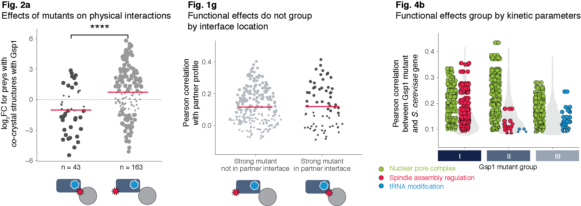

We hope that these overarching points will be helpful when considering our point-by-point responses to the reviewers’ questions and comments below.

LEGEND:

*Reviewer comments are in italic, with specific suggestions underlined.*

Our responses to the reviewers are in black.

Text from the manuscript is in green, with changes in blue.

**Point by point replies to reviewers**

**Referee #1:**

*In their manuscript, Perica and colleagues describe a detailed system-wide genetic, cellular and biophysical analysis of a molecular switch protein in order to analyse the molecular mechanism by which these central regulators of signal transduction differentially affect multiple biological functions. To carry out this work the authors focused on the small GTPase Ran/Gsp1, which is a very good choice as its activity is modulated by one main GEF and one main GAP, but forms protein-protein interactions with many different binding partners. High resolution crystal structures for 16 of such complexes are available, which allowed the authors to carry out a detailed analysis of the protein interfaces involved and design 56 point mutations that would likely interfere with a given interaction, and allow analysis of their functional significance on the biological processes regulated by Gsp1.*

*Making use of the genetic power of yeast the authors carry out a careful genetic interaction screen of the mutations selected, followed by mapping the physical interactions of the mutants by AP-MS. The AP-MS experiments indicated that many mutations had significant effects on the interaction with GAP and GEF proteins, which prompted the authors to quantify the effect of the mutations on GAP-mediated GTP hydrolysis and GEF-mediated nucleotide exchange, followed by NMR analysis of the effect of mutations on the conformational behaviour of active site residues with respect to GTP status.*

*This is a well-executed, exciting and insightful study that makes a fundamental contribution to our understanding of protein interaction networks and how a single switch protein can independently regulate multiple cellular processes. A key, and unexpected finding, of this study is the observation that the GI profiles did not group according to their location on the Gsp1 surface and binding partner interfaces, and hence that functional specificity is not determined solely by interaction with a given binding partner. Instead, the data show that the kinetic parameters of the GTPase cycle of Gsp1 are allosterically regulated by distal interface mutations. This leads the authors to suggest that the effect of a mutation on a biological process depends on its sensitivity to different properties of the GTPase cycle. This is an appealing and novel concept that will attract a lot of attention. The discovery of novel allosteric sites in a GTPase is particularly interesting given the link of mutations to disease and efforts to target their activity therapeutically.*

*Specific points:*

*- Ext. Data Fig. 2*

*Some mutants show quite a lot of variation between replicates and differ up to 6-fold from WT. Is this really close to WT expression? How may this effect the genetic interaction profiles?*

We thank the reviewer for raising this important point (see also related comment on expression levels by reviewer #3, point 5). There are indeed 2 outlier data points in our Western blot data (one for K154M and one for R108G) that deviate 6-fold from the mean WT expression (but also from other replicates for these mutants). To address the key point whether potential variations in expression level affect the functional profiles from genetic interactions, we added an additional analysis and panel to the **Extended Data Figure 2**. Panel c now shows more explicitly that the variation in expression levels is not predictive of the differences between the mutants with strong and weak genetic interaction profiles (the distributions of relative expression levels of weak and strong mutants are essentially indistinguishable).

However, expression level differences could contribute to the functional effects observed for at least some mutants, and we modified a sentence in our Discussion section which now reads:

Other effects such as direct perturbations of interactions, binding partner competition, and small changes in expression of Gsp1 or its partners undoubtedly also play a role in modulating the functional effects of our Gsp1 mutations.

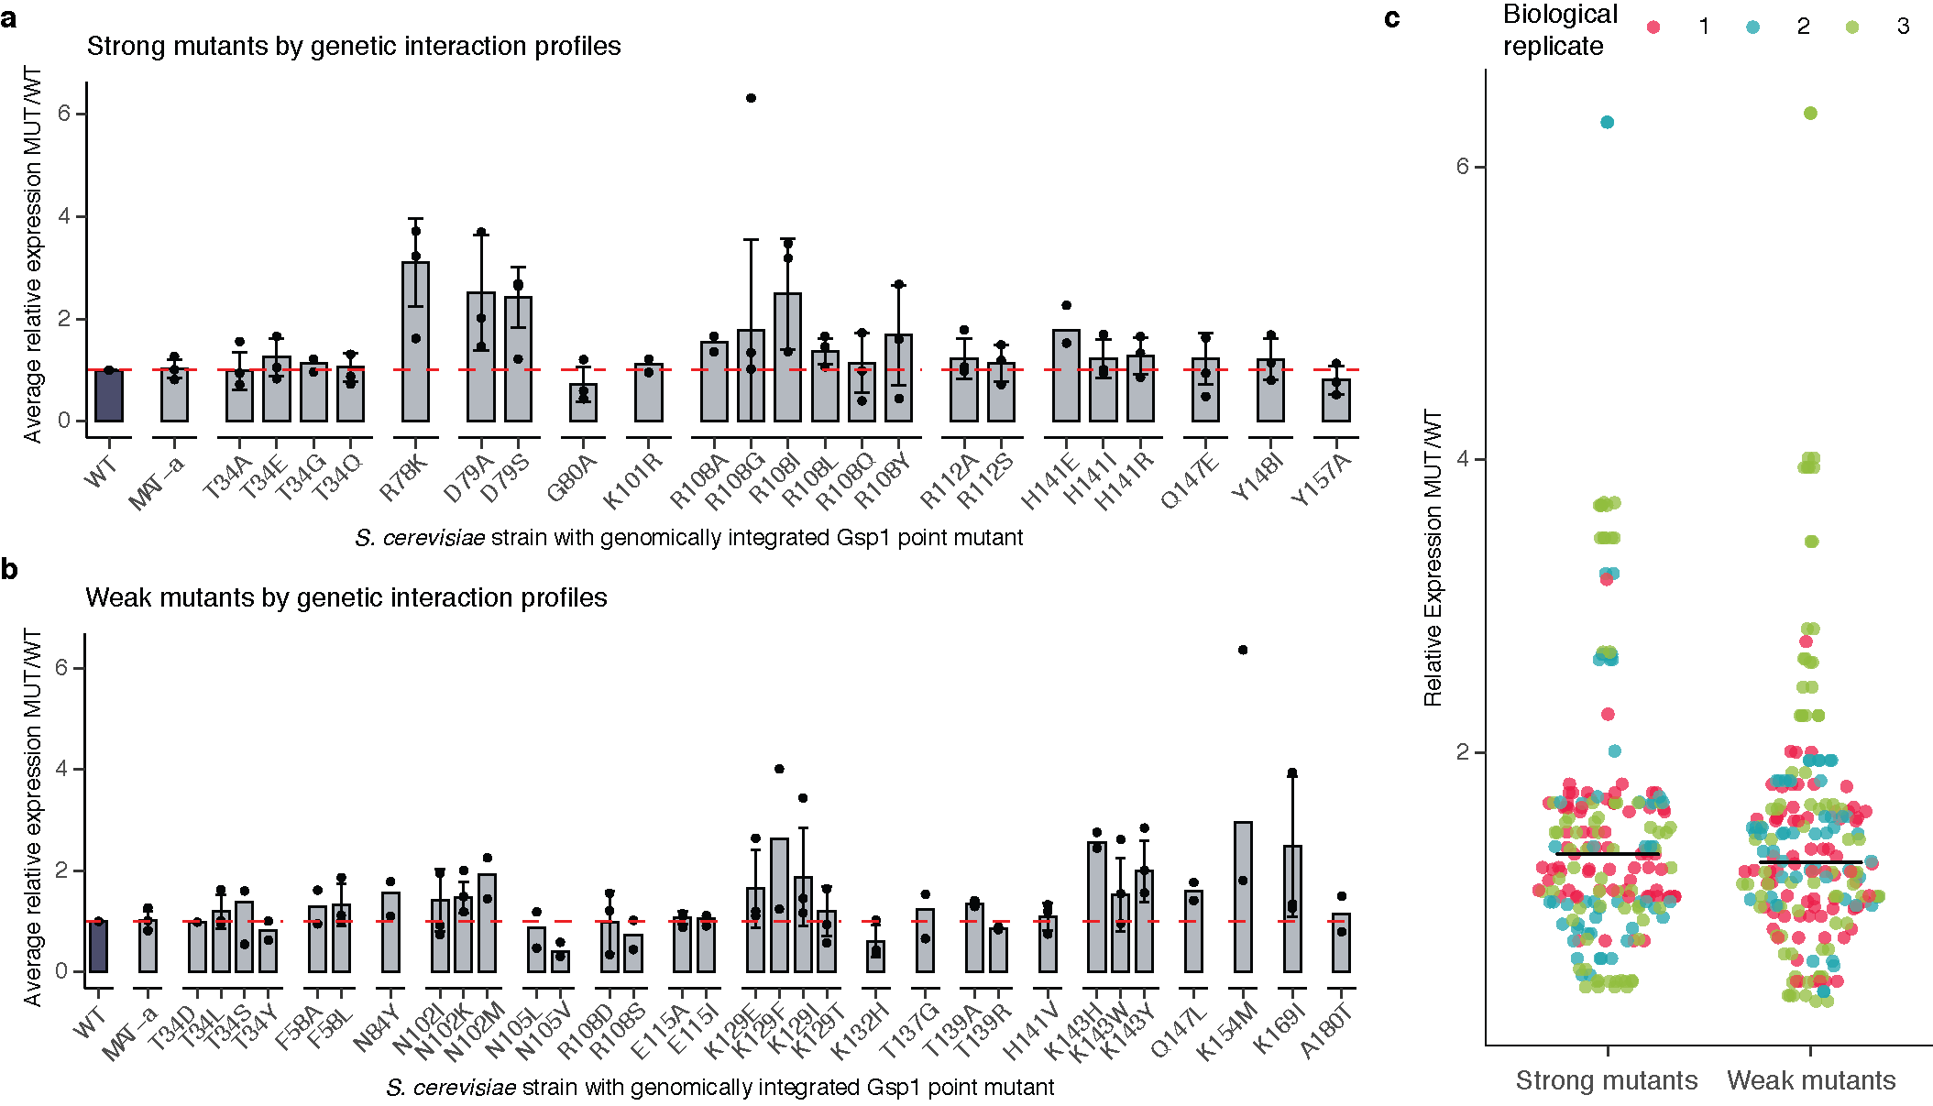

**Extended Data Figure 2. Expression levels of endogenously expressed Gsp1 protein in *S. cerevisiae* strains with genomically integrated Gsp1 point mutations profiled by Western Blot.** Expression levels are relative to the expression levels of wild-type Gsp1 protein. **a,** Expression data for strong mutants, defined as mutants with more than nine significant GIs. **b,** Expression data for weak mutants, defined as mutants with fewer than nine significant GIs. Bar heights indicate averages over 2 or more biological replicates (n) with error bars indicating one standard deviation for n >= 3. Overlaid points indicate individual biological replicates (each an average over at least 12 technical replicates per biological replicate for wild-type and MAT-α strains, and between one and six technical replicates per biological replicate for mutant strains). Dashed red line indicates expression at the level of wild-type Gsp1 (fold change of 1). **c,** Distributions of average relative expression changes for strong and weak mutants, coloured by biological replicate. All strains in a replicate were grown in parallel. Each point indicates an average over technical replicates, as in **a** and **b**. Bars indicated the mean of the point distributions.

*- The authors present an enormous amount of data in this manuscript, which has resulted in some of the figures being overloaded and difficult to follow. I understand that there are restrictions to the number of figures in the main text, and hence the authors have tried to include a lot of subpanels. However, this has resulted in some of the figures not being as easy to interpret as they should be. This is particularly relevant to the figures depicting protein structures. They are crucial to the manuscript as they visualise some of the key messages of this story. Hence the authors should rethink how to illustrate these points and at least add additional structure figures to Supplementary.*

*Examples:*

*- The structures shown in Fig. 1c are not sufficient to allow the reader to fully understand the special relationship of the different protein surfaces mutated and their importance in the interaction with binding partners. The authors should consider showing a surface representation in addition in which the different protein interfaces are highlighted, maybe coloured according to the number of times they have been detected in protein-protein interactions.*

We agree and have made two changes: First, we now indicate the interface locations of the mutated residues in **Fig. 1c** (we decided to use color-coded dots to keep the representation simple). Second, we added a new **Extended Data Fig. 1a** that highlights each interface in more detail with the Cα atoms of mutated residues in Gsp1 in sphere representation colored by the different interfaces. (To accommodate this change, we have moved the original Extended Data Fig. 1a showing the complex structures to the Supplementary File 1 Figure 1).

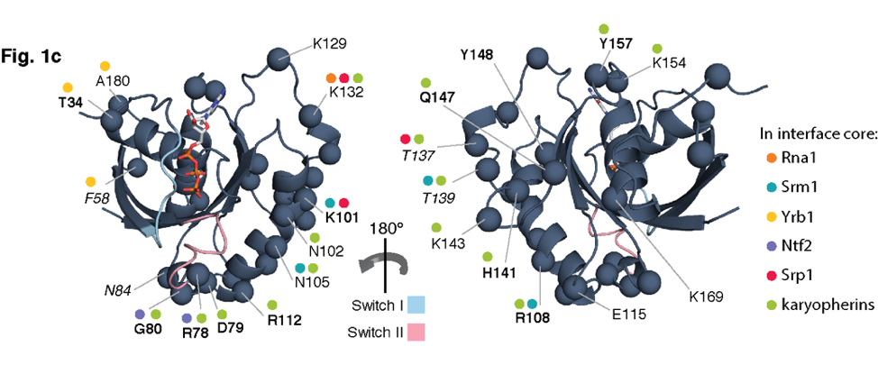

**Figure 1 c**, Structure of GTP-bound (navy, PDB ID: 3m1i). The 24 mutated Gsp1 residue positions are shown as Cα atom spheres. Positions of mutations with strong genetic interaction profiles are in **bold**, and positions that are not conserved in sequence between *S. cerevisiae* Gsp1 and human RAN are in *italic*. Coloured dots represent the interaction partners for which the residue is in the interface core. Switch I and II regions are shown in light blue and pale pink, respectively.

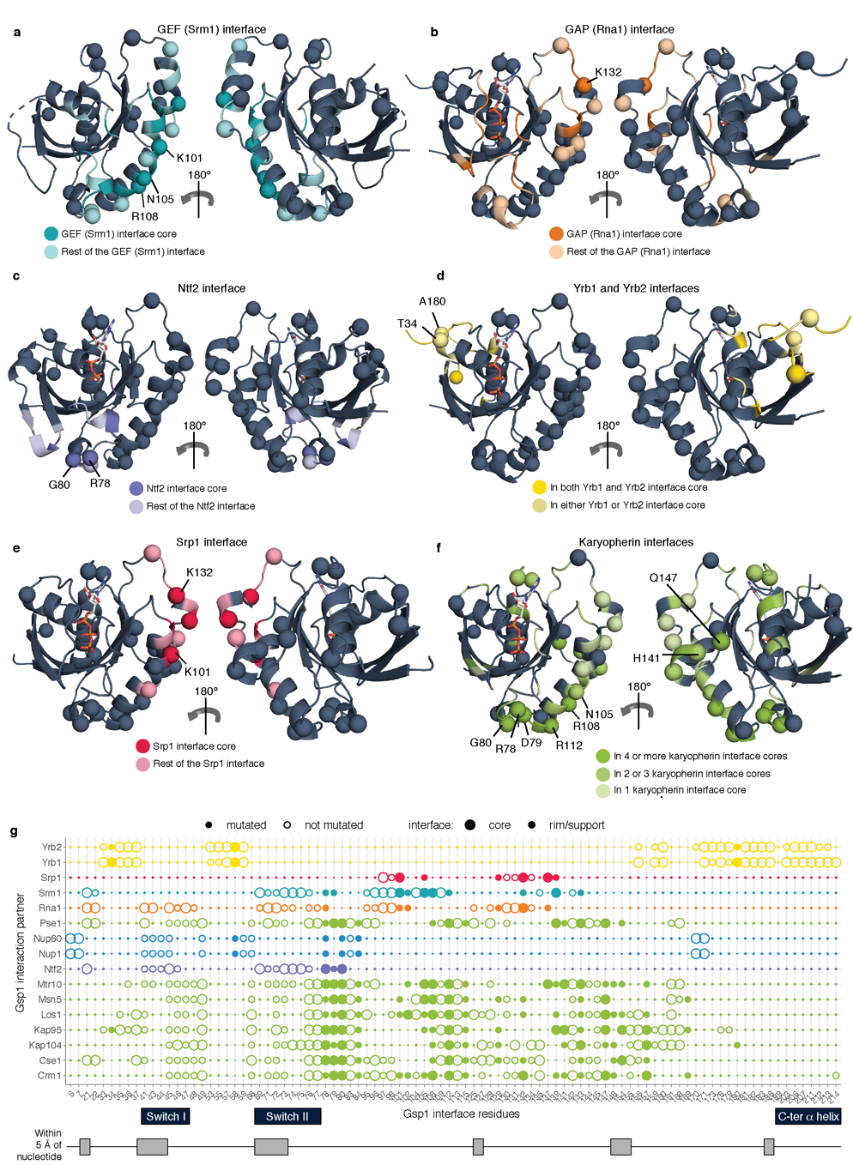

**Extended Data Figure 1 Design of interface point mutations in *S. cerevisiae* Gsp1.** **a-f,** Structures of Ran/Gsp1 in different binding conformations. Mutated Gsp1 residues are shown as spheres. Interface core, rim, and support positions are defined as in (Levy, 2010) (see **Methods**). Interface residues are coloured by the type of partner protein: **a,** Srm1 (GEF) interface core (dark teal) and interface rim and support (light teal) PDB ID: 1i2m; **b,** Rna1 (GAP) interface core (dark orange) and interface rim and support (light orange) PDB ID: 1k5d; **c,** Ntf2 interface core (dark purple) and interface rim and support (light purple) PDB ID: 1a2k; **d,** Residues that are in both the core of the Yrb1 and Yrb2 interfaces (dark yellow), and in only one of the two interfaces (light yellow) PDB ID: 1k5d; **e,** Srp1 interface core (dark pink) and interface rim and support (light pink) PDB ID: 1wa5; **f,** Residues that are in the core of more than four (dark green), two to three (green) and one (light green) karyopherin interface. Karyopherins are: Kap95, Crm1, Los1, Kap104, Msn5, Cse1, Mtr10. PDB ID: 2bku.

*- Similarly, the structures shown in Fig. 2d-f are not intuitive and don’t sufficiently convey the message. It may help to add figures with Gsp1 in a surface representation with the position of the different residues described indicated.*

Since all three reviewers indicated that our original version of **Fig. 2** was unclear, we have now reworked **Fig. 2** and the accompanying text section (see also response to reviewer #2 point 4). We hope that the new representations in **Fig. 2** now more clearly highlight the positions of the described residues.

*Minor points*

*- Suppl. Table 2 and Ext. Data Fig. 1:*

*Please provide the definition for rim and support.*

We thank the reviewer for pointing out this omission and have now added these definitions to the **Methods** section: Residues comprising interface core, support or rim were defined based on relative solvent accessible surface area (rASA), as previously defined (Levy, 2010), compared to the empirical maximum solvent accessible surface area for each of the 20 amino acids (Tien, 2013). Per residue relative accessible surface area (rASA) was calculated for a monomer (rASAmonomer) and for the complex (rASAcomplex) using the bio3d R package (Grant, 2006). The three types of interface residues were defined as: interface CORE if ΔrASA > 0 and rASAmonomer > 25% and rASAcomplex < 25%; SUPPORT residues if ΔrASA > 0 and rASAmonomer < 25%; RIM residues if ΔrASA > 0 and rASAcomplex > 25%.

*- Page 46*

*The authors use the S. pombe homologue of the Gsp1 GAP Rna1 for their kinetic experiments as the S. cerevisiae homologue forms soluble aggregates. They should provide a brief comment on how they think this may (or may not) affect the kinetic parameters determined.*

While we cannot exclude slight differences between the kinetic parameters of *S. pombe* and *S. cerevisiae* GAP Rna1, we do not believe such differences would significantly affect our conclusions, for two main reasons: First, residues in the interface with Gsp1 are highly conserved between *S. pombe* and *S. cerevisiae* GAP Rna1, suggesting that mechanism of catalysis and kinetic parameters are also likely to be similar. Second, we rely only on the *relative differences* between GAP kinetic parameters between different Gsp1 mutants to group our mutants into three classes. Even in the case of differences between the absolute kinetic parameters between the *S. pombe* and *S. cerevisiae* GAP Rna1, the order of mutants is less likely to be different, and even in the case of some differences, we expect the grouping to be robust to these changes. We have added a brief comment in the main manuscript, and a more detailed discussion in the Supplement, including a sequence alignment between *S. cerevisiae*, *S. pombe* and human GAP (**Supplementary File 1 Fig. 12**).

Main manuscript Methods section, page 52:

We were, however, successful in purifying the *S. pombe* homologue of GAP (Rna1, Uniprot P41391) as a monomer of high purity as described above. *S. pombe* and *S. cerevisiae* Rna1 proteins have an overall 39% sequence identity and 53% sequence similarity, with all but one interface core residues being identical in sequence between *S. cerevisiae* and *S. pombe* homologues (**Supplementary File 1 Fig. 12**). The X-ray crystal structure of Ran GTPase and its GAP used in our analyses is a co-complex structure of the *S. pombe* homolog of Rna1 (PDB: 15kd), human RAN, and human RANBP1 (**Supplementary File 1 Table 1**). We used the purified *S. pombe* homolog of Rna1 in all of our GTP hydrolysis kinetic experiments. Although the relationships between the mutants based on the GAP-mediated GTP hydrolysis could be different for *S. cerevisiae* we believe it is unlikely that the differences would be substantial enough to alter our conclusions (see **Supplementary File 1 Supplementary Discussion** for more detail).

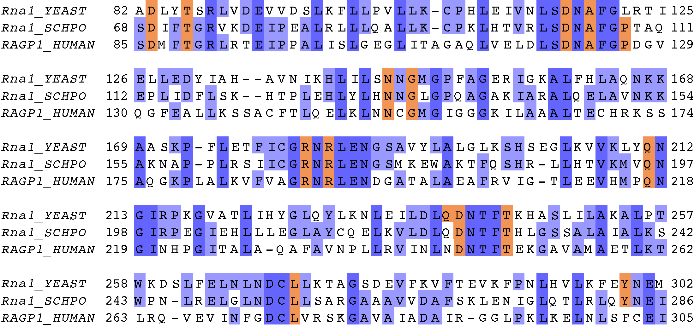

**Supplementary Figure 12 Multiple sequence alignment between Rna1 from *S. cerevisiae* (*Rna1_YEAST*) and *S. pombe* (*Rna1_SCHPO*), as well as human RanGAP (*RAGP1_human,*** excluding the C-terminal SUMO conjugation domainwhich is absent in Fungi**).** Overall sequence identity between *S. cerevisiae* and *S. pombe* Rna1 is 39%, with 53% sequence similarity.Interface core residues (based on the X-ray crystal structure between *S. pombe* Rna1 and mammalian RAN, PDB ID: 1k5d) are highlighted in orange. All residues except Pro108 in *S. pombe* Rna1, which corresponds to Leu122 in *S. cerevisiae* Rna1 are conserved in sequence between *S. cerevisiae* and *S. pombe* Rna1.

Supplementary File 1 Supplementary Discussion section:

**Potential caveats associated with using the GAP (Rna1) from *S. pombe.***

All of our GAP-mediated GTP hydrolysis kinetics experiments used the wild type and mutant Gsp1 from *S. cerevisiae*, but Rna1 GAP from *S. pombe*. We chose to use the Rna1 ortholog from *S. pombe* as *S. cerevisiae* Rna1 formed soluble aggregates after purification, and *S. pombe* Rna1 was the only RanGAP for which there was a structure in complex with Ran (PDB IDs: 1k5d and 1k5g).

While there could be slight differences between the kinetic parameters of *S. pombe* and *S. cerevisiae* GAP Rna1 acting on Gsp1, we do not believe these differences would significantly affect our conclusions, based on the following considerations:

1.) **Sequence conservation between *S. cerevisiae* and *S. pombe* Rna1.** A sequence alignment between *S. cerevisiae* *S. pombe* and human GAP proteins shows that all but one interface core residue in the PDB file 1k5d is conserved in sequence between *S. cerevisiae* and *S. pombe* (**Supplementary File 1 Supplementary Fig. 12**). Overall, out of the 1290 Å2 buried by *S. pombe* Rna1 upon interface formation with Ran/Gsp1 (PDB ID: 1k5d), 997 Å2 (77%)is buried by residues that are conserved in sequence between *S. pombe* and *S. cerevisiae*, and the sequence identity of the Rna1 interface with Ran/Gsp1 overall is 71% (Supplementary File 1 Table 1).

2.) **Comparable kinetic parameters to the human RAN/RANGAP1 pair.** The kinetic parameters for our *S. cerevisiae* Gsp1 and *S. pombe* Rna1 GAP are comparable to the kinetic parameters for the human RAN and human RANGAP1 reported by (Klebe, 1995a). They estimate a Km of 0.45 μM and kcat of 2.1 s-1 for RAN/RANGAP1 at 25˚C, while our values for the wild type *S. cerevisiae* Gsp1 and *S. pombe* Rna1 at 30˚C are a Km of 0.4 μM and kcat of 8.9 s-1. In addition, it was shown that Rna1 from *S. pombe* can activate the hydrolysis in both human and *S. cerevisiae* Ran/Gsp1 with very similar observed rates of hydrolysis (Fig. 4a in Becker, 1995).

3.) **Our conclusions are based on relative values between the wild-type Gsp1 and its point mutants.**

Although we report the absolute values of the kinetic parameters, when we compare the kinetic parameters with the results from genetic interaction profiles or AP-MS, we always use the relative parameters as compared to the wild type. Based on the sequence conservation and comparable kinetics described above, we expect the relative ordering of mutants to be similar as well. Importantly, we use the relative kinetic data to group our mutants into three classes. Even in the case of small quantitative differences caused by using the *S. pombe* instead of the *S. cerevisae* Rna1 GAP, we make the assumption that these differences would not significantly affect this grouping.

*- Suppl. Tables 6-8*

*Please rearrange these tables such that the order of mutants listed is the same across all tables to make a comparison between them easier, ideally in ascending aa sequence.*

We have changed the three tables accordingly.

*- Suppl. Figs 2 and 3*

*The authors should show plots for GAP-mediated GTP hydrolysis and GEF-mediated nucleotide exchange for all their mutants.*

We now show plots for all mutants in **Supplementary File 1 Figures 3 and 4**.

*- Page 11, line 213:*

*Is anything known about PTMs modifying K101 in yeast? Are any proteomic data sets available that may allow the authors to comment on this?*

We would like to thank Reviewer 1 and Reviewer 3 for raising this point. Initially we cited studies showing that the corresponding residue in human RAN, K99 (K101 in Gsp1), is acetylated (Choudhary, C. *et al.*, 2009), and that this acetylation perturbs GEF-mediated nucleotide exchange of human RAN *in vitro* (de Boor, S. *et al,* 2015). We should have also cited work by C. Choudhary and colleagues that shows K101 is also acetylated in *S. cerevisiae* (Henriksen et al, Mol Cell Proteomics, 2012). We have now added this reference and changed the manuscript accordingly:

A clear outlier of this ordering is the K101R mutant, which primarily affects GEF-mediated nucleotide exchange *in vitro* but, by GI profiles, groups with mutations affecting the efficiency of GTP hydrolysis. The lysine at this position was found to be acetylated in both *S. cerevisiae* (Henriksen, 2012) and human cells (Choudhary, 2009). The acetylation at this position in human RAN was shown to reduce the efficiency of nucleotide release from the RAN:GDP:GEF complex (de Boor, 2015).

REFERENCES

Choudhary, C. *et al.* Lysine acetylation targets protein complexes and co-regulates major cellular functions. *Science* **325,** 834–840 (2009).

de Boor, S. *et al.* Small GTP-binding protein Ran is regulated by posttranslational lysine acetylation. *Proceedings of the National Academy of Sciences* **112,** E3679–88 (2015).

Henriksen, P. *et al.* Proteome-wide Analysis of Lysine Acetylation Suggests its Broad Regulatory Scope in Saccharomyces cerevisiae. *Mol. Cell Proteomics* **11,** 1510–1522 (2012).

*Referee #2:*

*This manuscript by Kortemme, Krogan and coworkers addresses a very interesting question of how molecular switches regulate multiple processes. The authors use mutations as molecular perturbations to the input and output pathways of the switch and integrate systems level approaches with molecular and biophysical methods to tackle this problem. The conclusions are also exciting in that the switch cycle properties seem to tune the sensitivity of biological processes to this particular switch. Overall, the manuscript is written clearly and the authors have made a commendable effort to catalogue the methodology underlying the numerous methods they have used.*

*However, I have a number of major and minor reservations listed below that need to be addressed before the manuscript can be considered for publication.*

*Major questions:*

*1) The main conclusion from this work is a model for Gsp1 function, where different biological processes are sensitive to different aspects of the switching cycle, either cycling, GTP hydrolysis or nucleotide exchange (GDP to GTP). The authors ended up with this model starting with mutations to perturb various Gsp1-protein interaction interfaces. The power of this model is that it can now predict which processes will be affected if various parts of the cycle are tickled. However, this model has not been validated. The authors must now go the reverse direction, rationally design mutations to perturb the three aspects of the switch (cycling, activation and nucleotide exchange) and demonstrate that the model can successfully predict the effects of these mutations on downstream biological processes. Without this validation step, the predictive power of the model remains unclear and the manuscript remains one-sided.*

We agree with the reviewer that it would be desirable to support our model with additional experiments and mutations, ideally even probing all residues of Gsp1. However, there are several considerations that ultimately lead us to conclude that new insights might be limited by simply adding more attempted mutations, and that tests of the model would best be done using additional orthogonal approaches (which, to do rigorously, would require a new study of similar scope to our current manuscript). Below we outline our reasoning which we hope is agreeable:

1. Because of the considerable and unexpected allostery we uncovered in Gsp1, it is beyond current structural modeling methods to *rationally design* mutations with notable success that will differentially perturb the different aspects of the GTPase switch cycle and in turn have specific functional consequences. We therefore do not propose that we can directly predict the effects of point mutations of Gsp1 on cellular functions. We apologize if this was misleading and we have now explicitly stated that in the manuscript (see modified manuscript text below).
2. There are of course known mutations in GTPases with drastic effects on the switching cycle, such as the Q to L mutation in switch II (Q69L in RAN) or G to V mutations in the P-loop (G21V in Gsp1) that impair intrinsic and GAP-catalyzed hydrolysis, and the T to N mutation at position 24 in RAN that impairs nucleotide exchange. We have not tested such drastic mutations in our system because they are unlikely to be viable when made in the *S. cerevisiae* genomic copy of *GSP1* (we attempted to make several mutations in critical regions of the Gsp1 active site comprising the P loop, switch I or switch II (listed in **Supplementary File 1 Table 3**) but none of them were viable). However, effects of these mutations seen previously in overexpression / protein injection assays are broadly consistent with our conclusions. For example:
   1. The G21V mutant of Gsp1 with impaired GTP hydrolysis abrogates the turnover of Mad1 during spindle assembly checkpoint regulation in *S. cerevisiae* (Scott, 2009), consistent with our observation that the effects of OFF switch mutants correlate with spindle assembly regulation genes (**Fig. 4c**).
   2. The T24N mutant, which inhibits nucleotide exchange, disrupts spindle assembly in Xenopus oocyte extracts (Kalab et al, 1999), consistent with our observation that the effects of ON switch mutants correlate with actin and polarity related genes (**Extended Data Fig. 10**).
3. We could attempt to identify additional mutations with milder effects that are viable, but because of the difficulty in predicting kinetic behavior mentioned above, this effort would necessarily require trial-and-error, designing a range of new mutants, test both the kinetics parameters of those mutants *in vitro*, as well as measure their effects on cellular function by performing E-MAP screens. Because our mutants already have a considerable range of kinetic parameters and span the entire range of the conformational equilibrium observable by our NMR experiment, we are not sure we would uncover fundamentally new behaviors, at least as measurable by the current assays. While it is of course hard to argue against more data that would support our findings, we already include a considerable number of mutations in our current rather extensive study, and new mutants would add significant time and expense of genetic interactions, AP-MS, individual kinetics and NMR, perhaps yielding limited new insights.
4. Finally, a study that could address the Reviewer’s point and would test our model with a different approach would be to specifically perturb the GTPase cycle by modulating the GAP or the GEF activities directly and compare the cellular effects to those of the Gsp1 cycle mutants. However, the tools and constructs for such systematic perturbations are not established, and their development, rigorous characterization, and application would be an entire new study.

In response to the reviewer’s points, we modified the Discussion (Page 13):

Our findings lead to a model where Ran/Gsp1 acts by *three* different paradigms that are defined by the sensitivity of different biological processes to perturbations of different characteristics of the Gsp1 GTPase cycle, i.e. the ability to (i) *cycle*, (ii) *turn off* by hydrolyzing to Gsp1:GDP, and (iii) *turn on* by producing Gsp1:GTP. Other effects such as direct perturbations of interactions, binding partner competition, and changes in expression of Gsp1 or its partners also undoubtedly play a role in modulating the phenotype of our Gsp1 mutations. Nevertheless, our model explains to a remarkable degree how a single molecular switch motif can differentially control subsets of biological processes by using one of the three functional modes. Furthermore, our model is consistent with previous studies of canonical GTPase mutations in Ran, in which mutants defective in hydrolysis or nucleotide exchange were exogenously expressed or injected into cells and their effects on specific cellular processes were observed. For example, the *S. cerevisiae* Gsp1 G21V mutant defective in GTP hydrolysis abrogated Mad1 turnover during spindle assembly checkpoint regulation (Scott, 2009) consistent with the functional effects of our Gsp1 mutants affecting hydrolysis (**Fig. 4c**). The Xenopus Ran T24N mutant with impaired nucleotide exchange disrupted actin assembly (Kalab, 1999), consistent with our observation that the effects of ON switch mutants correlate with actin and polarity related genes (**Extended Data Fig. 10**). Due to the widespread allostery observed in Gsp1, precisely designing novel mutations to perturb individual Gsp1 functions remains a significant challenge, but our work provides a set of viable mutants with a range of effects on the GTPase cycle that can be used to study further molecular details of the cellular functions of Gsp1.

References:

Scott, R. J., Cairo, L. V., Van de Vosse, D. W., & Wozniak, R. W. (2009). The nuclear export factor Xpo1p targets Mad1p to kinetochores in yeast. *The Journal of Cell Biology*, *184*(1), 21–29.

Kalab, P., Pu, R. T., & Dasso, M. (1999). The ran GTPase regulates mitotic spindle assembly. *Current Biology: CB*, *9*(9), 481–484.

*2) I have concerns listed below with the Michaelis-Menten data acquisition and analysis that need to be addressed because the enzyme data form a linchpin for the correlations and the eventual model generated in this paper.*

*a) As far as I could gather from the Methods section, the GAP-mediated GTP hydrolysis kcat and Km values have been obtained from data acquired at a single substrate concentration [S] >> Km (in contrast to GEF-mediated nucleotide exchange where 0.25 um - [S] >> Km have been used) and not by varying [S]. A single substrate concentration >> Km is insufficient to determine both kcat and Km reliably. At high [S], only kcat can be obtained since the velocity of the reaction becomes independent of Km. If the velocity is forcibly fit to kcat and Km, Km and kcat/Km values will be error-prone and this may explain why errors are larger in the GTP hydrolysis data than in GEF data (Extended data figure 5 panels a,b vs c,d). Since kcat/Km values are central to their conclusions, the authors must determine Km reliably using multiple [S] data.*

Instead of using a standard Michaelis-Menten approach, as used for the GEF data, we determined the kcat and Km parameters for the GAP-mediated hydrolysis by fitting the ***integrated*** Michaelis-Menten equation to the *full* reaction progress curve, which was continuously monitored from [S] >> Km at the initial time point to [S] << Km at the final time point. Analyzing the full reaction progress curve with the integrated Michaelis-Menten equation differs fundamentally from traditional enzyme kinetic analysis of initial velocities for which case, as the reviewer correctly notes, the value of Km cannot be determined from a single initial [S] >> Km. To address the reviewer’s concern in more detail, we first outline our rationale for using the integrated Michaelis-Menten formalism, then describe the method in detail, and discuss its accuracy.

A general difficulty with our measurements of both GAP and GEF GTPase kinetics of RAN/Gsp1 is the low Km and high kcat values compared to the *in vitro* measured values of other small GTPases and their GAPs and GEFs and the relatively weak biochemical effects of mutations that are viable in *S. cerevisiae*. For the GEF assay we obtained reproducible measurements between biological replicates by measuring the decrease in tryptophan fluorescence due to tryptophan to mant-group FRET after GEF-mediated exchange (as described in Klebe *et al*. Biochemistry, 1995a). Using intrinsic tryptophan fluorescence can in principle also be used to measure GTP hydrolysis, as was done initially by Klebe *et al*, Biochemistry, 1995a, but the small change of fluorescence (10%, compared to 40% upon to tryptophan to mant FRET) was not compatible with a plate reader measurement that was desirable for our relatively large number of samples. For that reason, we decided to use a more recently established protocol that uses a phosphate sensor (Mishra and Lambright, 2015), shown to work for GAP hydrolysis measurements for RAB GTPases, as well as more recently for RAS (Bandaru *et al*, 2017).

We first confirmed for wild-type Gsp1 that the values of kinetic parameters we obtained using a phosphate sensor were similar to those estimated by Klebe *et al* using intrinsic tryptophan fluorescence and we state that in the Methods section:

We could confirm that the kinetic value parameters we obtained for wild-type Gsp1 using the phosphate sensor and integrated Michaelis-Menten equation were similar to those estimated using intrinsic tryptophan fluorescence (Klebe, 1995). Their values were a Km of 0.45 μM and kcat of 2.1 s-1 at 25˚C for mammalian RAN hydrolysis activated by *S. pombe* GAP, while our values for wild type *S. cerevisiae* Gsp1 and *S. pombe* GAP at 30˚C are Km of 0.38 μM and kcat of 9.2 s-1.

For the GEF-mediated exchange reaction, the Km values were high enough for us to obtain the Km and kcat by fitting the data for a range of Gsp1 concentrations to the standard exponential form of the Michaelis-Menten equation. However, as the Km for the GAP-mediated hydrolysis for many of the Gsp1 variants was rather low (0.1-0.4 μM), obtaining the kcat and the Km by fitting the data for a range of Gsp1:GTP concentrations would have required measuring GTP hydrolysis at Gsp1:GTP concentrations of <50 nM, which is too low for a reliable measurement of fluorescence signal increase by the phosphate sensor. We now explain that in the Methods section:

As the estimated Km for the GAP-mediated hydrolysis for many of the Gsp1 variants was in the 0.1-0.4 μM range, we sought to estimate the kinetic parameters (kcat and Km) by directly analysing the full reaction progress curve with an analytical solution of the integrated Michaelis-Menten equation.

Finally, we now discuss the integrated Michaelis-Menten approach and its accuracy in the separate paragraph of the **Methods** section in the revised manuscript (starting at page 57): **Estimating the kcat and Km parameters of GAP-mediated hydrolysis using an accurate solution to the integrated Michaelis-Menten equation.**

Others (e.g. Goudar, 1999) have shown that both kcat and Km can be estimated with reasonable accuracy/precision from a single *initial* [S] > Km by directly analyzing the *full* reaction progress curve with an analytical solution of the *integrated* Michaelis-Menten equation based on the Lambert ω function. This analysis is possible because the full reaction progress curve is characterized by an initial linear phase for [S] > Km, a final exponential phase for [S], and a transition phase for [S] ~ Km. Whereas kcat is sensitive to the slope of the initial linear phase (i.e. the initial velocity), Km is sensitive to the shape of the progress curve, which will have an extended linear phase if Km << initial [S] or no linear phase if Km >> initial [S].

Use of the integrated Michaelis-Menten analysis requires the experiment to be set up with the following conditions: (i) [Gsp1:GTP0] > Km, (ii) [GAP0] <<< [Gsp1:GTP0], and (iii) the reaction time course F(t) is measured to completion (i.e. until it approached equilibrium). Our experiments were all set up to fulfill those conditions, which means that the F(t) sampled a concentration range from [Gsp1:GTP] (at t = 0) > Km to [Gsp1:GTP] (at t = final time) << Km.

The entire F(t) can then be directly analyzed by a non-linear fit with the analytical solution for the integrated Michaelis-Menten equation. As the initial linear phase of the time course is well measured, kcat can be well determined. As the exponential phase and transition region of the time course are also well measured, the maximum likelihood value of Km can also be determined.

Specifically, each time course was fitted to an integrated Michaelis Menten equation: , where [E]t is the total enzyme (GAP) concentration, Ci is the initial fluorescence, Cf is the final fluorescence, and [S]0 is the initial concentration of the substrate (GTP loaded Gsp1), and B is the baseline slope in fluorescence per second. Exact concentration of loaded Gsp1:GTP [S]0 was estimated based on the plateau fluorescence and the sensor calibration parameters to convert the fluorescence to free phosphate concentration. The ω parameter was solved by using the Lambert ω algorithm, as previously described{Goudar, 1999, r04995}, where . The curves were fit with the custom-made software DELA (Malaby, 2015, r05863).

One way to illustrate how a single time course obtained from an experiment that satisfies the conditions (i) - (iii) above contains enough information to estimate a classical v0 vs [S0] plot is to think of the time course curve as a series of consecutive linear segments where the initial velocity (v0) was determined from the slope of each segment and the [S] from the midpoint value that can be estimated from the fluorescence signal (as we have calibrated the sensor for our experimental conditions with free phosphate). These values can then be fitted with a hyperbolic function and Km and kcat values can be calculated using the Michaelis-Menten equation (kcat[S0] / (Km + [S0])). If we follow this procedure for one of our wild-type Gsp1 time courses, we obtain similar kcat and Km values as when using the integrated Michaelis-Menten fit for the same time course (two examples are given in the figure below). The above “trick” of using linear segments and the classical Michaelis-Menten equation is of course only an approximate method for calculating the kinetic parameters, but we believe it to be a good way to intuitively illustrate the approach and comparison to the integrated Michaelis-Menten equation formalism. The yellow and purple points are from separate experiments with 1 nM [GAP].

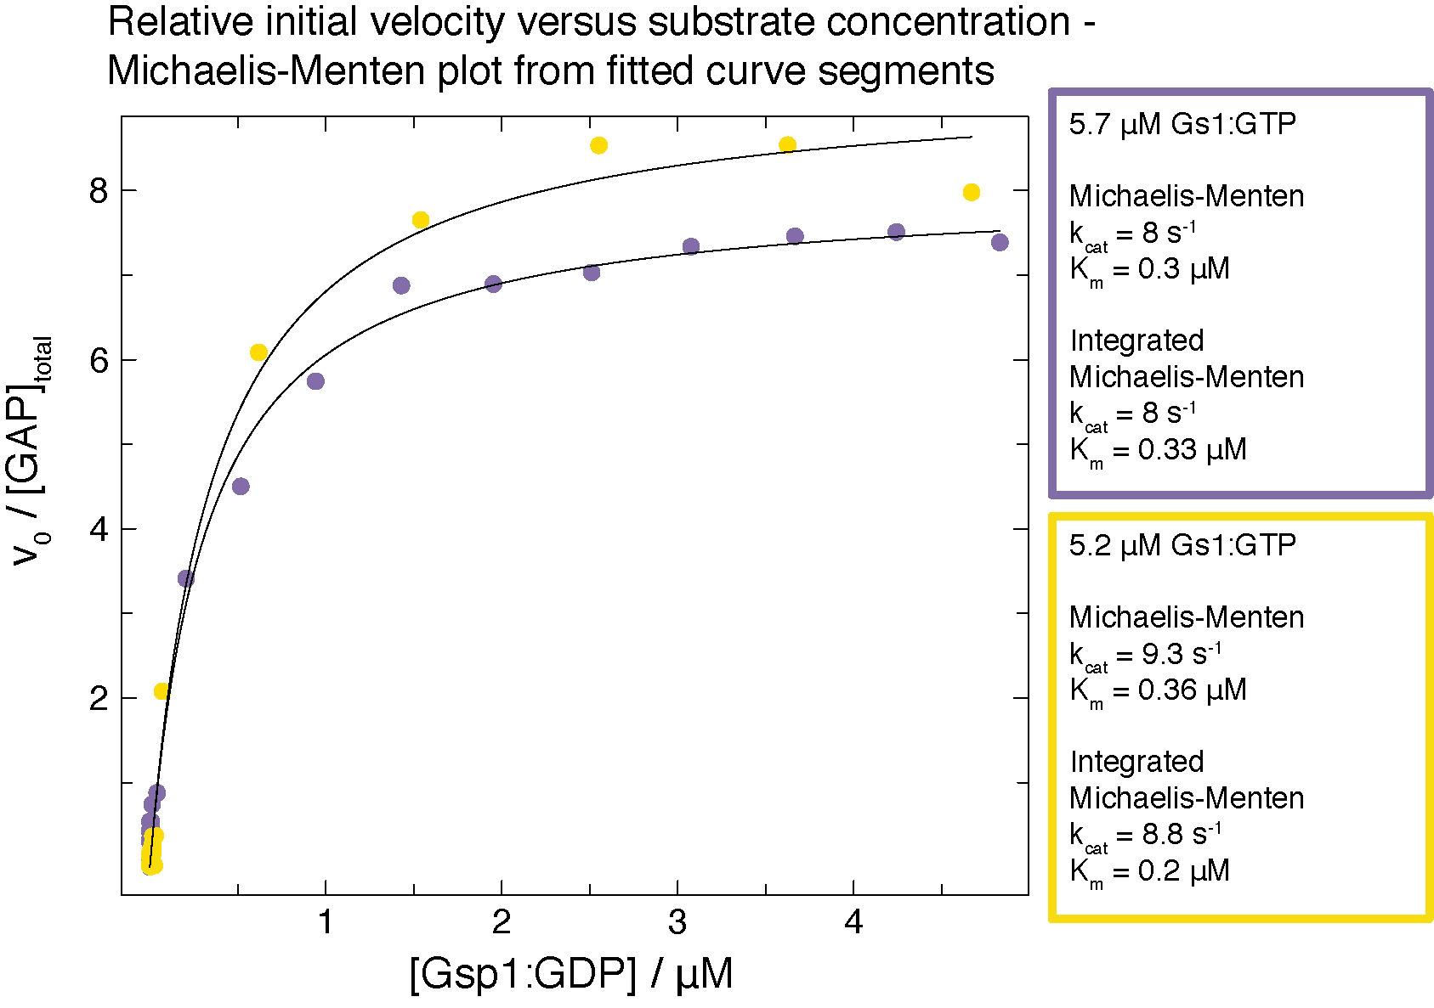

We also performed an accuracy estimation analysis (**Supplementary File 1 Fig. 14**) where we show that the standard deviation across a range of [S]/Km ratios ranges from maximum 3% for kcat and 15% for Km.

**Supplementary Figure 14 Accuracy estimation for determining the kinetic parameters of GAP-mediated GTP hydrolysis from individual time courses spanning [S] > Km to [S] << Km fit with an accurate solution of the integrated Michaelis Menten (IMM) equation.** Each time course was simulated using the experimentally determined parameters determined from the fitted IMM model, with added Gaussian noise similar to the experimental fluorescence signal noise. The deviation from the mean is plotted against a ratio of initial substrate (Gsp1:GTP) concentration and the experimentally determined Km. Deviation from the mean is reported either as standard deviation or, where N = 100 simulations, and simulation_param and experimental_param are experimental and simulated kcat, Km, and kcat/Km, respectively. Here, simulated refers to the average of the fitted values for the simulated data sets.

Importantly, in the revisions we added more replicates of GAP-mediated GTP hydrolysis for several mutants, resulting in parameter values in which we are now more confident (**Fig. 3a**, **Extended Data Fig. 6**, as well as individual curves in **Supplementary File 1 Fig. 3**). We also corrected our error analysis. In the original manuscript we reported standard errors (std.dev/sqrt(n)) for the GEF data and standard deviations for the GAP data. In addition, we overestimated the standard deviations of the kcat/Km by treating the kcat and Km values as independent observations, which is not the case since they are simultaneously determined from an analysis of the same experimental data set. The correct approach, which does not assume independence of the kcat and Km values, is to estimate the error for the mean kcat/Km directly from the variation in individual kcat/Km values between data sets. We now report correctly calculated standard *errors of mean* and numbers of replicates for **both** the GAP and the GEF experiments.

*b) Interpretation: Enzyme kinetics data in Gsp1 must be interpreted with care because there are multiple steps involved in each reaction. The authors are referred to work on the Hsp70 chaperone system which is very similar to this switch in having ATP hydrolysis-enhancing factors (J-proteins) and nucleotide exchange factors (NEFs) facilitating the cycle. Careful enzyme kinetics work by the groups of Philip Christen, Roger McMacken, Bernd Bukau and others show that multiple steps must be considered in building a model (Hu, Mayer and Tomita, BiophysJ 2006).*

We agree, the GTPase cycle is only approximated by the two reactions forming the two sides of the cycle (exchange and hydrolysis) represented as simple enzyme-substrate Michaelis-Menten reactions. Especially the GEF-mediated nucleotide exchange is a multi-step reaction, and the individual steps for the RAN GTPase were worked out by Klebe *et al*. (Klebe et al., Biochemistry, 1995a). The same authors (Klebe et al, Biochemistry, 1995b) have also proposed that both reactions can be described enzymatically, and this approach has been regularly used for other small GTPases. (We will discuss this point further in our reply to comment (iv)).

We apologize that we did not discuss the relevant considerations in sufficient detail in our manuscript and hope that our responses to the reviewer’s questions below, as well as the additional discussion we added to the paper, will rectify this issue.

*Some of the questions that authors need to consider are:*

*(i) How is the basal GTPase activity of Gsp1 taken into account? The authors have mentioned controls in the Methods. Equations used for correcting for the basal rate and equations used for fitting the data should be stated.*

RAN/Gsp1 has very low intrinsic nucleotide exchange and hydrolysis rates, which are low even compared to other small GTPases, and both the GAP and the GEF increase the reactions 105-fold (Klebe et al, Biochemistry, 1995b). Although we do report the intrinsic hydrolysis rate for our mutants, the intrinsic rates remain orders of magnitude below the enzyme facilitated reactions and we do not add the intrinsic exchange/hydrolysis term when we fit the data. We now add a note discussing this point to the methods section (line 1385), in addition, the equation for fitting the data are given in in the Methods section (see answer to point 2a above).

*ii) What are the relative affinities of GDP and GTP for Gsp1? This is important, for example, in deciding how much excess GTP is needed in a nucleotide exchange experiment.*

RAN has a 10-fold higher affinity for GDP than for GTP (Kd > 109 M-1 for GTP) (Klebe et al., 1995b). Low dissociation rates leads to Ran:GDP and Ran:GTP complexes having half-lives of several hours (Bischoff and Ponstingl, 1991; Klebe et al., 1995a; Klebe et al., 1995b). The low intrinsic dissociation rates of GDP and GTP are paralleled by a low intrinsic rate of Ran·GTP hydrolysis.

As we state in our Methods, for most of our nucleotide exchange experiments we used 200 μM mant-GTP, going up to 1 mM mant-GTP for higher concentrations of Gsp1, i.e. at least 16-fold excess of mant-GTP over the ***final*** concentration of released GDP upon reaction completion. The starting value of 200 μM was taken from the first published nucleotide exchange experiment using mant-labeled nucleotides in Klebe *et al*, 1995b. We have now added a note to our Methods stating the nucleotide affinities:

As the affinity of RAN/Gsp1 is ten-fold higher for GDP than for GTP (Kd > 109 M-1 for GTP) (Klebe, 1995), for most variants of Gsp1 we measured time courses at Gsp1:GDP concentrations ranging from 0.25 to 12 μM with an excess mant-GTP concentration of 200 μM. For Gsp1 variants with high Km values that had to be measured at concentrations of up to 200 μM we used an excess of 1000 μM mant-GTP.

*(iii) Factors such as GAP and GEF may have residual affinities for the products of the enzyme reaction (GDP-Gsp1 and GTP-Gsp1 respectively). Are these numbers known to be negligible? If not, they have to be taken into account in determining 'kcat' and 'Km'.*

The affinity of RanGAP for GDP-bound RAN is negligible; it is around ~100 μM, which is ~250-fold higher than the estimated Km for GAP-mediated GTP hydrolysis (0.4 μM from human RAN (Klebe et al, 1995a)). We have now added a note to the Methods:

Similarly, as the affinity of Rna1 for GDP-bound RAN is negligible (~ 100 μM, which is ~250-fold higher than the estimated Km for GAP-mediated GTP hydrolysis), we have not taken this affinity into account when fitting the data.

RanGEF, on the other hand, has comparable affinity for Gsp1:mant-GTP and Gsp1:GDP, which means that towards later stages of the time course, the [ES] and [EP] complexes are equally likely to form. For that reason, we followed the approach by Klebe *et al* (1995a) and fit the data using a combination of fits. We have now added a note to the Methods:

In addition, we fit the data using a combination of fits. For concentrations of substrate (Gsp1:GDP) that was much lower than the excess of mant-nucleotide (200 μM) we used a combination of two exponential decays, and for reactions with high concentrations of Gsp1, where the relative excess of mant-nucleotide was lower, we always estimated the initial rates using linear fits to the very beginning of the reaction, when levels of mant-nucleotide-bound Gsp1 are very low and therefore exchange is overwhelmingly from Gsp1-GDP to Gsp1-mant-nucleotide.

*(iv) Is there justification for using the Michaelis-Menten equations for these two reactions, instead of approximation-free A=B=C reaction kinetics? Is [ES] at a steady-state and very close to zero throughout the reaction?*

*Overall, I would like to see a more careful analysis of the enzyme kinetics data in the context of the entire cycle.*

There is considerable precedent in the literature for using Michaelis-Menten equations to describe the GTPase cycle, by different labs and for different small GTPases including Ran (Klebe et al, 1995a), Ras (Gideon et al, 1992), or Rap (Brinkmann et al, 2002), and we have now added a paragraph about the validity of the Michaelis-Menten equations for the GTPase cycle to the **Supplementary File 1 Discussion**:

**Validity of the Michaelis-Menten equation under the experimental conditions used in our GTP cycle experiments.**

Historically there have been many attempts to formalize the conditions under which the Michaelis-Menten equation to describe enzyme kinetics are valid (as reviewed in Schnell, FEBS J, 2013). These conditions have converged on the steady-state approximation or more generally, on the reactant stationary assumption. The formal condition for steady-state approximation is that t[ES] (the time it takes for the steady-state levels of [ES] complex to accumulate) is substantially shorter than t[S] (the time where [S] changes significantly). The formal condition for reactant stationary assumption is that [S] ≈ [S0] during initial build-up of [ES].

The formal condition for validity of the Michaelis-Menten equation can be expressed as:

, where and , and koff and kon are the rates of [ES] complex formation (Hanson and Schnell, 2008).

The measured dissociation constant, , for the formation of the Ran:GDP:RCC1 complex from Ran:GDP and RCC1, where RCC1 is the human RanGEF is 0.9 μM (Klebe, 1995a), which is approximately the same as the KM value obtained for the GEF-mediate nucleotide exchange for both yeast and human Ran. That means that , which means the condition for validity of the Michaelis-Menten equation can be approximated as , and since in all of our GEF experiments both [E0] = 5-20 nM << Km and [E0] << [S0], the condition holds true for the entire range of [S0] values, both below and above the Km.

As can also be expressed as , and the measured koff of human Ran:GTP and RanGAP from *S. pombe* is estimated to be around 150 s-1, while our measured kcat values range from 1 to 10 s-1, as above, the assumption of steady-state holds true as long as [E0] << Km and [E0] << [S0], which is the case as we used 1-5 nM GAP in all of our experiments.

Michaelis-Menten formalisms have been used for multiple GTPases including Ran (Klebe et al, 1995a), Ras (Gideon et al, 1992), or Rap (Brinkmann et al, 2002).

Cited REFERENCES for GAP and GEF kinetics:

Bandaru, P. *et al.* Deconstruction of the Ras switching cycle through saturation mutagenesis. *Elife* **6,** (2017).

Bischoff, F. R. & Ponstingl, H. Mitotic regulator protein RCC1 is complexed with a nuclear ras-related polypeptide. *Proceedings of the National Academy of Sciences* **88,** 10830–10834 (1991).

Brinkmann, T. *et al.* Rap-specific GTPase Activating Protein follows an Alternative Mechanism. *Journal of Biological Chemistry* **277,** 12525–12531 (2002).

Gideon, P. *et al.* Mutational and kinetic analyses of the GTPase-activating protein (GAP)-p21 interaction: the C-terminal domain of GAP is not sufficient for full activity. *Molecular and Cellular Biology* **12,** 2050–2056 (1992).

Goudar, C. T., Sonnad, J. R. & Duggleby, R. G. Parameter estimation using a direct solution of the integrated Michaelis-Menten equation. *Biochimica et biophysica acta* **1429,** 377–383 (1999).

Klebe, C., Bischoff, F. R., Ponstingl, H. & Wittinghofer, A. Interaction of the nuclear GTP-binding protein Ran with its regulatory proteins RCC1 and RanGAP1. *Biochemistry* **34,** 639–647 (1995).

Klebe, C., Prinz, H., Wittinghofer, A. & Goody, R. S. The Kinetic Mechanism of Ran-Nucleotide Exchange Catalyzed by RCC1. *Biochemistry* **34,** 12543–12552 (1995).)

Hanson, S. M. & Schnell, S. Reactant Stationary Approximation in Enzyme Kinetics. *J Phys Chem A* **112,** 8654–8658 (2008).

Mishra, A. K. & Lambright, D. G. High-throughput assay for profiling the substrate specificity of Rab GTPase-activating proteins. *Methods Mol. Biol.* **1298,** 47–60 (2015).

Schnell, S. Validity of the Michaelis-Menten equation - steady-state or reactant stationary assumption: that is the question. *FEBS J* **281,** 464–472 (2013).

*3) Lines 183-186: "Taken together, the 31P NMR and kinetic data support a molecular mechanism whereby Gsp1 interface mutations allosterically shift the conformational distribution at the active site which in turn alters the GTPase switch cycle". This conclusion is too strong for the amount of data available to support it, though the data does indeed suggest such a possibility. Given that the allostery in Gsp1 is only an interesting side-story in this manuscript, the authors can tone down this conclusion.*

*a) The correlation in Fig. 3f looks much weaker when I plot the data without the log scale on the y-axis. It is equally likely to state from the plot that the y-ratio (without log) remains between 0.05 and 0.5 regardless of what the % of the second conformation is.*

We address this comment together with b) below.

*b) While the 31P NMR data show that there are two conformations in slow exchange, they definitely don't indicate what the structural changes are between the two states and whether the conformational differences are local or global. For all we know, there may be two peaks because some sidechain is flipping in the vicinity, resulting in two peaks for 31P. Without data on other nuclei and strong correlations to structure across the entire protein, it is unwise to draw strong conclusions regarding the conformational exchange.*

We thank the reviewer for these comments, which prompted us to more carefully consider the representation and interpretation of the relationship between the conformational distributions of GTP-bound Gsp1 mutants monitored by NMR and the GAP-mediated hydrolysis kinetics.

(i) Correlation in **Fig. 3f**: We revised our data representation to now directly compare energy differences on both axes. To do so, we plotted the natural log-transformed ratios of relative catalytic efficiencies MUT/WT on the y axis and the natural log-transformed ratios of the relative equilibrium constants for exchange (ratio of γ2 and γ1 peaks) MUT/WT on the x axis (**Fig. 3d**).

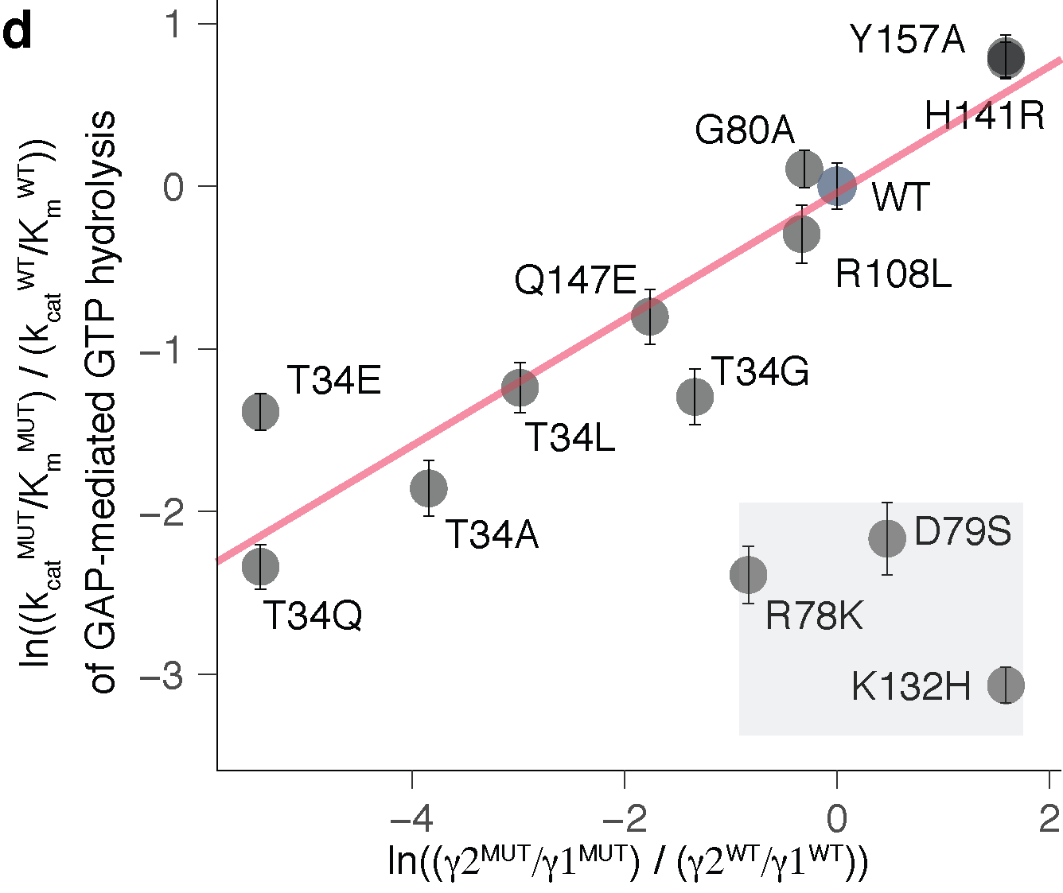

**Fig.3 d,** Log-transformed ratios MUT/WT of the exchange constants Kex = population in γ2 / population in γ1 (assuming a detection limit of 3% for the γ peak estimation by 31P NMR) plotted against the log-transformed ratios MUT/WT of the relative catalytic efficiency (kcat/Km) of GAP-mediated GTP hydrolysis. Error bars represent the mean plus/minus standard error of the mean across at least three replicates of individual GAP-mediated GTP hydrolysis measurements. Red line shows the least-squares linear fit, excluding the GAP interface mutation K132H and the two mutations adjacent to the switch II, R78K and D79S (gray box).

The observed decrease in kcat/Km for mutants shifted to γ state 1 supports an induced fit mechanism, in which GTP-bound Gsp1 in either state can bind GAP, but in cases where Gsp1 is in γ state 1 (such as for T34E and T34Q) binding energy must be used to distort Gsp1 into γ state 2, which results in an overall increase in *Km* (Fersht, 1999). This model requires state 2 to be the hydrolytically competent conformation, consistent with the observation that the intrinsic hydrolysis rate of GTP-bound Gsp1 mutants systematically increases as mutants more greatly populate γ state 2 (**Extended Data Fig. 7c**).

(ii) Conformational differences. We agree that the 31P NMR data alone do not provide structural detail on the differences between the two states across the entire protein, as our probe, the γ phosphate, is located in the active site. However, the observed chemical shift differences of the γ phosphate are caused by a several mutations that are distal (at least 18 Å away) from the site of the probe, as well as distributed across the protein surface (**Fig. 3e,f** and **Extended Data Fig.** **7d**). Our data therefore support an allosteric mechanism, rather than purely local changes in the vicinity of the active site.

Moreover, prior structural studies on the related GTPase RAS have described considerable differences between the two γ phosphate state conformations. 31P studies of H-RAS found that state 2 is associated with effector binding (Geyer et al 1996), while state 1 favors GTP loading (Liao et al 2008). High resolution crystal structures for each of the two states (state 1: PDB ID 3KKN, Shima et al 2010; state 2: PDB ID 1CTQ, Scheidig et al 1999) and the co-complex with RasGAP (PDB ID 1WQ1, Scheffzek et al 1997) have been reported, and the switch loop conformations of the RasGAP-bound structure more closely align with state 2. In RAN, just as in H-RAS, GAP binding result in a stabilization of the state 2 conformation (Geyer et al, 1999; Seewald, 2002). Furthermore, binding of the RanBP1 effector (homolog of Yrb1) to RAN shifts RAN into the γ2 conformation (Geyer et al, 1999).

Taken together, these studies suggest that RanBP1 accomplishes its activation of GAP-mediated hydrolysis by contributing binding energy towards distorting RAN to γ2 state, and that this distortion is achieved through binding at a site distal from the active site loops and the GAP interface. Given that the T34 position is in the Gsp1 interface with Yrb1 (the yeast RanBP1 homolog), we propose that the T34 mutants that primarily populate γ state 1 (T34E/Q/A/L) increase the energetic cost that GAP binding must overcome to distort Gsp1-GTP to γ state 2. This is a similar but opposite effect to RanBP1 binding, which decreases the cost that GAP binding must overcome, and is associated with decreased (tightened) *Kd* and *Km* values (Seewald et al 2003).

SHORTER VERSION I WOULD KEEP: Moreover, previous studies on the substates of GTP-bound GTPases support larger conformational differences between the γ states 1 and 2 observed by 31P NMR. The γ2 conformation of RAN is known to be stabilized by binding of its GAP (Geyer, 1999; Seewald, 2002) and by binding of the RanBP1 effector, the homolog of *S. cerevisiae* Yrb1) (Geyer, 1999). Similarly, 31P studies of HRAS found that state 2 is associated with effector binding (Geyer, 1996), while state 1 favors GTP loading (Liao, 2008). Importantly, for HRAS, high resolution crystal structures for each of the two states (state 1: PDB ID 3KKN, Shima, 2010; state 2: PDB ID 1CTQ, Scheidig, 1999) and the co-complex with RasGAP (PDB ID 1WQ1, Scheffzek, 1997) have been reported. The differences between the state 1 and state 2 structures include large rearrangements of both switch I and switch II, and the RasGAP-bound structure more closely aligns with state 21

To reflect these considerations, we have revised the manuscript section on allosteric effects as follows:.

To probe the mechanism of these allosteric effects, we examined the impact of Gsp1 point mutations on the conformational distribution in the active site of GTP-bound Gsp1 using 1D 31P nuclear magnetic resonance (NMR) spectroscopy. Prior 31P NMR data on human RAN (Geyer, 1999) and RAS (Geyer, 1996) showed two distinct peaks for the γ-phosphate of bound GTP arising from differences in the local chemical environment of the γ-phosphate in each of two distinct conformations (termed γ1 and γ2) (**Extended Data Fig. 7a**). This work also showed that the ratio of γ1 and γ2 active state conformations in human RAN can be altered by the Q69L, T42A, and F35L mutations close to the nucleotide binding site, as well as by distal effector binding. Our 31P NMR spectra of *S. cerevisiae* wild-type Gsp1:GTP showed two distinct peaks for the γ-phosphate of bound GTP with 87% of wild-type Gsp1:GTP in the γ2 state conformation. Strikingly, the populations of the γ2 state in Gsp1 interface mutants ranged from close to 0% for T34E and T34Q, to close to 100% for H141R, Y157A, and K132H (**Fig. 3c**).

Furthermore, we observed a linear relationship between the effect of the mutations on the equilibrium between the two γ conformations (plotted as log-transformed ratio of the equilibrium constant) and the log-transformed ratio of the relative catalytic efficiencies of GAP-mediated GTP hydrolysis **(Fig. 3d**) and intrinsic GTP hydrolysis (**Supplementary File 1 Table 8,** **Extended Data Fig. 7b, c**). This relationship suggests that the γ2 state represents the active site conformation of Gsp1:GTP competent for GTP hydrolysis. Remarkably, the mutated residues that tune the population of the γ2 state (T34, H141, Q147, and Y157) are all distal, affecting the chemical environment of the Gsp1-bound GTP γ phosphate from at least 18 Å away (**Fig. 3e, f**). Therefore, our data support an allosteric mechanism where distal mutations at different surface sites of Gsp1 alter the GTPase switch cycle and in particular the efficiency of GTP hydrolysis, although further studies are required to characterize the conformational changes underlying these effects. Interestingly, neither of the allosteric surface sites in Gsp1 overlap with the allosteric inhibitor pockets successfully targeted by small molecule inhibitors in RAS (Canon, 2019; Kessler, 2019; Ostrem, 2013) (**Extended Data Fig. 7d**). Exceptions to the linear relationship are the K132H mutation, which is in the core of the GAP interface and is hence expected to directly affect the interaction with the GAP, and the D79S and R78K mutations, which are on the edge of the GTPase switch II region (from residues 69 to 77) and could lead to different perturbations of the nucleotide binding site geometry.

Cited REFERENCES relevant to 31P NMR and GTPase conformations:

Fersht, A. (1999). *Structure and Mechanism in Protein Science: A Guide to Enzyme Catalysis and Protein Folding*. Macmillan. Chapter 12: Enzyme-substrate complementarity and the use of binding energy in catalysis

Geyer, M., Schweins, T., Herrmann, C., Prisner, T., Wittinghofer, A., & Kalbitzer, H. R. (1996). Conformational transitions in p21 ras and in its complexes with the effector protein Raf-RBD and the GTPase activating protein GAP. *Biochemistry*, *35*(32), 10308-10320.

Geyer, M., Assheuer, R., Klebe, C., Kuhlmann, J., Becker, J., Wittinghofer, A., & Kalbitzer, H. R. (1999). Conformational states of the nuclear GTP-binding protein Ran and its complexes with the exchange factor RCC1 and the effector protein RanBP1. *Biochemistry*, *38*(35), 11250–11260.

Liao, J., Shima, F., Araki, M., Ye, M., Muraoka, S., Sugimoto, T., ... & Kataoka, T. (2008). Two conformational states of Ras GTPase exhibit differential GTP-binding kinetics. *Biochemical and biophysical research communications*, *369*(2), 327-332.

Scheffzek, K., Ahmadian, M. R., Kabsch, W., Wiesmüller, L., Lautwein, A., Schmitz, F., & Wittinghofer, A. (1997). The Ras-RasGAP complex: structural basis for GTPase activation and its loss in oncogenic Ras mutants. *Science*, *277*(5324), 333-339.

Scheidig, A. J., Burmester, C., & Goody, R. S. (1999). The pre-hydrolysis state of p21ras in complex with GTP: new insights into the role of water molecules in the GTP hydrolysis reaction of ras-like proteins. *Structure*, *7*(11), 1311-S2.

Seewald, M. J., Körner, C., Wittinghofer, A., & Vetter, I. R. (2002). RanGAP mediates GTP hydrolysis without an arginine finger. *Nature*, *415*(6872), 662–666.

Seewald, M. J., Kraemer, A., Farkasovsky, M., Körner, C., Wittinghofer, A., & Vetter*.* I. R. (2003). Biochemical Characterization of the Ran-RanBP1-RanGAP System: Are RanBP Proteins and the Acidic Tail of RanGAP Required for the Ran-RanGAP GTPase Reaction? *Molecular and Cellular Biology* 23, 8124–8136 (2003).

Shima, F., Ijiri, Y., Muraoka, S., Liao, J., Ye, M., Araki, M., ... & Kumasaka, T. (2010). Structural basis for conformational dynamics of GTP-bound Ras protein. *Journal of Biological Chemistry*, *285*(29), 22696-22705.

*4) I find it difficult from the data to disentangle the effects of the mutations on the binding and on the cycle. A part of this problem is because the some of the mutations are directly at the interface of Srm1 and Rna1, which facilitate the cycle turnover. Secondly, I find the representation of AP-MS data in Fig. 2b/c very confusing. Particularly in Fig. 2b,*

We agree and have reworked **Fig. 2** and the representation of the AP-MS data, as described in more detail below.

*a) Why have only 6 prey proteins been quantified out of 16 whose interfaces were to be perturbed? How do we estimate how the interactions with the other 10 proteins have been affected?*

This is an important point and we should have explained it more explicitly. We opted for using AP-MS so that we could quantify changes in physical interactions under conditions where all binding partners are present at their endogenous levels. However, the drawback of AP-MS is that it is not optimal for quantifying weak interactions or interactions with partners present at very low levels. As a consequence, we were only able to quantify the interaction differences for six of the partners which we could robustly detect in pulldowns with **both** wild type and mutant Gsp1. We now clarify this point in the manuscript (see the revised Physical interactions of Gsp1 mutants paragraph below).

Nevertheless, even for the six most abundant physical interaction partners (new **Fig. 2a**), including the two main regulators (new **Fig. 2b**), we observed changes in the physical interactions that are more extensive than expected purely based on interface position. Taken together with data in **Fig. 1g**, these results suggested that effects of mutations on individual pairwise interactions do not explain the functional consequences seen in the genetic interaction profiles, and led us to uncover the effects of mutations on the GTPase cycle as the underlying explanation (see further comments below).

*b) Kap95 has 7 core residues at the interface with Gsp1 from Ext. Data Fig. 1b (79, 80, 112, 143, 147, 154 and 157). In Fig. 2b for Kap95, I don't see 7 circles/half-circles of the same size. Has the classification of core residues changed?*

Core residues had the same definition (ΔrASA > 0 & rASAm > 0.25 & rASAcomplex < 0.25) but there were two different sizes of half-circles (ΔrASA >0.25 and >0.5) in the original Fig. 2b that represented residues 79, 80, 112, 143, 147, and 157 (we do not have AP-MS data for residue 154). Moreover, we had not described these definitions, derived from the original reference, explicitly in the Methods section (we do so now). We have now reworked the presentation of AP-MS data (**Fig. 2 and Extended Data Figure 5**) eliminating the half-circle representation.

*c) Again, for example, Kap95 seems to have approximately the same number of reds and blues. Pse1 has two reds and one blue. Srm1 has four bluish tinges and four reddish tinges. Excepting Yrb1, I don't find this evidence convincing for the statement that the introduced mutations perturb the interactions they were meant to perturb (lines 130 and 142 in the manuscript.*

*Overall, I am not convinced of the extent to which the mutations introduced in this work perturb the interfaces of the 16 interactors of Supplementary File 1 Table 1. The authors should purify the mutant Gsp1 proteins and measure their interactions with the partners whose interactions the mutations were meant to perturb, using robust biophysical methods such as ITC to settle this point.*

We thank the reviewer for these comments, which highlighted that our presentation of the AP-MS data was unclear and consequently misleading. In particular, we did not intend to imply that the AP-MS data show that *all* the targeted interactions were affected as predicted, nor that these effects explain the functional data. Notably, we find that the effects of the point mutants on biological functions *cannot* be explained by the position of the mutations in each individual targeted interface. Instead, the AP-MS data suggest rather extensive changes of many physical interactions in the cellular context. We therefore think that pairwise affinity measurements *in vitro* of selected individual complexes are unlikely to better explain the functional data. We hope that our revisions clarify these points. In particular, we now highlight that: (i) Overall many (but not all) of the mutations affect the targeted interactions based on complex structures (new **Fig. 2a**, left distribution), but the AP-MS data also indicate widespread rewiring of physical protein-protein interactions (new **Fig. 2a**, right distribution). (ii) Importantly, the functional consequences of the mutations seen in the E-MAP data are better explained by changes in kinetic parameters (new **Fig. 4**) than effects directly perturbing the targeted physical interaction interfaces (**Fig. 1g**).

We revised the main text, **Fig.2**, and **Extended Data Figure 5** as follows:

**Figure 2 Gsp1 point mutations in the interfaces with protein partners globally rewire the physical interaction network of Gsp1, including changes in interactions with the switch regulators GEF (Srm1) and GAP (Rna1). a,** The change in abundance partner pulled down with Gsp1 mutants is represented as log2-transformed fold change between abundance pulled-down with mutant versus with the wild-type Gsp1. Change in abundance of pulled-down physical interaction partners for which there are also co-complex crystal structures (Rna1, Srm1, Yrb1, Kap95, Pse1, Srp1). On average, when the point mutation is in the core of the interface with the partner mean log2-transformed fold change of abundance is lower ( mean(log2FC) = -1), than when the mutation is not in the interface core with the pulled down partner (mean(log2FC) = 0.73), t-test p-value = 1.6x10-5. **b,** Change in abundance of pulled-down Rna1 (GAP) and Srm1 (GEF). There is significant change in abundance of pulled-down central regulators for most tested mutants, even when the mutations are not in the cores of GAP or GEF interfaces, for example for mutations at the T34 position. Threonine 34 is neither in the interface with the Rna1 (GAP, PDB id: 1k5d), nor the Srm1 (GEF, PDB id: 2i1m). As the coordinates for T34 are not resolved in the 2i1m structure, on the right-hand side the pink spheres show where the residue is in the aligned 1k5d structure.

**Physical interactions of Gsp1 mutants.**

To investigate further why the GI profiles of Gsp1 mutations did not group based on targeted specific physical interactions of Gsp1, we sought to determine how the physical protein interaction network of Gsp1 changes in response to the interface point mutations when all binding partners are present at their endogenous levels. We tagged wild-type Gsp1 and 28 mutants covering all interface residues shown in **Fig. 1e** with an amino- or carboxy-terminal 3xFLAG tag and quantified the abundance of 316 high confidence ‘prey’ partner proteins in complex with Gsp1 by AP-MS (**Fig. 2a**, **Extended Data Fig. 4**, **Supplementary File 4**). We refer to the prey partner protein abundance in the pulled-down Gsp1 complexes simply as “abundance” below. We quantified the abundance changes of six of the 16 Gsp1 binding partners for which we had structural information and that were robustly observable in the AP-MS data for both Gsp1 wild type and mutants: the two core regulators Rna1 (GAP) and Srm1 (GEF), as well as four effectors Yrb1, Kap95, Pse1 and Srp1 (data for other prey proteins are in **Supplementary File 4, Extended Data Figs. 4, 5**). As expected, the abundance of the prey partner was decreased on average when the Gsp1 mutation was in the interface core with the prey partner. However, we also found notable changes in prey abundance in cases where the mutation was not directly in the interface (**Fig. 2a, Extended Data Fig. 5b**). A wide spread of abundance was apparent for the two main GTPase regulators, GAP (Rna1) and GEF (Srm1), even for the mutations that are outside either of the interfaces (**Fig. 2b**, **Extended Data Fig. 5**, **Supplementary File 1 Table 5**). For example, mutations at position 34 of Gsp1, which is in the core of the interface with Yrb1, increase the levels of pulled-down GEF, and decrease the levels of pulled-down GAP, even though the residue is outside either of the interfaces (**Fig. 2b**). In summary, the AP-MS experiments confirm that the point mutations, in addition to affecting the targeted interactions also introduce extensive changes to the physical interaction network of Gsp1 that cannot simply be explained by the interface location of the mutations.

*Minor changes:*

*1) It will help to put the function of the 16 proteins in Supplementary File 1 Table 1 as a separate column.*

We agree and have added this information to Supplementary File 1 Table 1.

*2) Line 320, "highlighted in yellow": I was unable to locate the yellow colouring in Fig. 3c.*

We apologize, it seems that the transparent yellow box got converted to a gray box during the file conversion process. We hope our Figure revision fixes the issue.

*3) Line 844 should read "run in parallel".*

Thank you, we have fixed the error.

*4) Numbers seem to be slightly off in line 155: R78K and T34Q are ~10-fold, but T34A is 6.3 and T34E is 3.7, hardly 10-fold.*

To correct our error, we now use a range of values instead of only the maximum value:

In particular, mutations that are not in the interface with the GAP both increased (3-fold, R108G mutant) and decreased (3 to 10-fold, T34E/Q/A, R78K, D79S, and R112S mutants) the catalytic efficiency of GAP-mediated GTP hydrolysis, compared to wild-type Gsp1 (**Fig. 3a)**.

*5) I find it very interesting that a cycling between two forms of a switch is necessary rather than one or the other conformation. A similar effect has been observed in a cis-trans molecular switch in the circadian clock (Partch and coworkers, Mol. Cell, 2017, 66:447). Perhaps the authors can comment on a possible mechanism of how cycle dynamics, rather end populations can impact downstream biological processes?*

We agree with the reviewer that this is an interesting point and we believe it was beautifully presented in an essay we cite (Rush & D’Eustachio, BioEssays, 1996). The paper distinguishes “two distinct coupling mechanisms” of how a GTPase switch can regulate cellular processes (to which we add a third one).

1.) A “Ras paradigm” where the cellular function is defined by a gradient of “active” GTP-bound GTPase. It is a system in which only the GTP-bound GTPase binds the “effectors”. In Ras signaling, where the GEF is localized to the membrane the levels of GTP-bound Ras are highest at the membrane and dilute towards the middle of the cell. The same mechanism of active state gradient, where Gsp1:GTP gradient radiates from chromatin (where GEF is localized), diluting towards the periphery of the cell/nucleus, guides spindle assembly early in the cell cycle.

2.) For systems where a GTPase drives unidirectional transport across organelles, the difference in the GTP and GDP conformations between compartments is not gradual, as it involves regulated transport across a barrier (e.g. nuclear pore). By this “Rab paradigm” of GTPase function, both the GDP and the GTP-bound conformations are recognized by effectors.

In brief, nuclear transport is driven by a following mechanism: After karyopherins have facilitated import of cargo protein into the nucleus, GTP-bound Gsp1 binds nuclear karyopherins and recycles them back to the cytoplasm where Gsp1:GTP is hydrolysed by the GAP (Rna1), and the karyopherins are released. The GDP-bound Gsp1 is then bound to Ntf2 and recycled back to the nucleus, where Gsp1 is again converted to the GTP-bound conformation by the GEF (Srm1).

*6) While reading the manuscript, I felt that the work was not sufficiently placed in perspective of what is known about the mode of operation of other molecular switches. A short paragraph on this may help the manuscript.*

We agree and have now added a more explicit connection to switches in general when we pose our main research question in the introduction:

Proteins perform their cellular functions through interactions with many partners (Eisenberg, 2000; Mellis, 2015), organized into functional signaling networks built of elementary cycles, such as GTPases or kinase/phosphatase pairs. Switch behaviour is defined by their ultrasensitive response to regulation (Ferrell, 2014), however, the fundamental question of their functional specificity still remains: How can switches individually control different functions with the required precision and accuracy, when distinct cellular processes are inter-connected and common regulators are often shared?

We mirror the question from the Introduction in the Discussion section where we now expand on how our work sheds light on the multi-specificity with a three paradigms model of how the cycle switch is coupled to different cellular processes (see answers to points 1 and 5 above). We also note how our data on the wide-spread functional effects by relatively small changes in kinetics parameters supports the model of zero-order ultrasensitivity in GTPases:

Our observation of widespread functional effects of point mutations inducing relatively small perturbations in the GTPase kinetics is reminiscent of the zero-order ultrasensitivity achievable in biological motifs with opposing regulators (Goldbeter, 1981).

*Data presentation:*

*1) Fig. 2b/c is extremely confusing and took me a long time to interpret. They depict quantitative AP-MS data as semi-qualitative colours which do not help in making quantitative assessments.*

*a) Why are some half-circles missing their counterparts?*

The half circles represent either the N- or C-terminally FLAG tagged mutants. Although we attempted to make each of the mutants with both tags, for some mutants we only obtained viable yeast strains for one of the tags (see explanation in the ***S. cerevisiae* cell lysate preparation** paragraph of the Methods section).

*b) The meaning of circle size has changed between panels b and c. While this is indeed mentioned both on the plot and in the legend, it makes it very difficult to grasp the import of the figures.*

We agree and have eliminated the circle representation in the main Figure. Instead, we now show two distributions in Fig. 2a side-by-side in the same representation.

*c) In panel b, I found it very difficult to get a reliable estimate of circle size, which reports on the key DASA parameter, without actually using a ruler. Why has the core/rim classification of Ext. Data Fig. 1b changed though it portrays the same parameter? Consistency between these two figures will help.*

We agree and have now changed the representation in the main Figure to directly represent the fold change.

*Fig. 2b/c has to be reworked so that it is easier to understand the data. A simple histogram may work.*

We agree and have completely reworked **Fig. 2** and the main text to hopefully make the AP-MS data easier to understand (see also above) per combined suggestions by Reviewers 1 and 2. **Extended Data Fig. 5 a,b** now shows barplots representing the changes for individual prey proteins.

**Extended Data Figure 5 Gsp1 interface mutations rewire the protein-protein interactions with the partners of Gsp1 for which there are co-complex X-ray crystal structures (core regulators Srm1 and Rna1, and effectors Yrb1, Kap95, Pse1, and Srp1). a, b** Change in pulled-down prey partner abundance is expressed as log2(PREY abundanceMUT/PREY abundanceWT)). N-3xFL and C-3xFL labelled mutants are tagged with an amino- or carboxy-terminal triple FLAG tag, respectively. **a,** Changes in pulled-down prey partner abundance when the point mutation is in the core of the Gsp1 interface with the prey partner. **b,** All changes in pulled-down prey partner abundance for core regulators Srm1 and Rna1, and effectors Yrb1, Kap95, Pse1, and Srp1, regardless whether the mutation is directly in the interface or not.

Referee #3:

*Perica et al. interrogate the small GTPase Gsp1 to identify the effects of directed point mutations, largely in interface regions. Through multiple assays, including genetic interaction, protein-protein interactions, NMR, and enzyme kinetics, they determine that mutations fall into three categories, affecting overall function, GTPase function, or GTP loading.*

*Unfortunately, despite starting the manuscript with 56 mutants, at the end, through multiple rounds of experimentation, the authors manage to describe the functional impact of mutating 11 sites in Gsp1. The core findings, that mutating 11 disparate sites in a GTPase affects its overall function and that many mutations affect function through allosteric regulation, are somewhat dissatisfying. Perhaps because of the systems-level scale of the analysis, there appears to be a lack of depth of understanding for any given mutation. For instance, how does T34Q (or any other amino acid substitution at the T34 position) lead to a strong change in GAP function?*

*Points to address:*

*1. 2-9 replicates for Michaelis-Menten measurements? Why were there different numbers of replicates for some mutants compared to others?*

We conducted additional experiments that now add more replicates for the GAP-mediated GTP hydrolysis measurements, such that all of the mutants now have at least 3 replicates (**Fig. 3a** and **Extended Data Fig. 6**). We have nine replicates for the wild type Gsp1, as we periodically tested for consistency across different LOTs of the sensor and to ensure that the GAP stock had maintained its activity. We have also added more replicates for the mutants with very high Km values, to make sure that the parameters do not change significantly as we increase the difference between the [Gsp1:GTP] and the Km.

*2. Correlation plots for AP-MS experiments are disconcerting, as they show that, in many cases, the replicate pull-downs for a given mutant do not cluster together. For instance, the WT pulldown replicates do not cluster. Even more disconcerting is that the replicates for each mutant appear to have correlation values that are much less than 1.*

We would like to thank the reviewer for this comment and apologize for not including a discussion in the original manuscript. We believe the main reason our clustering appears to be less distinct than in other AP-MS studies is the different nature of our dataset (using point mutants of the same protein as opposed to comparing different proteins). If we acknowledge that in AP-MS >95% of identified proteins are typically background, clustering by total peptide signature is difficult as we compare almost identical proteins and correlations in the 0.6-0.8 range (as ours are) are not surprising. The reviewer is absolutely correct to raise this point and call for caution. However, the quality control correlation analysis based on **protein** **abundance**, instead of individual peptide counts, shows clear grouping of replicates by mutation, as well as correlation values >0.8 between replicates (new **Supplementary File 1 Figs. 10 and 11**). We chose AP-MS for its ability to measure interactions in an unbiased way in cell lysates, but the key conclusions in our manuscript do not depend on quantitative values for individual interactions (although we of course make all of our data available). Instead, our conclusions are based on significant differences in abundance change distributions of individual partner proteins (**Fig. 2a**), including changes in abundance even when the Gsp1 mutation is not in an interface with a given partner (**Fig. 2b**). Moreover, even considering the limitations of our AP-MS experiments, we still observe that the relative interactions with the GAP and the GEF are consistent with the *in vitro* kinetic parameters (**Extended Data Fig. 8a-c**).

As all of our conclusions are based on abundance of pulled down proteins, we have replaced the **Supplementary File 1 Figs. 10 and 11** with the quality control heatmaps based on correlations of protein abundance.

*3. Orthogonal validation experiments would strengthen the AP-Ms data. For instance, it should be fairly straightforward to perform co-IP western blots to demonstrate the loss of binding of SRM1 to T34A, as an example.*

Please see our responses to point 4 by Reviewer 2. While individual (pairwise) measurements of interface affinities would be interesting from a biophysical perspective, we think these experiments would not change our main conclusion that kinetic parameters of the GTPase cycle explain a large fraction of the observed functional differences.

*4. p 11: The discussion of K101R and acetylation is speculative. The authors do not show that this lysine is acetylated in yeast.*

Reviewer 1 has raised the same point and we have now modified the text and added a reference that shows the K101 position is also acetylated in yeast (please see our response to Reviewer 1).

*5. The authors start with 56 mutants, but then drop to 22 mutants that ‘express and purify well’. What does this say about the other 34 mutants? Did they not express well? If so, then the GI and AP-MS data for these mutants should be removed.*

We thank the reviewer for this comment and apologize for our misleading description. In *S. cerevisiae*, all 56 mutants express from their genomic locus at levels similar to wild type, and there is no significant difference in protein expression levels between mutants with weak and strong genetic interaction profiles (see expression quantification by Western blot in **Extended Data Fig. 2** as well as the response to reviewer #1 point 1).

Moreover, all mutants we tried to express did express in *E. coli* at similar levels to the wild type, and could be purified. However, GAP assays and NMR experiments required highly concentrated (> 1 mM) pure protein samples. In addition, both experiments required loading Gsp1 with GTP via a nucleotide-free state. In our hands, as well as noted by others (Klebe *et al*, 1995), even wild type RAN/Gsp1 is more unstable than other small GTPases without the nucleotide bound. Taken together, while all the mutants expressed well, both in *E. coli* and endogenously, difficulties arose for a few mutants when stripping them off the nucleotide at very high (>1 mM) concentrations *in vitro*.

We changed the unclear sentence to say:

To address the question whether the mutations act indirectly (i.e. by altering the competition between physical interaction partners in the cell) or directly, we recombinantly expressed and purified wild-type and 24 Gsp1 mutants and measured their effects on GAP-mediated GTP hydrolysis and GEF-mediated nucleotide exchange *in vitro* (**Fig. 3a, b, Extended Data Fig. 6**, **Supplementary File 1 Figures 3, 4,** and **Tables 6, 7**).

REFERENCE for RAN stability without nucleotide:

Klebe, C., Prinz, H., Wittinghofer, A. & Goody, R. S. The Kinetic Mechanism of Ran-Nucleotide Exchange Catalyzed by RCC1. *Biochemistry* **34,** 12543–12552 (1995).)

*6. Similar note regarding the AP-MS experiments. 56 mutants were used for GI, but only 28 for AP-MS? The other 28, even if they were not in interface regions, should have been assessed for altered protein interactions, even as controls. Are the 22 mutants for enzyme kinetics a subset of the 28 mutants for AP-MS?*

We agree that it would be desirable to have data on kinetics, NMR and physical interactions for all 56 mutations, but these would double or triple the scope of our study which already analyses a rather large set of mutations with several different methods in cells and *in vitro*. To make the scope doable, we first conducted completely unbiased genetic interaction measurements, which are suited to high-throughput measurements of many mutations simultaneously. For the other experiments that are considerably more resource and time-intensive as they are one-at-a-time measurements, we chose representative mutants, covering all the functional subgroups. We hope that these choices are understandable given finite resources and have added to the manuscript:

In summary, when choosing mutants to characterize by AP-MS and *in vitro* kinetics, we sought to cover all the residues whose mutants had strong GI profiles (**Fig. 1e**), as well as several “weak” mutants. The final set of mutants was constrained by the viability of FLAG-tagged mutants and the feasibility of protein loading at high concentrations, as explained in the point above. There are 23 mutants with complete E-MAP, AP-MS and kinetics data: We could not make the FLAG-tagged R108Q mutant for AP-MS, and we are missing *in vitro* kinetics data for H141E/I/V and Y148I mutants which were more unstable than the wild type in the nucleotide free state, as well as a “weak” N105L mutant.

Overall, based on the spread of kinetic parameters (**Fig. 4a** and **Extended Data Fig. 8**) we believe that the final set of 23 mutants covers the spread of kinetics properties sufficiently for us to draw the final conclusions about the three paradigms of how multiple cellular processes are coupled to a single molecular switch.

XXX

We now explain the final set of mutants for AP-MS in the Methods:

When choosing mutants for AP-MS we sought to cover all the residues whose mutations had strong GI profiles (**Fig. 1e**), as well as several ‘weak’ mutants. We observed that tagging the endogenous Gsp1 with either the amino-terminal or the carboxy-terminal FLAG tag affects the *S. cerevisiae* growth in culture. We therefore attempted to make each of the mutants intended for AP-MS experiments with either tag, and where both tags were viable we obtained the AP-MS data for both.

*7. Were only 13 of the mutants used for NMR?*

Yes, we collected and presented NMR data for 13 mutants. As mentioned in our response to point 5, adequate signal for the 31P NMR studies required relatively large volumes (400 µL) of highly concentrated samples of purified protein (> 800 µM) after GTP-loading (which in our hands dilutes samples to ~40% initial concentration). Thus, our workflow began with concentration of purified Gsp1:GDP mutants to well over 1 mM. Attempts to concentrate several mutants to these high concentrations were unfortunately in vain, with most of the protein precipitating out, despite these mutants being readily purified at lower concentrations, active in the GEF and GAP assays, and stably folded as confirmed by CD spectroscopy (**Supplementary File 1 Fig. 12** and **Supplementary Table 9**). However, the data for those mutants which we did collect span the entire range of observable behaviours in the assay, as it included two mutants only observable in state 1, three mutants only observable in state 2, the WT variant, two mutants with WT-like distributions, and several intermediate mutants (**Fig. 3c** and **d**). While we would have been eager to collect a larger set if the samples were attainable, we do not believe those additional mutants would significantly change our conclusions.

*8. In Supp. Tables 6-8 the authors include std. dev. and std. error values. Often these values are of similar magnitude to the measured value, indicating that the confidence in the measured value is low. Yet it seems that these measured values were still used in the main figures, with no indication of the error. Some indication of significance should be assigned to these figures.*

We agree and thank the reviewer, as addressing this important comment has improved our manuscript. The three main changes we made are:

1. We have collected additional data on GAP-mediated GTP hydrolysis for several of the mutants to better assess confidence in the measurements.

2. We now report the standard error for both the GAP and the GEF data to reflect the confidence in the mean value.

3. We now report the propagated standard error in all of our plots that show relative ratio (MUT/WT) of the kinetic parameters, most notably in **Fig. 4** (as well as accompanied **Extended Data Fig. 9** and **10**). In cases where we report the ln ratios (MUT/WT), we report the standard error as standard error divided by the relative value (MUT/WT).