VAJA 15. in 18.6.

**HTML**

<meta charset="UTF-8">

Je za šumnike!!

Congratulations on completing the second unit of HTML & CSS! In this unit, you learned how to add content to a web page using some of the most common HTML elements.

Let's review what you've learned so far:

* [<p>](https://www.w3schools.com/tags/tag_p.asp) defines a paragraph
* You can add headings of different sizes using the different headings elements: <h1> through <h6>.
* Paragraphs are added with the <p> element.
* Unordered lists are created with the <ul> element and list items are added using the <li> element.
* Ordered lists are created with the <ol> element and list items are added using the <li> element.
* You can add links to your web page using the <a> element - don't forget the href attribute!
* Images can be added with the <img> element - don't forget the src attribute!
* Images help support visually impaired users when <img> elements include the alt attribute.
* You can turn anything into a link by wrapping it with an <a> element.
* White space in the HTML file does not affect the positioning of elements in the browser.
* The W3C recommends 2 spaces of indentation for nested HTML elements.
* Comments are used to take notes inside of an HTML file. You can add a comment with
* <!-- This is a comment -->.

      <div> defines a division or a section in an HTML document. Is used to group block-elements to format them with CSS.

**CSS**

**NUJNO VEDET ZA OSNOVO CSS-ja:**

**1.**

**Tag <style></style> v HTML kodi definira CSS.**

*Če ne pišeš CSS kode ločeno ampak direktno v index.html fajl mora ta imeti v <head> nujno tag <style>!*

*če v <head> ne zapišeš začetnega <style> in zaključnega </style> tag-a, se tako css zapis ne bo videl!*

**2.**

**CSS koda se piše z zavitim oklepajem in zaklepajem**

shift+alt+š {

shift+alt+đ }

- - - - - - - -

style.css ime fajla!

Ime {

pravilo: vrednost;

}

**3.**

**atributi in tagi:**

**atribut “class”** definira vsebino kode

tag [<p>](https://www.w3schools.com/tags/tag_p.asp) definira paragraf

p {

  color: red;

  text-decoration: underline;

}

.green {

  color: green;

}

**atribut “id**” definira identiteto objekta

primer zapisa barve

}

#verySpecialParagraph {

}

**primer zapisa velikih črk**

}

#verySpecialParagraph {

  text-transform: uppercase;

}

*En id se lahko pojavi le enkrat v našem HTML (samo pri enem HTML elementu), medtem ko lahko en class uporabimo večkrat.*

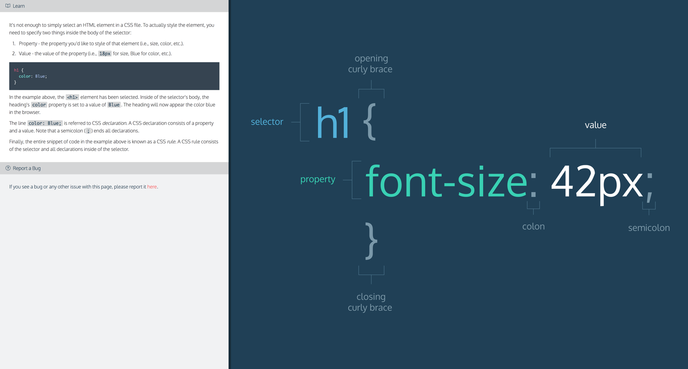

- - - - - - - - - - - - - - - - -

**POMEMBNO**

**Povečava črk “span”**

<span class="green">Jst sem še vedno zelen!</span>

(Glej primer v JSFiddle vajah)

Kako povežemo CSS datoteko s HTML datoteko?

ukaz **rel="stylesheet"** v html kodi pomeni ukaz, da css ve da bomo písali zanj

* **če je url na tvojem kompu potem tako:**

**<link href=”/style.css” type="text/css"** **rel="stylesheet"**

* **če je url iz spleta pa takole (z linkom določene spletne strani):**

**<link href=”www.google.com” type="text/css"** **rel="stylesheet"**

**opis atributov v zgornji kodi:**

href - like the anchor element, the value of this attribute must be the address, or path, to the CSS file.

type - this attribute describes the type of document that you are linking to (in this case, a CSS file). The value of this attribute should be set to text/css.

rel - this attribute describes the relationship between the HTML file and the CSS file. Because you are linking to a stylesheet, the value should be set to stylesheet.

zapis je tak:

<head>

*<!-- ostala koda -->*

<link rel=”stylesheet” href=”style.css”>

</head>

*LINK VEDNO UMESTIMO ZNOTRAJ <head>!!!*

- - - - - - - - - - - - - - - - -

**KORISTNO**

*Za povečavo prve črke v stavku*

p : : first-letter { font-size: 30px; }

*Pisanje komentarjev v kodi:*

za pisanje komentarjev v html kodi

<!-- blablabla -->

torej “blablabla” del se v brskalinku ne bo videl

za pisanje komentarjev v css:

/* blabla */

*Knjižnice za animacije:*

Animate.css (www.daneden.github.io)

GitHubova je kul

*Kje najti primere CSS lastnosti (CSS properties)?*

* CSS properties: <http://www.w3schools.com/cssref/default.asp>
* CSS selectors: <http://www.w3schools.com/cssref/css_selectors.asp>
* StackOverflow: <http://stackoverflow.com/>
* CSS examples: <http://www.w3schools.com/css/default.asp>

VAJA 22.6.