Root Directory

├── scseq_2.Rmd

├── go_nr1d1.Rmd

├── go_hdac3.Rmd

├── go_nfil3.Rmd

├── compare.Rmd

└── 3.11

├── foldchange_genelist_get.ipynb

├── nr1d1_dependent_genes_with_fold_change.txt

├── hdac3_dependent_genes_with_fold_change.txt

├── nfil3_dependent_genes_with_fold_change.txt

├── nr1d1_uniq_ID.txt

├── hdac3_uniq_ID.txt

├── nfil3_uniq_ID.txt

├── atlas_mean.txt

├── clustered_data_2.txt

├── genes_cluster_21.txt

├── genes_cluster_22.txt

├── meta2d_nfil3_WT.txt

├── meta2d_nfil3_KO.txt

├── meta2d_nr1d1_WT.txt

├── meta2d_nr1d1_KO.txt

├── meta2d_hdac3_WT.txt

└── meta2d_hdac3_KO.txt

Some progress and changes

1. **Get foldchange for each dependent gene list**

***Foldchange_genelist_get.ipynb***

(eg:Nr1d1) Input : *meta2d_nr1d1_KO.txt ,meta2d_nr1d1_KO.txt* - - - use ramp column

*nr1d1_uniq_ID.txt*

Output : nr1d1_dependent_genes_with_fold_change.txt

Description:calculate original all gene foldchange based on ‘ramp’ column and then filter out genes by dependent genelist

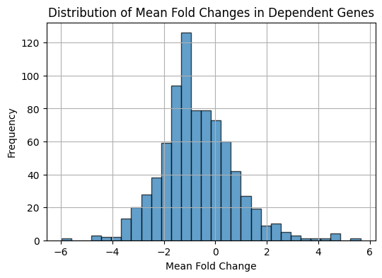

*Nr1d1 distribution of gene foldchange*

1. **For each dependent gene list with foldchange file, perform GO, network**

Follow tutorial <https://yulab-smu.top/biomedical-knowledge-mining-book/enrichplot.html>

(eg:Nr1d1)

***go_nr1d1.Rmd go_nr1d1.Rmd go_nr1d1.Rmd***

Input files needed :

*nr1d1_dependent_genes_with_fold_change.txt hdac3_dependent_genes_with_fold_change.txt hdac3_dependent_genes_with_fold_change.txt*

```{r}

*edo <- enrichGO(gene = names(gene_list), OrgDb = org.Mm.eg.db, keyType = "ENTREZID", ont = "BP", pvalueCutoff = 0.05)*

```

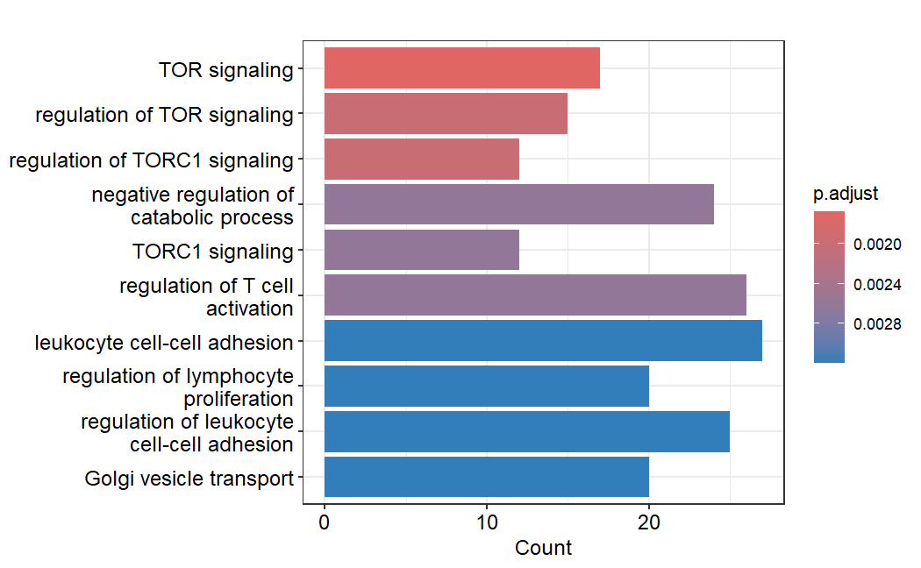

*Bar plot of 10 go terms*

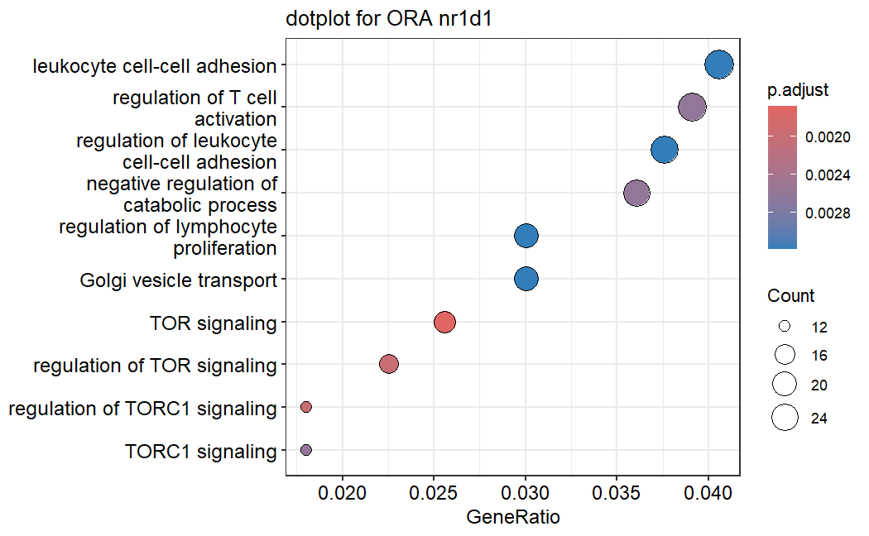

*Dot plot of 10 go terms*

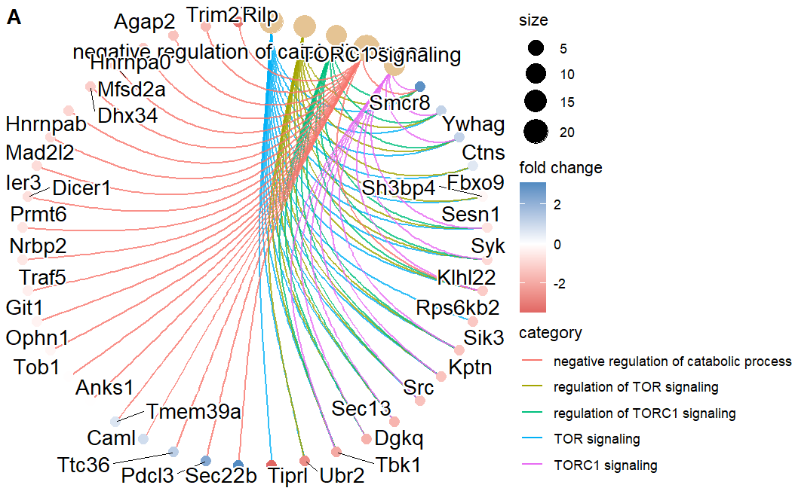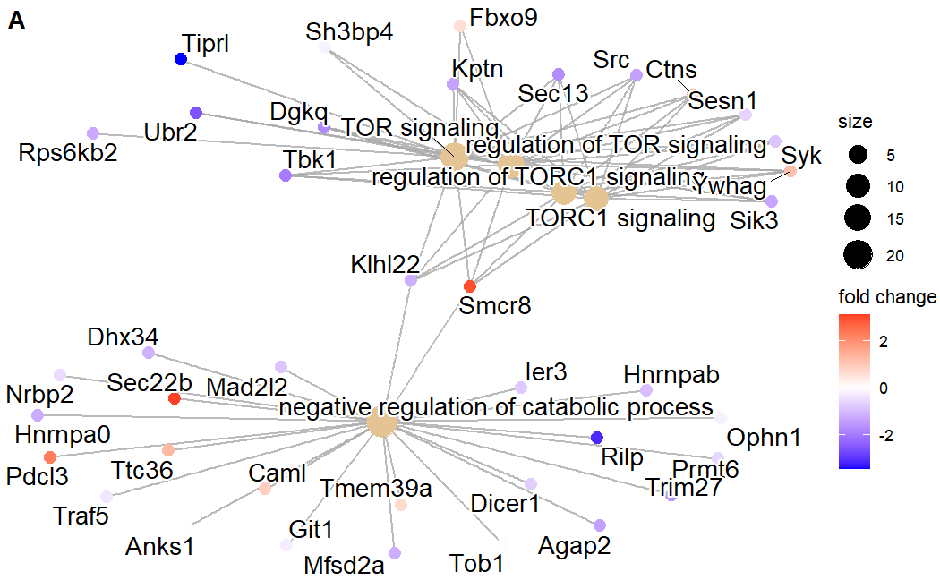

*Gene - concept network*

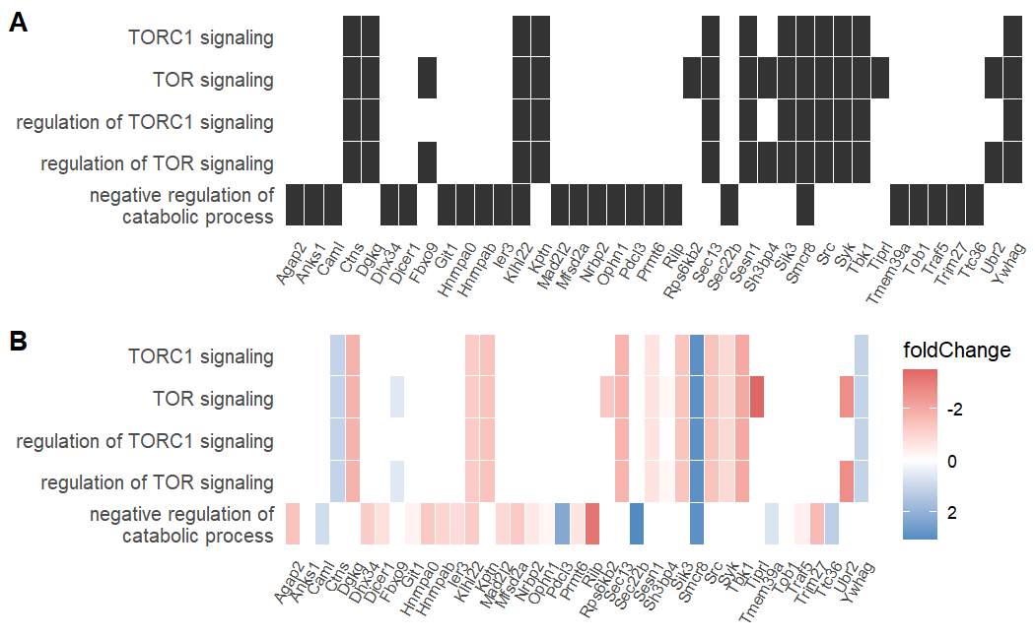

*Heatmap-like functional classification*

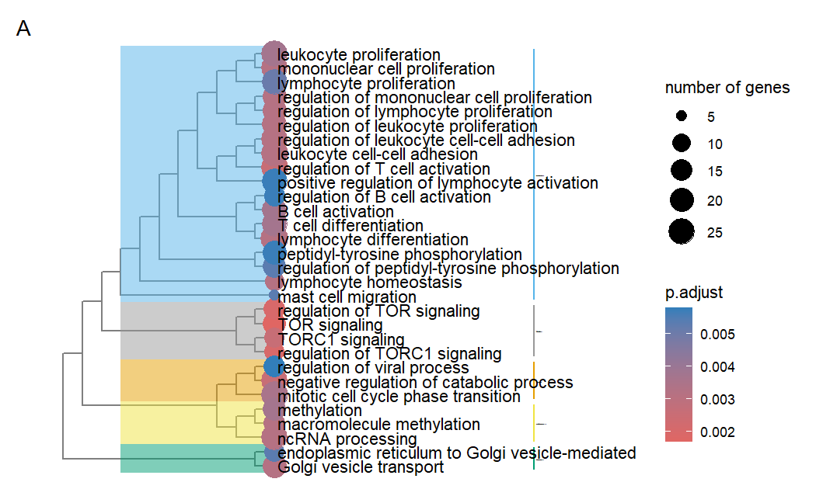

*Tree plot*

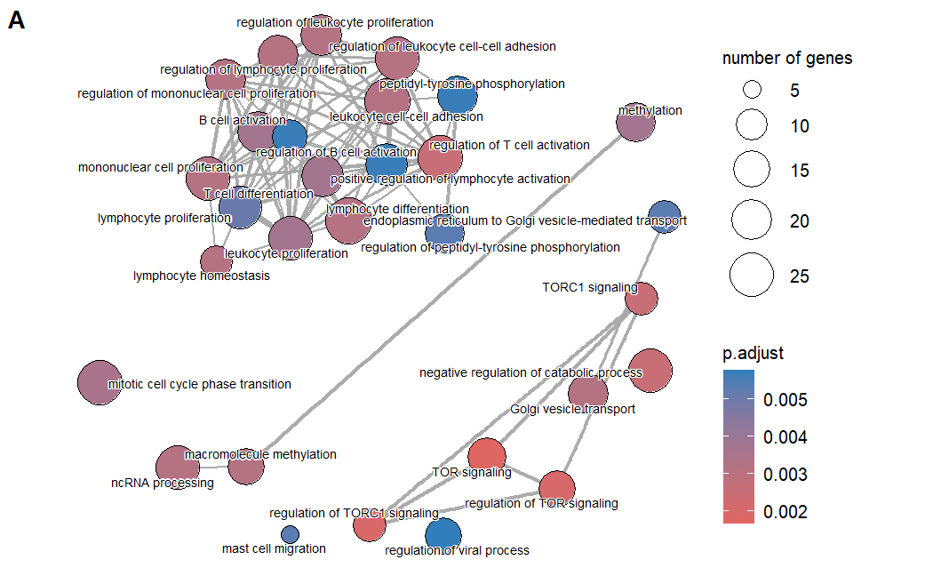

*Enrichment Map*

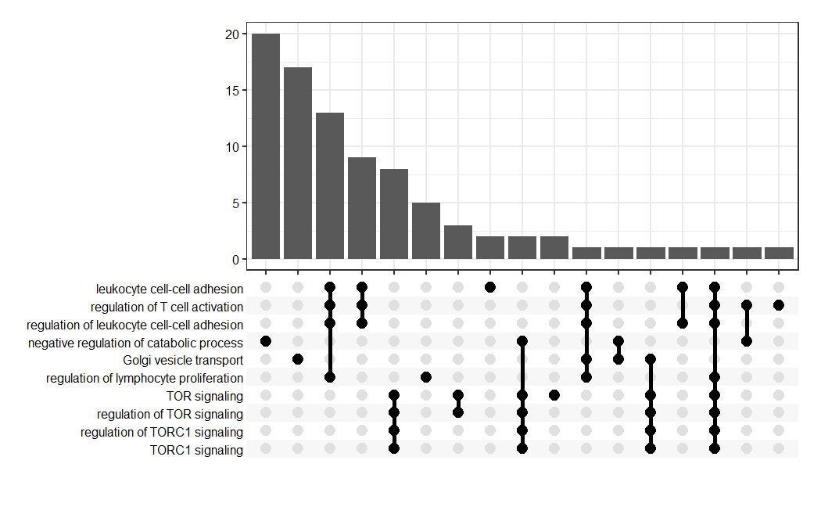

*Upset plot*

1. **Compare 3 gene lists without foldchange**

*Follow tutorial* [*https://yulab-smu.top/biomedical-knowledge-mining-book/clusterprofiler-comparecluster.html*](https://yulab-smu.top/biomedical-knowledge-mining-book/clusterprofiler-comparecluster.html)

*Have questions for this part, I notice 3 gene lists not overlapped*

***compare.Rmd***

Input files needed: *nr1d1_uniq_ID.txt hdac3_uniq_ID.txt nfil3_uniq_ID.txt*

1. ***KEGG***

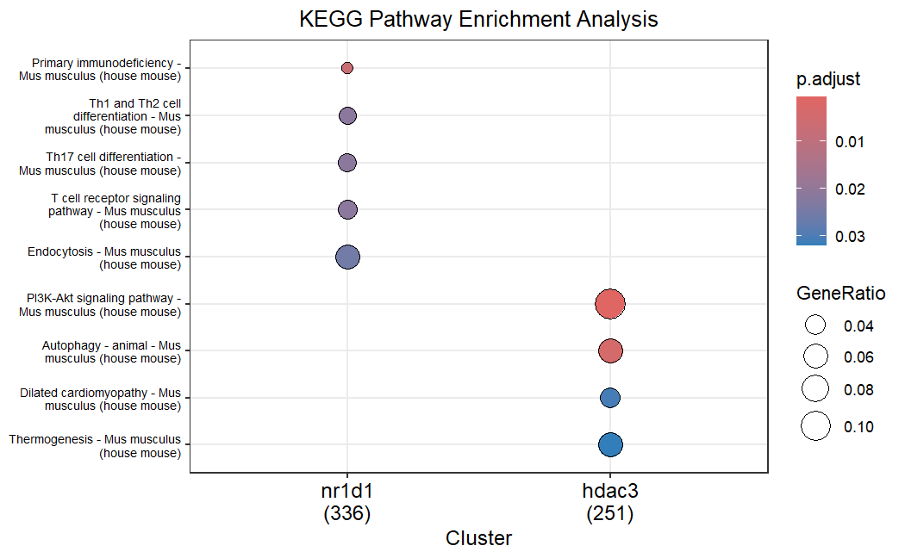

when I use KEGG, nfil3 group not shown in the graph, I think this make sense. Enriched terms very few with KEGG.

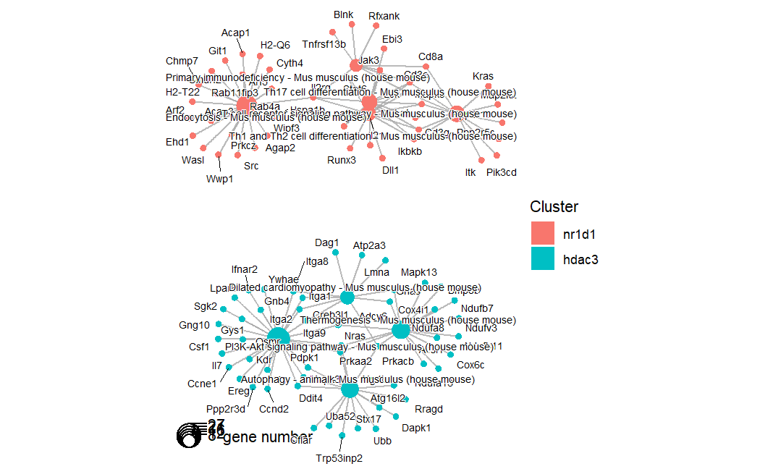

While the go term network looks like there is no overlap between 2 groups which is weird. No genes in 2 groups share same go term.

1. ***GO***

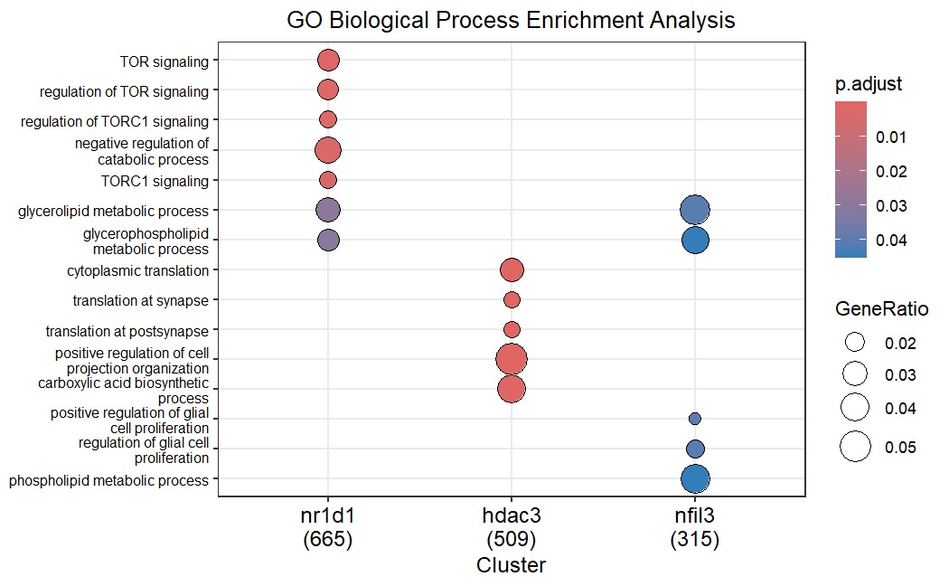

*Go enrichment Compare 3 groups (dotplot)*

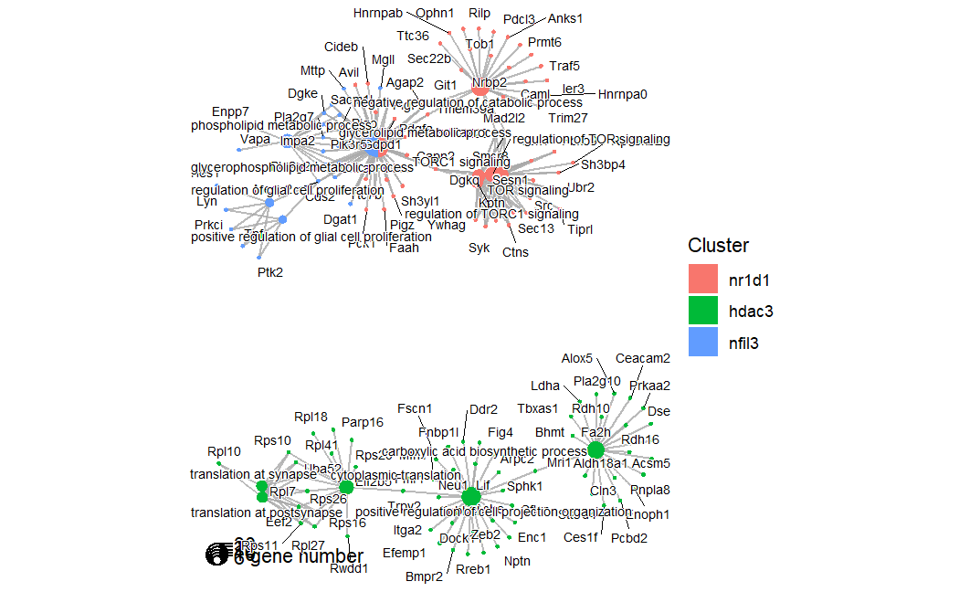

*Go enrichment Compare 3 groups(network)*

**4. Scrnaseq, dependent_genes**

Combine 3 dependent genelists

Filter scrnaseq data *atlas_mean.txt* by combined genes: *# 1530*

***scseq_2.Rmd***

Q: I pre-define the cluster of genes based on gene expression levels among cell types.

Use elbow plot to find optimal k ->2, and then plot heatmap based on cluster 2

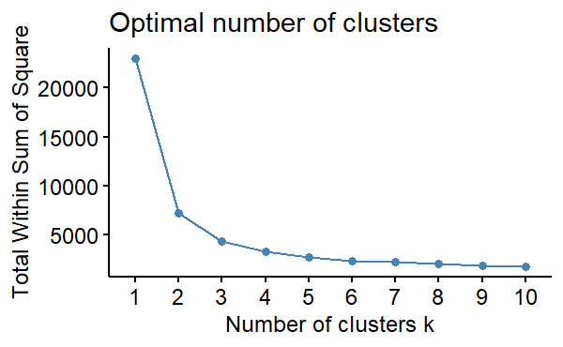

*Elbow plot*

A little confused by this heatmap of 2 clusters

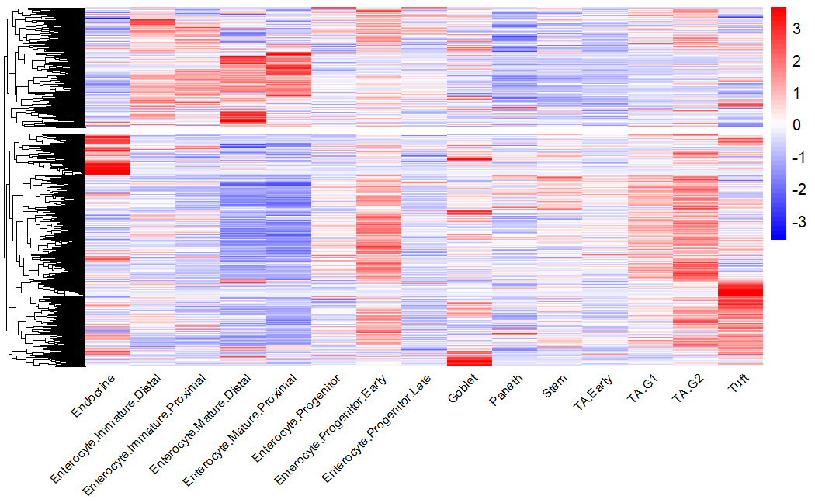

*Heatmap of 2 clusters based on rows(genes)*

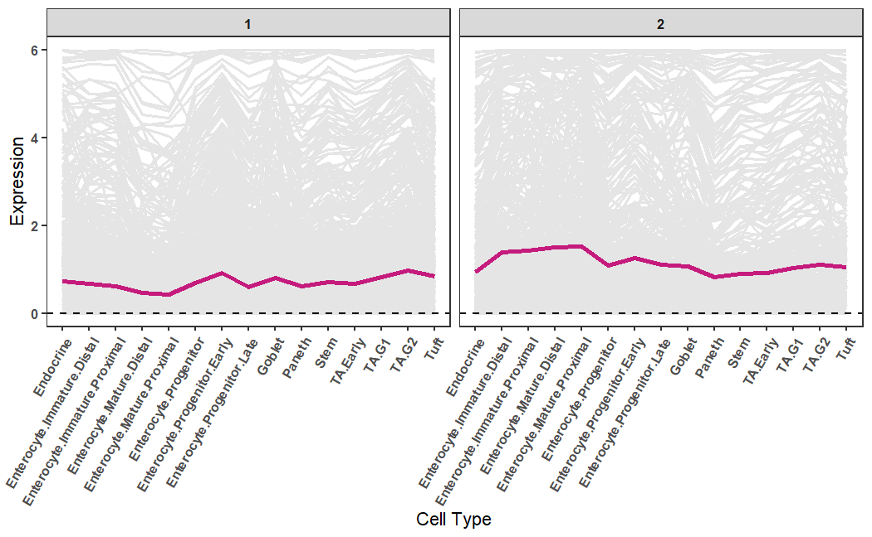

*gene expression trends*

**Some visualizations of the percentage and counts :**

