Tinashe Chisango
Capstone Project
December 2, 2025

U.S. Business Formation Statistics from 2021-2024: Final Report

Introduction
This project analyzes U.S. Business Formation Statistics (BFS) from 2021–2024 to understand trends in business applications and employer formations. Primary goals included cleaning the raw dataset, producing descriptive statistics, answering six case study questions, and running two hypothesis tests to evaluate differences between states and across time periods. All work was completed in RStudio using a reproducible R Project structure.

Data
The data came from the U.S. Census Bureau’s website in the form of a csv file titled “bfs_monthly.csv”. This file contains monthly business application and formation counts organized by a variety of variables, including seasonal adjustment status, NAICS sector, application or formation series types, geographic codes, the year of observation, and twelve columns representing monthly counts from January through December. These monthly fields were later reshaped into a long format to support time-series analysis. The original data set had 35,190 rows of data, dating back to 2004. For the scope of this project, only data from 2021-2024 and for the 50 US states (plus DC) was necessary. A filter was applied to limit the dataset to non-seasonally adjusted observations (so that the values were of true unadjusted counts rather than Census-adjusted values); the TOTAL industry category; excluded the geographic tags of US, NO, MW, SO, WE, PR; and the years 2021-2024.
Exploratory Data Analysis
Initial exploration included listing the most common filing series, checking for missing values, identifying the top states by total business applications, and examining national totals by year. This included computing descriptive statistics for both business applications and employer formations by month and year. Mean, median, standard deviation, quartiles, interquartile ranges, and minimum and maximum values were each calculated to understand the distribution of activity across states and over time. The descriptive statistics provided a foundational understanding of the variability and magnitude of business formation activity.

Case Study Questions
- What is the total count of new business applications per month for each year (2021–2024)?
Monthly totals revealed clear patterns in application behavior across the four years, as seen in Figure 1. Business applications show consistent seasonal peaks in spring, especially in the months of March, April, and May. There are dips in business applications at the end of each year. The highest peak came in March 2023, which was just above March 2021. The year 2021 seemed to see the highest monthly peaks following the pandemic surge, while 2022 dropped slightly before stabilizing through 2023 and 2024.
- What are the most common types of business filings (e.g., high-propensity, corporation, LLC)?
The results shown in Figure 2 indicate that the highest total is obviously the total business applications, which collects all applications. The next highest, and therefore the most common meaningful filing type, is high-propensity applications. Corporate applications and wage-related filings were much smaller. Employer formations were only a fraction of total applications, which shows that many applications do not lead to employer businesses.
- What is the monthly count of employer-identifying business formations by year?
Employer formations displayed seasonal patterns similar to applications, with early-year peaks and late-year declines (Figure 3). Activity decreased slightly in 2022, leveled off somewhat in 2023, and then experienced another slight decline in 2024. This pattern indicates that employer business formation is responsive to the same macroeconomic or seasonal factors that affect application volume.
- What are the percentage increases or decreases in applications and formations compared to the previous year, extending through the most recent data in 2024?
The results showed that both applications and formations declined in 2022 after the 2021 boom, rebounded sharply in 2023, and softened again in 2024, though the 2024 drop was not as steep as the decline from 2021 to 2022 (Figure 4). The alternating increases and decreases indicate a high degree of short-term variation, but there is no evidence of a long-term, sustained downward trend across these years.
- What is the propensity (trend line) of increases or decreases in total business applications over time through 2024?
The national time series of total monthly applications revealed a consistent pattern, as seen in Figure 5. It seems like there is a pretty visible pattern of total applications each year with a peak in the beginning of the year followed by decreases. It was interesting to see how similar each year's pattern was in shape. Although there are fluctuations throughout each year, there is still consistent activity which is encouraging.
- What is the propensity of increases or decreases in high-propensity business formations over time through 2024?
The trends for high-propensity applications closely mirrored those of total applications, shown in Figure 6. High-propensity applications, or those most likely to become employer formations, had very similar trends to those of the total applications. This trend was a peak at the beginning of the year followed by decreases. This suggests that entrepreneurial intent, specifically intent to form employer firms, follows the same annual pattern seen in overall business activity.

Hypothesis Testing
The first hypothesis test compared mean monthly employer formations between states with high total business application levels and those with lower application levels. The null hypothesis stated that there was no difference between the two groups, and the alternative hypothesis proposed that high-application states would have higher formation activity. A Welch two-sample t-test produced a p-value of 0.0002441. Because this p-value is well below 0.05, we rejected the null hypothesis. High-application states have significantly higher average monthly employer business formations, approximately 1,227 per month, compared to about 220 per month in lower-application states. This finding shows a strong and statistically significant relationship between high business application activity and higher employer formation rates.
The second hypothesis test evaluated whether business applications declined in the later post-pandemic period (2023–2024) compared to the early post-pandemic period (2021–2022). An ANOVA test produced a p-value of 0.679. Since this value is far above 0.05, we failed to reject the null hypothesis. There is no statistically significant difference in mean monthly business applications between the early post-pandemic period and the later post-pandemic period, indicating that overall application levels did not meaningfully drop after 2022.

Teamwork
Each team member contributed to different aspects of the project, as instructed in the project guidelines. We met as a group multiple times to talk about progress updates and work on the code. The final report and presentation reflect the combined effort and input of the entire team.

Conclusion
Analysis performed on business applications and formations in the US from 2021-2024 showed that entrepreneurial activity follows a relatively consistent pattern throughout each year, even after the pandemic. RStudio was an effective tool for this project’s data and statistical analysis. Limitations included only one semester’s worth of knowledge of the R programming language. Only non-seasonally adjusted data was focused on for this project, which may have exaggerated monthly fluctuations. Future work could include further investigation into seasonally adjusted data, more detailed aggregation into county or city level data, and tracking how the formed businesses survive in the real world.

Appendix
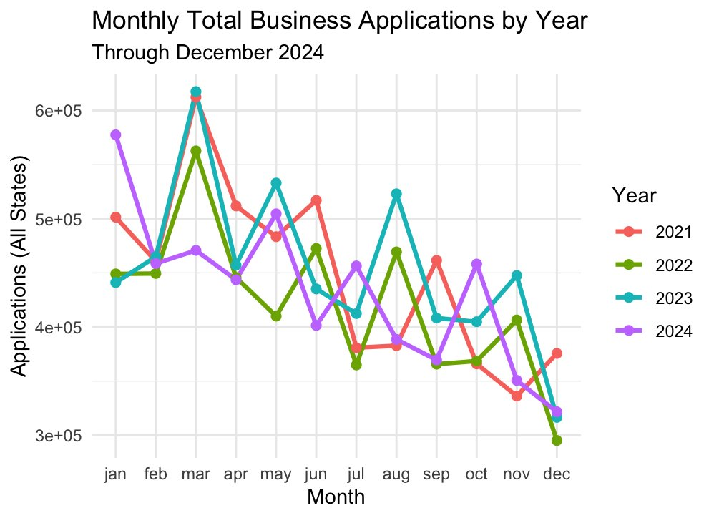Figure 1. Monthly Total Business Applications by Year
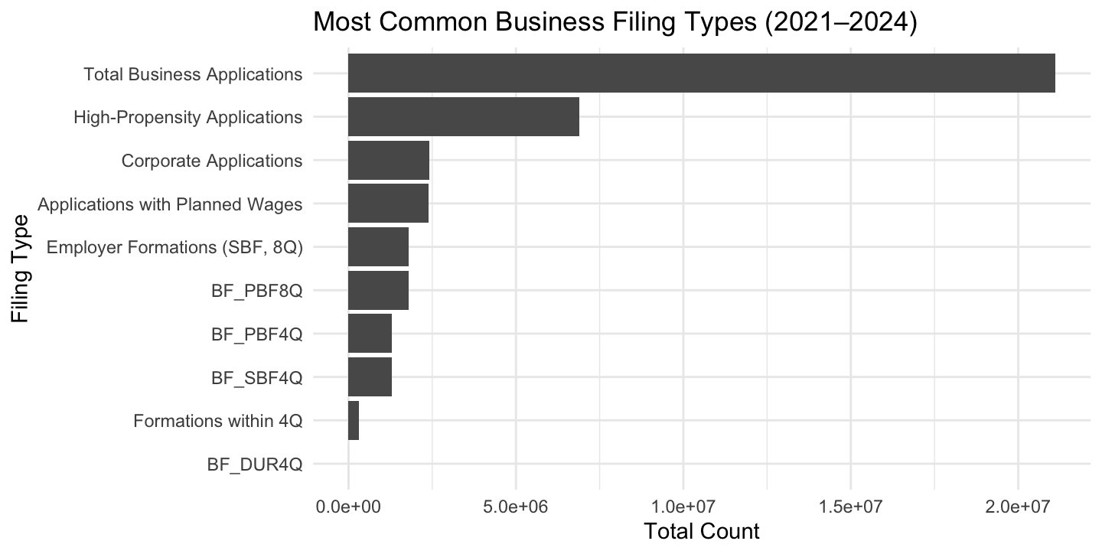Figure 2. Most Common Business Filing Types

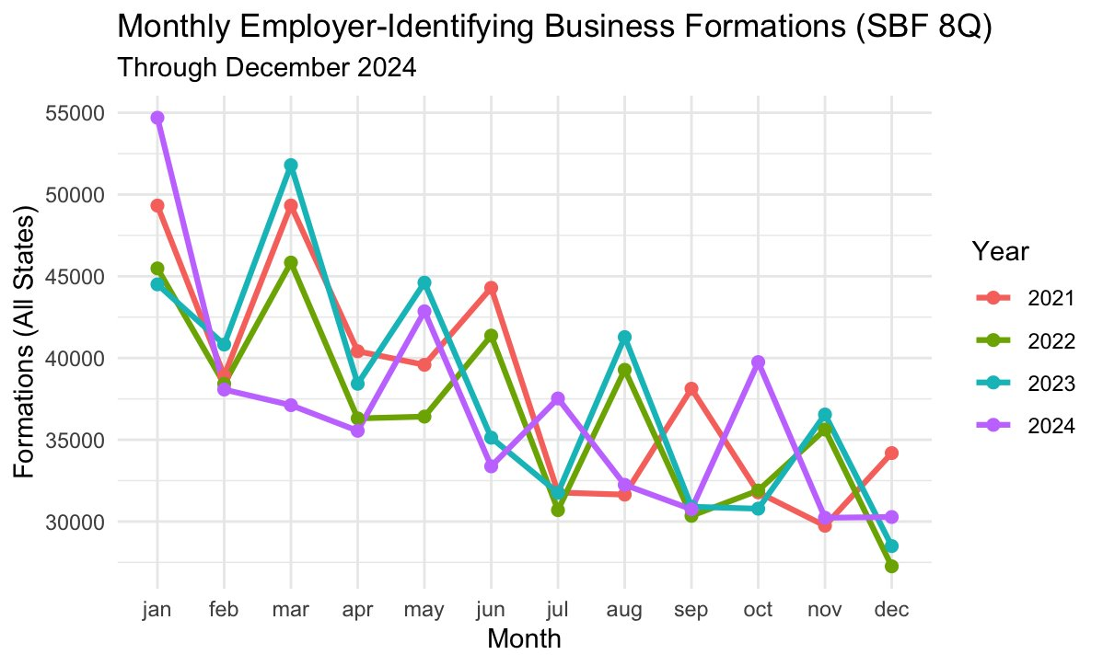Figure 3. Monthly Employer-Identifying Business Formations

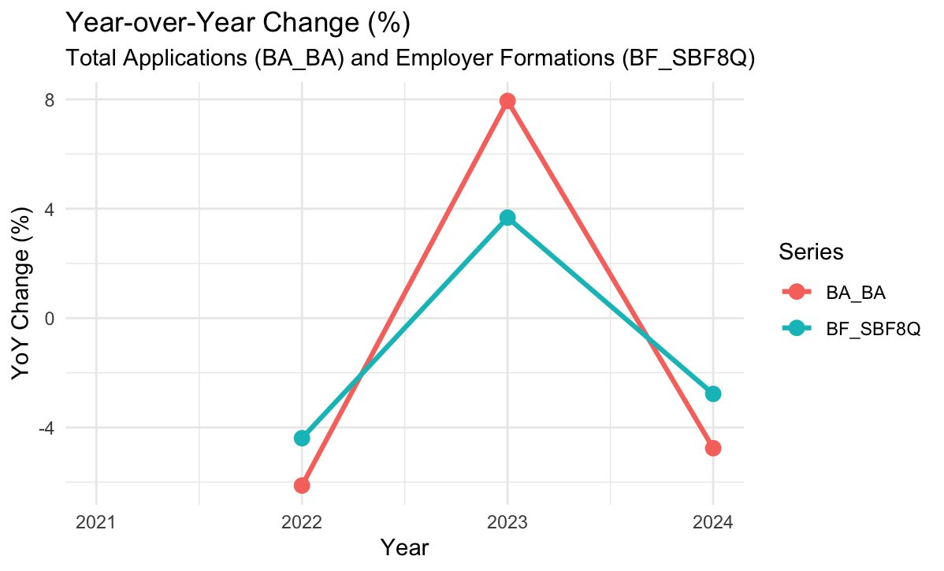Figure 4. Year-over-Year Change (%)

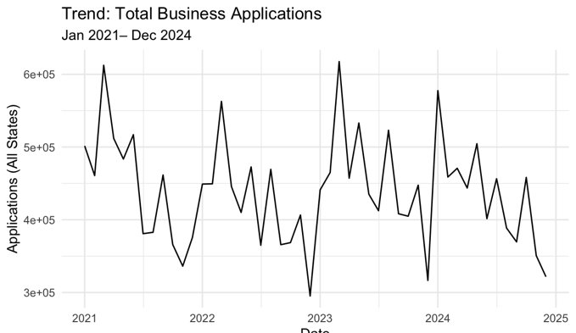Figure 5. Total Business Applications Trend Line

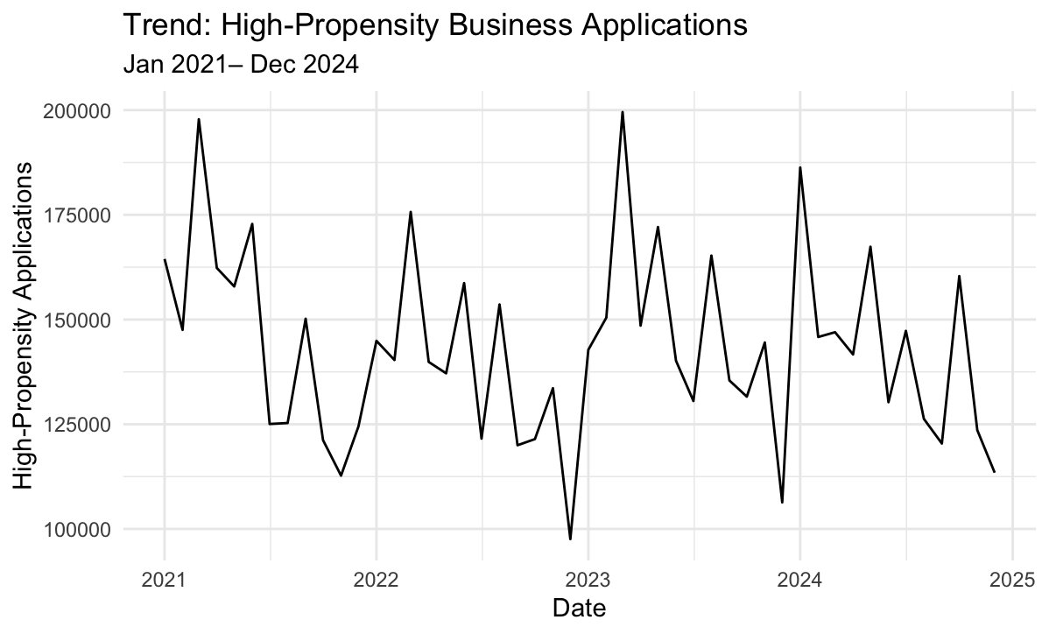Figure 6: High-Propensity Business Applications Trend Line

References
U.S. Census Bureau. (n.d.). Business Formation Statistics (BFS): Current release. https://www.census.gov/econ/bfs/current/index.html
U.S. Census Bureau. (n.d.). Business Formation Statistics: Selected monthly and quarterly data (PDF). https://www.census.gov/econ/bfs/pdf/bfs_current.pdf
U.S. Census Bureau. (n.d.). Business Formation Statistics methodology. https://www.census.gov/econ/bfs/technicaldocumentation/methodology.html
Federal Reserve Bank of St. Louis. (n.d.). Business formation statistics. FRED Economic Data. https://fred.stlouisfed.org/release?rid=443&t=business%20formations&rt=business%20formations&ob=pv&od=desc

