Software Design Specification (SDS)

Agile System Design & Implementation Readiness Document
Course: PRJ566
Status: FINAL LOCKED VERSION – S26 | Version: v1.0 | Last Updated: 2026-05-03

Section: NCC
Project Title: Smart Spend
Team Number: 03
Team Members: Tina Srivastava, Ananeya Devarasan, Zena Mohamed
Instructor / Faculty Reviewer: Behshid Behkamal
Date: 2026-05-26
GITHUB Link: https://github.com/tinatintina/PRJ566-Group3

Executive Summary
Background
Students often struggle to manage personal finances due to limited financial literacy, irregular income, and lack of simple budgeting tools designed specifically for students. Existing financial applications are often too complex or targeted toward working professionals instead of student lifestyles.
Description
The Student Smart Finance & Expense Management System is a web-based application that allows students to track income and expenses, create monthly budgets, categorize transactions, and visualize spending patterns using dashboards and reports.
Company Value Add
The system demonstrates practical software engineering concepts including full-stack development, database management, authentication, responsive UI/UX design, and Agile project planning. It also provides experience in developing a real-world business application.
End-User Value Add
The platform helps students:
- improve financial awareness
- reduce overspending
- build budgeting habits
- manage monthly expenses more effectively
- visualize spending trends through reports and dashboards
Scope
What is Included:
- User registration and login
- Income and expense tracking
- Transaction categorization
- Monthly budgeting
- Dashboards and reporting
- Responsive web interface
- Relational database integration
What is Not Included:
- Online banking integration
- Investment management
- Cryptocurrency tracking
- Tax filing
- Financial advisor integration
Justification
This project is suitable as a two-semester software engineering project because it involves frontend development, backend programming, database management, authentication/security, UI/UX design, reporting systems, and Agile planning.

Table of Contents
Executive Summary
1. Introduction (Week 1-2)
1.1 Document Authors
1.2 Document Revision History
1.3 Document Purpose
1.4 Audience
1.5 Group Agreement
1.6 File Naming Convention (Required)
2. Project Proposal & Scope (Week 2 / Sprint 1)
2.1 Project Background
2.2 Problem Statement
2.3 Product Vision
2.4 Stakeholders and Users
2.5 Project Scope
2.6 System Risks
2.7 Operating Environment
3. System Behavior & Scenarios (Sprint 1-2)
3.1 Preliminary Product Backlog
3.2 Functional Requirements
3.3 Non-Functional Requirements
3.4 Data Flow Diagrams (DFDs)
3.5 Business Rules
3.6 Refined User Stories and Use Case Scenarios
3.7 Scenario Flows & UI Mapping
4. Sprint 3 Design Artifacts
4.1 UI/UX Design & Prototype
4.2 Domain Model
5. Data Design (Sprint 3)
5.1 RDBMS Design: ERD
5.2 RDBMS Design: Data Dictionary
5.3 NoSQL Design Option
6. Agile Planning Overview (Sprint 4)
6.1 System Setup & Environment Readiness
6.2 GitHub & Project Setup
6.3 Vertical Slice Planning
7. Product Backlog & Sprint Readiness (Sprint 4)
7.1 Product Backlog
7.2 Sprint 1 Candidates
8. Client / Faculty Sign-off

1. Introduction (Week 1-2)

1.1 Document Authors
Name | Role / Responsibility | Email
Ananeya Devarasan | Documentation / Frontend Support | adevarasan@myseneca.ca
Tina Srivastava | Scrum Master / Planning | tsrivastava5@myseneca.ca
Zena Mohamed | Backend / Database Support | zmohamed24@myseneca.ca

1.2 Document Revision History
Week / Sprint | Date | Revisions Made
Week 2 | 2026-05-14 | Added approved business proposal and project scope
Sprint 1 | 2026-05-24 | Added stakeholders, risks, operating environment, and initial system requirements
Sprint 2 | 2026-07-05 | Added user stories, use case scenarios, UI/UX prototype, system architecture, and design specifications.
Sprint 3 | 2026-07-15 | Added domain model (UML class diagram), RDBMS database design (ERD), data dictionary, and selected the RDBMS database approach for the Smart Spend system.

1.3 Document Purpose
This document defines the Software Design Specification (SDS) for the Student Smart Finance & Expense Management System using an Agile software development approach. The document includes project scope, system requirements, user scenarios, business rules, data design, UI/UX planning, and implementation readiness artifacts for PRJ566 and PRJ666.

1.4 Audience
The intended audience for this document includes:
- Faculty reviewers and instructors
- Project team members
- Future PRJ666 developers
- Stakeholders and evaluators
- Users involved in system testing and feedback

1.5 Group Agreement
This section defines the team’s working agreement, responsibilities, communication expectations, and overall commitment throughout PRJ566 and PRJ666.
Team Overview
Item | Team Response
Team Number | Team 03
Project Title | Student Smart Finance & Expense Management System
Project Time Frame | PRJ566 (Planning & Design) to PRJ666 (Implementation)

Team Members
Name | Student ID | Email | Signature
Ananeya Devarasan | 171549231 | adevarasan@myseneca.ca | Ananeya Devarasan
Tina Srivastava | 103297230 | tsrivastava5@myseneca.ca | Tina Srivastava
Zena Mohamed |  | zmohamed24@myseneca.ca

Team Leadership
Leadership Area | Team Response
Coordination Approach | Leadership responsibilities may rotate depending on sprint goals and project needs. The team lead is responsible for coordination, communication, and ensuring sprint deliverables are completed on time. Team communication is mainly handled through WhatsApp group chats, Microsoft Teams meetings, and in-person discussions when required.

Team Functions / Roles
Team Member | Primary Role | Secondary Responsibilities
Ananeya Devarasan | Documentation Lead / Frontend Support | Coordinates SDS updates, assists with UI planning, and supports project documentation
Tina Srivastava | Scrum Master / Project Coordinator | Coordinates meetings, tracks sprint progress, and manages team communication
Zena Mohamed | Backend & Database Support | Assists with database planning, backend requirements, and testing support

Team Meetings
Describe the expected meeting schedule and communication approach.
Meeting Type | Frequency / Timing | Platform / Location | Notes
Team Meeting | Twice weekly outside scheduled class hours | WhatsApp, Microsoft Teams, and in-person meetings | Additional meetings during sprint reviews

Team Strategy for Managing Issues and Conflict Resolution
Describe how the team plans to handle communication issues, missed deadlines, uneven workload distribution, and team conflicts.
Issue Type | Team Strategy | Escalation
Missed deadlines | Redistribute tasks and discuss internally | Escalate to professor if unresolved
Uneven workload | Reassign tasks fairly among members | Team discussion
Communication issues | Use WhatsApp group chats, Microsoft Teams meetings, and regular communication to resolve issues quickly. | Escalate if necessary

Team Commitment
The undersigned members agree to work together on the project throughout PRJ566 and continue into PRJ666 during the following semester. Team members recognize that both individually and collectively they are responsible for the quality, professionalism, and timely completion of all project deliverables.
Name | Date | Signature
Ananeya Devarasan | 2026-05-25 | Ananeya Devarasan
Tina Srivastava | 2026-05-25 | Tina Srivastava
Zena Mohamed | 2026-05-25 | Zena Mohamed

1.6 File Naming Convention (Required)
To ensure consistency and proper tracking across all teams and submissions, the following file naming convention must be used for all SDS documents:
Format:
Team##_PRJ566_N##_SDS_S26_WK##
Example:
Team03_PRJ566_NAA_SDS_S26_WK05
Naming Components:
- Team## → Team number (e.g., Team01, Team02)
- PRJ566 → Course code
- N## → Section identifier (e.g., NAA, NBB)
- SDS → Document type
- S26 → Semester (Summer 2026)
- WK## → Week or Sprint number of the submission
Important Notes:
- All submissions must follow this naming convention exactly
- Update the WK## value for each submission or major update
- Do not use spaces or additional characters in the file name
- Consistent naming ensures proper version tracking and evaluation

2. Project Proposal & Scope (Week 2 / Sprint 1)

2.1 Project Background
Managing personal finances is a significant challenge for many post-secondary students, particularly those living independently, studying abroad, or balancing academic responsibilities with part-time employment. Students often struggle to monitor spending, maintain budgets, and understand their financial habits. Existing budgeting applications tend to be designed for working professionals and often include complex features that can discourage student adoption.
The Student Smart Finance & Expense Management System is a web-based platform designed specifically for students. The system will provide tools for tracking income and expenses, categorizing transactions, setting monthly budgets, and visualizing spending patterns through dashboards and reports. The project aims to promote financial awareness and support responsible money management among students.

2.2 Problem Statement
The problem of | Students struggling to effectively manage their personal finances due to limited financial literacy, irregular income, rising living costs, and a lack of budgeting tools designed specifically for student lifestyles.
Affects | Domestic students, international students, students with part-time jobs, newcomers and educational institutions that aim to support student well-being and financial success.
The impact of which is | Overspending, poor budgeting habits, financial stress, missed financial obligations, and difficulty managing expenses across multiple currencies for international students.
A successful solution would be | A centralized financial management platform through which students can track income and expenses, manage budgets, monitor exchange rates, compare spending between their home currency and Canadian dollars, receive a Student Spending Health Score, and gain personalized insights to improve their financial habits.

2.3 Product Vision
For | college and university students, especially international students managing finances across different currencies
Who | need a simple and effective way to budget, track spending, and improve financial literacy
Smart Spend | is a student-focused financial management platform
That | helps users track expenses, manage budgets, monitor exchange rates, compare spending in multiple currencies, and receive a Student Spending Health Score with personalized recommendations
Unlike | traditional budgeting applications such as Mint, YNAB, and PocketGuard, which are primarily designed for working professionals
Our product | is specifically tailored to student financial needs, offering student-focused expense categories, multi-currency tracking for international students, and a Student Spending Health Score that helps students build healthy financial habits and reduce financial stress

2.4 Stakeholders and Users
Stakeholder / User Group | Internal or External | Needs / Interests | Notes
Students (Domestic & International) | External | Track expenses, create budgets, monitor spending, manage different currencies | Primary users
Currency Exchange API Provider | External | Provide up-to-date exchange rates for international students | External service provider
Educational Institutions | External | Support student well-being and financial literacy | Potential future partners
Development Team | Internal | Deliver functional and maintainable software | Responsible for project delivery
Faculty Reviewer | Internal | Evaluate project quality and requirements | Academic stakeholder

2.5 Project Scope
Included in Scope | Not Included in Scope | Rationale
User registration and login | Online payment processing | The application records spending but does not process payments or transfer money between accounts.
Income tracking | Automatic bank account synchronization | Secure banking integration requires financial institution APIs, user authorization, and compliance beyond this project's scope.
Expense tracking | Investment and stock portfolio management | Intended for personal budgeting only
Transaction categorization | Cryptocurrency management | The system focuses only on personal budgeting
Monthly budgeting | Cryptocurrency wallet integration | Not part of the project's target users or objectives
Spending Health Score | Loan or credit approval services | Outside the purpose of student budgeting
Currency conversion | Financial advisor services | Future enhancement

2.6 System Risks
Risk ID | Risk Description | Impact | Mitigation
R-01 | Underestimating development effort | High | Prioritize MVP features and maintain sprint planning
R-02 | Team scheduling conflicts | Medium | Weekly meetings and task tracking
R-03 | Database integration issues | Medium | Early database design and testing
R-04 | Security vulnerabilities | High | Use password hashing and input validation
R-05 | Scope creep | High | Strict backlog management and approval process
R-06 | User interface usability concerns | Medium | Conduct usability testing with student users

2.7 Operating Environment
Environment Area | Description / Assumption
Web Application | Runs in modern browsers such as Chrome and Edge.
Application Type | Web-based application
Client Platform | Modern desktop and mobile browsers
Supported Browsers | Chrome, Edge, Firefox, Safari
Frontend Technology | React.js
Backend Technology | Node.js with Express.js
Database | MySQL
Authentication | Secure login using encrypted passwords
Hosting Environment | Cloud-hosted web server
Internet Requirement | Active internet connection required
Screen Compatibility | Responsive design for desktop, tablet, and mobile devices

3. System Behavior & Scenarios (Sprint 1-2)
This section captures the reviewed Sprint 2 items in the same sequence as the deliverable schedule: preliminary backlog, FRs, NFRs, DFDs, business rules, and refined stories/scenarios.

3.1 Preliminary Product Backlog
The preliminary backlog includes high-level user stories with descriptions only. Detailed grooming is required only for Sprint 1 candidates in Section 7.2.
User Story ID | Description | Priority | Status / Notes
US-01 | As a student, I want to register an account so that I can securely access the system. | High | Sprint 1 Candidate
US-02 | As a student, I want to log into my account so that I can manage my finances. | High | Sprint 1 Candidate
US-03 | As a student, I want to add income transactions so that I can track my earnings. | High | Sprint 1 Candidate
US-04 | As a student, I want to add expense transactions so that I can monitor my spending. | High | Sprint 1 Candidate
US-05 | As a student, I want to categorize transactions so that I can analyze my spending habits. | Medium | Product Backlog
US-06 | As a student, I want to create monthly budgets so that I can manage my expenses effectively. | High | Product Backlog
US-07 | As a student, I want to view reports and charts so that I can understand my financial activity. | Medium | Product Backlog
US-08 | As an international student, I want to track expenses in multiple currencies so that I can compare spending in my home currency and Canadian dollars. | High | Product Backlog
US-09 | As a student, I want to receive a Student Spending Health Score so that I can evaluate my financial habits. | Medium | Product Backlog
US-10 | As a student, I want personalized spending recommendations so that I can improve my budgeting decisions. | Medium | Product Backlog

3.2 Functional Requirements
Functional requirements should be derived from user stories and scenarios and should remain traceable.
FR ID | Functional Requirement Description | Related User Story / Scenario | Priority
FR-01 | The system shall allow users to register an account. | US-01 | High
FR-02 | The system shall allow users to log in using their credentials. | US-02 | High
FR-03 | The system shall allow users to record income transactions. | US-03 | High
FR-04 | The system shall allow users to record expense transactions. | US-04 | High
FR-05 | The system shall allow users to categorize transactions. | US-05 | Medium
FR-06 | The system shall allow users to create and manage monthly budgets. | US-06 | High
FR-07 | The system shall generate reports and dashboard summaries. | US-07 | Medium
FR-08 | The system shall support multi-currency expense tracking and allow users to view transactions in different currencies. | US-08 | High
FR-09 | The system shall calculate and display a Student Spending Health Score based on user spending patterns and budgeting behavior. | US-09 | Medium
FR-10 | The system shall provide personalized spending recommendations based on transaction history and budget performance. | US-10 | Medium

3.3 Non-Functional Requirements
Include important constraints such as performance, security, usability, availability, privacy, and platform compatibility.
NFR ID | Non-Functional Requirement Description | Category | Measurement / Criteria
NFR-01 | System pages should load quickly. | Performance | Response time under 2 seconds
NFR-02 | User passwords must be securely encrypted. | Security | Password hashing implemented
NFR-03 | The application shall be accessible from desktops and mobile devices. | Compatibility | Responsive design
NFR-04 | The system should be available at all times except maintenance periods. | Availability | 99% uptime
NFR-05 | Financial information must only be accessible to authenticated users. | Privacy | Login required
NFR-06 | The system shall support at least 100 concurrent users. | Scalability | 100 users simultaneously
NFR-07 | The system shall maintain data integrity during unexpected failures. | Reliability | No loss of committed data
NFR-08 | The system shall provide an intuitive and easy-to-use interface. | Usability | New users can complete key tasks within 5 minutes
NFR-09 | The system shall comply with standard web accessibility guidelines. | Accessibility | WCAG 2.1 Level AA compliance

3.4 Data Flow Diagrams (DFDs)
Include DFDs for key system flows only. Activity diagrams are not required in this template.

DFD ID | Level / Name | Related Scenario(s) | Brief Description
DFD-01 | Level 0 – Smart Spend Context Diagram | SC-01, SC-02, SC-03, SC-04, SC-05, SC-06 | Shows Smart Spend as one main system and shows how data flows between the Student/User, Admin, Bank/Payment Gateway, and Currency Exchange Service.
DFD-02 | Student/User Data Flow | SC-01, SC-02, SC-03, SC-04, SC-05, SC-06 | Shows how the student sends registration/login details, transaction data, budget data, category data, and currency preferences to the system. The system returns login confirmation, dashboard reports, spending health score, alerts, and converted currency amounts.
DFD-03 | Admin Data Flow | SC-04, SC-06 | Shows how the admin sends user management and system configuration requests to the system and receives financial reports and analytics.
DFD-04 | Bank / Payment Gateway Data Flow | SC-02 | Shows how transaction details may be sent to an external payment gateway for future use and how transaction status or confirmation is returned.
DFD-05 | Currency Exchange Service Data Flow | SC-05 | Shows how Smart Spend sends exchange rate requests and receives exchange rate data for multi-currency expense tracking.

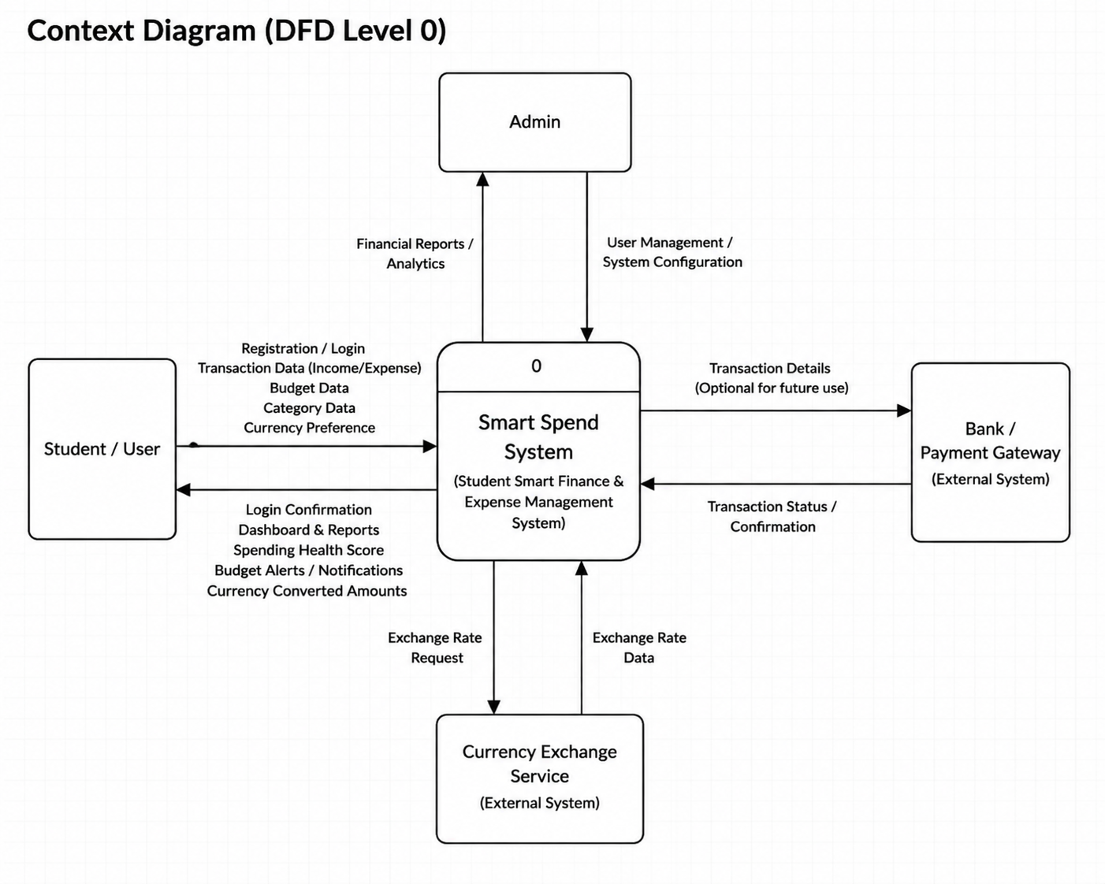

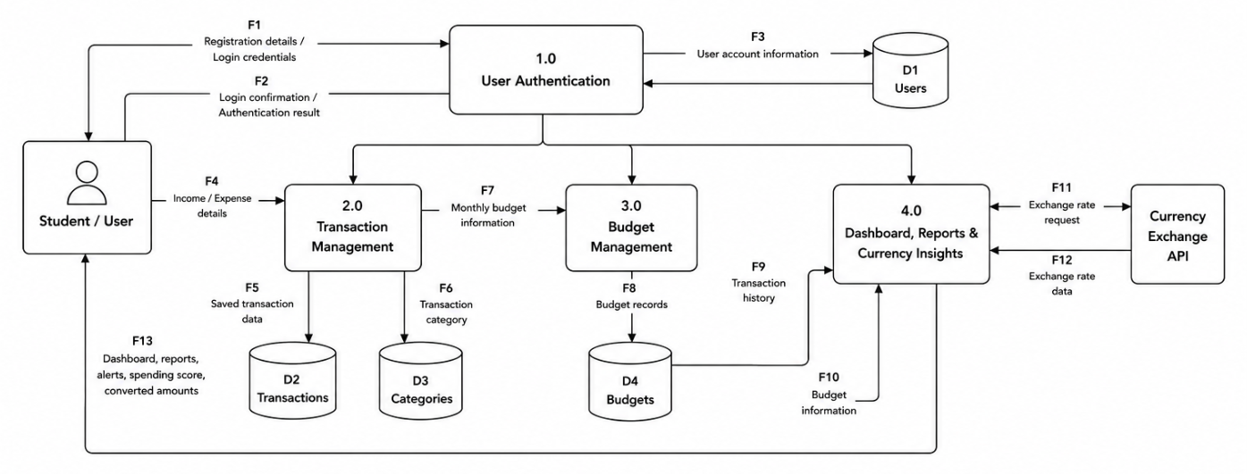

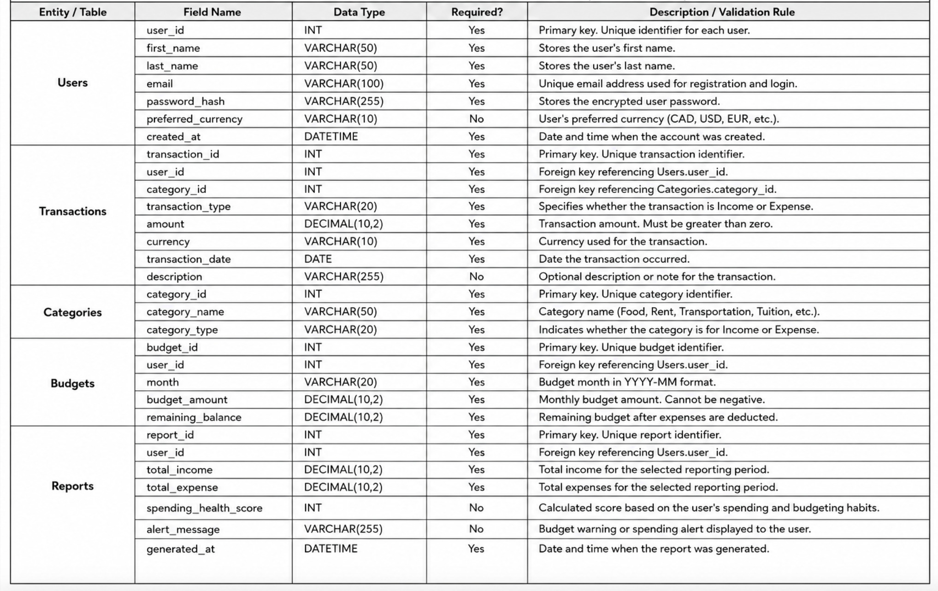

3.5 Business Rules
List only critical business rules that affect system behavior, validation, workflow, or decision logic.
Business Rule ID | Description | Related Scenario / User Story | Related UI / System Area
BR-01 | Every user must register with a unique email address. | US-01 / SC-01 | Registration
BR-02 | Users must be logged in before accessing financial information. | US-02 / SC-01 | Authentication
BR-03 | Transaction amount must be greater than zero. | US-03, US-04 / SC-02 | Transaction Form
BR-04 | Every transaction must belong to exactly one category. | US-05 / SC-02 | Transaction Management
BR-05 | Budget amount cannot be negative. | US-06 / SC-03 | Budget Management
BR-06 | Spending Health Score is calculated only when sufficient transaction history exists. | US-09 / SC-06 | Dashboard

3.6 Refined User Stories and Use Case Scenarios
Use this section to refine the most important stories and describe key end-to-end user interactions.
Scenario ID | Actor / Persona | Trigger | Main Flow | Alternative / Exception Flow
SC-01 | Student | User wants to create an account and access the system | Open registration page → Enter personal details → Submit registration form → Create account → Log in → Access dashboard | Email already registered → System displays error message and requests a different email. Invalid login credentials → Access denied and user prompted to retry.
SC-02 | Student | User wants to record income or expenses | Log in → Open Transactions page → Select Income or Expense → Enter transaction details → Select category → Save transaction → Transaction appears in history | Required fields missing → System prompts user to complete fields. Invalid amount entered → System displays validation error.
SC-03 | Student | User wants to create and manage a monthly budget | Log in → Open Budget Management page → Enter monthly budget amount → Save budget → System displays budget summary and remaining balance | Budget amount is invalid or empty → System displays validation message and prevents submission.
SC-04 | Student | User wants to view spending insights and reports | Log in → Open Dashboard → View charts, reports, spending categories, and budget performance → Analyze financial trends | No transaction data available → System displays message requesting user to add transactions before generating reports.
SC-05 | International Student | User wants to monitor expenses in multiple currencies | Log in → Add transaction → Select preferred currency → System converts and displays values in selected currency → User compares spending patterns | Currency conversion data unavailable → System notifies user and displays stored transaction values only.
SC-06 | Student | User wants to view their Spending Health Score | Log in → Open Dashboard → System analyzes transaction history and budget usage → Generate Spending Health Score → Display score with recommendations | Insufficient transaction history → System informs user that additional data is required to calculate the score.

3.7 Scenario Flows & UI Mapping
Map user stories and scenarios to UI screens or prototype flows. This replaces the previous activity diagram requirement.
Scenario ID | Related User Story | UI Screen / Mockup Reference | Flow Notes
SC-01 | US-01 | UI-01 Registration / Login | User creates an account and signs in.
SC-02 | US-03, US-04 | UI-02 Transactions | User adds income or expense and saves it.
SC-03 | US-06 | UI-03 Budget | User creates monthly budget and views remaining balance.
SC-04 | US-07 | UI-04 Dashboard | User views reports and charts.
SC-05 | US-08 | UI-05 Currency Converter | User selects preferred currency and views converted values.
SC-06 | US-09, US-10 | UI-06 Spending Health Score | User views score and personalized recommendations.

4. Sprint 3 Design Artifacts

4.1 UI/UX Design & Prototype
Develop a scenario-driven prototype based on personas, user stories, and use case scenarios. The prototype should demonstrate end-to-end flows rather than isolated screens.
Prototype Area | Related Scenario / User Story | Screen / Flow Reference | Notes
User Authentication | US-01, US-02 / SC-01 | UI-01 – Login / Register | Students create a new account or log in securely before accessing the application dashboard.
Student Dashboard | SC-01, SC-04, SC-06 | UI-02 – Dashboard | Displays account summary, income, expenses, remaining budget, spending charts, recent transactions, and Spending Health Score after successful login.
Transaction Management | US-03, US-04 / SC-02 | UI-03 – Transactions | Students add, edit, delete, search, and filter income and expense transactions. Transactions are automatically saved and reflected in reports.
Budget Management | US-06 / SC-03 | UI-04 – Budget | Students create monthly budgets, monitor spending progress, receive budget status updates, and view remaining balances.
Financial Reports | US-07 / SC-04 | UI-05 – Reports | Generates visual reports including spending trends, category analysis, monthly comparisons, and financial summaries
Category Management | US-05 / SC-02 | UI-06 – Categories | Students create, edit, organize, and manage income and expense categories used throughout the application.
Financial Goals | US-10 / SC-06 | UI-07 – Goals | Students create savings goals, monitor progress, receive motivational insights, and track completion percentages.
Account Settings & Profile | SC-01 | UI-08 – Settings & Profile | Students update personal information, change preferences, manage security settings, and customize their account.

Mockup Link: https://www.figma.com/make/F7cNcuidWC5UnoKId2Ikxt/Smart-Spend-Wireframe-Prototype?code-node-id=0-9&p=f&fullscreen=1

4.1.1 End-to-End Prototype Flows

Prototype Flow 1 – Student Registration and Login
Related User Stories: US-01, US-02
Related Scenario: SC-01
- Welcome Page
- Registration
- Login
- Dashboard
Outcome: The student successfully creates an account, logs in, and accesses the Smart Spend dashboard.

Prototype Flow 2 – Record an Expense
Related User Stories: US-03, US-04
Related Scenario: SC-02
- Dashboard
- Transactions
- Add Expense
- Save Transaction
- Transaction History Updated
- Dashboard Summary Updated
Outcome: The expense is recorded and reflected in the dashboard, reports, and budget calculations.

Prototype Flow 3 – Create a Monthly Budget
Related User Stories: US-06
Related Scenario: SC-03
- Dashboard
- Budget Management
- Create Budget
- Save Budget
- Updated Budget Summary
Outcome: The student's monthly budget is created and displayed.

Prototype Flow 4 – Review Spending Insights
Related User Stories: US-07
Related Scenario: SC-04
- Dashboard
- Reports
- View Charts
- Analyze Spending Trends
Outcome: The student reviews spending reports and financial summaries.

Prototype Flow 5 – Monitor Spending Health
Related User Stories: US-09, US-10
Related Scenario: SC-06
- Dashboard
- Spending Health Score
- Personalized Recommendations
Outcome: The student receives a Spending Health Score and personalized recommendations.

4.1.2 Data Requirements Identified from UI Flows
The UI prototype identifies the information required on each screen to support the refined user stories and system functionality. These requirements guide the domain model and database design.
UI Screen | User Input | Data Displayed
Registration | First Name, Last Name, Email, Password, Preferred Currency | Registration Confirmation
Login | Email, Password | Authentication Status
Dashboard | None | Income Summary, Expense Summary, Remaining Budget, Spending Health Score, Recent Transactions
Transactions | Transaction Type, Amount, Category, Currency, Date, Description | Updated Transaction History
Budget | Budget Amount, Month | Remaining Budget, Budget Progress
Reports | Date Range | Spending Charts, Financial Summary
Categories | Category Name, Category Type | Available Categories
Goals | Goal Name, Target Amount, Target Date | Progress Percentage
Settings & Profile | Personal Information, Preferred Currency | Updated User Profile

4.2 Domain Model
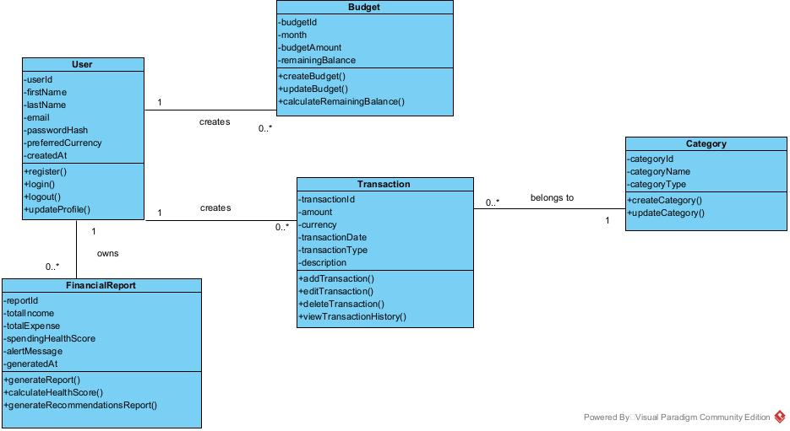

Class / Entity | Key Attributes | Relationships | Notes
User | userId, firstName, lastName, email, preferredCurrency | Creates Transactions, Budgets, and Financial Reports. | Represents registered users of the Smart Spend system.
Transaction | transactionId, amount, currency, transactionDate, transactionType | Created by User; Belongs to one Category. | Stores income and expense records.
Category | categoryId, categoryName, categoryType | One Category contains many Transactions | Organizes transactions into predefined categories.
Budget | budgetId, month, budgetAmount, remainingBalance | Created by User. | Manages monthly spending limits and remaining balance.
FinancialReport | reportId, totalIncome, totalExpense, spendingHealthScore | Generated for a User or Created by User. | Provides financial summaries and spending insights.

5. Data Design (Sprint 3)

The Smart Spend system uses MySQL, a Relational Database Management System (RDBMS), as its database solution. An RDBMS was selected because the application stores structured financial data with well-defined relationships between users, transactions, categories, budgets, and financial reports. MySQL supports data integrity through primary and foreign keys and provides efficient querying for financial data management.

5.1 RDBMS Design: ERD

Link to ERD diagram: https://www.figma.com/board/12NlIRaWsX8ITR04kpYtfB/Entity-relationship--ER--Diagram--Community-?node-id=303-741

Entity | Primary Key | Relationships | Notes
User | user_id | One user has many Transactions, Budgets, and FinancialReports. | Stores user account information.
Transaction | transaction_id | Belongs to one User and one Category. | Stores income and expense records.
Category | category_id | One category contains many Transactions. | Organizes transactions into predefined categories.
Budget | budget_id | Belongs to one User. | Stores users' monthly
FinancialReport | report_id | Belongs to one User. | Stores generated financial reports and spending analysis.

5.2 RDBMS Design: Data Dictionary
Entity / Table | Field Name | Data Type | Required? | Description / Validation Rule
Users | user_id | INT | Yes | Primary key. Unique identifier for each user.
Users | first_name | VARCHAR(50) | Yes | User's first name.
Users | last_name | VARCHAR(50) | Yes | User's last name.
Users | email | VARCHAR(100) | Yes | Unique email address used for login.
Users | password_hash | VARCHAR(255) | Yes | Stores the encrypted user password.
Users | preferred_currency | VARCHAR(10) | Yes | User's preferred currency.
Users | created_at | TIMESTAMP | Yes | Date and time the user account was created.
Transactions | transaction_id | INT | Yes | Primary key. Unique identifier for each transaction.
Transactions | user_id | INT | Yes | Foreign key referencing Users.user_id.
Transactions | category_id | INT | Yes | Foreign key referencing Categories.category_id.
Transactions | amount | DECIMAL(10,2) | Yes | Monetary value of the transaction.
Transactions | currency | VARCHAR(10) | Yes | Currency used for the transaction.
Transactions | transaction_date | DATE | Yes | Date the transaction occurred.
Transactions | transaction_type | VARCHAR(20) | Yes | Indicates whether the transaction is Income or Expense.
Transactions | description | VARCHAR(255) | No | Optional description of the transaction.
Categories | category_id | INT | Yes | Primary key. Unique identifier for each category.
Categories | category_name | VARCHAR(50) | Yes | Name of the transaction category.
Categories | category_type | VARCHAR(20) | Yes | Specifies whether the category is for Income or Expense.
Budgets | budget_id | INT | Yes | Primary key. Unique identifier for each budget.
Budgets | user_id | INT | Yes | Foreign key referencing Users.user_id.
Budgets | month | VARCHAR(20) | Yes | Month the budget applies to.
Budgets | budget_amount | DECIMAL(10,2) | Yes | Total budget allocated for the month.
Budgets | remaining_balance | DECIMAL(10,2) | Yes | Remaining budget available after transactions.
FinancialReports | report_id | INT | Yes | Primary key. Unique identifier for each financial report.
FinancialReports | user_id | INT | Yes | Foreign key referencing Users.user_id.
FinancialReports | total_income | DECIMAL(10,2) | Yes | Total income calculated for the report.
FinancialReports | total_expense | DECIMAL(10,2) | Yes | Total expenses calculated for the report.
FinancialReports | spending_health_score | INT | Yes | Calculated score indicating the user's spending health.
FinancialReports | alert_message | VARCHAR(255) | No | Displays budget or spending alerts when applicable.
FinancialReports | generated_at | TIMESTAMP | Yes | Date and time the financial report was generated.

5.3 NoSQL Design Option
Not Applicable
This project uses MySQL, a Relational Database Management System (RDBMS), as its database solution. Since the application stores structured data with well-defined relationships between users, transactions, categories, budgets, and financial reports, a NoSQL database design is not required.

Important: Database design must support at least one complete end-to-end user scenario demonstrated in the prototype.

6. Agile Planning Overview (Sprint 4)
This section captures the system’s readiness for implementation in PRJ666. It focuses on environment setup, repository structure, and the initial vertical slice required to begin development.

6.1 System Setup & Environment Readiness
Item | Description | Status / Notes
Development Tools | Visual Studio Code will be used as the primary code editor. Git and GitHub will be used for source control and collaboration. | Ready for PRJ666 implementation.
Frontend Environment | React.js will be used to develop the responsive user interface. Node.js and npm must be installed to run and manage frontend dependencies. | Technology selected; implementation will begin in PRJ666.
Backend Environment | Node.js with Express.js will be used to create REST API endpoints and manage application logic. | Technology selected; initial project structure prepared.
Database Environment | MySQL will be used to store users, transactions, categories, budgets, and financial reports. MySQL Workbench may be used for database administration. | ERD and data dictionary completed. Database implementation planned for PRJ666.
Authentication Setup | User registration and login will use encrypted password storage and authenticated access to financial information. | Authentication requirements and business rules documented.
Configuration Management | Environment variables will be stored in a .env file for database credentials, server ports, and authentication settings. The .env file will not be committed to GitHub. | Planned and documented.
Dependency Management | npm will be used to install and manage frontend and backend dependencies. Separate package.json files may be maintained for the client and server. | Ready for project initialization.
Local Application Execution | Developers will clone the GitHub repository, install dependencies, configure the .env file, create the MySQL database, and start the frontend and backend servers. | Setup steps will be documented in the README.
Testing Environment | Frontend, backend, API, validation, and database integration testing will be completed during implementation. | Initial testing approach identified.
Browser Compatibility | The application will be tested in Chrome, Edge, Firefox, and Safari on desktop and mobile screen sizes. | Supported platforms documented.
Team Readiness | All team members will have access to the GitHub repository and use feature branches, pull requests, and code reviews. | Repository access and team workflow ready.

- Install Node.js, npm, Git, Visual Studio Code, MySQL Server, and MySQL Workbench.
- Clone the Smart Spend GitHub repository.
- Open the project folder in Visual Studio Code.
- Run npm install in the frontend and backend folders.
- Create the Smart Spend MySQL database.
- Create a .env file containing the database connection information and server configuration.
- Run the backend server using the appropriate npm command.
- Run the React frontend using the appropriate npm command.
- Open the application in a modern web browser.
- Test the connection between the user interface, backend API, and MySQL database.

6.2 GitHub & Project Setup

Item | Description | Status / Notes
GitHub Repository | Central Smart Spend repository used for source control, documentation, and team collaboration. Repository: https://github.com/tinatintina/PRJ566-Group3 | Created and available to the team.
Repository Structure | Project will be organized into frontend/client, backend/server, database/configuration, and documentation areas so responsibilities remain separated and maintainable. | Structure planned and ready for PRJ666 implementation.
README & Setup Instructions | README documents the project purpose, selected technology stack, required software, installation steps, environment configuration, and local run instructions. | Initial documentation prepared; implementation commands will be updated in PRJ666.
Branching Strategy | The main branch will contain reviewed/stable work. Team members will create feature branches for individual user stories or tasks and merge changes through pull requests. | Team workflow defined.
Pull Requests & Code Review | Feature work will be submitted through pull requests. At least one team member will review changes for correctness, consistency, and possible conflicts before merge. | Planned for all implementation work.
Configuration & Secrets | Database credentials, server configuration, and authentication values will be stored in a local .env file. Sensitive configuration will not be committed to GitHub. | Documented; .env excluded from source control.

6.3 Vertical Slice Planning
A vertical slice represents one complete end-to-end feature that connects the UI, application logic, and data layers. In PRJ566, the vertical slice is designed, validated, and demonstrated conceptually, ensuring readiness for PRJ666 implementation.

Feature | UI Component(s) | Application Logic / Service | Data Layer | Status / Notes
Record an Expense | Dashboard, Transactions page, Add Expense form, transaction history | Authenticate user; validate required fields; confirm amount is greater than zero; verify category; create transaction; refresh transaction history and dashboard totals. | Users, Transactions, Categories | Primary vertical slice. Designed and validated conceptually in PRJ566; ready for PRJ666 implementation.
User Registration & Login | Registration page, Login page, Dashboard | Validate registration data and unique email; securely store password hash; authenticate credentials; create user session; allow authenticated dashboard access. | Users | Required foundation for the expense slice; mapped to US-01, US-02 and SC-01.
Create Monthly Budget | Dashboard, Budget Management page, Create Budget form, budget summary | Authenticate user; validate budget amount; save monthly budget; calculate and display remaining balance and budget status. | Users, Budgets, Transactions | Planned next vertical slice; mapped to US-06 and SC-03.
View Spending Insights | Dashboard, Reports page, charts and summaries | Retrieve authenticated user's transactions and budget data; calculate totals and category summaries; generate dashboard/report information. | Users, Transactions, Categories, Budgets, FinancialReports | Planned after core transaction and budget functionality; mapped to US-07 and SC-04.

7. Product Backlog & Sprint Readiness (Sprint 4)

7.1 Product Backlog
The general product backlog includes high-level user stories with clear descriptions only. Detailed grooming can continue in PRJ666.
User Story ID | Description | Priority | Status / Notes
US-05 | As a student, I want to categorize transactions so that I can analyze my spending habits. | Medium | Future backlog item; not fully groomed yet.
US-06 | As a student, I want to create monthly budgets so that I can manage my expenses effectively. | High | Future backlog item; not fully groomed yet.
US-07 | As a student, I want to view reports and charts so that I can understand my financial activity. | Medium | Future backlog item; not fully groomed yet.
US-08 | As an international student, I want to track expenses in multiple currencies so that I can compare spending in my home currency and Canadian dollars. | High | Future backlog item; not fully groomed yet.
US-09 | As a student, I want to receive a Student Spending Health Score so that I can evaluate my financial habits. | Medium | Future backlog item; not fully groomed yet.
US-10 | As a student, I want personalized spending recommendations so that I can improve my budgeting decisions. | Medium | Future backlog item; not fully groomed yet.

7.2 Sprint 1 Candidates
Only Sprint 1 candidate stories must be fully groomed before PRJ666 Sprint 1 planning.
User Story ID | Description | Acceptance Criteria | Testing Scenarios | Notes
US-01 | As a student, I want to register an account so that I can securely access the system. | For a new user, when registration information and an email address that is unique are inputted and submitted, then a new account is created successfully. | Test successful registration; test duplicate email; test missing required fields. | Candidate for PRJ666 Sprint 1.
US-02 | As a student, I want to log into my account so that I can manage my finances. | For a registered user, when login details are provided, then authentication takes place and the user is granted access into the system. | Test successful login; test incorrect credentials; test missing required fields. | Candidate for PRJ666 Sprint 1.
US-03 | As a student, I want to add income transactions so that I can track my earnings. | For a logged in user, when transaction details for income are inputted and saved, then the transaction details are recorded and shown on the transaction history page. | Test successful income entry; test invalid amount; test missing required fields; test missing category. | Candidate for PRJ666 Sprint 1.
US-04 | As a student, I want to add expense transactions so that I can monitor my spending. | For a logged in user, when transaction details for expenses are inputted and saved, then the transaction details are recorded and shown on the transaction history page. | Test successful expense entry; test zero or negative amount; test missing required fields; test missing category. | Candidate for PRJ666 Sprint 1.

8. Client / Faculty Sign-off
Use this section to confirm final review, scope approval, and readiness for PRJ666 implementation.

Name | Role | Approval / Comments | Date | Signature
Team 03 | Project Team | SDS reviewed by the team. Scope, requirements, prototype flows, data design, environment readiness, GitHub workflow, product backlog, and vertical slice planning are prepared for transition to PRJ666. | 2026-08-11 | Team confirmation
Faculty Reviewer | Instructor / Faculty Reviewer | Pending faculty review and approval for PRJ666 implementation readiness.

References:

Government of Canada. (n.d.). Financial literacy programs and resources. Retrieved June 5, 2026, from https://www.canada.ca/en/financial-consumer-agency/services/financial-literacy-programs.html
YNAB. (n.d.). You Need A Budget. Retrieved June 5, 2026, from https://www.ynab.com
PocketGuard. (n.d.). PocketGuard budgeting app. Retrieved June 5, 2026, from https://pocketguard.com

