CSS Layouts

**DEADLINE:** 20/04/2022

## FOLDER STRUCTURE

| FL19_HW4/*  └─ task/**  └─ homework/*  └─ css/*  └─ style.css*  └─ img/*  └─cat1.png*  └─cat2.png*  └─ebo1.jpg*  └─ebo2.jpg*  └─ebo3.jpg*  └─logo.png*  └─main.png*  └─ index.html* | * – required  ** – restricted(no need to submit) |
| --- | --- |

## TASK

In this homework you have to create an HTML page template according to provided design, which you can find in the file “***design.png”*** or you can view it on [Figma](https://www.figma.com/file/adG7EuvmxRhCxGZs1ztgki/FL19_HW4?node-id=0%3A1)***.*** All required images can be found in the folder “***img”***. All text content you can find in the file “***content.txt***”.

Use HTML5 **semantic** tags where they are needed. All your styles should be written in the file “***style.css***”. The minimum size of the screen when a web page shouldn’t be “broken” is more and equal to **1100px.**

**Colors used in the design**

* #000000 - dark text
* #FFFFFF - light text
* #079FD0 - accented text, “Order now” button background
* #C4C4C4AD - background for the main section
* #C4C4C433 - footer background

## PLEASE NOTE

* There are no strict restrictions for distances between blocks, you can set them by yourself (tips: you can use Pixelperfect browser addon but it is not mandatory)
* The font-family used in the template is ‘Montserrat’
* All navigation links (header, footer), buttons (“order now”, “learn more”) should hover with a cursor pointer:

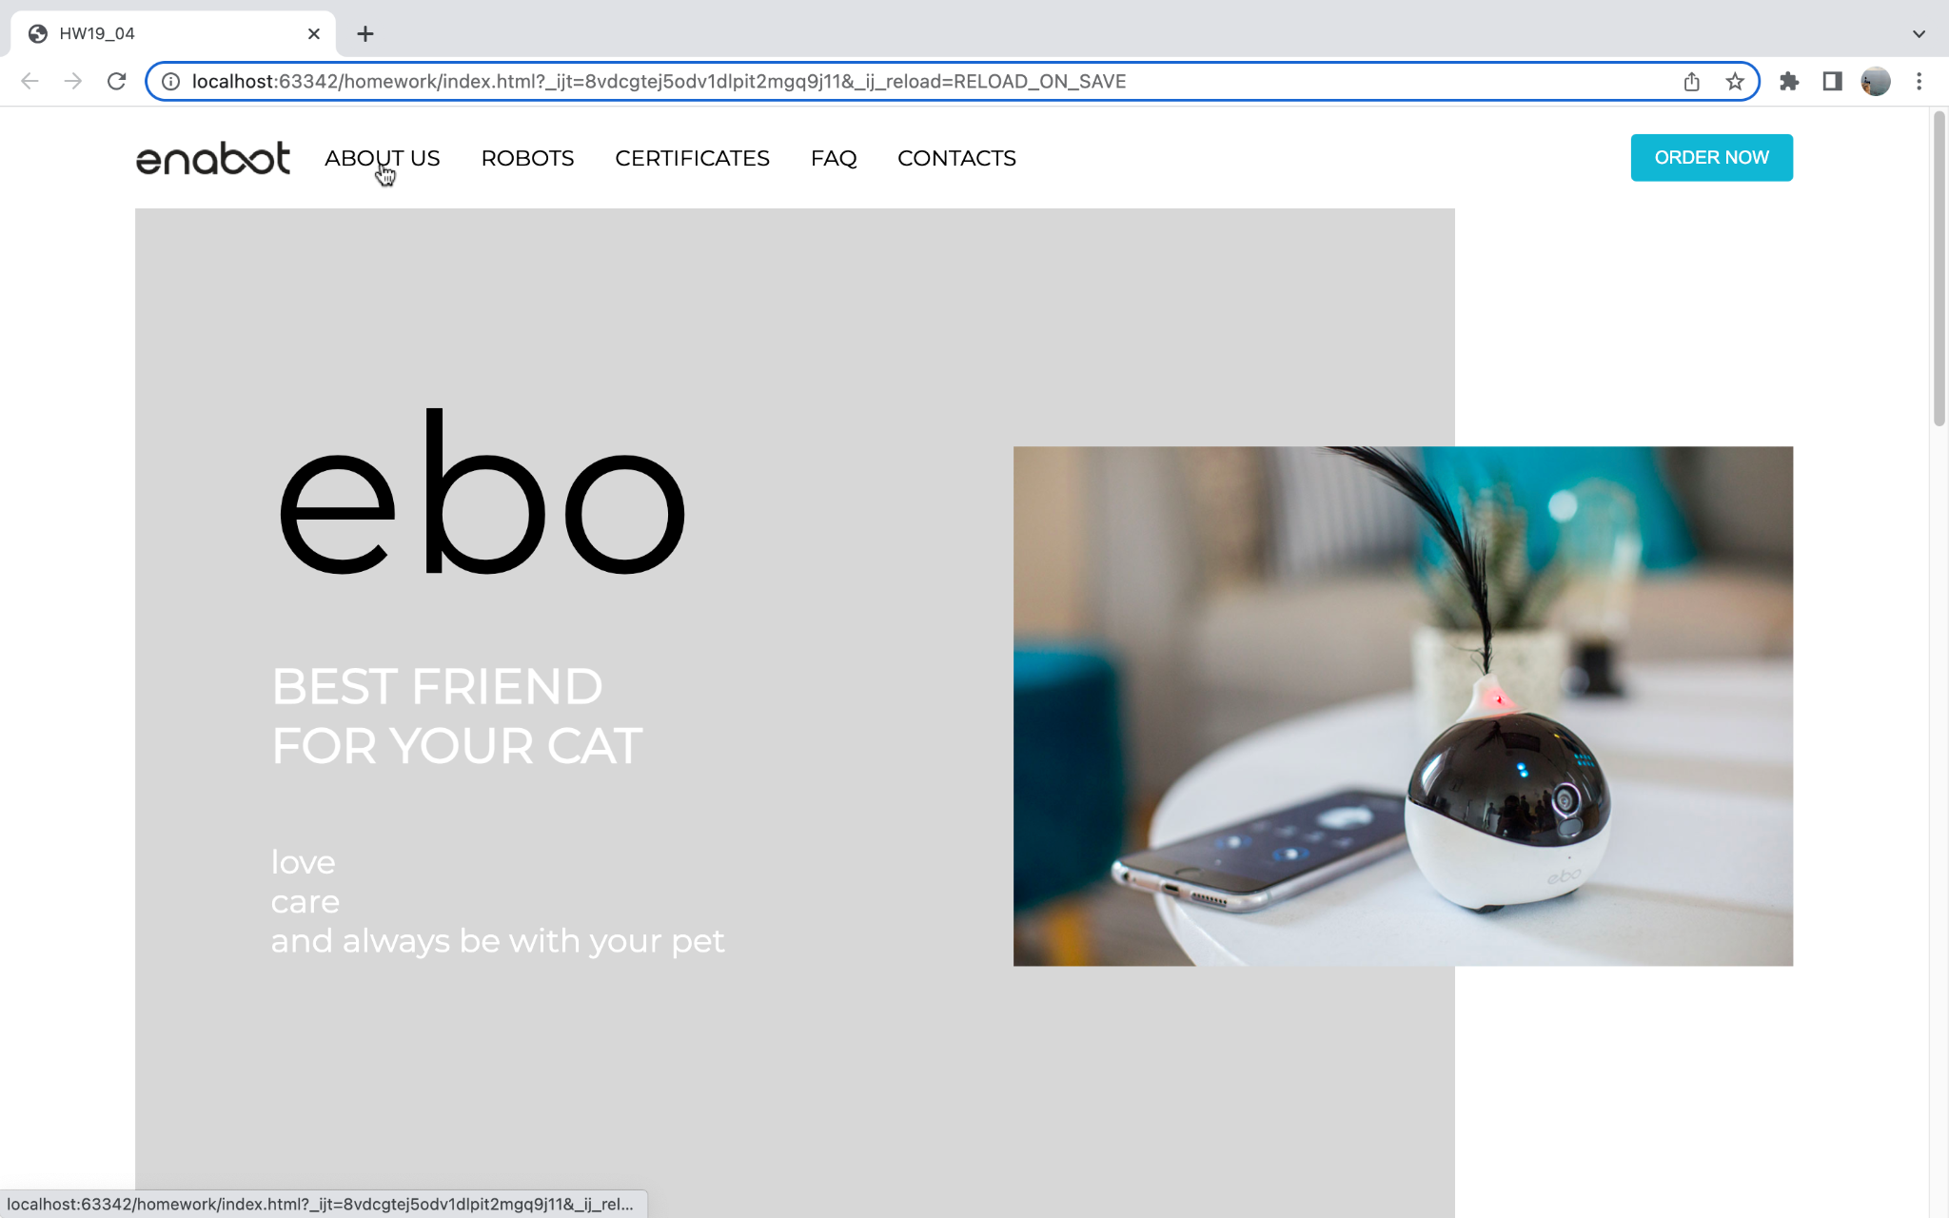

* This part of the design should occupy all height of the browser window:

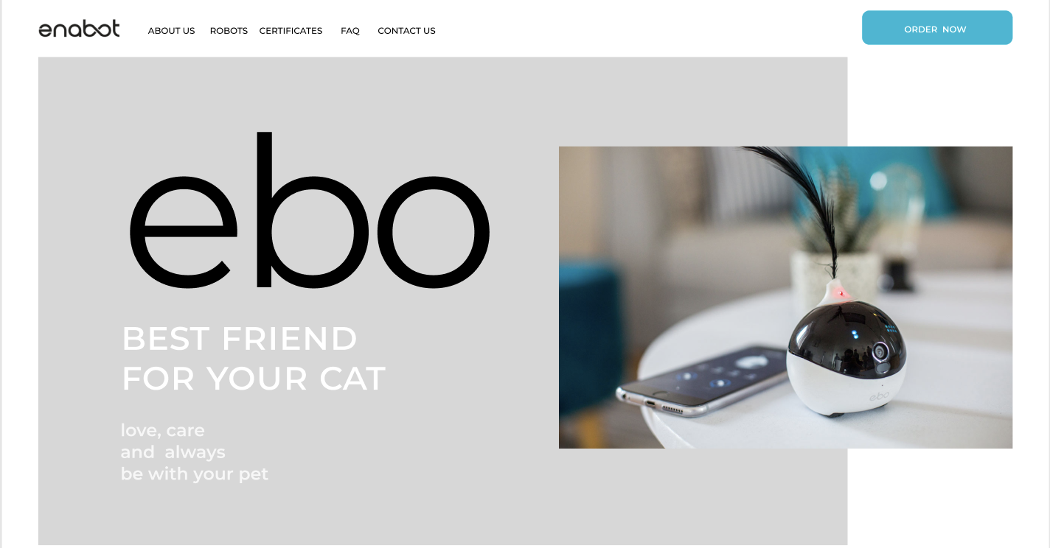

## RESTRICTIONS

* Using CSS frameworks are forbidden (e.g. Bootstrap, Materialize)
* Using JS is forbidden
* Do not use preprocessors in this homework

## BEFORE SUBMIT

* Remove all unnecessary files that you might have included by mistake
* Verify that all functionality is implemented according to requirements
* Format the code, and remove unnecessary lines of code.
* Verify that the name of the folders and files meet the requirements
* Validate HTML(<https://validator.w3.org/>) and CSS (<https://jigsaw.w3.org/css-validator/> )

## SUBMIT

* The folder **“FL19_HW4”** without “task” folder should be uploaded to GitLab repository 'FL-19' into **main** branch

## USEFUL LINKS

* <https://www.w3schools.com/html/html5_semantic_elements.asp>
* <https://css-tricks.com/snippets/css/a-guide-to-flexbox/>