Creating Designs by Leveraging OpenAI and Gradio UI
January 2026
Situation
At a cutting-edge creative agency, you are responsible for delivering eye-catching visual content for digital marketing campaigns. For high-profile clients such as Netflix, conventional design workflows can be slow and repetitive. The project brief explains that you have access to an innovative platform that combines OpenAI’s API with Gradio’s web interface, allowing you to revolutionize visual content creation. With this platform, designers can transform text prompts into bespoke images, creating unique banners and posters for streaming promotions.
Task
The goal is to build a tool that generates custom images from textual descriptions. According to the project statement, the system must accept a text prompt and produce a visually compelling design using OpenAI’s DALL-E model. The interface should be intuitive for creatives: a simple textbox for entering prompts and a display area for the resulting image. Ultimately, the tool should aid Netflix campaigns by quickly translating abstract ideas into striking visuals.
Action
- Import necessary libraries. The platform relies on gradio for the user interface, requests for fetching the generated image, Pillow for handling images, io.BytesIO for streaming binary data, and the openai library for accessing the DALL-E API. These components enable seamless conversion from text prompts to images.
- Define the generate_image function. This function accepts a prompt, calls openai.Image.create to generate an image with the DALL-E API, extracts the image URL from the response, retrieves the image bytes via requests, and loads the result into a PIL.Image object.
- Create the Gradio interface. Using gr.Interface, set up a text input labeled “Design Prompt” and an image output. The fn parameter is the generate_image function, while inputs and outputs specify the appropriate Gradio components for user interaction. A title and description make the interface easy to understand.
- Launch the app. Running demo.launch() starts the local web server and presents the design generator. Users can enter prompts like “Epic sci-fi adventure on an alien planet” and instantly view a custom poster. The interface can be shared or embedded into client workflows.
- Prepare deliverables. Compile the code into a Jupyter notebook (design_generator.ipynb), package it into a ZIP file, create this report, and capture a screenshot of the interface for the submission.
Design generator interface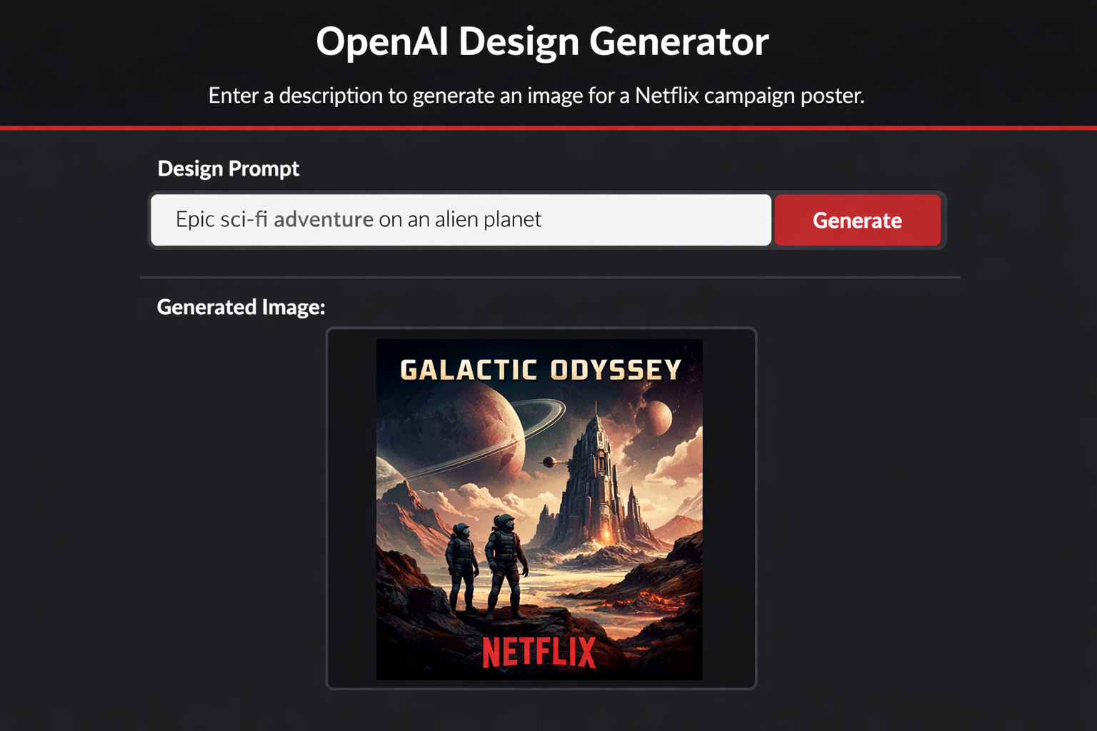

Result
The completed design generator showcases how AI can empower creativity. Designers simply describe what they need, and the tool produces high-quality images in seconds. For example, a prompt like “galactic odyssey poster featuring astronauts exploring a distant planet” yields a polished Netflix-style campaign poster. By automating the image creation process, the agency can iterate rapidly and deliver unique visuals that captivate audiences.
This project demonstrates the synergy of OpenAI’s DALL-E model and Gradio’s intuitive web interface. It simplifies the designer’s workflow and provides a glimpse into a future where AI accelerates creative industries. The package contains all the files required for submission:

