RESUME
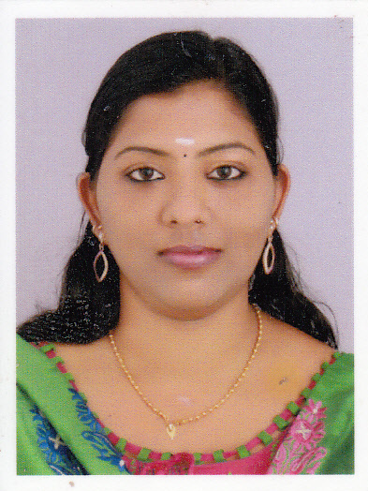

AMBILI.C
Perumpillil House
Chengamanad p o
Aluva
Pin – 683578
Ph: 0484 2476402
Mob: 09446576402
Email – ambilidileepkumar@gmail.com

CAREER OBJECTIVE
A Career in an organization with major responsibilities that will effectively utilize my leadership skills and help me in personal growth and offers me a gateway for higher prospects.

PERSONAL EXPERIENCES

- Presently working as a Front Office In charge / GRE with Atlas Airport Hotel Apartments Nedumbassery Since May 2014

- Golf View Hotel & Suites ,Nedumbassery Front office manager (April 2012- 2014)

- Supervisor of customer service Handling with Air India Pvt Ltd Cochin International Airport(March2011- 2012)

- Golf View Hotel & Suites, Nedumbassery Front office & Guest Relation Executive (August 2010-February 2011)

- Air – India LTD, Cochin International Airport Pvt Ltd, Nedumbassery,
Ground Handling / Check in staff.November2007- November 2008

- Kotak securities Ltd, Ernakulam Customer Care Executive. October 2006- October2007

- Creations Hr. Consultancy, Kadavanthra ,Ernakulam
Front Office / Customer Care Executive. April2006 – October2006

EDUCATIONAL QUALIFICATION

- IATA-UFTAA FOUNDATION & EBT COURSE
October 2006 – March 2007, SATM , Ernakulam

- Computer Proficiency In Office Automation ( M-Es Office Course),Ernakulam
March 2006

- BSc Chemistry, M.G University , March 2003-2006

COMPUTER SKILLS

- Spread sheets: Excel
- Presentation Software: Power Point
- MS Word: Internet Applications

LANGUAGES KNOWN

- English : Read, Write, Speak
- Hindi : Read, Write, Speak
- Malayalam : Read, Write, Speak

HOBBIES

- Listening to music
- Travelling
- Reading

PERSONAL DETAILS

Age & Date of Birth : 29, 14/03/1985
Father : R. Chandrasekharan
Mother : Syamala Chandrasekharan
Husband : Dileepkumar.K.V

DECLARATION

I here by declaring that the information furnished is true to the best of my knowledge and belief.

DATE: 27.04.2015
AMBILI.C
NEDUMBASSERY

