CURRICULUM VITAE

JOJI MATHEW
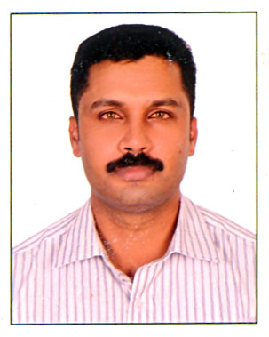
Valliparambil House
Wallaradie P.O.,
Vandiperiyar - 685 533
Mob :- 91 – 9562158140
Email : jojimv2004@yahoo.co.uk / jojimv2009@gmail.com

About Myself
I would like to introduce myself as honest, sincere, and fully committed person. I always work with best of my abilities and efforts with full determination and commitment.

Professional Objective
A challenging job in a fast growing company professionally managed which provides ample opportunities of my growth.

Hobbies
Reading, Music, Movies, Traveling, Driving.

Computer proficiency
Proficiency in MS Office, Foxpro, COBOL, Tally 4.5 and 7.2, Internet, Email etc.

Educational Qualifications
Degree : University of Calicut, Calicut - BBA
Diploma : Govt. Polytechnic College, Kumily - Computer
Application and Business Management (CABM)
Computer Technology : Glory Soft – Tech, Vandiperiyar – DCA
College : Govt. College, Kattappana – PDC
High School : St. Mary’s H.S., Vellaramkunnu - SSLC

(Continued ……..2)

-2-

Working Experience
- Now working as Front Office Executive at Hotel Broad Bean, Vyttila, Cochin from September 2013 to May 2015.
- Worked as Administrative Assistant at Dallas Glass Tempering Factory, Doha, Qatar from January 2009 to January 2012.
- Worked as Front Office Executive at Palazhi Tourist Home and Restaurant, Perumbavoor.
- Worked as Head Cashier at QRS - Quilon Radio Service, Kottayam.
- Worked as Administrative Assistant at Jura Percepta, Nizamudin West, New Delhi.
- Worked as Inventory cum Accounts Assistant at Kriti Creations, Gurgaon, Haryana.
- Worked as Administrative Assistant at Samaritan Social Service Society, Satna M.P. Worked as Supporting Staff at Center for Continuing Education cell, Kalamassery, Ernakulam.
- Worked as Apprentice (Apprenticeship Training) at Supervisory Development Centre, Kalamassery, Ernakulam.

Personnel Details
Present Address : Hotel Broad Bean,
Vyttila, Cochin.
Date of Birth : 16th March 1975
Religion : Christian
Caste : Roman Catholic
Passport No. : G 006 1376
Driving Licence No. : 37/1044/2002
ID Card No. (ECI) : KL/14/086/099501
Bank A/C Nos. : SBT/KMLY/57060827006 / 67117330893
Father’s Name : V.S. Mathew
Occupation : Agriculture
Mother’s Name : Thresiamma Mathew
Occupation : House Wife

DELCLERATION
I hereby declare that the above furnished information is true to the best of my knowledge and belief.

Place : Cochin,
Date : 11/05/2015 Joji Mathew

References
- V.A. Shamsudeen , Principal, Govt. Polytechnic College, Kalamassery, Ernakulam.
- Fr. Varghese Parappilly, Director, Samaritan Social Service Society, Pateri, Mahadeva P.O., Satna - 482 006.
- Mr. Anil Koshy, Manager – Operations & Administration, Dallas Glass Tempering Factory, PB No. 17750, Doha, Qatar.

