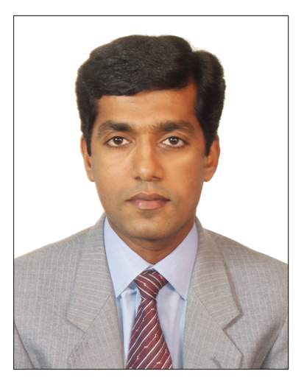
LAIJU ELIAS
THOTTATHIL HOUSE
AIRAPURAM
AIRAPURAM P.O.
ERNAKULAM DIST.
KERALA, INDIA, PIN-683541

Mobile : 0091 9747583658
0091 8943355000
E-mail : laijuthottathil@yahoo.com
Skip ID: laiju.thottathil

Post Applied For: Any Suitable Post in F & B Service

OBJECTIVE

Overall 12 years experience as F& B professional in the management field and working with leading business Hotel groups. Looking for a carrier based position in an established organization, where I can impart my knowledge and experience to the optimum growth and mutual success of the endeavors.

EDUCATIONAL QUALIFICATION

- Diploma in Hotel Management and Catering Technology from Indian Institute of Management studies in Cochin, 1994
- Pre-Degree from Mahatma Gandhi University, India, 1990
- Secondary School Certificate from, St.Thomas High School, Keezhillam, India, 1988

PERSONAL DETAILS

Date of Birth : 15.09.1970
Gender : Male
Marital Status : Married
Religion : Christian
Nationality : Indian
Languages Known : English, Malayalam, and Hindi
Passport No. : H 2694354

WORK EXPERIENCE

- Worked as a Captain F&B Rotana Hotel (Arjaan) media city, Dubai, July 2008 to August 2015.

- Worked as a bar casher and waiter in Oasis Beach Hotel in Coco Cabana Bar (Jebel Ali international group -5 star) March 2006 to June 2008.

- Worked as a Waiter and Cashier in Holiday Beach Club, Ajman, October 2003 to January 2006

- Worked as Senior Waiter in Hotel Avenue Regent, India, February 1999 to October 2003

PERSONAL STRENTH

Strong interpersonal and Communications skills with proven ability to contribute to the development and overall growth of an organization. Hard working, determined and a desire to succeed are my strong assets.

CERTIFICATE IN HAND Basic Fist Aid, CPR&AED, Ronnefeldt Tea Academy, Train to Trainer, Elementary Food Hygiene (Scotland).

Declaration

I here by certify that the information above is true and correct to the best of knowledge and belief.
References..
Mr.Christopher Andrade
Food and Beverage Manager,
Arjaan By Rotana,Media city,
Dubai U A E,
Contact-00971506846476,
E-mail chris.andrade@gmail.com,
Office mail chris.andrade@rotana.com
LAIJU ELIAS

