JAYESH GOPI
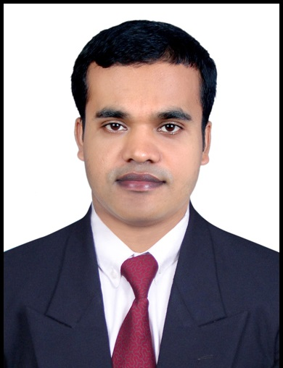
Naraleli House, Azhakom post,
Moonnamparabu ,Ekm Dist,
Kerala-India.
Mobile-0091-8943502440
Email-gopi.jayesh@yahoo.com

Skills Summary :-

Highly motivated, enthusiastic, experience with more than 10 years national and international hotel experience in Food and Beverage Management. Strong ability to lead and develop people with excellent communication skills and detail oriented and strong focus on guest satisfaction. Innovative problem solver, great motivator and excellent communicator.

Willingly adapt to change and have experience of 5 start Resort & Hotel , business and luxury hotels .Personable and trustworthy with proven track record of meeting and exceeding company goal and vision.

Core Competencies:-

- Guest Service Focused
- Team Work & Leadership
- Strategic Planning
- Implementing system for improvement
- Cost Saving Initiatives
- Inventory control profit
Technical Knowledge:-

- Mc, Fidelio & Opera
- Microsoft Window & Excel
- Power Point
Technical/Educational Qualification:

- Diploma in Food and Beverage Service
- University / Institute : Government of Kerala Food Craft Institute Kalamessery Kerala-2002

Pre-degree ( A-Level)

- Year passed : 1999
- University / Institute : Mahatma Gandhi University-Kerala

S.S.L.C ( O-Level)

- Year passed : 1997
- University / Institute : Board of Public Examination Kerala.

Professional Experience:

- At Present Working as a Bar Supervisor in Hotel AirLink Castle Nedubassery Kerala-India Since 1st March 2013

- Head Bartender in Kanuhura Maldives Since 26th April 2012 to 21th of January -2013

- Head Bartender in Veligandu Island Resort &spa Maldives Since 26th February 2006 to 14th of Dec 2011

- Bartender in Clubmed kani Maldives Since 15th November 2004 to 25th of January-2006

Industrial training: Resort Dona Sylvia Beach Resort Goa India And working as Waiter in The International Hotel Cochin

Additional Training Course:

- Knowledge of Bartender/Sheesha Making Training Course Club med kani Maldives ( Htc in Asia Hospitality & Tourism Consulty).
- Certificate of attendance, Highlights on the wine world 11th of Nov-2011 Conducted by Mr. Enrigo Donati Grape Expectation Head Sommelier/ Wine Educator
- Certificate of Food Safety Asia (Haccp) Level 2 and Level 3 in Kanuhra Resort Maldives
- Customer Service Training Course from Veligandu Island Resort Maldives (Crown & Champa Resot).
- Basic German Course from Veligandu Island Resort Maldives (Crown & Champa Resort)

Achievements:

Awarded certificate of appreciation of Supervisor of Month –June-2008 and June- 2011 From Veligandu Island Resort & Spa Maldives.

Personal Deatails :

Date of birth : 02/04/1981
Sex : Male
Nationality : Indian
Marital status : Married
Passport No : K 0375399
Place of Issue : Cochin
Date of Expiry : 05-03-2022
Permanent Address : Naraleli House, Azhakom post, Ekm dist,
Kerala- India
Languages know : English, Hindi,Dhivehi, and Basic German
Hobbies : Listing to Music, Making friends
Personal strengths : Hard working, self confident

Declaration:

I herby furnish that the particular in this curriculum vita true and accurate to the best of my knowledge.

Place : Cochin Yours Faithfully
Date :25/03/2015

Gopi jayesh.

