JINUMOL THOMAS
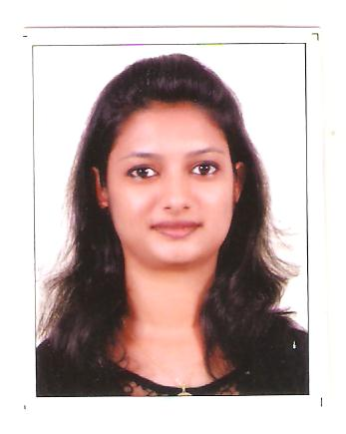
CHIRAYIL (H), AMARAVATHY (P.O), FIRST MILE
KUMILY, IDUKKI (D.T), Pin : 685509
Mob: 08281613290, 9747901490
Tel : 04869211226
E Mail – jinumolt@gmail.com

Summary Profile
- Effective communication and coordination skills in various fields.
- Excellent learner with the ability to dynamically adapt to new environments.
- Adept in computer – knowledge in MS Windows, MS Excel, MS Word, MS PowerPoint and all Internet related activities.
PRESENT ORGANISATION

VLCC HEALTH CARE LTD

- JOB DESIGNATION: DIETITIAN/ NUTRITIONIST
- JOB DURATION : 15-01-2014 –TILL THE DATE
- JOB DUTIES : Doing Diet assessment and giving diet counseling on healthy eating habits. Working on personalized diet charts for targeted weight loss. Working towards to achieve given monthly targets. Coordinating with other nutritionist for arranging diet related events.

EDUCATIONAL DETAILS

COURSE | INSTITUTION | BOARD / | YEAR OF | %/Grade
COURSE | INSTITUTION | UNIVERSITY | COMPLETION | %/Grade
Master of Science in  Clinical Nutrition  & Dietetics, (M.Sc -2 Yr) | Alphonsa College, Pala | Mahathma  GandhiUniversity | 2011-13 | 75%
Bachelor of Science in  Clinical Nutrition &  Dietetics,(B.Sc-3 Yr) | Alphonsa College,Pala | Mahathma GandhiUniversity | 2008-11 | 65%
Plus Two(Science) | St. Thomas E.M.H.S.S, Attappallam, Idukki | Board of  Public Exams,  Kerala | 2008 | 73%
10th Secondary | Gov.HSSS Amaravathy,  Idukki | Board of  Public Exams,  Kerala | 2004 | 53%

TRAINING UNDERGONE

- 1 month Internship from 01st June 2012 to 30th June 2012 in the Medical Nutrition Department of MIMS Hospital Calicut, Kerala on 2012.
- 1 month Internship from 03rd May 2010 to 12th June 2010 in Dietary Department of Orthodox Syrian Church Medical College Hospital, Kolenchery, Ernakulam, Kerala.

ACHIEVEMENTS

- Participated in the ICMR Sponsored "International Conference on Bioactive Natural Compounds from Plant Food in Nutrition and Health"on 2012.
- Participated 10 days programe in Dairy Training Center, Kottayam on 2008

PERSONAL DETAILS

DATE OF BIRTH : 01.07.1989
AGE : 25YRS
GENDER : FEMALE
PERMANENT ADDRESS : JINUMOL THOMAS
CHIRAYIL (H)
AMARAVATHY (P.O),
FIRST MILE
KUMILY
IDUKKI (D.T)

NATIONALTITY : INDIAN
FATHER’S NAME : MR THOMAS ANTONY
MOTHER’S NAME : MRS. SUSAMMA THOMAS
MOTHER TONGUE : MALAYALAM
LINGUISTIC ABILITY : TO READ :MALAYALAM, ENGLISH,HINDHI&TAMIL
TO WRITE :MALAYALAM, ENGLISH&,HINDI
TO SPEAK :MALAYALAM, ENGLISH, TAMIL &, HIN

PASSPORT DETAILS

Passport Number : H 8930700
Date of Issue : 30-06-2010
Place of Issue : Cochin
Date of Expiry : 30-06-2020

DECLARATION:

I do here by confirm that the information given above is true to the best of
my knowledge.

Place: Idukki
Date: 06/08/2015 (Jinumol Thomas)

