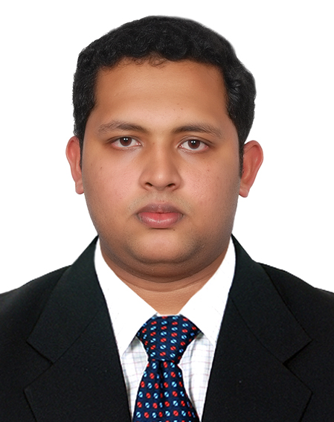
CURRICULUM VITAE

JITHIN KUMAR T
THULASIMANDIRUM
ENATHU P.O.
PATHANAMTHITTA (DIST)
KERALA,INDIA.

Current Address  ONE & ONLY ROYAL MIRAGE STAFF ACCOMADATION  P O BOX 37836  DUBAI  UAE Mobile:+971551543431  E-mail- jithinkumar36@yahoo.  com  Personal Data:  Date Of Birth : 19/06/1989  Sex : Male  Nationality : Indian.  Marital Status : Single  Religion : Hindu  Languages Known:  English,Hindi,Tamil &  Malayalam.  Hobbies:  Playingcricket,Lisaningmusic  Passport Details:  Passport Number : H8852720  Date of issue : 27/07/2010  Date of Expiry : 26/07/2020  Place of issue : Trivandrum  Computer Qualification :  Microsoft Office, Micros,  Internet & e-mail. | CAREER OBJECTIVE  Looking for a successful career with an organization of immense repute, which will bring out the best of my professional ability in terms of analytical, organizational and communicational skills, and helps me in broadening and enhancing my current skills and knowledge while being resourceful, innovative and flexible.  EXPERIENCE  October 2011to present, One & Only Royal Mirage Hotel, Jumeira Beach, Dubai.(467 Rooms 5 star deluxe hotel with 9 dining outlets and banqueting up to 900 guest.  Working as a Captain.  February 2009 to September 2011, Travancore Court Hotel,Kerala, India. 4 Star Delux Hotel with 6 dining outlets and banqueting upto 700 guest.  Worked as a Jun. Captain.  Industrial explosure Training.  August 2008 to January 2009, Marari Beach Resort, Kerala, India.5 star hotel resort with 2 dining outlets.  EDUCATION  - 2 YEAR DIPLOMA in Hotel Management and Travel & Tourism .  - Higher Scondory education( Board of Higher Secondary Education, Kerala)

COMPETENCIES
- Flexible
- Responsible
- Excellent Communication Skills
- Positive Attitude
- Proactive
- Team Oriented
- crediblity and
- Visionary

KEY SKILLS

- Committed to providing excellent quality service.

- Learn quickly, and able to work under pressure.
- Provide excellent service and develop rapport with customers.
- Could be able to give home away home experience to guest.
- Proven commitment to team building, demonstrated by the ability to lead and motivate staff to perform at top efficiency levels.
- Excellent analytical and communication skills.

SCHOOL /COLLEGE ACHIEVEMENTS

- Effectively performed as Food&Beverage Supervisor for Food Festival conducted by our batch .

REFERENCE

Mr. Sebastian. MR.Nassim
F&B Manager Restaurant Manager.
One&Only Royal Mirage One&Only Royal Mirage
Dubai. Dubai.

DECLERATION

I, JITHIN KUMAR T, hereby declare that the information given above is true to the best of my knowledge.

Place: DUBAI Yours Sincerely,

(JITHIN KUMAR T).

