CURRICULAM VITAE

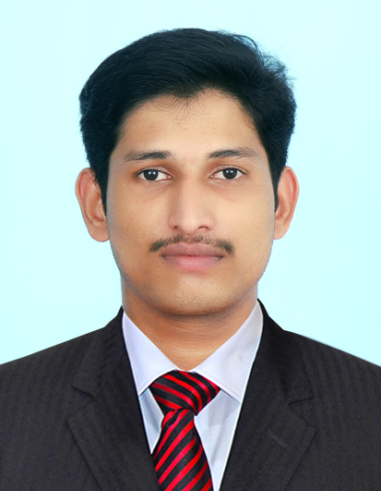

Mr. Justin C Paul

justincherady@yahoo.in

OBJECTIVE:

Intend to build a career with leading Hotels or Hotel groups with committed & dedicated people, which will help me to explore myself fully and realize my potential. Willing to work as a key player in challenging and creative environment. Seeking a good profession to extract my knowledge in Hotel field. Currently I look forward for the best opportunity where I can grow in my career.

PERSONAL SKILLS:

Comprehensive problem solving abilities, excellent verbal and written communication skills, Ability to deal with people diplomatically, willingness to learn, Team facilitator.

COMPUTER KNOWLEDGE

- Basic knowledge in Computer applications, like MS Office.
- Good knowledge in Shaw man point of sale and Orion material management system.

RESPONSIBILITIES

- Ensure that the guests are greeted and seated and served as per the request and specification.
- Good team leader as well as team member.
- Ensure the F & B outlets are stocked with adequate mis-en-place for smooth functioning of meal periods.
- Kept excellent working atmosphere in all day dinning and in room dinning.
- Kept excellent working atmosphere in main Bar, Beach Bar, Pool Bar and Restaurant Bar.
- Put the weekly duty roaster and plan according to that for the next week.
- Keep the area clean and tidy.
- Keep excellent inter-personal relationship with the guest.
- Maintain stock register at Main Bar.
- Acting bar supervisor and in charge of main bar, restaurant bar and beach bar.
- Taking care of coffee shop.

EDUCATIONAL QUALIFICATION:

Course | Board/University | Name Of Institution | Year Of Passing | Percentage%
10th | State board | O.L.L.H.S.S. Uzhavoor | 2006 | 73.81 %
12th | State board | St. Joseph H S S Vayattuparamba | 2009 | 73.16 %
BSc HMCTT | Punjab Technical University | IIMS Cochin | 2009-2012 | 63.60 %

AREA OF INTEREST

Food and Beverage Service.
Bar, Restaurant

WORK EXPERIENCE

- Working as F & B Supervisor in Eriyadu Island Resort, North Male, from 15th November 2014 to till date.

- Worked as Barman in Eriyadu Island Resort, North Male, from 18th May 2014 to 15th November.

- Worked as steward in Vivanta by Taj Kumarakom Kerala 6th April 2013 to 15th May 2014.

- Worked as Taj Bud (On the job training) in Vivanta by Taj Kumarakom, Kerala from 5th February 2013 to 5th April 2013.

- Industrial Exposure Training attended in Vivanta Fisherman’s Cove by Taj Chennai from 16th April 2012 to 14th September 2012.

PERSONAL DETAILS:

Name : Mr. JUSTIN C PAUL

Father’s Name : Mr. C.A. PAUL

Age & DOB : 25 years, 30-07-1989

Sex : Male.

Religion : Christian RCSC

Marital Status : Single.

Nationality : Indian.

Passport Number : H6793464

Place of issue : Cochin

Date of issue : 07-04-2010

Date of expiry : 06-04-2020

Permanent Address : Cheradiyil House
Uzhavoor East P O
Kottayam Dist
Kerala- 686634
India

Mobile no : +960 9828310 (Maldives)
: +91 9656416426 (India)
E-Mail : justincherady@yahoo.in

Skype : justincherady

LinkedIn : justincherady

Languages known | To speak | To write | To read
English
Malayalam
Hindi

Declaration
I hereby declare that the above written particulars are true to the best of my knowledge and belief.

Date:
Place: Cochin
Justin C Paul

