BIPIN RAJ.R

EDUCATION

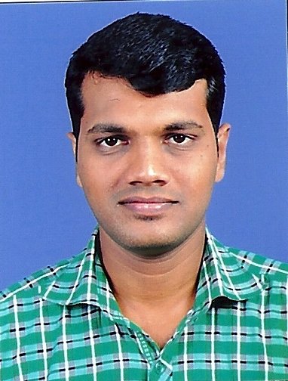

Email address:
rbipinraj@gmail.com

Permanent Address:
Bipin raj.R
450-B III,
Puthuveettil Thekkethil,
l, Edavanaserry,
Mynagapally,
Kollam (Dist),
Kerala (State) Pin: 690519
Mob: +91 8086909442

Personal Data:
D.O.B : 07/02/1985
Sex : Male
Father : Rajan.P.K
Nationality : Indian
Marital Status: Single

Passport Details:
Passport No: G0838442
Date of Issue: 21/11/2006
Date of expiry: 20/11/2016

Objective:

To occupy a position in a growing/ established organization that will enable me to progress in my career in my field, to develop my practical life, and to participate in achieving organizational goals and objectives.
Professional Qualifications:

Course | Year | Institution | Board / University
B.Sc Catering Science and Hotel Management | 2002 -2006 | Snr and Sons College | Bharathiyar University

Educational Qualifications:
Course | Year | Institution | Board / University
Higher Secondary | 2000 - 2002 | K.Krishnaswamy Naidu Higher Secondary School | Matriculation
S.S.L.C | 2000 | Smt.D.Padmavathi Ammal High School | Stateboard

Experience:

Worked in Hamdan Plaza Hotel– Salalah (Sultanate of Oman) as a Headwaiter from April 12th 2013 to May 6th 2015.
Worked in Backwater Ripples-Kumarakom (resort) as Captain from 6th March 2012 to 31st March 2013.
Worked in Hotel Royal Regency (Ochira-Kerala) as
Tr Captain, Captain for two years.

Industrial Training:

Industrial training in F&B Service at Hotel Heritage Inn (Coimbatore) for Three Months.
Key skills:

Creating positive working environment.
Motivating and support the team.
Can work well under pressure.
Strong sense of responsibility.
Excellent communication skills.
Excellent Sales promotion.
Able to work as part of a team.
Good relationship with all departments.
Job description:

Restaurant :
Checking all misc en place is ready for proper service.
Advising customers on menu choices.
Taking down the customer’s order and serving the food exactly as requested.
Maintain the standard of service to all guests.
Serving dishes according to course by course.
Room service:
Taking down the room service orders.
Serving the order in a proper way to the room.
Clearing the dishes from the room at correct time.
Handing the cash and bills.
Maintaining proper room service order taking sheet and register.
Banquets:

Setting up of banquet hall according to type of function.
Setting up of buffet counter and bar counter according to the function prospects.
Maintaining the standard of service and guest satisfaction.
Computer Skills:

Basic knowledge in operating system (windows 7,windows 8).
Basic knowledge in Microsoft Office.
Basic knowledge in handling billing softwares (POS, HOTSOFT).
Language known:

To Speak-English, Tamil, Hindi & Malayalam
To Read & Write- English, Tamil
Hobbies:

Listening music.
Watching Movies.
Achievements:

Have been awarded as divisional runners during high school
Ball badminton meets.
Have represented Coimbatore district level junior ball
Badminton team as front.
Declaration:

I hereby declare that all the above information is true to the best of my knowledge.

Place:
Date: BIPINRAJ.R

