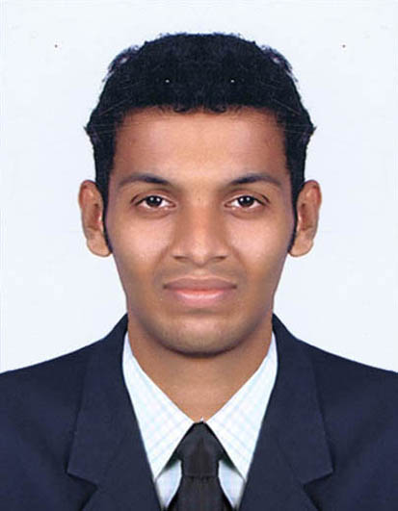

Aravind K CHANDRAN
Contacts: (91) 9633203939
Email: aravindchandran12@gmail.com
KANNIMEL HOUSE, SREYAS NAGAR, NARYANASAN ROAD, EROOR .P.O. KOCHI 682306

CAREER OBJECTIVE
A budding professional seeking initial assignment to make a good career in
a well reputed Hotel management where I can show my skills in order to serve
The organization achieving their goals

sNAPSHOT
- An effective communicator with excellent relationship building & interpersonal skills.
- An exceptionally well organized professional with an ability` to maintain cordial relations at all levels of management

Technical skill set
- Communication Skill
- Expert in solving the guest related problems
- Specialized in Microsoft Word.

Academia
- Examination passed Year Board/university % Of Marks
- SSLC march 2008 General Edun Dept Govt Of Kerala 64%
- Higher Secondary march 2010 Board Of Higher Secondary Exam 60%
- BHM&CT 1st sem Janu 2011 University Of Kerala 58.6%
2nd Sem June 2011 “ 55.1%
3rd Sem Janu 2012 “ 59.7%
4th Sem octo 2012 “ 60.5%

- Academic Project Details
- Successfully done Project of Hotel Holiday Inn

- AREA of PREFERENCE

CONCIERGE TEAM LEADER
EXPERIENCE: DUTIES AND RESPONSIBLITES
Holiday Inn Cochin.
Successfully done in Industrial Training in Holiday Inn Cochin From 5th of March 2011 to 7 of July 2011 I had worked in front office and housekeeping department
Currently working at Crowne Plaza Kochi as Bell desk Assosiate

Personal Vitae

- Date of Birth: 12th April, 1991
- Languages Known: English, Malayalam, Hindi
- Nationality: Indian
- Gender: Male
Permanent Address: KANNIMEL HOUSE, , Sreyas Nagar, Kaniampuzha, Eroor.P.O
Ernakulum, Cochin-682306, Kerala – India

Declaration

I hereby declare that the above given details are true and fair to the best of my knowledge, if selected I shall put in my very best effort for the satisfaction of the superiors and rapid progression of the Organization.

ARAVIND K CHANDRAN

