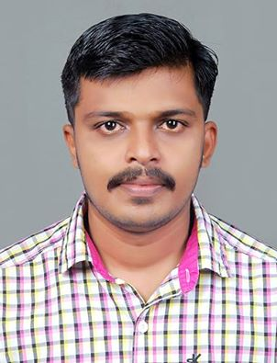  VISHNU GOPINATH  Passport no: L 8024825  Email ID:vishnugopinath1@gmail.com  PERMANENT ADDRESS  Nadukkoottil (house)  karukadom (PO)  venduvazhy  Ernakulam (DT)  Kerala-686691  PH.no: 9605588005 (mob)  PERSONAL DATA: | Objective :  - To Work in a leading financial organization in a creative and challenging environment using all learning’s, where I could constantly learn and successfully deliver solutions to problems as a team member.  Personal:  Organized, dependable and innovative. Detail oriented. Maintains discipline, good work habits, ethical conduct, and a philosophy of life-long learning. Meticulous about the quality of products, documents and the work environment. Works well with others to accomplish goals and foster individual development  Accomplishments :  - Fluency in English.  - Good analytical and managing skills.  - Ability to learn things quickly.  Leisure pursuits :  - Surfing in the net to learn share marketing  - Updating knowledge in business  - Reading books.
  Date of birth | : | 6.08.1989
  Languages | : | English, Hindi, Malayalam,
  Gender | : | Male
  Nationality | : | Indian
  Marital Status | : | Single
  Father’s Name | : | Gopinath
  Father’s Occupation | : | Driver
  Mother Tongue | : | Malayalam
  Mother’s Name | : | Chandrika Gopinath
  Mother’s Occupation | : | Housewife
EDUCATIONAL QUALIFICATION:

Course | Year of Completion | Institution | Board/University | Class
M.COM (FINANCE) | 2013 | YELDHO MAR BASELIOUS  COLLAGE KOTHAMANGALAM  ERNAKULAM (DIS)  KERALA | MG UNIVERSITY | First Class
B.B.A | 2009 | INDIRA GANDHI COLLEGE OF ARTS AND SCIENCE, NELLLIKUZHY  ERNAKULAM (DIS)  KERALA | MG UNIVERSITY | First Class
PLUS TWO  (+2) | 2006 | FR. J. B. M. H. S. PUTHUPADY  ERNAKULAM(DIS)  KERALA | COMMERCE | First  Class
SSLC | 2004 | MAR BASIL HIGHER SECONDARY SCOOL  ERNAKULAM(DIS)  KERALA | SSLC KERALA | Second  Class

EXPERIENCE.

- 2 year experience in Manappuram General Finance as a Branch Head
- Now working as an Accountant in Broad Bean Hotel.

DECLARATION:

I promise you conscientious and loyal service, sincere interest in my duties and responsibilities to the at most satisfaction of my superiors.
I VISHNU GOPINATH do hereby declare that the details furnished above are true to the best of my knowledge and belief.

Place: KOTHAMANGLAM

VISHNU GOPINATH

