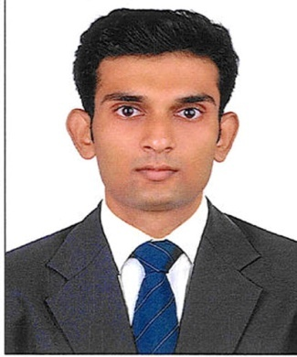 **ANVER P.N** PUNNILATH HOUSE CHALINGAD P.O KAIPAMANGALAM THRISSUR – 680 681 KERALA E- mail id : [anverpn@yahoo.com](mailto:anverpn@yahoo.com) Mob: +91 9995218297

**OBJECTIVE**

to seek a carreer in management position in Travel and Tourism industry.

**EDUCATIONAL QUALIFICATION**

|  |  |  |
| --- | --- | --- |
| **Course** | **Institution** | **Year** |
| B.sc.Airline Tourism and Hospitality management | St. Antony’s School of management studies | 2011 -2014 |
| +2 – Computer Science ( State) | Hira English School Kaipamangalam | 2011 |
| S.S.L.C (CBSE) | Hira English School Kaipamangalam | 2009 |

**PROFESSIONAL QUALIFICATIUON**

Travel documentation , Computer Reservation System of Amadeus.

**EXPERIENCE**

* Worked as a F&B service staff in reputed family club in cochin from Dec-9-2013 to present.
* Acquired experiences in Food and Beverage service - customer care and hospitality.
* Completed one month training in Trivandrum International Airport

**LANGUAGES KNOWN**

|  |  |  |  |
| --- | --- | --- | --- |
| **Language** | **Read** | **Write** | **Speak** |
| English | Yes | Yes | Yes |
| Malayalam | Yes | Yes | Yes |
| Arabic | Yes | Yes | No |
| Hindi | Yes | Yes | No |

**STRENGTHS & ACHIVEMENTS**

* Friendly
* Result Oriented
* Sincere and hardworking
* Good team player
* Have won prizes Athletics in School
* Active in Arts and dramatics in College

**HOBBIES**

* Travelling
* People Watching

**PERSONAL DETAILS**

Age & Date of Birth : 23, 05/04/1992

Father’s Name : Nazer .E

Nationality : Indian

Height : 168 cm

Weight : 56kg

Passport No. : K5969095

**DECLARATION**

I hereby declarethat the above details are true to the best of my knowledge and belief.

Place :Thrissur **ANVER P.N**

Date :