**BIODATA**

**SURJITH VAYALODI** 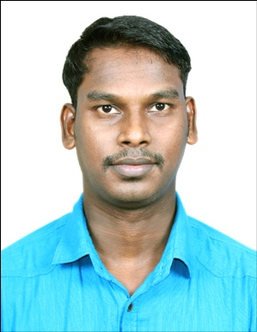

**KANACHERY (H)**

**ELAMBACHI (PO)**

**KASARGODE (DIST)**

**KERALA 671311**

**PH: 09744241416**

**Mail:surjithvayalodi@gmail.com**

**CAREER OBJECTIVE**

To be associated with a dynamic and professionally oriented organization in order to contribute my skills, efficiency, experience and knowledge towards its continuous growth and expansion and to assure a remarkable service in my assigned endeavour for fulfilling business interests of management through its graphical rice-up of motivated tasks .

**EDUCATIONAL QUALIFICATION**

* Secured second class in Secondary Leaving Certificate
* Secured second class in Higher Secondary Education
* B.A in Hindi payyanur college payyanur 2005-2008

**PROFESSIONAL QUALIFICATION**

* FCI Institute of Hotel Management ,ondain road kannur. (2010-11 )

**PROFESSIONAL EXPERIENCE**

* Worked as a industrial Trainee in Hotel Avenue Regent Cochin from 2011
* worked as a Steward in Hotel Avenue Regent Cochin-2011-2012
* worked as senior steward in O.G & BLUE (KANTHARI),kundannur, cochin 6 months
* Presently working as a Senior Steward The Dunes Cochin from 2013 Till Date

**REFFERENCE**

**Mr. ANOOP CHANDRAN F & B MANAGER THE DUNES COCHIN**

**PH: 07561822113**

**PERSONAL DETAILS**

Father Name : MANOHARAN

Date of Birth : 27-05-1986

Gender : Male

Marital status : Single

Nationality : Indian

Religion : Hindu

Place of Domicile : Kasaragod, Kerala

Blood Group : O+ VE

**LANGUAGES KNOWN**

|  |  |  |  |  |
| --- | --- | --- | --- | --- |
| **SNO** | **LANGUAGES** | **SPEAK** | **READ** | **WRITTING** |
| **01.** | **MALAYALAM** |  |  |  |
| **02.** | **ENGLISH** |  |  |  |
| **03.** | **HINDI** |  |  |  |
| **04** | **TAMIL** |  |  |  |

**PERSONAL STATEMENT**

**PERSONAL STATEMENT**

I the undersigned, state that the data i have given here is correctly described my qualification, experience and about myself to the best of my knowledge and belief.

Place: THRIKKARIPPUR

Date: 13-05-2015

**SURJITH VAYALODI**