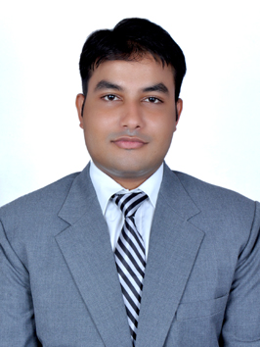**CURRICULUM VITAE**

**RISHAB KHANNA**

Address:B1/83A, 1st floor Kiran garden, Uttam Nagar, New Delhi- 59.

E-mail- [rishabkhanna91@yahoo.com](mailto:rishabkhanna91@yahoo.com)

Mobile- +91 9650708897

Career Objectives:

* I look at myself as a Sous Chef of a big and premium reputed organization with-in the next 5-6 years, by harnessing my ability as a Food production professional.

Key Attributes:

* A professional with high energy and enthusiastic approach to work in a stressed and high pressure working environment.
* By determining results by using optimum amount of my caliber and proving myself as an asset for the organization.
* Result orientation is the key motto of my professional prolife.

Educational Qualifications:

* Done B.Sc in Hospitality and Hotel Administration from Chandigarh Institute of Hotel Management and catering technology. (Result Awaited)
* Passed senior secondary schooling via CBSE board with both Medicine and Scientific Science discipline.
* Successful completion of metric education from CBSE board with general subjects.

Corporate Exposure:

Successful completion of 21 weeks of industrial training and exposure from The Park, New Delhi.

Extra Curricular Activities:

* Achieved the award for Kitchen Coordinator.
* Participated in blood donation camps.
* Volunteered for prestigious Air Force catering event in which Hon’ble President of India “Mr. Pranab Mukherjee” was invited as the guest of honor sponsored by Indian Government and Facilitated by The Taj, Chandigarh.
* Participated at Cornitos Mexican Culinary Challenge 2014 under the aegis of 13th Chandiwala Hospitality Ensemble held at Banarsidas Chandiwala Institute Of Hotel Management, New Delhi.
* Participated at Battle for The Best Chef under the aegis of 13th Chandiwala Hospitality Ensemble held at Banarsidas Chandiwala Institute Of Hotel Management, New Delhi.
* Participated at R-Pure Regional India Culinary Contest 2014 under the aegis of 13th Chandiwala Hospitality Ensemble held at Banarsidas Chandiwala Institute Of Hotel Management, New Delhi.

Management and General readings:

* [www.hospitalitybizindia.com](http://www.hospitalitybizindia.com)
* One Minute Manager By Ken Blanchard

Personal Details:

Father’s Name: Mr. Vijay Khanna

Date of Birth: June 12, 1991

Language Proficiency: competency to speak read and write English and Hindi.

Height: 5’7’’

Weight: 86.5 Kg

Professional Reference:

Name: Mr. Tarpan Kulshreshta Name: Mr. Ashish Dhaundiyal

Designation: Asst. Training Manager Designation: Training Captain, Aqua

Company: The Park, New Delhi Company: The Park, New Delhi

Contact Details: (+91) 8130889312 Contact Details: (+91) 9654274782

Date : 22nd June 2015 RISHAB KHANNA Place: New Delhi