RESUME

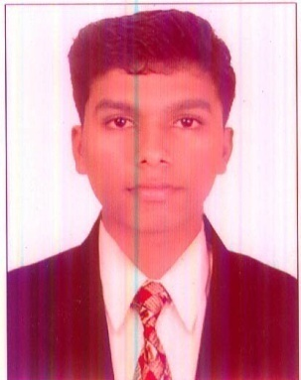

**ABHIJITH PRAKASH**

**Email : abhijithp96@gmail.com**

**MOB : 8129611956**

**Passport No :M3451401**

Objective

**To gain professional expertise as hotelier that would best utilize skills in the hotel environment and shoulder the responsibilities , where hard work is recognized to achieve the organizational goals & grow along with the firm.**

Professional Qualification

**SECONDARY SCHOOL LEAVING CERTIFICATE 2008**

**(V.H.S.S.Brahmamangalam,Vaikom Kottayam)**

**HIGHER SECONDARY EXAMINATION CERTIFICATE 2010**

**(S.N.D.P.H.S.S. UDAYAMPEROOR,ERNAKULAM)**

**BSC HOTEL MANAGEMENT AND CATERING SCIENCE**

**(Chavara Institute Of Management Studies,Cochin Affiliated to Bharathidasn University,Trichy))**

Industrial experience

**Industrial exposure traning at pride biznotel Emarald,Kochi**

**(Specialized in Bakery and Confectionery)**

**On The Job Training at The Woods Manor cochin**

**(Specialized in Bakery and Confectionery)**

**Working as Commi 3 at Emarald Hotel,Cochin from January 19 2015**

Personal Details

**Age & Date of Birth : 22-28-03-1993**

**Sex : Male**

**Nationality : Indian**

**Religion : Hindu**

**Marital Status : Single**

**Languages Known : Malayalam, English, Elementary French**

**Hobbies : Listening to Music, playing football**

Permanent Address

**Kalayiparambil (H),**

**Kulayattikkara (P.O),**

**Ernakulam , Kerala , India , Pin : 682315**

**I hereby declare that the above mentioned details are true to my knowledge and belief submitting my resume for your kind perusal & expecting a favorable response from your side. Assuming you the maximum output expected from me.**

**ABHIJITH PRAKASH**

**KOCHI**

**DATE : 01.05.2015**