**SIJO SEBASTIAN** 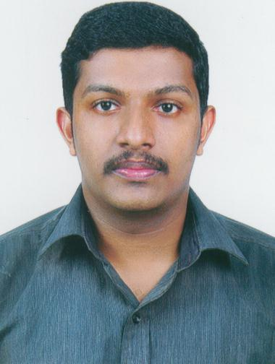

Email [sijosebastian90@gmail.com](mailto:sijosebastian90@gmail.com)

Contact +91 8547816158

+91 9539352587

**CAREER OBJECTIVE**

To be a part of your organization wherein I can use the knowledge imbibed from my education in both professional & practical life and working with a highly efficient group of people in your organization, to achieve organizational goals and groom myself according to the demand of the industry.

**EDUCATIONAL QUALIFICATION**

**B com with computer application** from DEVAMATHA College Kurvilanguad affiliated to Mahatma Gandhi University: - 72.5%

**Certified Financial Accountant:** - Manual & Computerized Accounting.

**WORK EXPERIENCE**

Presently working as an **Accountant** in a resort since 16/02/2015

**Organization**: **WETZLAR RESORTS & HOTELS PVT. LTD**  
 A Kandamkulathy Enterprise f Muvattupuzha, Ernakulam 686 673,  
 Kerala, India

**2.** Period: **2/04/2013** to **14/02/2015**

**Organization: COCHIN PALACE HOTEL**  
 28/698 A, KP Vallon Road, f Kadavanthra, Kochi - 20  
 Kerala, India

Designation: **Accounts in charge**

**3.** Period: **02/07/2012** to  **30/3/2013**

**Organization:** **CINOJ & ASSOCIATES.**

Chartered Accountants

2nd Floor, Kaniyamattam Building,

Koothattukulam,Ernakulam, Kerala – 686 662.

Designation: **Audit Assistant**

**COMPUTER PROFICIENCY**

Accounting experience in **HOTSOFT** Accounting and Auditing experience in **Tally** Working knowledge in **MS Office** applications

**DUTIES AND RESPONSIBILITY**

1. Handled weekly and monthly banking deposits. Trusted to handle large sums. Ensured accuracy of deposits by tallying the information onto deposit reconciliation forms

2. Processed Accounts Receivable and Payments from cash, cheque, & credit card. Applied payments accurately to client accounts

3. Preparations of staff salary statement and updating staff details

4. Provided accurate and complete accounting information to the management level for review

**ACHIEVEMENT**

1. Certificate in Business Communication and Managerial skill 2.SBI TALENT AWARD Certificate for excellence performance 3.NSS Certificate from Mahatma Gandhi University

**PASSPORT DETAILS**

Passport No : L4178977

Issued date : 16/08/2013

Expiry date : 15/08/2023

Place of issue : Cochin

**PERSONAL DETAILS**

Father’s name : Sebastian Date of birth : 01/12/1990 Gender : Male Religion & caste : Christian RCSC Marital status : Single Address for communication : Mullammadackal House as Elanji PO a Ernakulam-686665

**DECLARATION** I hereby declare that all the statements given above are true and correct to the best of my Knowledge and belief.

Yours Truly

**Sijo Sebastian**

**23-09-2015**