**Curriculum Vitae**

My introduction to the hospitality industry was outstanding and highly valuable as I had the rare opportunity to work with the renowned hotel like Sheraton, k K Groups of Hotels , Abaam hotels cochin. In constant improvement and growth in the market this remarkable and luxurious company inspired me to absorb hospitality as a life style by living it with passion by heart and by soul.

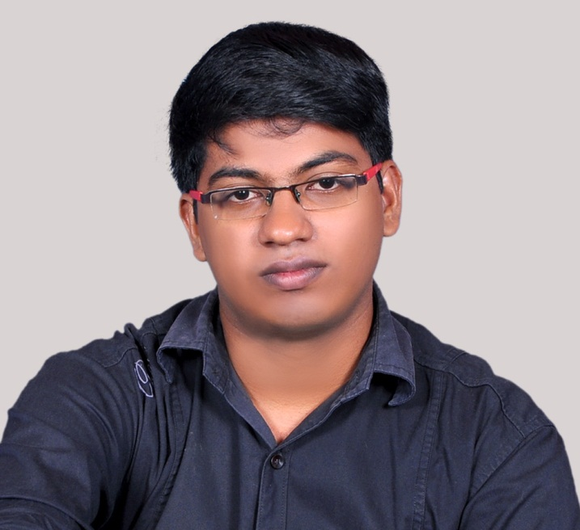

**SUSANTH.N**

**So nithananthan.p**

**Karivellur**

**Po Kannur**

**Pin 670521**

[**Nsusanth740@gmail.com**](mailto:Nsusanth740@gmail.com)

**P h: 09809914406**

**Skype ID susanth679**

**PERSONAL INFORMATION:**

Father’s Name: Mr. Nithananthan.p

Date of Birth: 22.02.1992

Languages Known: English and Malayalam, Tamil.

Gender: Male.

Nationality: Indian.

Marital Status: Single

**OBJECTIVE**

To reach the benchmark of the hospitality industry and to utilize my professional experiences and abilities in acquiring the customer satisfaction at par. To derive a sense of accomplishments in my endeavors while keeping in mind the company's objectives.

**PERSONAL PROFILE**

I am well versed in English and have excellent language skills, motivated, smart working, reliable and productive, proven ability to deliver high quality work*.* Areas of strength include:

* Good Command over the Language.
* Ensuring high quality service
* Able to work effectively in pressurised environment and to tight to time frames.
* Talent for proactively identifying and resolving problems.
* Presentable and well motivated GSA.

**PROFESSIONAL QUALIFICATION**

* Degree In hospitality(Bhs) from Shree Devi college Mangalore (2012-2013)

**EDUCATIONAL QUALIFICATION**

|  |  |  |  |  |
| --- | --- | --- | --- | --- |
| **CLASS** | **YEAR** | **BOARD** | **SCHOOL** | **RESULT** |
| +2 commerce | 2010 | State | Avs ghss  karivellur | Pass |
| 10 | 2007 | State | Avs ghss  karivellur | Pass |

**PROFESSIONAL SYNOPSIS**

Present - Abaam HOTEL Cochin: (GSA) working in front office FROM 15/2/2015

* Experience : Trainee in Sheraton Bangalore (2012 November –Feb)
* Nyle plaza : commie 3rd in south Indian kitchen (2013 November-2014 September)

***Key Skills and Competences:***

* Enthusiastic to work for the hospitality industry.
* Committed to provide outstanding guest service.
* Able to follow instructions of daily project and procedures.
* Clean and professional appearance.

**REFERENCES**

* **Mr. Subramanian –**  GM Munnar board bean hotels(k k groups of hotels)

Contact No: +9995804223

Date: 13.04.2015 (SUSANTH.N)