**BIODATA**

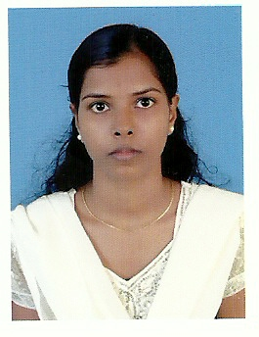

VINEETHA.P.WILLS

E-mail:vineetha.p.wills@gmail.com

Mobile: 7561049179

Trivandrum, Kerala

**OBJECTIVE**

To seek a challenging career in an industry that provides a channel for enhancement of my knowledge& strength to reach the organizations goals as well as to have an upward personal career growth.

**EDUCATIONAL QUALIFICATION**

**Higher Secondary School**

GHSS Kollamcode

Still I am pursuing BSC Hotel management in

UEI Global

**COMPETENCIES**

Hard Working

Enthusiastic

Reliable

Responsible

Good communication skills

Positive attitude

Integrity

Proactive

Team oriented

**KEY SKILLS**

Committed to providing excellent quality service.

Willing to go out of my way to make guests comfortable.

Learn quickly, and able to work under pressure.

Provide excellent service and develop report with customers.

Results –oriented, self-starter with experience.

Strongly developed management, supervisory and training skills.

Reputation for being motivated, dedicated and dependable in all areas of employment.

**WORKING EXPERIENCE**

6 Months experience in VIVANTA by TAJ, Kovalam as a trainee in housekeeping.

6 Months experience in Desk attender in housekeeping in Vivanta By Taj Kovalm, Kerala.

2year experience in Housekeeping Desk Attendant in Crowne plaza Cochin Kerala

Presently working in Front office Associate in Crowne plaza Cochin Kerala

**HOBBIES**

Reading

Listening Music

Swimming

**PERSONAL PROFILE**

NAME VINEETHA P WILLS

FATHERS NAME WILLSON

MOTHERS NAME PUSHPA LATHA

DATE OF BIRTH 26/05/1993

SEX FEMALE

NATIONALITY INDIAN

MARRITAL STATUS MARRIED

LANGUAGES ENGLISH, MALAYALAM

PERMANENT ADDRESS CHRIST BHAVAN, KOTTARATHERI,

THOTTUVARAMBU, PLAMOOTTUKADA P O

TRIVANDRUM, KERALA

695128

**DECLARATION**

I do hereby declare that the information given above by me are true to the best of my knowledge and belief.

Place: Trivandrum

Date:06/056/2015 Vineetha.P.Wills