**VIPIN THOMAS**

Thunduparampil House

Churulikode P.O

Pathanamthitta

Kerala, India‐ 689668.

E‐ mail: vipin.thomas268@gmail.com

Contact #: +91 9447705114

|  |
| --- |
|  |

Desire a position , where I will be able to fulfill my goals of working with a prestigious firm such as yours and to have an opportunity to utilize my quality driven professional ethic, result oriented personality and creative problem solving skills to the best of my abilities for being a useful asset to the organization.



* Finance
* Sales



|  |  |  |  |  |
| --- | --- | --- | --- | --- |
| **Course** | **Institution** | **Board/**  **University** | **Year of completion** | **Marks %** |
| Post Gradauation Diploma In International Business Operations | Distance  Education | Indira Gandhi National Open University | 2013 | 61 |
| M.com  (Finance & Control) | CMS College Coimbatore | Bharathiar University | 2013 | 64 |
| B.Com  (Computer Application) | CMS College Coimbatore | Bharathiar University | 2011 | 60 |
| Plus Two | Marthoma H.S.S, Pathanamthitta | Kerala State Board | 2008 | 51 |
| 10th | Marthoma H.S.S, Pathanamthitta | Kerala State Board | 2006 | 55 |



|  |  |
| --- | --- |
| Computer Skills | MS Office |
| Accounting Skills | Tally |



**M.com FC Project:** M.com FC final semester academic project on ““**A CUSTOMER SATISFACTION ON ATM SERVICES WITH SPECIAL REFERENCE TO COIMBATORE CITY**” during January 2013‐ March 2013.

**Description:** The main objective of the project is to study customer satisfaction of different ATM services. In concern with the above study, the researcher has analyzed information relating to different bank’s ATM users and to know the advantages disadvantages & future of ATM services. This project will also helps to study customer satisfaction of ATM services offered by banks and to find out the problem encountered by customer while using ATM services.



Name : Vipin Thomas

Father’s Name : T.S.Thomas

Date of Birth : 15-05-1990

Sex : Male

Marital Status : Single

Nationality : Indian

Religion : Christian

Passport No : L5206034

Issue Date : 06 November 2013

Expire Date : 05 November 2023

Language Known : English, Hindi, Malayalam, Tamil

Permanent Telephone No : 0091-9447705114



|  |  |  |  |
| --- | --- | --- | --- |
| Aswini Distributors | Pathanamthitta | Accountant | 1st May 2013 to 28th February 2014 |
| Popular Finance | Pathanamthitta | Accountant | 3rd March 2014 to Till Dated |



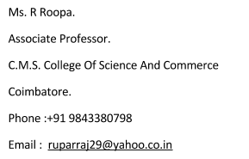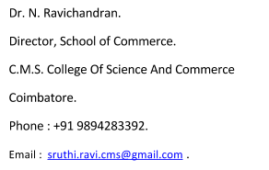



I hereby declare that the above mentioned information is true to the best of my knowledge and I bear responsibility for the correctness of the above mentioned particulars.

**Place :** Pathanamthitta.

**Date :** VIPIN THOMAS