**VISHNU ASHOK** 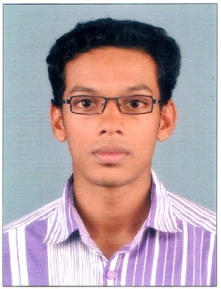

EDACHERIL (H)

ARUNAPURAM P.O **Address for Communication**:-

PALA, KOTTAYAM Email: vishnuashok701@gmail.com

KERALA Ph : +91 9633664939 (M)

PIN: 68657404822-200748 (R)

**Objective**

To be a part of and support the management and functions of a dynamic organization,utilizing my capabilities to the fullest, to contribute to the success,profit and expansion of the organization.

**Academic Profile**

|  |  |  |  |  |
| --- | --- | --- | --- | --- |
| Course/  Degree | School/  College | Board/  University | Year of Passing | Marks Percentage |
| M B A | Phoenix Aviation Training academy | Bharathiyar University. Distance Education Centre | Currently pursuing |  |
| B.Sc. Chemistry | St.Thomas College, Pala | M.G University | 2014 | 63% |
| Plus Two | St.Thomas Higher Secondary School,Pala | Board of Higher  Secondary Education | March 2011 | 73% |
| 10 th | St.Thomas Higher Secondary School, Pala | SSLC, Kerala | March 2009 | 77% |

**Technical Skills**

Operating Systems : Windows(XP,7,8),

Application : MS Office

**Achievements**

* Participated in athletics competitions and got prizes at school level and sub district level.
* Participated in Football tournaments at intercollegiate level.
* Was the main coordinator of I-Speak reality show in school level.
* Worked as the secretary of Chemistry association in college for two years.

**Strengths and Hobbies**

**Strengths**: Dedicated and disciplined with an ability to coordinate all members equally.Able to work independently or together in a team for coordinate events and projects.

**Hobbies** : Riding and travelling, Reading books, playing football.

**Experience**

* Worked as Admin and Guest relation executive from July 2014 to May 2015 in Hotel Holiday Inn Cochin.

**PERSONAL PROFILE**

Name : Vishnu Ashok

Father’s name: Ashok Kumar S

Marital Status: Single

Nationality : Indian

Languages Known: English, Malayalam,and Hindi

Ph No : 91-9633664939 (M)

Date of Birth: 30/07/1993

Place: Pala

**REFERENCES:**

1. Prof. K K Jose

Principal

St. Thomas College Pala

04822-212317

1. Mr. Purushothaman Chakravarthy

Program Manager

Holiday Inn Cochin

+91 8089206677

**Declaration**

I hereby solemnly affirm that the particulars furnished details above are true to the best of my knowledge.

PLACE: Pala yours faithfully

Date: **VISHNU ASHOK**