**RESUME**

**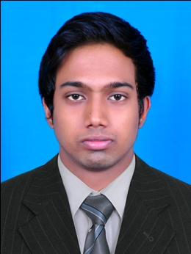 *DILEEP.S***

S/o Suresh.c

Thettankavu (ho)

Kodunthirappully (po)

Palakkad

E-mail ID:dileepdilz@yahoo.com

MOB: 7293649152

|  |
| --- |
| CAREER OBJECTIVE |

To be a professional and utilize my skill and knowledge to fulfill requirement of the

Organization in customer service

**ACADEMIC CHRONICLES**

* Pursuing Diploma in AVIATION, HOSPITALITY, TRAVEL MANAGEMENT in **FRANKFINN** institute of air hostess training @ PALAKKAD
* Higher secondary education in **commerce**  from pulliyaparamb Higher secondary school pudur , palakkad
* S.S.L.C From GRACE Higher secondary school Athalur, Palakkad

**TECHNICAL SKILLS**

* Basic in Animation
* Basics in MS Office
* Galileo
* **INFLIGHT Training** @ BANGALORE INTERNATIONAL AIRPORT

in **JET Airways**

**PRACTICAL EXPERIENCE**

* Fresher

**PROJECT DETAILS**

* Customer Relationship Management (CRM ) Project (ppt)
* Project on Aviation Assignment (ppt)
* Hospitality project (ppt)

**PERSONAL DETAILS**

Date of Birth : 25/12/1995

Father’s Name : Suresh.c

Nationality : Indian

Gender : Male

Religion : Hindu

Marital Status : Single

**LINGUISTIC ABILITIES**

* To speak , read & write : English & Malayalam
* To only read & write : Hindi
* To only speak : Tamil

PERSONAL TRAITS

* I easily adapt to new situations.
* To keep friendly
* Helping mentality
* Positive thinking
* **Co-operative with other team members**

****EXTRA CURRICULAR ACTIVITY****

* **Participated in cycle polo District & State level**
* **Participated in Football sub-District**

**INTERESTS**

* Short film making
* Listening music
* Dance
* Driving

**THANK YOU FOR VEIWING MY RESUME**

**DILEEP.S**