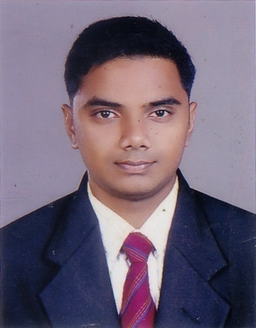

Rahul Rajeev

**Personal statement:**

I am a confident, dedicated and responsible personality who always likes to face challenges in today’s fast paced working environments. Likes to innovate and implement fresh ideas into the Food and Beverage industry with a positive outlook. Highly interested in updating myself on current trends in the hospitality industry and thus keeping up with the ever changing face of the business. Being very passionate about hospitality sector, I always love to explore the never-ending possibilities of my subject. Wide exposure in managing restaurants, bars, outlets, kitchen and catering operations and banquet operations. As a professional hotelier, now having pursued my PG has made me understand the industry in a much more business oriented angle.

CORE COMPETENCIES

F&B Operations Management ▪ Kitchen and Banquet Operations Management ▪ F&B Product Knowledge ▪ Quality Assurance ▪ Food Hygiene ▪ Food Presentation ▪ Menu Planning ▪ Inventory Management and Stock Control ▪ Project Critical Path Process ▪ HACCP Certification ▪ F&B Staff Briefing and Induction ▪ Department SWOT Analysis ▪ Employee Assessment ▪ Performance Review ▪ Business Operations ▪ Customer Relations ▪ Customer Satisfaction

KEY SKILLS

* ***ClientRelations*** – *Exceptional client service, professional mannerism, strong work ethic, building great rapport with customers, good situational awareness and high attention to detail.*
* ***People Management*** – *Highly experienced in managing various departments and developing training programmes. Establishing performance expectations, conducting regular performance evaluation of employees and developing a team-based work environment.*
* ***TeamBuilding*** – *Inspiring, motivating and guiding others towards goals. Actively encouraging and facilitating cooperative and collaborative working relationships. Realigning work groups and work roles to foster and develop teamwork and increase staff productivity.*
* ***Interpersonal and Communication Skills*** – *An excellent multilingual communicator with the ability to work under pressure in fast-paced, time sensitive environments. Proven ability to interact effectively with people of diverse nationalities, comfortable working in a multicultural setting.*

|  |
| --- |
|  |

EDUCATIONAL QUALIFICATIONS

* Graduate in bachelor hotel management from Bangalore University (2009)
* PG in international tourism and hospitality management (CTH) UK(2012)
* P.G Diploma in Business Administration UK(2014)

PROFESSIONAL CAREER

(IET) industrial exposure trainee. The Leela Palace, Bangalore (Kempinski. group) 6months

(HOT) Trainee Captian, kumarakom lake resort.11/2 year

(SENIOR WAITER) Mint and Mustard London 2 year

(CAPTAIN) Cochin Heritage ltd London.2year

PROFESSIONAL TRAININGS

|  |
| --- |
| * Health and Safety |
| * Hygiene Safety |
| * Food Safety Hygiene |
| * Fire Safety |

COMPUTER SKILLS

* Proficient in Microsoft Office Applications.

PERSONAL INFORMATION

Rahul Rajeev

Vazhangattu house

Koothattukulam

Koothattukulam686662

+91 7025012257

rajeev00576@gmail.com

**REFERENCES**

**Mr. Sijin Sudhakar**

**Mint & Mustard**

**Taunton, Somerset UK**

**TA11NH**

**+44 7732838488**

**Further references available on request**