**Abattoir**

**Masters:**

**Add Chicken Rates Record**

**To Add Chicken Rates Record**

1. You have to select "Date" and "unit".
2. Now select "Category" , "Code" and " Description"   
   If you select the 'Code' you will get the 'Description' and if you select the 'Description' you will get the 'code'

**Eg :** Suppose the Date is "6th June, 2011",unit is " Godown", Category "Chicken", Code "CHICK101" , Description "Boneless Chicken", Price "23".  
  
you have to select *06.06.2011* for "Date", *Godown* for "Unit ", *Chicken* for "Category " *CHICK101* for "Code", *Boneless Chicken* for "Description", enter *23* for "Price".  
  
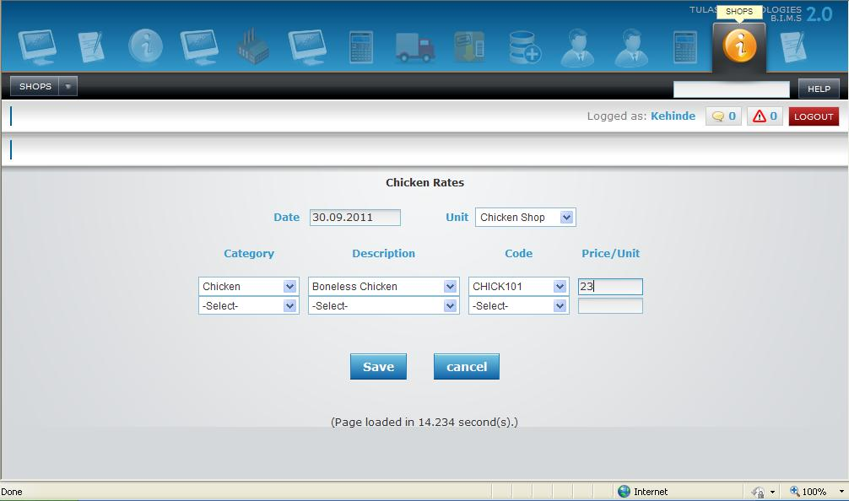

1. Repeat the above 2nd step until all the details are filled.
2. Once filled click on 'SAVE' button to save the Chicken rate details or 'CANCEL' to exit without saving the Chicken Rate details.

**Transactions:**

**Add Retail Rates Record**

**To Add Retail Rates Record**

1. You have to select "Date", "Cash Code" and "Unit".
2. Now select "Category" , "Code" and " Description"   
   If you select the 'Code' you will get the 'Description' and if you select the 'Description' you will get the 'code'
3. Enter the values for " Quantity " and " Price "

**Eg :** Suppose the Date is "30th September, 2011",cashcode is "AS103",unit is " Godown", Category "Chicken", Code "CHICK101" , Description "Boneless Chicken", Quantity "35",Price "23".  
  
You have to select *30.10.2011* for "Date", *AS103* for "Cash code ",*Godown* for "Unit ", *Hatch Eggs* for "Category " *CHICK101* for "Code", *Boneless Chicken* for "Description", enter *35* for "Quantity" and *23* for "Price".  
  
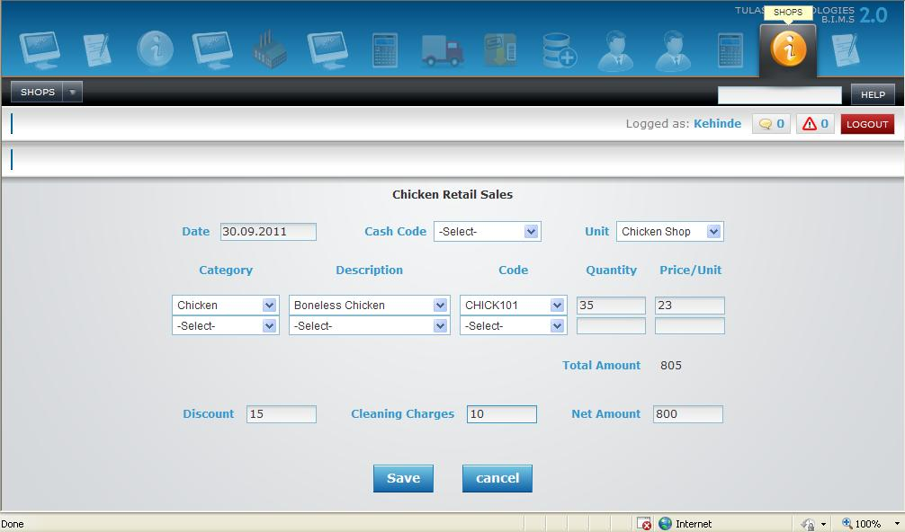

1. Repeat the above 2nd and 3rd steps until all the details are filled.
2. Enter the Discount value and Cleaning Charges, then the Net Amount will be displayed automatically.
3. Once filled click on 'SAVE' button to save the Chicken Retail Sales details or 'CANCEL' to exit without saving the Chicken Retail Sales details.

**Add New Live Birds Sale**

**To Add a New Live Birds Sale**

1. Select Values for "(Sale) Date" and enter value for "Book Invoice"(if any), select values for "Customer (Name)" and Enter values for "Unit".

**Eg :** Suppose if the Sale Date is "29th February, 2012", Book Invoice is "123", Customer Name is "RAHUL" and Unit Name is "Chicken Shop" then   
You have to select *29.02.2012* for "Date",*123* for "Book Invoice", *RAHUL* for "Customer" and *Chicken Shop* for "Unit".

1. You have to select code, description, "Birds(Sold)", "Weight", "Price/Kg", and enter "mortality".

**Eg :** Suppose if the code is "BROB101", Birds are "100", Weight is "235.5", Price is "45" and Mortality is "5"   
You have to select *BROB101* for "Code",*100* for "Birds", *235.5* for "weight",*45* for "Price",*5* for "Mortality".

1. Repeat the above step 2 until all the sales details are filled.
2. Enter the Vehicle No and select Driver and enter discount amount if discount is given.

**Eg :** Suppose if the Vehicle No. is "KA01KP143", Driver is "Trimurthy" and discount "10" then   
You have to enter *KA01KP123* for "Vehicle No.", *Trimurthy* for "Driver" and *10* for "Discount".  
  
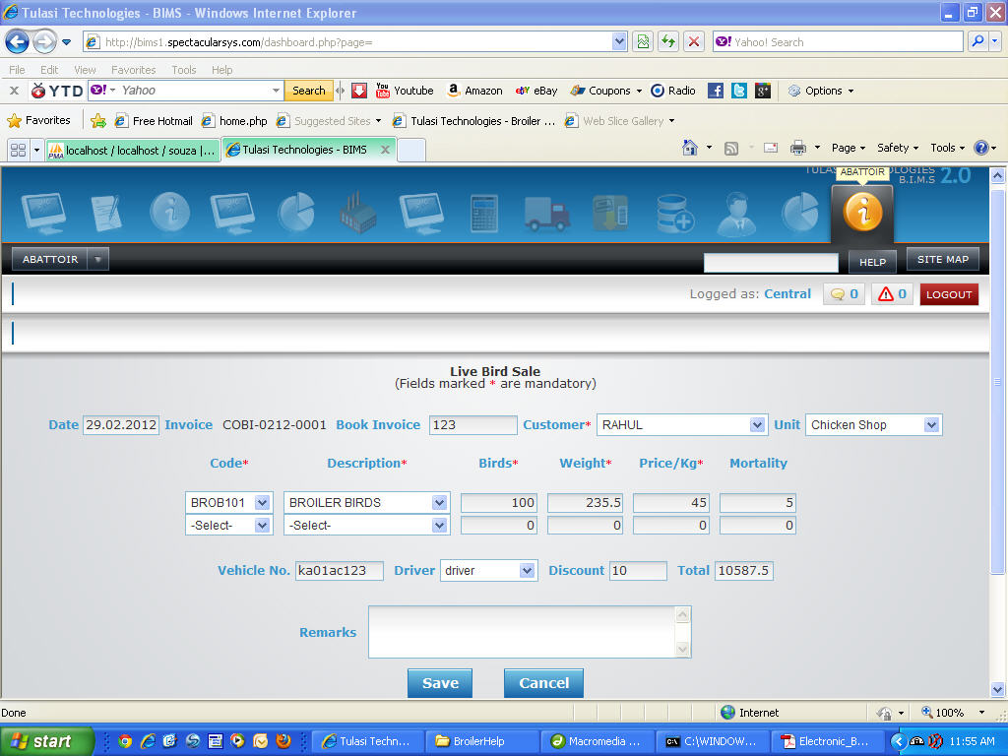

1. Now Click on "Save" button to save the Sale of Live Birds or "Cancel" to exit with out saving the Sale of Live Birds.

**Add New Live Birds Transfer**

**To Add Live Birds Transfer**

1. You have to select "Date" and "Warehouse"(From Warehouse).
2. Now enter values for "DC"(Transfer Memo / Delivery Challan ),"T.Cost"(Transportation Cost),"Vehicle Number" and select "Driver".
3. Select "Category", "Code", "Description" and "To"(To Warehouse).  
   if you select the "Code" the "Description" will be displayed automatically OR if you select the "Description" then the "Code" will be displayed automatically
4. Enter values for "Sent quantity", "Mortality" then you will get the "Received Quantity" automatically.  
   Enter "Price";

**Eg :** Suppose the Live Birds Transfer Date is "27th march, 2012",if you want to transfer an item from "Processing Unit", DC is "111", T.Cost is "1500", Vehicle Number is "KA072331", Driver is "Azim", Category is "Broiler Birds", Code is "BROB101", Description is "Broiler Birds", To "Chicken Shop", Sent Quantity is "800", Mortality is "10" and Price is "80"   
you have to select *27.3.2012* for "Date", *Processing Unit* for "Ware house".  
Enter *111* for "DC", *1500* for "T.Cost", *KA072331* for "Vehicle Number".  
Select *Azim* for "Driver", *Broiler Birds* for "Category", *BROB101* for "Code", *Broiler Birds* for "Description", *Chicken Shop* for "To",*800* for "Sent Quantity",*10* for "Mortality",*80* for "Price",

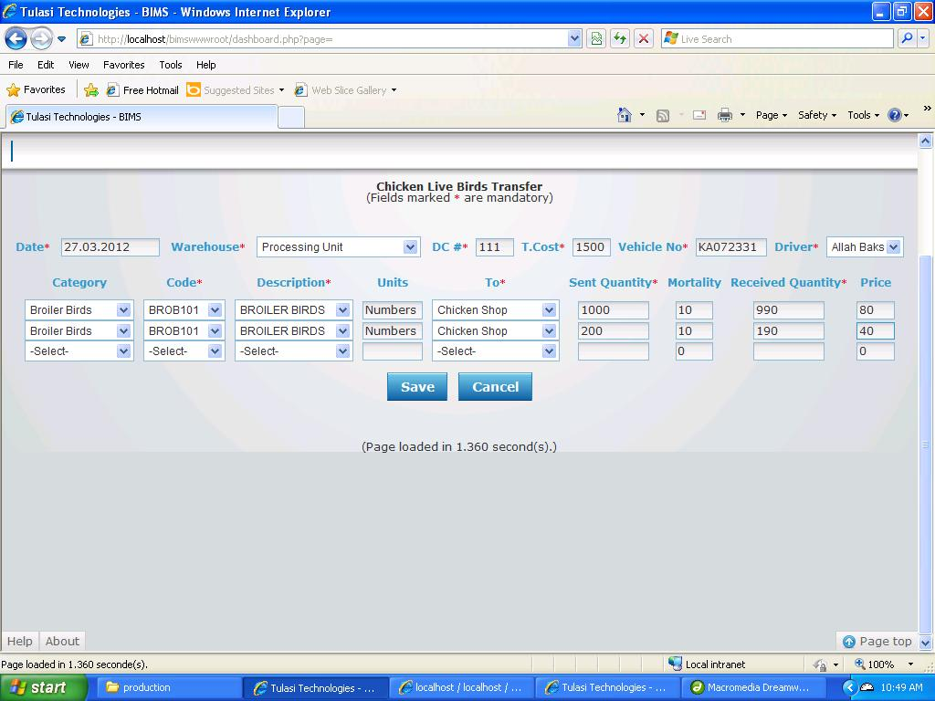

1. Repeat the above step until all the Live Birds transfer details are filled.
2. Once filled click on 'SAVE' button to save the Transfer details or 'CANCEL' to exit without saving the Transfer details.

**Processing:**

**Add Chicken Processing**

**To Add Chicken Processing Record**

1. You have to select "Date" and "unit".
2. Select "From Type"," From Description" and "From Code".  
   If you select the 'Code' you will get the 'Description' and if you select the 'Description' you will get the 'code'
3. Enter value for No of birds.
4. Now select "Category" , "Code" and " Description"   
   If you select the 'Code' you will get the 'Description' and if you select the 'Description' you will get the 'code'

**Eg :** Suppose the Date is "6th June, 2011",unit is " Godown", From Type "Layer Birds", From Description "Layer Birds", From COde "LBRD101",No Of Birds "12",Category "Chicken", Description "Bone Less Chicken", Code "CHICK101" , Units "23",Quantity "31".  
  
you have to select *06.06.2011* for "Date", *Godown* for "Unit ", *Layer Birds* for "From Type ",*Layer Birds* for "From Description", *LBRD101* for "From Code", enter *12* for "No of birds", *Chicken* for "Category ",*Bone Less Chicken* for "Description" *CHICK101* for "Code", enter *23* for "units",*31* for "quantity".  
  
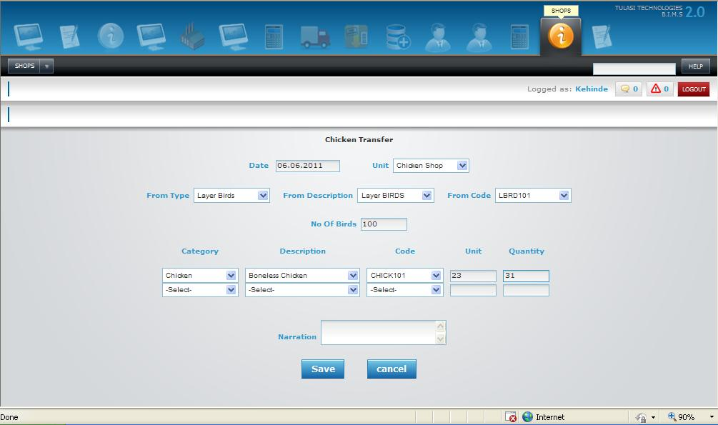

1. Repeat the above 4th step until all the details are filled.
2. Once filled click on 'SAVE' button to save the Chicken Transfer Details or 'CANCEL' to exit without saving the Chicken Transfer details.

**Broiler Birds Receiving**

**To Add Broiler Birds Receiving**

1. You have to select date.
2. You have to select Received By.  
   **Eg :**Suppose if birds transfer is received by "Steven" you have to select *steven* for "Received By".
3. You have to select Chicken Shop(from where you received birds).  
   **Eg :**Suppose if the Chicken Shop is "Puttur" you have to select *Puttur* for "Chicken Shop".
4. You have to select Dc Number.  
   **Eg :**Suppose the Dc Number is "1562" you have to select *1562* for "DcNo". After selecting DcNo total no of "birds sent" will be displayed automatically.
5. You have to enter Birds Mortality.  
   **Eg :**Suppose birds Mortality is "20" you have to enter *20* for "Birds Mortality". After entering birds mortality "Birds Remaining" will be displayed automatically.
6. You have to enter Birds Received.  
   **Eg :**Suppose birds Received are "600" you have to enter *600* for "Birds Received". After entering birds Received "Shortage" will be displayed automatically.

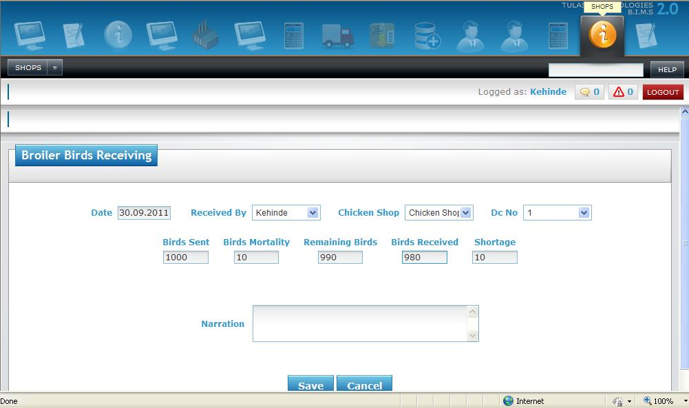

1. Once filled click "SAVE" button to Save the Birds Receiving or click "CANCEL" button to exit without Saving Birds Receiving.