**Accounts**

**Reports:**

**Balance Sheet**

1. Enter From Date, To date and Click on Report.

**Eg:**Suppose From Date is "1st April 2011" and To Date is "23rd August 2011".

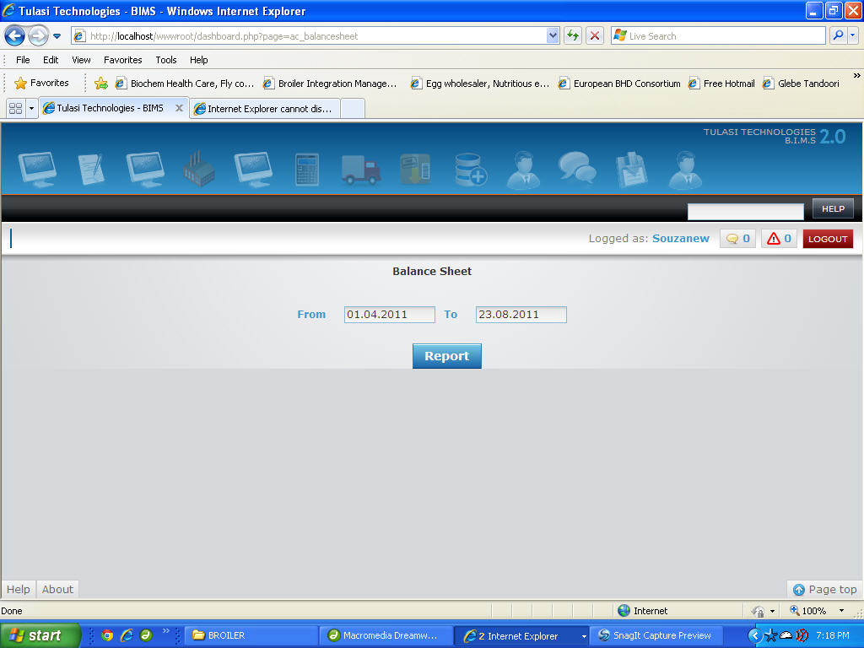

**Profit & Loss**

1. Enter From Date, To date and Click on Report.

**Eg:**Suppose From Date is "1st April 2011" and To Date is "23rd August 2011".

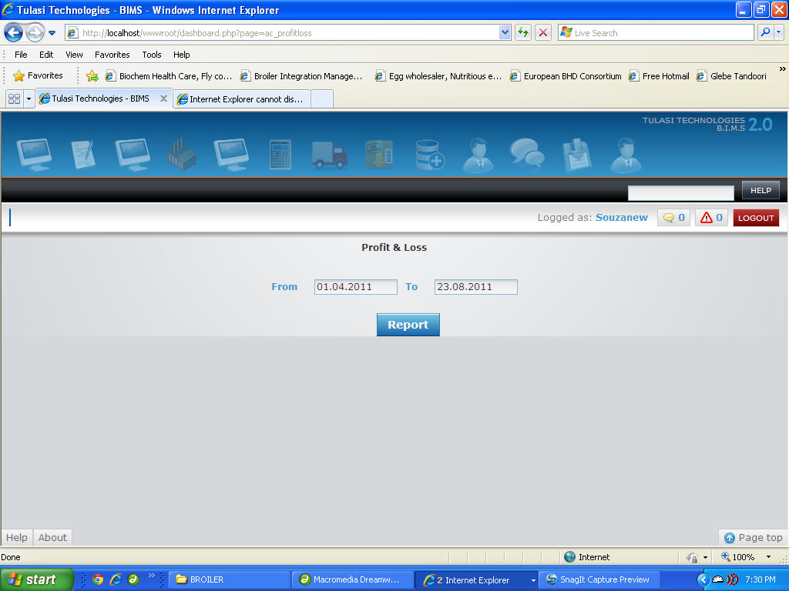

**Trial Balance**

1. Enter From Date, To date and Click on Report.  
   **Eg:**Suppose From Date is "1st April 2011" and To Date is "23rd August 2011".

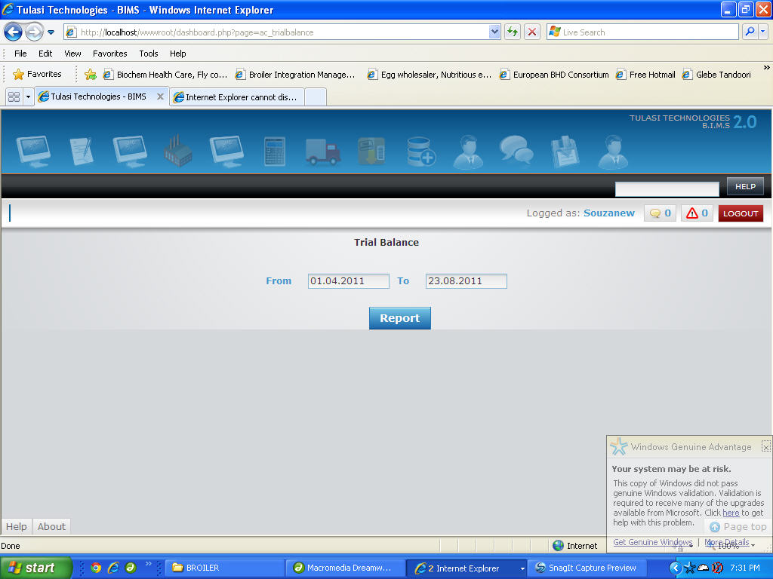

**CoA Ledger**

1. Select CoA, Description will be displayed automatically, Enter From Date and To date and Click on Report.   
   **Eg:**Suppose CoA is IE104, description is Staff Welfare, From Date is "1st April 2011" and To Date is "23rd August 2011".

