**Quail**

**Masters:**

**Add New Farm**

To Add a New Farm

1. Click on "New Farm".
2. You have to enter the values for "Code", "Description" and "Capacity".  
   **Eg :**Suppose the value of Code is "00100", Description is "Arikawe Poultry Farm" and Capacity is "398000" you have to enter *00100* for "Code", *Arikawe Poultry Farm* for "Description" and *398000* for "Capacity".
3. Once filled click "SAVE" button to Save the Farm or click "CANCEL" button to exit without Saving the Farm.

**Add New Unit**

**Pre-requisites :** "Farm" should be created.

To Add a New Unit

1. Click on "New Unit".
2. You have to select "Farm Code". As and when the Farm Code is selected "Description" will be displayed automatically.
3. Now enter the values for "Unit Code", "Unit Description", "OHT(Over Head Tank) Capacity", "Labour" and "Sump Capacity".  
   **Eg :** Suppose the value of Farm Code is "00100", Unit Code is "unit100", Unit Description is "unit100 in PF", OHT Capacity is "0", Labour is "100" and Sump Capacity is "0",   
   You have to select *00100* for "Farm Code" then Description *Arikawe Poultry Farm* will be displayed automatically.  
   Now enter *unit100* for "Unit Code", *unit100 in PF* for "Unit Description", *0* for "OHT Capacity", *100* for Labour and *0* for "Sump Capacity".
4. Once filled click "SAVE" button to Save the Unit or click "CANCEL" button to exit without Saving the Unit.

**Add New Shed**

**Pre-requisites :** "Unit" should be created.

To Add a New Shed

1. Click on "New Shed".
2. You have to select "Farm Code". As and when the Farm Code is selected "Description" will be displayed automatically.
3. You have to select "Unit Code". As and when the Unit Code is selected "Unit Description" will be displayed automatically.
4. Now enter the values for "Shed Code", "Shed Description", "Capacity" and select "Type".  
   **Eg :**Suppose the value of Farm Code is "00100", Unit Code is "unit100", Shed Code is "01", Shed Description is "LAYER I", Type is "Layer" and Capacity is "16272",   
   You have to select *00100* for "Farm Code" then Description *Arikawe Poultry Farm* will be displayed automatically.  
   Now select *unit100* for "Unit Code" then Unit Description *Unit 100 in PF* will be displayed automatically.  
   Now enter *01* for "Shed Code", *LAYER I* for "Shed Description", *16272* for "Capacity" and select *Layer* for "Type".
5. Once filled click "SAVE" button to Save the Shed or click "CANCEL" button to exit without Saving the Shed.

**Add New Flock**

**Pre-requisites :** "Shed" should be created.

To Add a New Flock

1. Click on "New Flock".
2. You have to select "Farm Code". As and when the Farm Code is selected "Description" will be displayed automatically.
3. You have to select "Unit Code". As and when the Unit Code is selected "Unit Description" will be displayed automatically.
4. You have to select "Shed Code". As and when the Shed Code is selected "Shed Description" will be displayed automatically.
5. Now enter the values for "Flock Code", "Flock Description", "Start Date"(Date from which the entries started for the Flock), "Age"(age on Start Date) and "Opening Birds"(when the Flock Started).  
   **Eg :**Suppose the value of Farm Code is "00100", Unit Code is "unit100", Shed Code is "01", Flock Code is "01", Flock Description is "Flock1", Start Date is "2011-01-01", Age is "594" and Opening Birds is "16212"  
   You have to select *00100* for "Farm Code" then Description *Arikawe Poultry Farm* will be displayed automatically.  
   Now select *unit100* for "Unit Code" then Unit Description *Unit 100 in PF* will be displayed automatically.  
   Now select *01* for "Shed Code" then Shed Description *Layer I* will be displayed automatically.  
   Now enter *01* for "Flock Code", *Flock1* for "Flock Description", *2011-01-01* for "Date", *594* for "Age" and *16212* for "Opening Birds".
6. Once filled click "SAVE" button to Save the Flock or click "CANCEL" button to exit without saving the Flock.

**Add Flock Wise Vaccination Schedule**

**Pre-requisites :** "Item Codes" for Vaccines should be created.

To Add a New Flock Wise Vaccination Schedule

1. You have to select the values for "Breed" and "Flcok" from the appropriate drop downs provided.  
   **Eg :**Suppose the value of Breed is "Cobb 400" and Flock is "B1-S57" you have to select *Cobb 400* for "Breed" and *B1-S57* for "Flock".
2. Now enter the value for "Age" in which Vaccination has to be scheduled in the text box provided.
3. Select the value for "Vaccine" which has to be scheduled from the dropdown provided.  
   Suppose if you want to schedule the vaccine 'ND Killed" with code "VAC 146" in the age of "17th week'" then you have to enter *17* for "Age" and select *VAC 146*(whose description can be seen as ND Killed on mouse over) for "Vaccine".

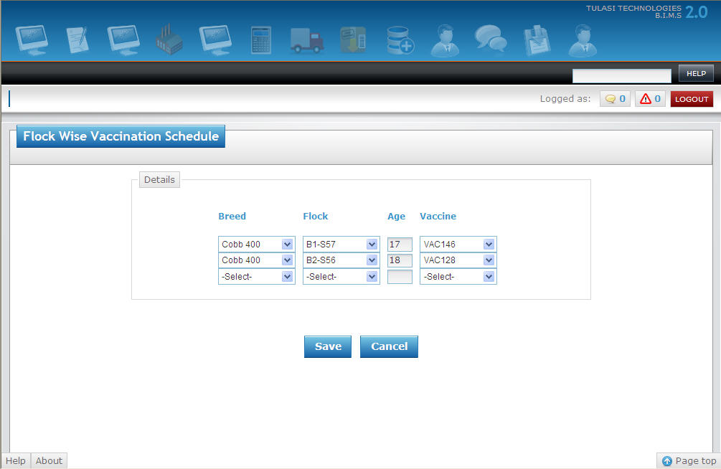

1. Repeat the above steps until you fill all the vaccination schedule details.
2. Once filled click "SAVE" button to Save the Flock Wise Vaccination Svhedule or click "CANCEL" button to exit without Saving the Flock Wise Vaccination schedule.

**Transactions:**

**Quail Daily Entry**

**Pre-requisites :** "Item Codes" for Feed should be created.

1. Select the value for Flock.  
   As and when the value for Flock is selected the values of Date and Age will be displayed automatically.
2. Now enter value for Female Mort, Female Culls, B.Wt (Female Body weight), select value for Feed(Female Feed), enter value for Kg's (No of Kg's of Female Feed).
3. Now enter value for Male Mort, Female Culls, B.Wt (Male Body weight), select value for Feed(Male Feed), enter value for Kg's (No of Kg's of Male Feed).
4. Enter values for E.Wt(Egg Weight), Water, Hatch Eggs, Table Eggs, Crack Eggs etc. in the appropriate boxes provided.   
   **Eg :** Suppose if Flock Name is "B1-S57", Date is "6th June, 2011", Age is "75", Female Mortality is "1", Female Culls is "0", Female Body Weight is "1220", Female Feed Type is "FD100"(whose description can be seen as Quail Chick Mash on mouse over), Female Feed in Kg's is "380", Male Feed Type is "FD106"(whose description can be seen as Male Mash on mouse over) and Male feed in Kg's is "32.8" then   
   You have to select *B1-S57* for "Flock". As and when you select the value for Flock the value for "Date" as *06.06.2011* and *75* for "Age" will be displayed automatically.  
   Now you can enter *1* for "Mort"(Female Mortality), select *FD100* for "Feed"(Female Feed), enter *380* for "Kg's"(Female Feed in Kg's), select *Fd106* for "Feed"(Male Feed) and enter *32.8* for "Kg's"(Male Feed in Kg's) .

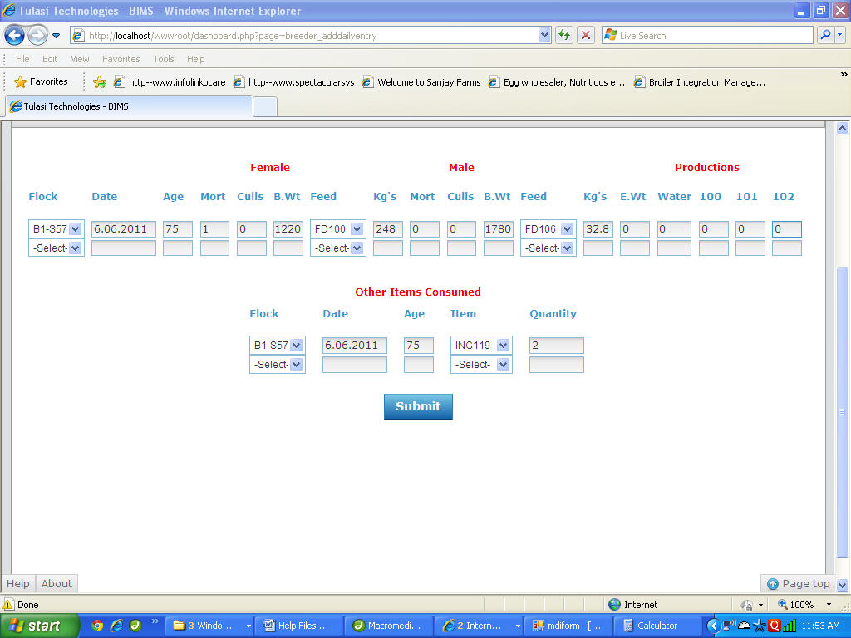

1. You can also enter Other Items consumed by selecting the values for "Flock", "Item" and entering the "Quantity".  
   Suppose if you want to enter the Item with Code "ING119" and Quantity of "2Kgs" for Flock "B1-S57" you have to select *B1-S57* for "Flock", *ING119* for "Item" and enter *2* for "Quantity".
2. Now Click on "Save" button to save the Quail Daily Entry or "Cancel" to exit with out saving the Quail Daily Entry.

**Processing:**

**Add New Birds Transfer**

To Add a New Birds Transfer

1. Select Values for "(Transfer)Date", "From Flock" and "Code".  
   As and when the value for Code is selected the value of "Birds Available" will be displayed automatically. You can also change the value of Birds Available manually by entering the required value in the given input box.
2. Now select the value for "To Flock" and enter value for "Birds(Transfered)".
3. Repeat above step 2 until you fill all the details of birds transfered from the flock.  
   **Eg :** Suppose if you want to transfer 1000 birds from flock "B1-S57" to "B2-S56" and 500 birds from flock "B1-S57" to "L2-S54" on "5th June, 2011" then   
   You have to select *05.06.2011* for "Date", *B1-S57* for "From Flock".  
   Now select *B2-S56* for "To Flock", enter *1000* for "Birds", select *B2-S56* for "To Flock" and enter *500* for "Birds".

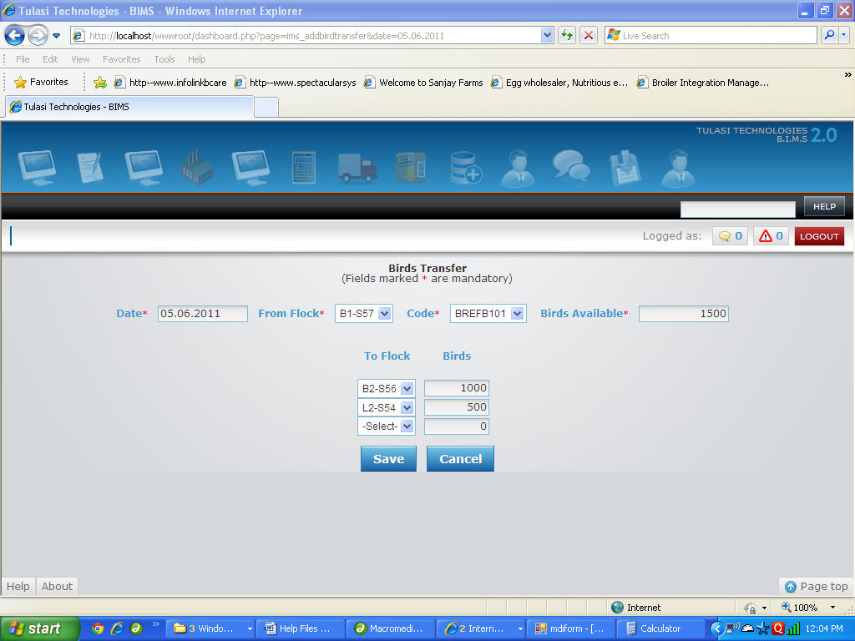

1. Now Click on "Save" button to save the Transfer of Birds or "Cancel" to exit with out saving the Transfer of Birds.

**Add New Flock Transfer**

To Add a New Flock Transfer

1. Select Values for "(Transfer)Date", "From Shed", "Flock".  
   As and when the value for Flock is selected the value of "Female Birds Avl" and "Male Birds Avl" will be displayed automatically.
2. Now enter the value for "To Shed".

**Eg :** Suppose if you want to transfer flock "B1-S57" from Shed "B1" to Shed "L1" on "7th June, 2011" then   
You have to select *07.06.2011* for "Date", *B1* for "From Shed" and *B1-S57* for "Flock".  
As and when you select value for Flock the values of "Female Birds Avl." and "Male Birds Avl." will be displayed automatically.   
Now select *L1* for "To Shed".  
  
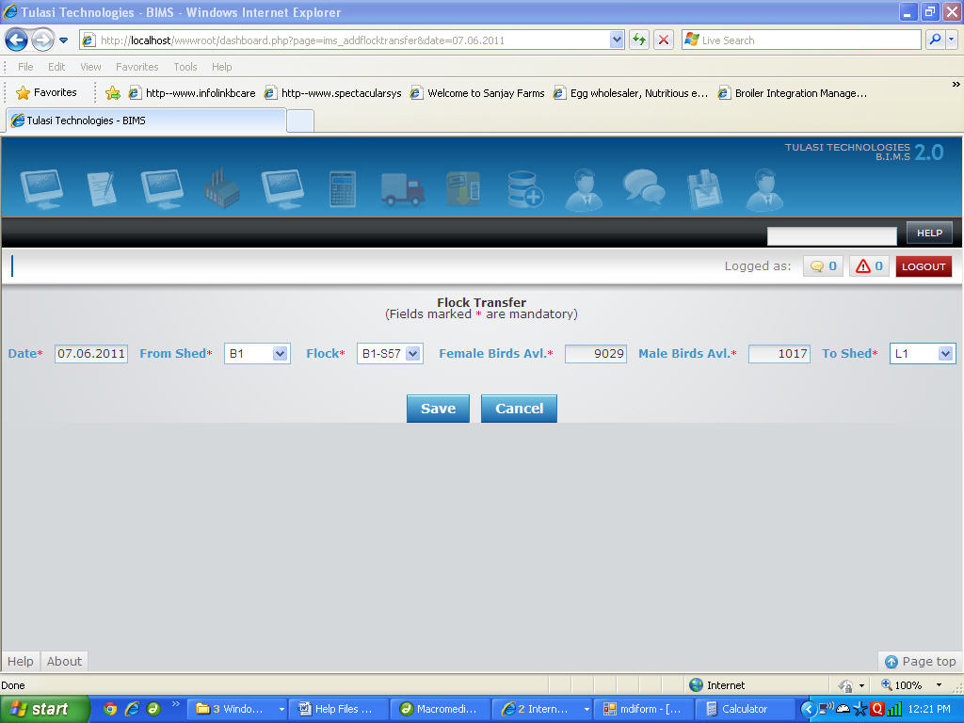

1. Now Click on "Save" button to save the Transfer of Flock or "Cancel" to exit with out saving the Transfer of Flock.

**Quail Birds Sending**

Add Quail Birds Sending

1. You have to select date, Processing Unit and Farm.

**Eg :** Suppose the Date is "23.04.2012" you have to select 23.04.2012 for "Date", Processing Unit for "Processing Unit" and Farm1 for "farm".

1. You have to Enter DcNumber, Driver and Vehicle Number.  
   **Eg :** Suppose the DcNumber is "1562" you have to enter 1562 for "DcNo", Karan for "Driver",KA123HR7 for "Vehicle Number".
2. You have to select Unit, House, Flock and Category.  
   **Eg :**Suppose the unit is "U1",House is "S1",Flock is "U1-S1-F1" and category is "Quail Female Birds" you have to select U1 for "Unit",S1 for "House",U1-S1-F1 for "Flock" and Quail Female Birds for "Category".
3. You have to enter number of birds.  
   **Eg :**Suppose if birds are "200" you have to enter 200 for "Birds".
4. You have to enter weight.  
   **Eg :**Suppose if weight is "400" you have to enter 400 for "Weight".
5. You have to enter Price.  
   **Eg :**Suppose if price is "1250.50" you have to enter 1250.50 for "Price".
6. You have to enter Mortality.  
   **Eg :**Suppose if mortality is "10" you have to enter 10 for "Mortality".
7. If any remarks write in remarks textbox

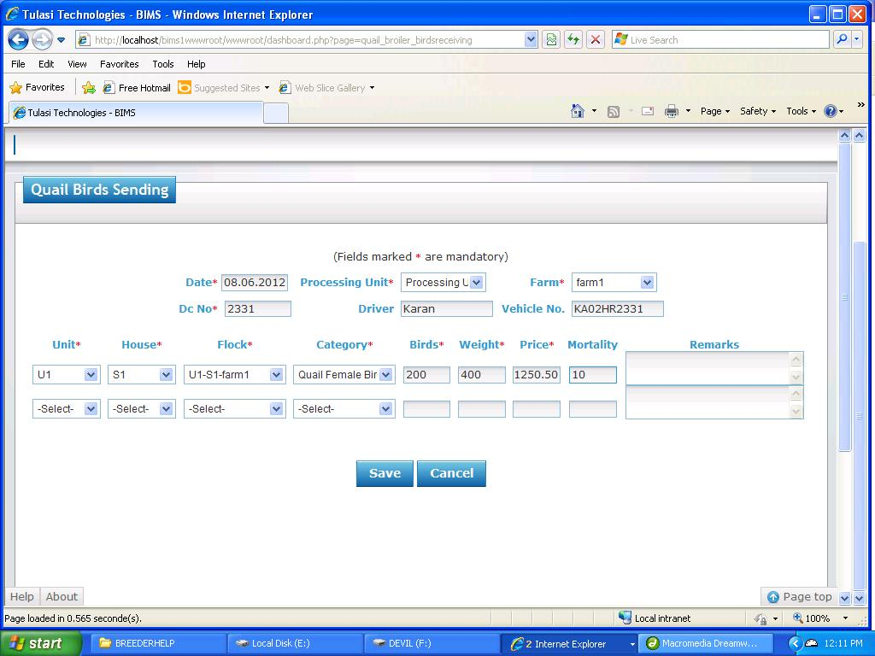

1. Once filled click "SAVE" button to Save the Birds Sending or click "CANCEL" button to exit without Saving the Birds Sending.