**Broiler**

**Masters:**

**Add New Supervisor**

**Click on "New Supervisor”**

* 1. You have to enter the values for “Supervisor (Name)", "Phone No. ", "Mobile No." and "Address".  
     **Eg :**Suppose the Supervisor Name is "Obafemi", Phone No. is "080-41274443", Mobile No. is "9686567656" and Address is "Lagos" you have to enter *Obafemi* for "Supervisor", *080-41274443* for "Phone No.",*9686567656* for "Mobile No." and *Lagos* for "Address".

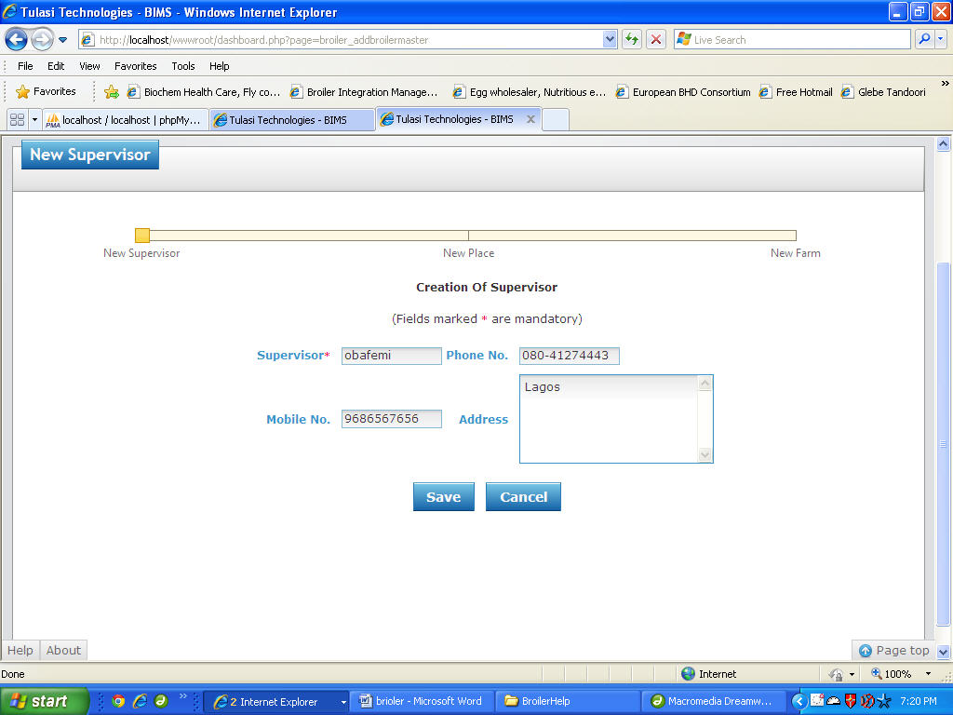

* 1. Once filled click "SAVE" button to Save the Supervisor or click "CANCEL" button to exit without Saving the Supervisor.

**Add New Place**

**Pre-requisites:** "Supervisor" should be created.

1. Click on "New Place".
2. You have to select "Supervisor".
3. Now enter the value for "Place (name)".  
   **Eg: Suppose** the value of Supervisor is "Obafemi" and Place is "Lagos" then   
   you have to select *Obafemi* for "Supervisor" and *Lagos* for "Place".

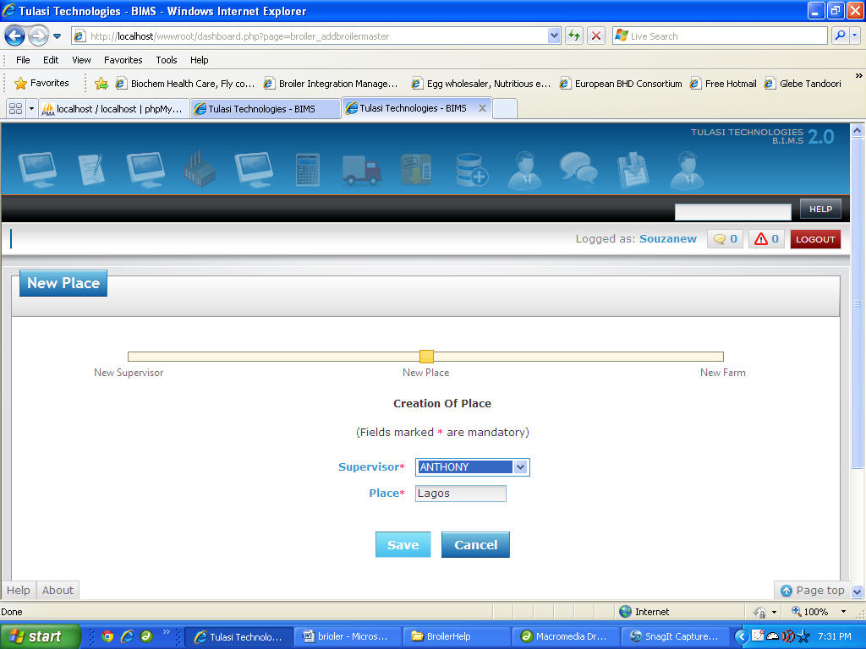

1. Once filled click "SAVE" button to Save the Place or click "CANCEL" button to exit without Saving the Place.

**Add New Farm**

**Pre-requisites :** "Place" should be created.

1. Click on "New Farm ".
2. You have to select the values for "Supervisor", "Place"
3. Now enter the values for "Farm Name", "Farmer Name", "Phone No. ", "Mobile No." and "Address".  
   **Eg :**Suppose the Supervisor Name is "Obafemi", Place is "Lagos", Farm Name is "Obafemi PF", Farmer Name is "Obafemi", Phone No. is "080-41274443", Mobile No. is "9686567656" and Address is "Lagos" then  
   You have to select *Obafemi* for "Supervisor", *Lagos* for "Place".  
   Now enter *Obafemi PF* for "Farm Name", *Obafemi* for "Farmer Name", *080-41274443* for "Phone No.",*9686567656* for "Mobile No." and *Lagos* for "Address".

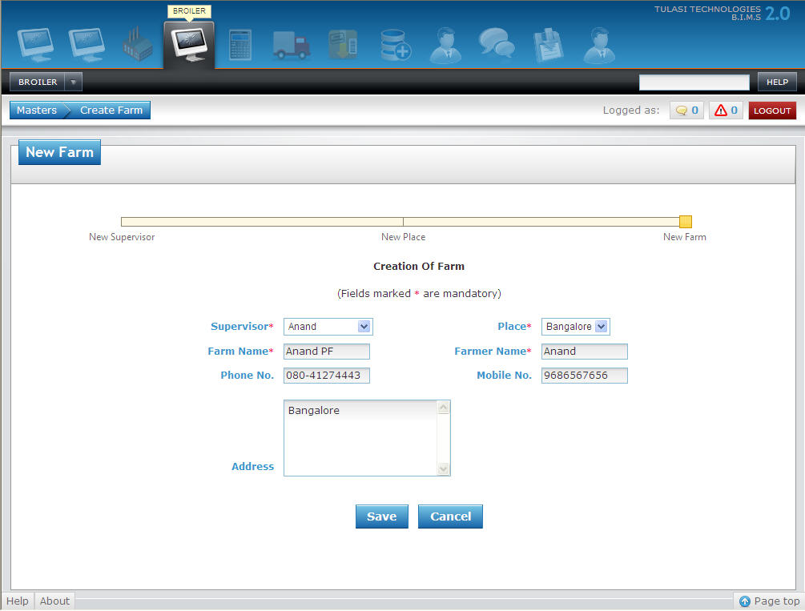

1. Once filled click "SAVE" button to Save the Farm or click "CANCEL" button to exit without Saving the Farm.

**Add New Feed Cost Settings**

1. Click on "Feed Cost Settings".
2. You have to enter the values for "From Date", "To Date", "Feed Cost/Kg", "Chick Cost/Bird", "Management Cost/Kg" and "Overhead Cost/Bird".  
   **Eg :**Suppose the value of From Date is "1st Jul, 2011", To Date is "30th Aug, 2011", Feed Cost/Kg is "18", Chick Cost/Bird is "20", Management Cost/Kg is "1" and Overhead Cost/Bird is "1"   
   you have to enter *01.07.2011* for "From Date", *30.08.2011* for "To Date", *18* for "Feed Cost/Kg", *20* for "Chick Cost/Bird", *1* for "Management Cost/Kg" and *1* for "Overhead Cost/Bird".
3. Once filled click "SAVE" button to Save the Feed Cost Settings or click "CANCEL" button to exit without Saving the Feed Cost Settings.

**Add New Growing Charges**

1. Click on "Growing Charges".
2. You have to enter the values for "From Date", "To Date", "FCR From", "FCR To" and "Growing Charge/Kg".

**Eg :**Suppose the value of From Date is "1st Jul, 2011", To Date is "30th Aug, 2011", FCR From is "1.6", FCR To is "1.8" and Growing Charge/Kg is "3.5"   
you have to enter *01.07.2011* for "From Date", *30.08.2011* for "To Date", *1.6* for "FCR From", *1.8* for "FCR To" and *3.5* for "Growing Charge/Kg".

1. Once filled click "SAVE" button to Save the Growing Charges or click "CANCEL" button to exit without Saving the Growing Charges.

**Add New Special Incentives**

1. Click on "Special Incentives".
2. You have to enter the values for "From Date", "To Date", "FCR From", "FCR To" and "Special Incentive/Kg".  
   **Eg :**Suppose the value of From Date is "1st Jul, 2011", To Date is "30th Aug, 2011", FCR From is "1.5", FCR To is "1.6" and Special Incentive/Kg is "2.5"   
   you have to enter *01.07.2011* for "From Date", *30.08.2011* for "To Date", *1.5* for "FCR From", *1.6* for "FCR To" and *2.5* for "Special Incentive/Kg".
3. Once filled click "SAVE" button to Save the Special Incentives or click "CANCEL" button to exit without Saving the Special Incentives.

**Add New Sales Special Incentives**

1. Click on "Sales Special Incentives".
2. You have to enter the values for "From Date", "To Date", "Sale Rate/Kg From", "Sale Rate/Kg To" and "Sales Incentive/Kg".  
   **Eg :**Suppose the value of From Date is "1st Jul, 2011", To Date is "30th Aug, 2011", Sale Rate/Kg From is "50", Sale Rate/Kg To is "55" and Sales Incentive/Kg is "0.2"   
   you have to enter *01.07.2011* for "From Date", *30.08.2011* for "To Date", *50* for "Sale Rate/Kg From", *55* for "Sale Rate/Kg To" and *0.2* for "Sales Incentive/Kg".
3. Once filled click "SAVE" button to Save the Sales Special Incentives or click "CANCEL" button to exit without Saving the Sales Special Incentives.

**Add New Mortality Recovery Details**

1. Click on "Mortality Recovery Details".
2. You have to enter the values for "From Date", "To Date", "Mortalit % Limit(1st Week)", "Mortality % Limit(Overall)","Recovery Rate For Birds(1-15 days)", "Recovery Rate For Birds(16-20 Days)" and "Recovery Rate For Birds(> 21 Days)".  
   **Eg :**Suppose the value of From Date is "1st Jul, 2011", To Date is "30th Aug, 2011", Mortalit % Limit(1st Week) is "1.5", Mortality % Limit(Overall) is "5", Recovery Rate For Birds(1-15 days) is "15", Recovery Rate For Birds(16-20 Days) is "0" and Recovery Rate For Birds(> 21 Days) is "0"   
   you have to enter *01.07.2011* for "From Date", *30.08.2011* for "To Date", *1.5* for "Mortalit % Limit(1st Week)", *5* for "Mortality % Limit(Overall)", *15* for "Recovery Rate For Birds(1-15 days)", *0*for "Recovery Rate For Birds(16-20 Days)" and *0* for "Recovery Rate For Birds(> 21 Days)".
3. Once filled click "SAVE" button to Save the Mortality Recovery Details or click "CANCEL" button to exit without Saving the Mortality Recovery Details.

**Transactions:**

**Broiler Daily Entry**

1. Select value for Supervisor.
2. Select Farm, Feed Type, Medicine, Vaccine enter values for Flock, Age, Date (of entry), Mort(Mortality), Cull, Feed(In Kgs), Avg Wgt.(In Gms), Water, (Medicine)Quantity and ( Vaccine)Quantity.   
   **Eg :** Suppose Supervisor is Obafemi, Farm is "Obafemi PF", Flock is "1", Age is "28", Date is "28 Feb,2011", Morality is "2", Feed Type is "FD111", Feed (In Kgs) is "120", Avg wt.(gms) is "1150", Vaccine is "VAC103" and Quantity is "2500" then   
   You have to select *Obafemi* for "Supervisor", *Obafemi PF* for "Farm", *28.02.2011* for "Date", *FD111* for "Feed Type", *VAC103* for "Vaccine", enter *1* for "Flockno", *28* for "Age", *2* for "Mortality", *120* for "Feed (In Kgs), *1150* for "Avg wt.(gms)" and *2500* for "(Vaccine)Quantity".

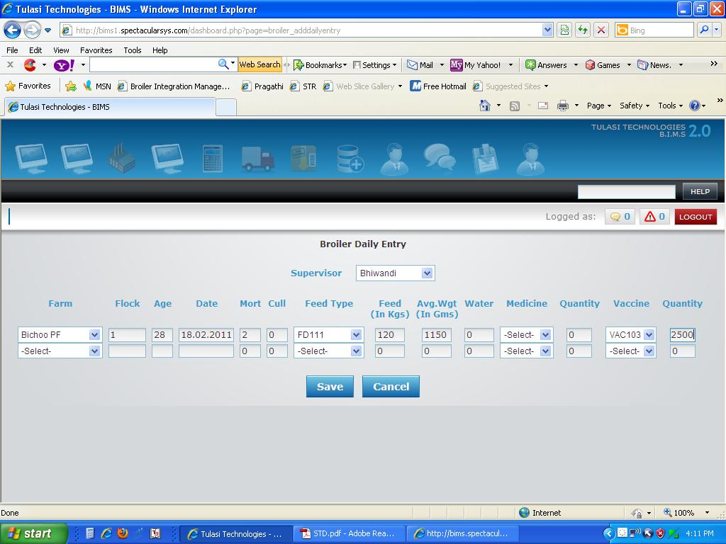

1. Now Click on "Save" button to save the Broiler Daily Entry or "Cancel" to exit without saving the Broiler Daily Entry.

**Add New Broiler Finalization**

1. Select values for Date, Supervisor, Farm and Flock.
2. Now enter value for T.Cost (Transportation Cost) in appropriate input boxes provided.   
   **Eg :** Suppose if the date is "10 June,2011", Supervisor is "Ehigha", Farm is "Healthy Farm", Flock is "MLR-111" and Transportation Cost is "1000" then   
   You have select *10.06.2011* for "Date", *Ehigha* for "Supervisor", *Healthy Farm* for "Farm", *MLR-111* for "Flock" and enter *1000* for "T.Cost".   
     
   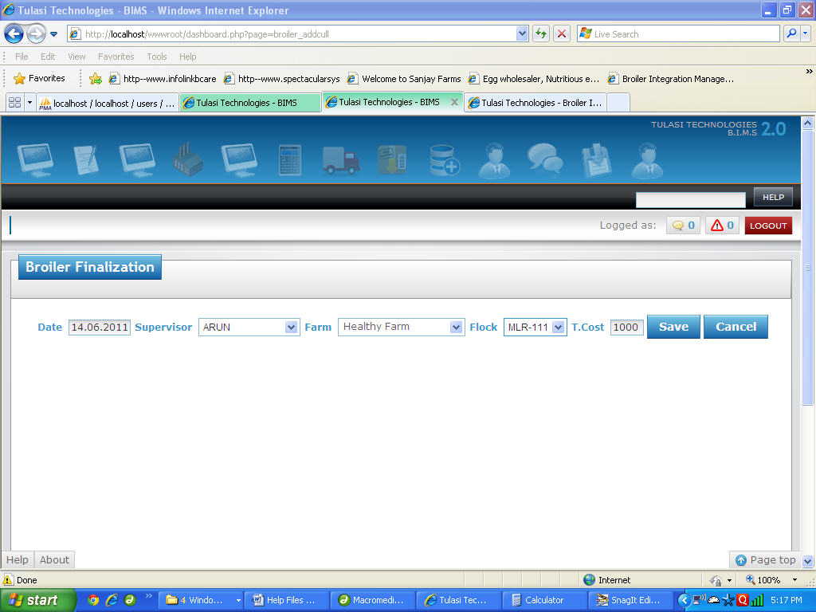
3. Now click on "Save" button to save the Broiler Finalization Details or "Cancel" to exit without saving the Broiler Finalization Details.

**Processing:**

**Add New Sale of Birds**

1. Select Values for "(Sale) Date" and enter value for "Book Invoice"(if any).
2. Now select values for "Farm", "Customer (Name)".
3. Enter values for "Birds(Sold)", "F.Weight(Farm Weight)", "Price/Kg", DC#, "Vehicle No.", select "Driver(Name)"(if any) and enter "remarks".   
     
   **Eg :** Suppose if the Sale Date is "14th June, 2011", Book Invoice is "2011-14", Customer Name is "Ehigha", Farm Name is "Healthy Farm", No Of Birds sold were "1765", F.Weight is "3475.9", Price/Kg is "50", DC# is "3125", Vehicle No. id "KA14 C 1456" and driver Name is "Obafemi" then   
   You have to select *14.06.2011* for "Date", *Ehigha* for "Customer", *Healthy Farm* for "Farm", *Obafemi* for "Driver".  
   Now enter *1765* for "Birds", *3475.9* for "F.Weight", *50* for "Price/Kg", *3125* for "DC#" and *KA14 C 1456* for "Vehicle No.".
4. Repeat the above step 2 until all the sales details are filled.

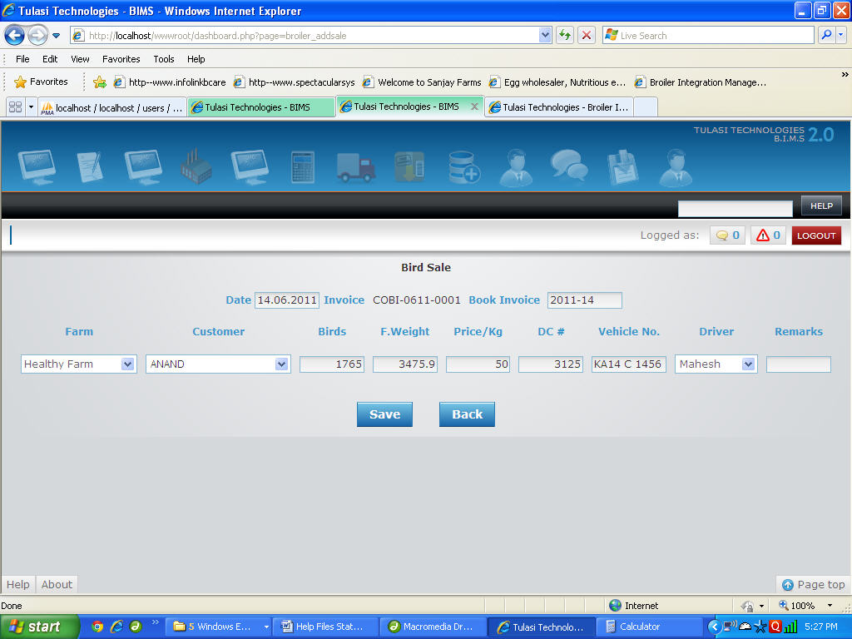

1. Now click on "Save" button to save the Sale of Birds or "Cancel" to exit without saving the Sale of Birds.

**Add New Shop Receipt**

1. Select Values for "(Sale) Date" and enter value for "Book Invoice"(if any).
2. Now select values for "Farm", "Customer (Name)".
3. Enter values for "Birds(Sold)", "S.Weight(Shop Weight)", "Price/Kg", DC#, "Vehicle No.", select "Driver(Name)"(if any) and enter "remarks".   
   **Eg :** Suppose if the Sale Date is "14th June, 2011", Book Invoice is "2011-14", Customer Name is "Obafemi", Farm Name is "Healthy Farm", No Of Birds sold were "1765", S.Weight is "3475.9", Price/Kg is "50", DC# is "3125", Vehicle No. id "KA14 C 1456" and driver Name is "Ehigha" then   
   You have to select *14.06.2011* for "Date", *Obafemi* for "Customer", *Healthy Farm* for "Farm", *Ehigha* for "Driver".  
   Now enter *1765* for "Birds", *3475.9* for "S.Weight", *50* for "Price/Kg", *3125* for "DC#" and *KA14 C 1456* for "Vehicle No.".
4. Repeat the above step 2 until all the sales details are filled.
5. Now Click on "Save" button to save the Shop Receipt or "Cancel" to exit without saving the Shop Receipt.