**Broiler**

**Reports:**

**Broiler Daily Entry Report**

1. Select Place, Supervisor, Farmer and Flock.

**Eg:**Suppose Place is "Lagos", Supervisor is "Ehigha", Farmer is Obafemi and Flock is "HSN-342"

**Day Wise Feed Remaining Report**

1. Select Place, Supervisor and Farm.

**Eg:**Suppose Place is "Lagos", Supervisor is "Ehigha" and Form is "Balalochana"

**Day Wise Feed and Mortality Report**

1. Select Place, Supervisor, Farmer and Try Date.

**Eg:**Suppose Place is "Lagos", Supervisor is Obafemi, Farmer is Ehigha and Try Date is 22-08-2011"

**Cost of Production (Live Flocks)**

1. Select Farm Name and Flock Name.  **Eg:**Suppose Farm name is "Balalochana" and Flock name is "HSN-342".   
     
   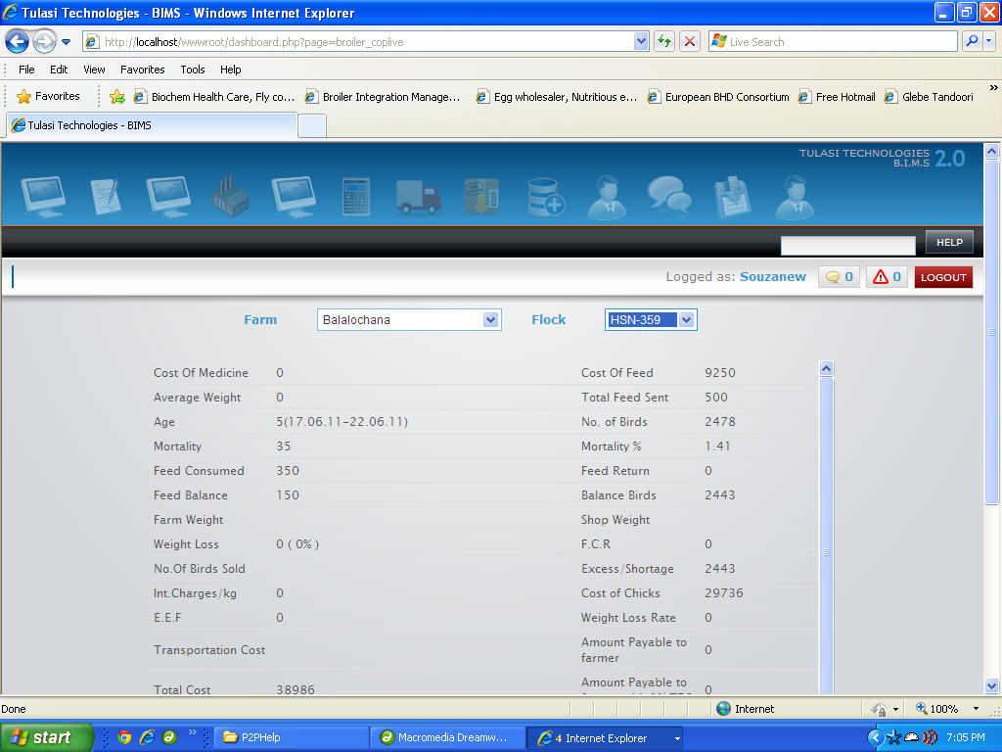

**Cost of Production (Cull Flocks)**

1. Select Farm Name and Flock Name.  
   **Eg:**Suppose Farm name is "Balalochana" and Flock name is "HSN-342".   
     
   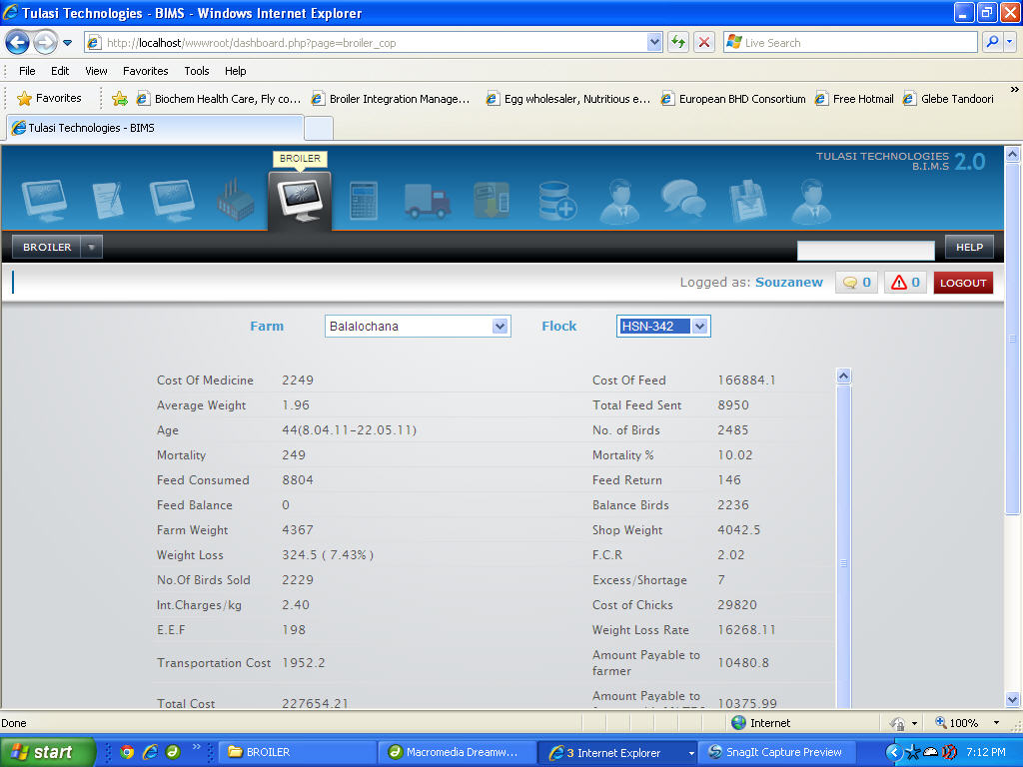

**Wrong SMS Report**

1. Select Date

**Eg:**Suppose Date is "22-08-2011".

**Feed Issue Report**

1. Select From warehouse

**Eg:**Suppose From warehouse is "Puttur".

**Broiler weekly Report**

1. Select Flock Type(Live or Cull)

**Eg:**Suppose Flock Type is "Live Flocks".