**Feed mill**

**Masters:**

**Add New Feed Standards**

1. Select values for "Feed Type"(whose description can be seen on mouse over), "Nutrient" and "Standard Value for 1 Kg".  
   As and when the value of "Nutrient" is selected the value of "Units" is displayed automatically.  
   **Eg :** Suppose for Feed Type "Breeder Grower Mash" with code "FD101" the Standard Value for 1 Kg of Nutrient "Vitamin C" is "0.25kg" then,  
   You have to select *FD101* for "Feed Type" and *Vitamin C* for "Nutrient".  
   As and when Vitamin C is selected *mg/kg* will be displayed for "Unit".  
   Now enter *0.25* for "Standard Value for 1 Kg".
2. Repeat the above step till required values are filled.
3. Once filled click "SAVE" button to save the Feed Standards or click "CANCEL" button to exit without saving the Feed Standards.

**NOTE:**You can directly add a New Nutrient click the ***+*** icon and enter the Values for "Nutrient" and "Units".

**Transactions:**

**Add New Feed Formula**

**Pre-requisites :**"Item Codes" should be created.

**To Add a New Feed Formula**

1. Select values for "Feed Mill", "Date", and “Type of Feed” (whose description can be seen on mouse over).  
   **Eg :**Suppose the Feed Mill name is "SSPC FeedMill", Date of creation of Formula is "4th JAN, 2011" and Type Of Feed is "FD101" you have to select *04.01.2011* for "Date", *SSPC FeedMill* for "Feed Mill" and *FD101* for "Type Of Feed".
2. Enter the values of "Formula Name" and "Kgs/Bag" in the appropriate boxes provided.  
   Suppose if the Formula Name is "Chick 04-01-2011" and Kgs/Bag is "50" you have to enter *Chick 04-01-2011* for "Formula Name" and *50* for Kgs/Bag.
3. Now select value for "Item Code" and enter "Quantity" of Item.  
   As and when the Item Code is selected the "description" of the Item is displayed automatically.
4. Repeat the above step 3 until all the Items in Feed Formula are filled.

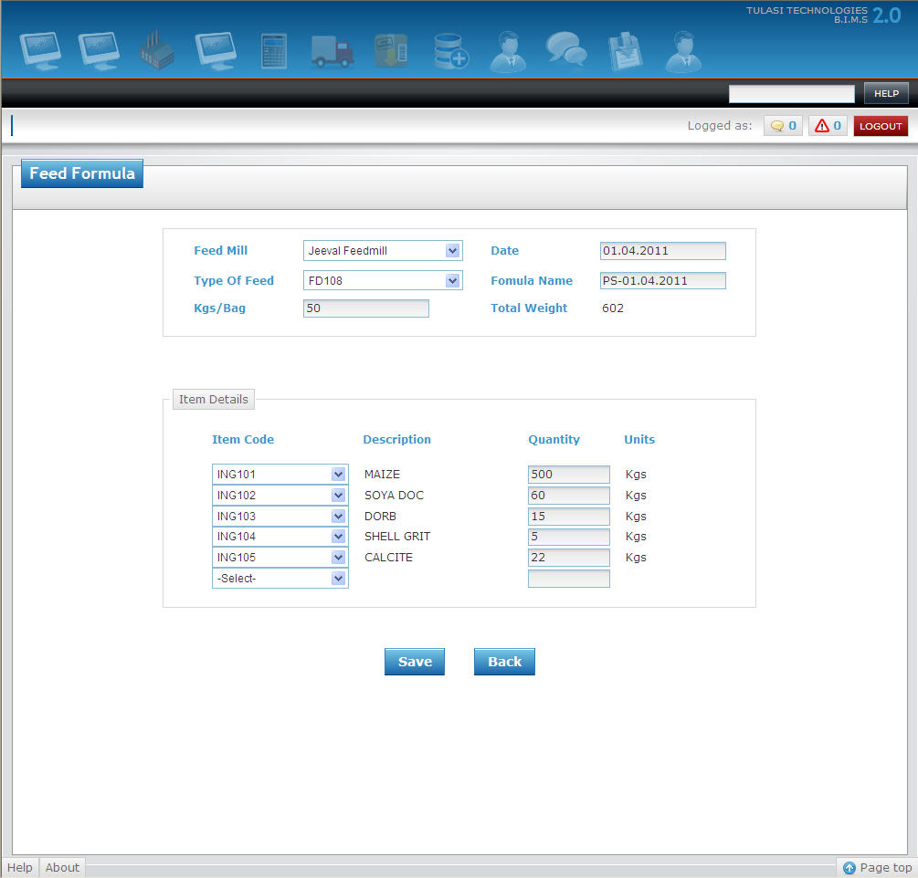

1. Once filled click "SAVE" button to Save the Feed Formula or click "CANCEL" button to exit without Saving the Feed Formula.

**Processing**:

**Add New Production**

**Pre-requisites :**"Feed Formula" should be created.

**To Add a New Production**

1. Select values for "Entry Date", "Feed Mill", "Feed Type"(whose description can be seen on mouse over), and “Formula. #" and enter value for "Batches".  
   As and when the value for "Batches" is entered the "Statistics" will be displayed automatically depending on the selected "Formula. #".  
   **Eg :**Suppose if the Entry Date is "5th Jan, 2011", Feed Mill is "SSPC FeedMill", Feed Type is "FD101", Formula. # is "Chick 04.01.2011" and Batches is "10”,   
   You have to select *05.01.2011* for "Entry Date", *SSPC FeedMill* for "Feed Mill", *FD101* for "Feed Type", *Chick 04.01.2011* for "Formula. #" and enter *10* for "Batches".
2. Now enter the values of "Actual Production", "Bag Type", "Labour Charges", "Units", "Cost/Unit", "Packing", "Transport" and "Other". As and when the Bag Type is selected "No of Bags" will be displayed automatically.

Now suppose if the actual Production is "10035", Labour Charges is "350", Units is "12", Cost/Unit is "4", Packing is "50",Transport is "100" and Other is "20",  
you have to enter *10035* for "Actual Production", *350* for "Labour Charges", *12* for "Units", *4* for "Cost/Unit", *50* for "Packing", *100* for "Transport" and *20* for "Other".

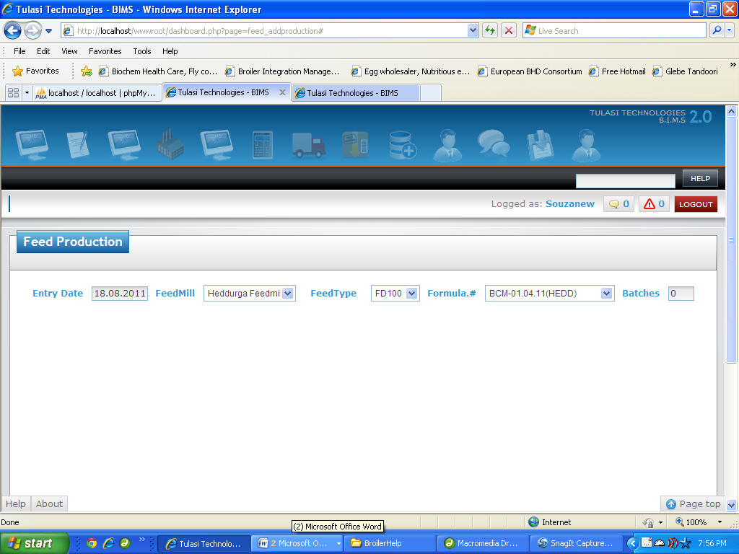

1. Once filled click "SAVE" button to Save the Production or click "CANCEL" button to exit without Saving the Production.