**Feedmill**

**Reports:**

**Feed Formula Report**

1. Select feed mill, feed type and feed formula.  
   **Eg:**Suppose Feed Mill is "SSPC Feed Mill", Feed Type is "FD101", Formula. # is "BCM 04.01.2011"

**Feed Formula with Standards’ Report**

1. Select feed mill, feed type and feed formula.  
   **Eg:**Suppose Feed Mill is "SSPC Feed Mill", Feed Type is "FD101", Formula. # is "BCM 04.01.2011"

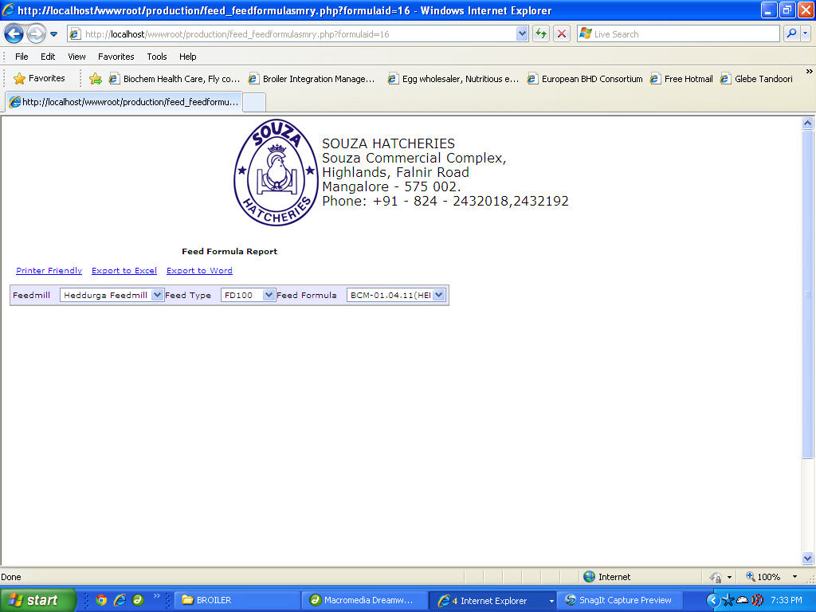

**Feed Formula with Costing Report**

1. Select feed type, and feed formula.  
   **Eg:**Suppose Feed Type is "FD101", Formula. # is "BCM 04.01.2011"

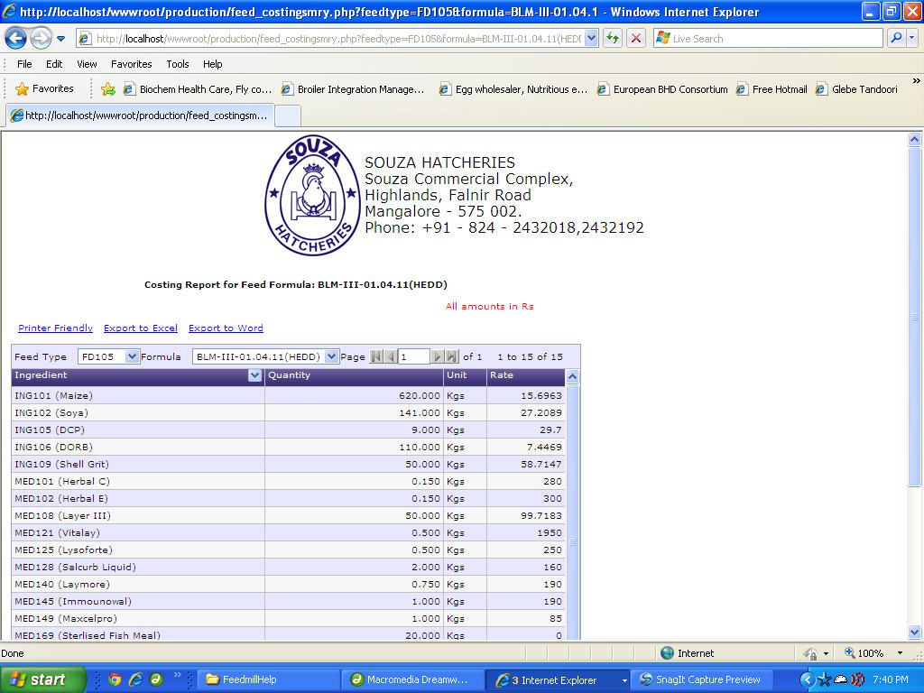

**Feed Production Report**

1. Select feed mill, enter from date and to date.

**Eg:**Suppose Feed Mill is "Puttur Feed Mill", from date is 22-08-2011 and to date is 23-08-2011.