**Hatchery**

**Reports:**

**Chicks/Parent Details Report**

     You have to select Chicks/Parent Details in Reports.

As and when you select Chicks/Parent Details, a new window will be opened.

The Report shows *Parent Flock, Eggs Set, Hatch, Hatch %, Saleable Chicks, Chicks %, Rejection %, Chicks/parent* Fields and corresponding data.

**Tray Settings Report**

     You have to select Tray Settings in Reports.

As and when you select Tray Settings, a new window will be opened.

The Report shows *Setting date, Flock, Eggs Set, Second set, Reject, Waste, No Of Eggs, Loading Time, Loaded By, Hatch Code, Expected Chicks* Fields and corresponding data.

1. You can select Single or all Dates at a time using *Setting date* drop down list box, to see corresponding data.
2. You can select Single or all Flocks at a time using *Flock* drop down list box.

Based on the options you select, corresponding details will be shown to you.

**Hatch Record**

     You have to select Hatch Record in Reports.

As and when you select Hatch Record a new window will be opened.

1. Select From Date.
2. Select To Date. Eg: Select 02 August 2011 as From date, and 10 August 2011 as To date.

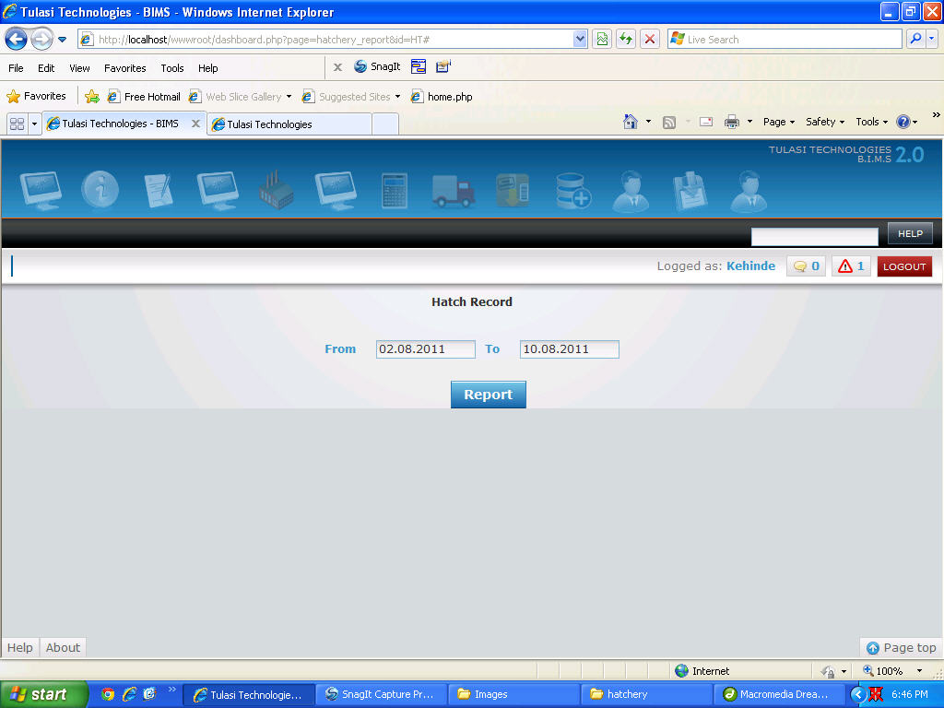

1. Click on Report Button. Report will be displayed in a new window.