**Home**

**ADD LOGO:**

**To Add Report Header(Logo & Address)**

1. Enter value for "Address" to be printed in Reports.
2. You have to click on "Browse" button and select image(Logo) to upload.   
   **Eg :** Suppose if the address is "Tulasi Technologies #9, 4th Main, 3rd cross, Basaveshwara Nagar, Bangalore - 79" you have to enter *Tulasi Technologies #9, 4th Main, 3rd cross, Basaveshwara Nagar, Bangalore - 79* for "Address". 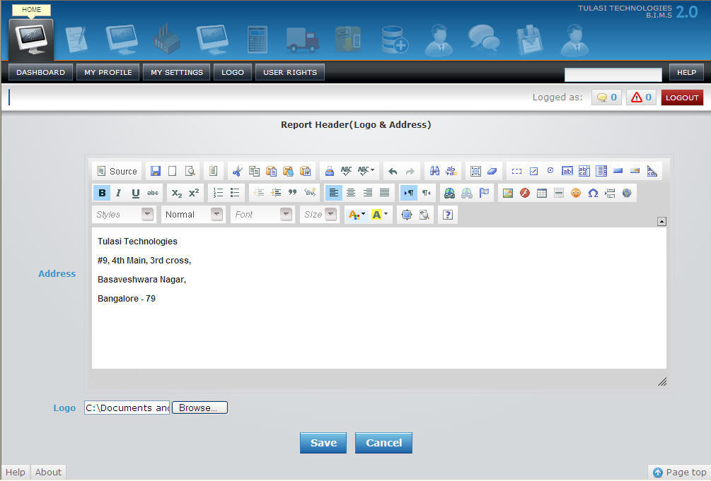
3. Once after selecting click on 'Save' button to save the logo and address or 'CANCEL' to exit without saving the logo and address.

**ADD USER RIGHTS:**

**To Add User Rights**

1. Select "Employee" from the dropdown provided.
2. Enter values for "Username", "Password" and "Email".
3. You have to click on Modules such as "Home", "Accounts", "P2P" etc and check sections to which user rights has to be provided.   
   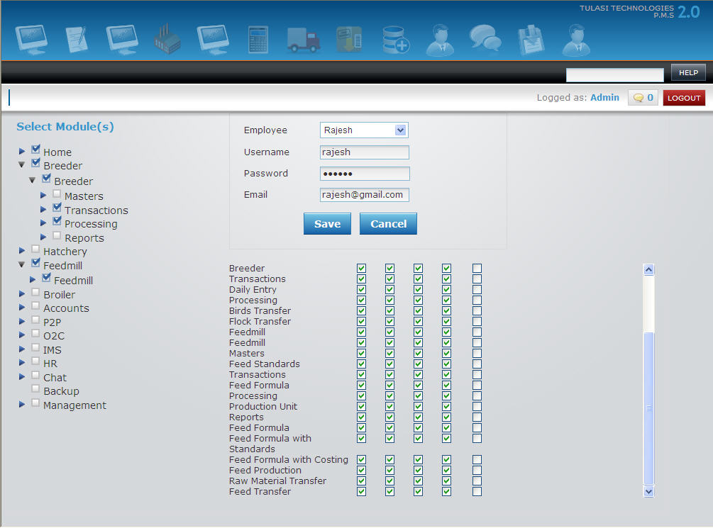
4. Check in "View", "Add", "Edit", "Delete" and "Authorize" as required.
5. Once after selecting click on 'SAVE' button to save the USER RIGHTS or 'CANCEL' to exit without saving the USR RIGHTS.