**Inventory Management System**

**Reports:**

**To Get Report on Item Ledger**

**To Get Report**

1. You have to Select a *Item Code* from the list ,as soon as you selected *Item Code* from the list its corresponding *Description* will be generated   
   **OR**If you select *Description* then its corresponding *Item Code* will be generated

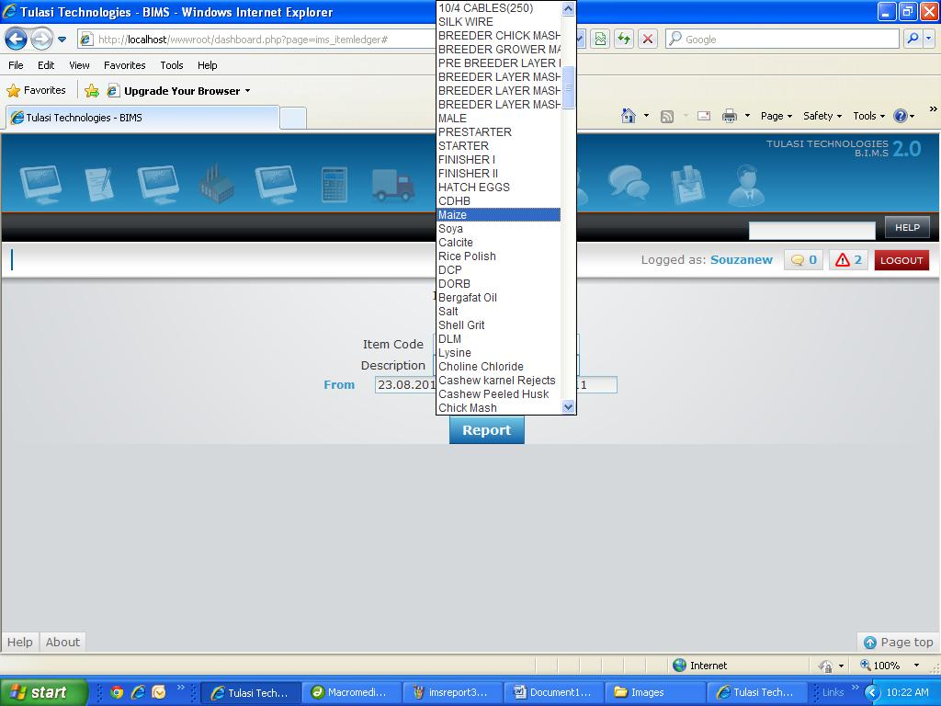

1. Pick *From*date with the help of date picker.

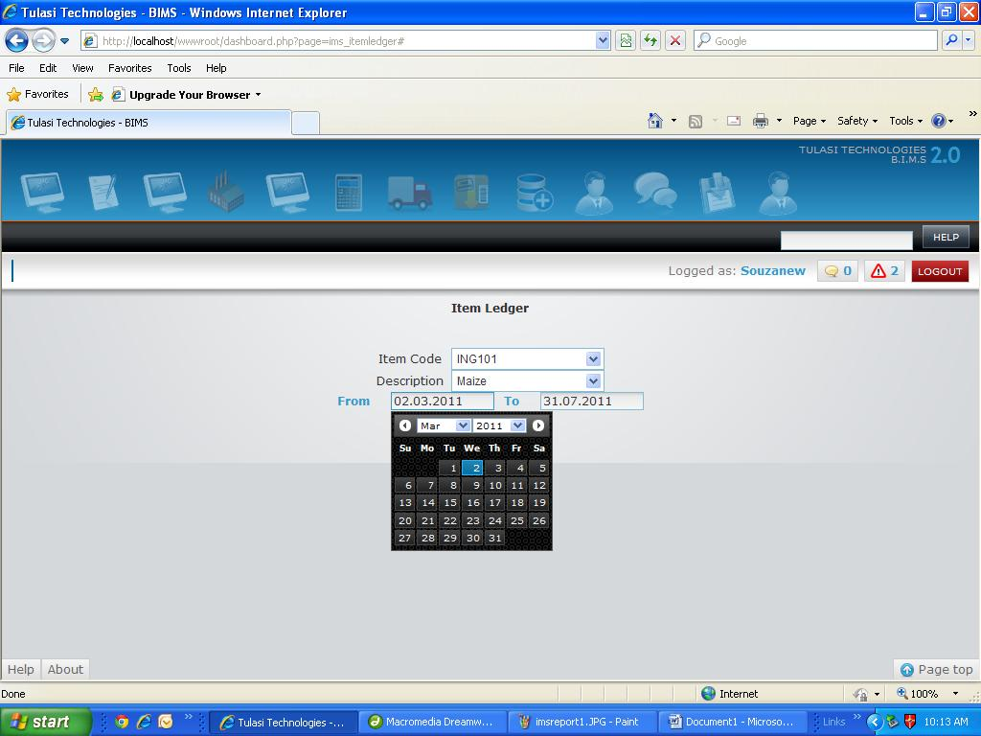

1. Pick *To*date with the help of date picker.

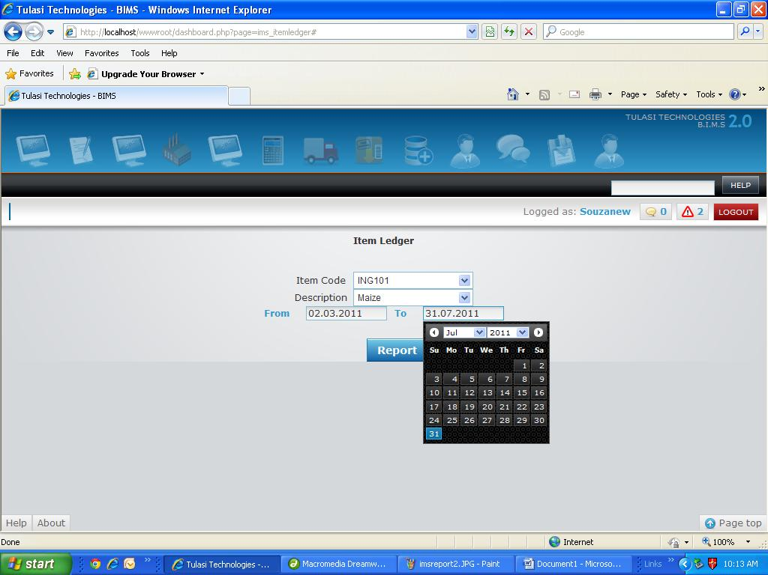

1. Now Click on *Report*to generate report.
2. Here is the report with all details *Transaction Type*, *Doc No*, *Date*, *Receipt*, *Issue*and *Closing Balance*