**Layer**

**Masters:**

**Add New Farm**

To Add a New Farm

1. Click on "New Farm".
2. You have to enter the values for "Code", "Description" and "Capacity".  
   **Eg :**Suppose the value of Code is "00100", Description is "Chiwetel Poultry Farm" and Capacity is "398000" you have to enter *00100* for "Code", *Chiwetel Poultry Farm* for "Description" and *398000* for "Capacity".
3. Once filled click "SAVE" button to Save the Farm or click "CANCEL" button to exit without Saving the Farm.

**Add New House**

**Pre-requisites :** "Unit" should be created.

To Add a New House

1. Click on "New House".
2. You have to select "Farm Code". As and when the Farm Code is selected "Description" will be displayed automatically.
3. You have to select "Unit Code". As and when the Unit Code is selected "Unit Description" will be displayed automatically.
4. Now enter the values for "House Code", "House Description", "Capacity" and select "Type".  
   **Eg :**Suppose the value of Farm Code is "00100", Unit Code is "unit100", House Code is "01", House Description is "LAYER I", Type is "Layer" and Capacity is "16272",   
   You have to select *00100* for "Farm Code" then Description *Chiwetel Poultry Farm* will be displayed automatically.  
   Now select *unit100* for "Unit Code" then Unit Description *Unit 100 in PF* will be displayed automatically.  
   Now enter *01* for "House Code", *LAYER I* for "House Description", *16272* for "Capacity" and select *Layer* for "Type".
5. Once filled click "SAVE" button to Save the House or click "CANCEL" button to exit without Saving the House.

**Add New Flock**

**Pre-requisites :** "Shed" should be created.

To Add a New Flock

1. Click on "New Flock".
2. You have to select "Farm Code". As and when the Farm Code is selected "Description" will be displayed automatically.
3. You have to select "Unit Code". As and when the Unit Code is selected "Unit Description" will be displayed automatically.
4. You have to select "Shed Code". As and when the Shed Code is selected "Shed Description" will be displayed automatically.
5. Now enter the values for "Flock Code", "Flock Description", "Start Date"(Date from which the entries started for the Flock), "Age"(age on Start Date) and "Opening Birds"(when the Flock Started).  
   **Eg :**Suppose the value of Farm Code is "00100", Unit Code is "unit100", Shed Code is "01", Flock Code is "01", Flock Description is "Flock1", Start Date is "2011-01-01", Age is "594" and Opening Birds is "16212"  
   You have to select *00100* for "Farm Code" then Description *Chiwetel Poultry Farm* will be displayed automatically.  
   Now select *unit100* for "Unit Code" then Unit Description *Unit 100 in PF* will be displayed automatically.  
   Now select *01* for "Shed Code" then Shed Description *Layer I* will be displayed automatically.  
   Now enter *01* for "Flock Code", *Flock1* for "Flock Description", *2011-01-01* for "Date", *594* for "Age" and *16212* for "Opening Birds".
6. Once filled click "SAVE" button to Save the Flock or click "CANCEL" button to exit without saving the Flock.

**Transactions:**

**Layer Daily Entry**

**Pre-requisites :** "Item Codes" for Feed should be created.

1. Select the value for Flock.  
   As and when the value for Flock is selected the values of Date, Age and Opening Birds will be displayed automatically.
2. Now enter value for Female Mort, Culls, B.Wt (Female Body weight), select value for Feed(Female Feed), enter value for Kg's (No of Kg's of Female Feed).
3. Now enter value for Male Mort, Female Culls, B.Wt (Body weight), E.Wt(Egg Weight), "Water", select value for Feed, enter value for Kg's (No of Kg's of Male Feed).
4. Enter values for 101(PULLETS), 102(MEDIUM), 103(LARGE), 104(BROKEN) etc. in the appropriate boxes provided.   
   **Eg :** Suppose if Flock Name is "GC-13A", Date is "10th June, 2011", Age is "67.2", Mortality is "7", Culls is "0", Body Weight is "1569", Egg Weight is "59", Feed Type is "FD104", Feed in Kg's is "43" and Production of Large Eggs with Code 103 is "645" then   
   You have to select *GC-13A* for "Flock". As and when you select the value for Flock the value for "Date" as *10.06.2011*, *67.2* for "Age" and *896* for "O.Birds" will be displayed automatically.  
   Now you can enter *7* for "Mort", *1569* for "B.Wt", *59* for "E.Wt", select *FD104* for "Feed", enter *43* for "Kg's" and *645* for "103".

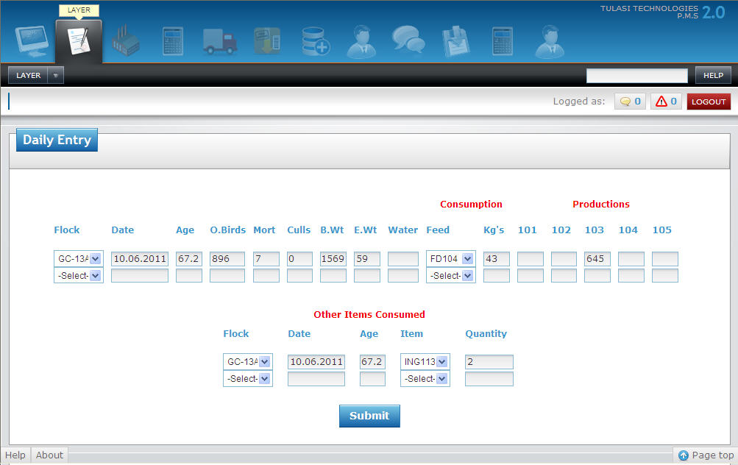

1. You can also enter Other Items consumed by selecting the values for "Flock", "Item" and entering the "Quantity".  
   Suppose if you want to enter the Item with Code "ING113" and Quantity of "2Kgs" for Flock "GC-13A" you have to select *GC-13A* for "Flock", *ING113* for "Item" and enter *2* for "Quantity".
2. Now Click on "Save" button to save the Layer Daily Entry or "Cancel" to exit with out saving the Layer Daily Entry.

**Processing:**

**Add New Birds Transfer**

To Add a New Birds Transfer

1. Select Values for "(Transfer)Date", "From Flock" and "Code".  
   As and when the value for Code is selected the value of "Birds Available" will be displayed automatically. You can also change the value of Birds Available manually by entering the required value in the given input box.
2. Now select the value for "To Flock" and enter value for "Birds (Transferred)".
3. Repeat above step 2 until you fill all the details of birds transferred from the flock.  
   **Eg :** Suppose if you want to transfer 1000 birds from flock "B1-S57" to "B2-S56" and 500 birds from flock "B1-S57" to "L2-S54" on "5th June, 2011" then   
   You have to select *05.06.2011* for "Date", *B1-S57* for "From Flock".  
   Now select *B2-S56* for "To Flock", enter *1000* for "Birds", select *B2-S56* for "To Flock" and enter *500* for "Birds".

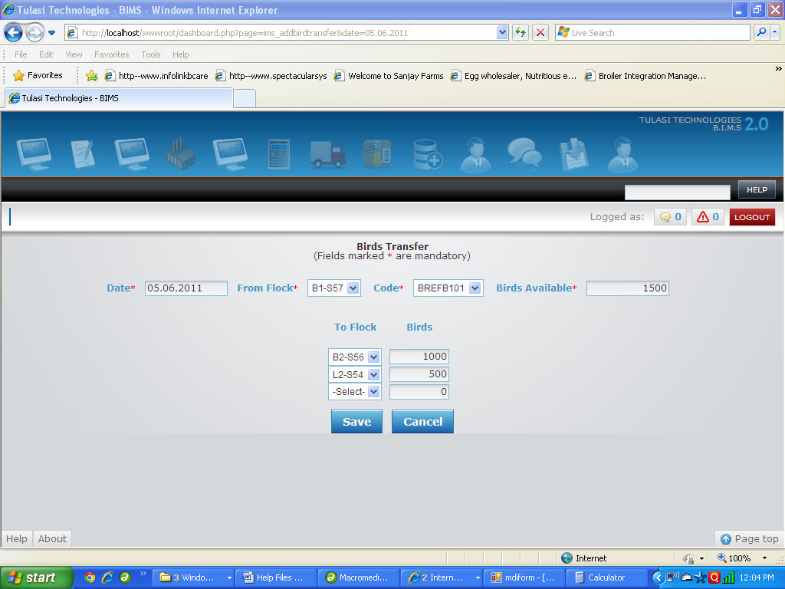

1. Now Click on "Save" button to save the Transfer of Birds or "Cancel" to exit with out saving the Transfer of Birds.

**Add New Flock Transfer**

To Add a New Flock Transfer

1. Select Values for "(Transfer)Date", "From Shed", "Flock".  
   As and when the value for Flock is selected the value of "Birds Available" will be displayed automatically.
2. Now enter the value for "To Shed".   
   **Eg :** Suppose if you want to transfer flock "19" from Shed "L1" to Shed "L3" on "7th June, 2011" then   
   You have to select *07.06.2011* for "Date", *L1* for "From Shed" and *19* for "Flock".  
   As and when you select value for Flock the values of "Birds Available" will be displayed automatically.   
   Now select *L3* for "To Shed".  
     
   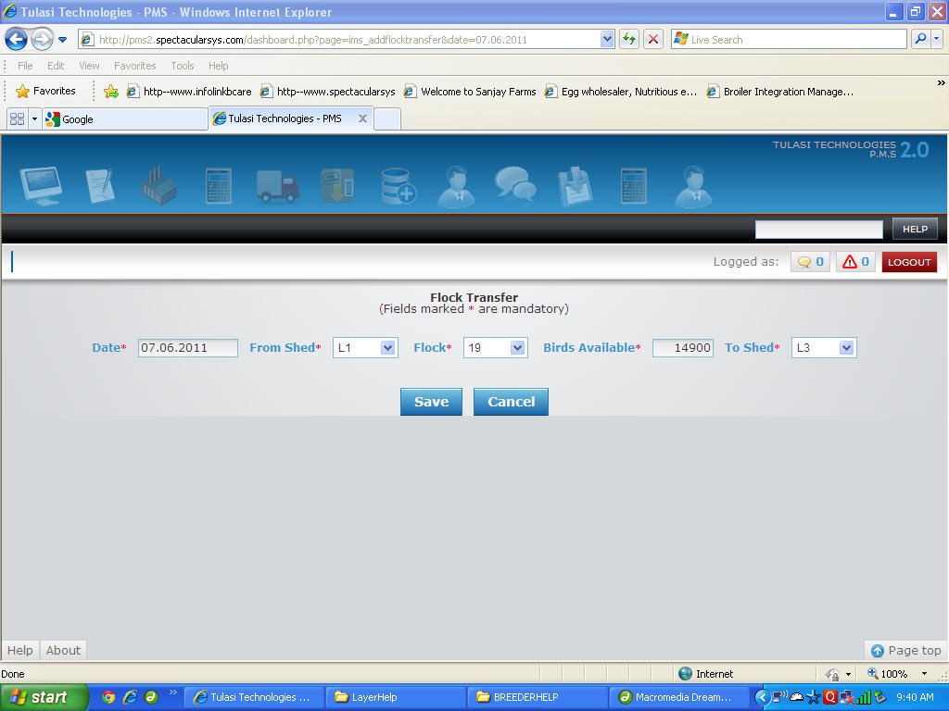
3. Now Click on "Save" button to save the Transfer of Flock or "Cancel" to exit with out saving the Transfer of Flock.