**Management**

**Masters:**

**Add New Feed Standards**

**To Add New Feed Standards**

1. Select values for "Feed Type"(whose description can be seen on mouse over), "Nutrient" and "Standard Value for 1 Kg".  
   As and when the value of "Nutrient" is selected the value of "Units" is displayed automatically.

**Eg :** Suppose for Feed Type "Breeder Grower Mash" with code "FD101" the Standard Value for 1 Kg of Nutrient "Vitamin C" is "0.25kg" then,  
You have to select *FD101* for "Feed Type" and *Vitamin C* for "Nutrient".  
As and when Vitamin C is selected *mg/kg* will be displayed for "Unit".  
Now enter *0.25* for "Standard Value for 1 Kg".

1. Repeat the above step till required values are filled.
2. Once filled click "SAVE" button to save the Feed Standards or click "CANCEL" button to exit without saving the Feed Standards.

**NOTE :** You can directly add a New Nutrient click the ***+*** icon and enter the Values for "Nutrient" and "Units".

**Add New Nutrients Standards**

**To Add New Nutrients Standards**

1. Select values for "Ingredient", "Nutrient" and "Standard Value for 1 Kg".  
   As and when the value of "Nutrient" is selected the value of "Units" is displayed automatically.
2. Once filled click "SAVE" button to Save the Nutrients Standards or click "CANCEL" button to exit without Saving the Nutrients Standards.

**NOTE :** You can directly add a New Nutrient click the *+* icon and enter the Values for "Nutrient" and "Units".

**Add New Production Standards**

**To Add New Production Standards**

1. Select value for "Breed".
2. Enter values for "Age", "Livability", "Production Hen Day %", "Body Weight" and "Egg Weight".

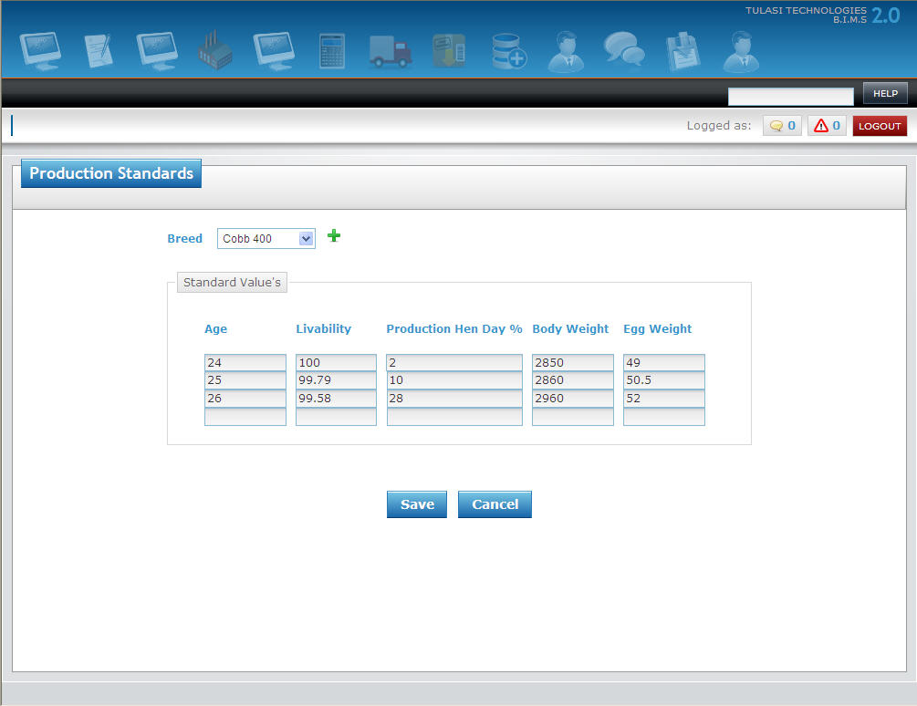

1. Once filled click "SAVE" button to Save the Production Standards or click "CANCEL" button to exit without Saving the Production Standards.

**Add New Vaccination Schedule**

**To Add New Vaccination Schedule**

1. Select value for "Breed".
2. Enter values for "Age" and select "Vaccine".

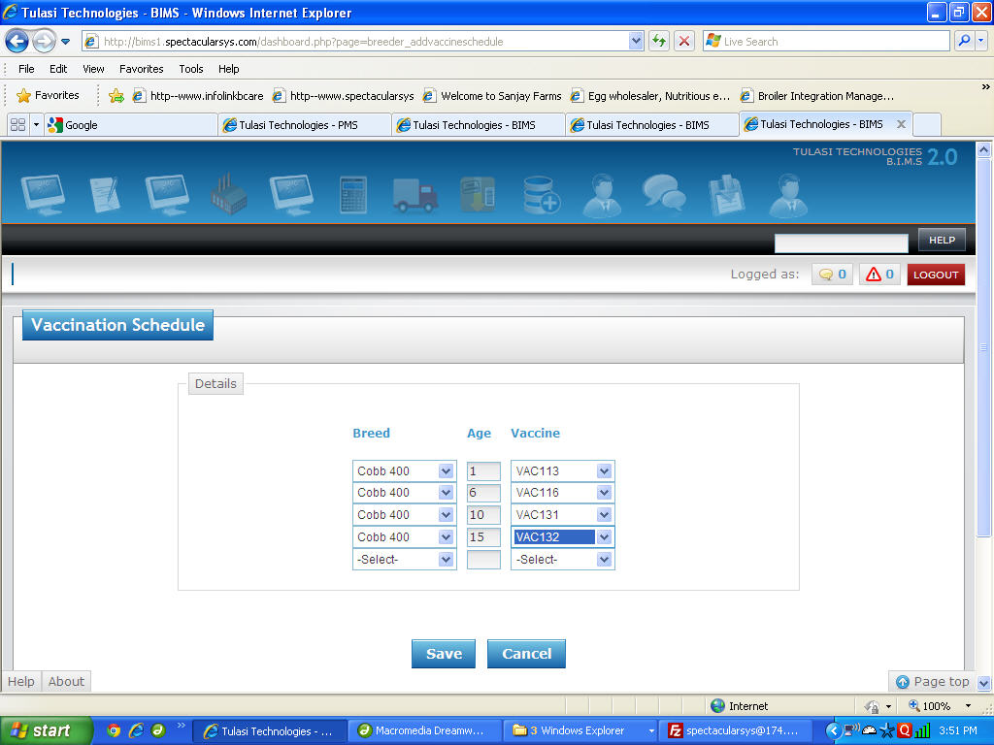

1. Once filled click "SAVE" button to Save the Vaccination Schedule or click "CANCEL" button to exit without Saving the Vaccination Schedule.

**Add New Alert**

**To Add New Alert**

1. Select value for "Item".
2. Enter values for "Min Qty." and "Max Qty.".

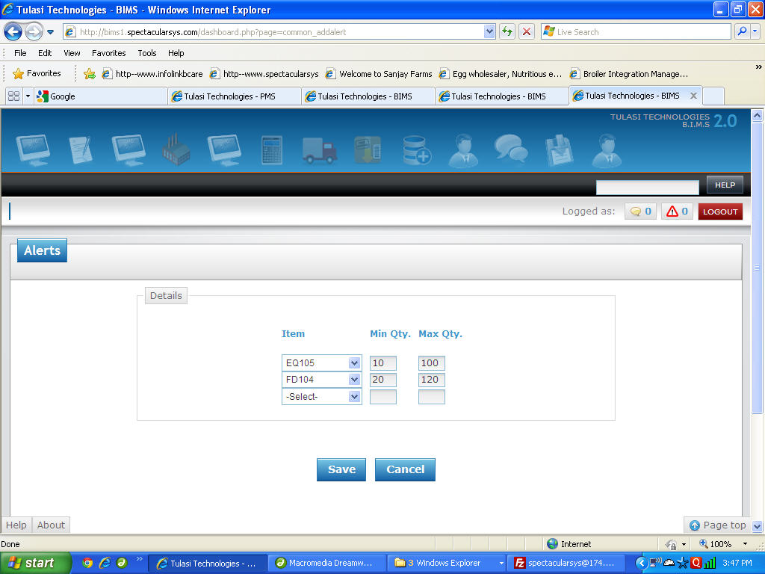

1. Once filled click "SAVE" button to Save the Alert or click "CANCEL" button to exit without Saving the Alert.